**Geovise Documentation**

By Joe Tingle

John Kyrle

Computer Science

# Introduction

In this document I am going to be investigating the current systems that are used for students to be able to revise for the AQA A level Geography specification, and improving on it by creating my own piece of software which will combine and add to these solutions. There will be four sections to this, Analysis, Design, Development and then finally the Evaluation. This means I will eventually create a program which will be the one place in which the student is able to revise from, a centred place for geography revision. I will also have a stakeholder for this project who will give valuable feedback in which I can act on to further improve it. I feel as though it is necessary to do this as I want the program to be the best and most efficient place for the user to revise from and improve the overall revision process.

# **Contents**

Table of Contents

**Contents** 1

Introduction 0

**1. Analysis of the problem** 2

1.1 Background & Problem identification 2

1.2 Identification of Stakeholders 3

**1.3 Research the Problem** 4

1.3.1 Current System 4

1.3.2 Essential Features 5

1.3.3 Hardware and Software requirements 7

1.3.4 Data Sources/volumes 8

DFD – Current System 9

1.3.5 Research the problem and analyse other solutions 10

**1.4 Specify the proposed solution** 13

Data Dictionary – End User 16

**2. Design of the Solution** 18

**2.1 Decompose the Problem** 18

**Usability Features and HCI** 23

**Login/Register** 24

**Main Menu** 27

**Options** 30

**Case Studies** 33

**Database** 35

**Quiz** 35

**Notes** 42

**Master Layouts** 44

**2.2 Describe the Solution** 45

Login/Register 45

Case Studies 46

Quiz 47

**2.3 Describe the approach to testing** 48

Test Plan for the Program 48

**3. Developing the Solution** 50

3.1 Iterative Development Process 50

**Introduction** 50

**Master Layouts** 52

**Login/Register Section** 64

**Main Menu** 74

**Case Studies** 80

**Quiz** 87

**4. Evaluation** 97

4.1 Testing to Inform Evaluation 97

**Alpha Testing** 97

**Beta Testing** 107

4.2 / 4.3 Describe the Final Product / Success of the Solution 119

4.4 Maintenance and Future Development 126

Appendices 128

Bibliography 130

# **1. Analysis of the problem**

## 1.1 Background & Problem identification

The problem with the current AQA geography qualification, and for fact most other subjects, is that there isn’t one centred place where you can easily find all of the revision material that you need. It is a problem as it is restricting the stakeholder from completely understanding the topics which are being taught and may even affect their final grade, due to spending time which could be spend actually revising, trying to find the relevant resources. The textbooks for the subject, in this case AQA geography A Level, are good and cover all of the topics but a more in depth understanding is required, to get the higher marks in the exam and the whole reason that people use the textbooks is to get all of the information it is what you expect. Also particularly for geography there is a need for case studies which the textbook does not always give you, even if they do they are not in the depth needed to fully understand them, and only by understanding it will they be able to achieve a high grade. In Geography especially you are required to know at least 8 separate case studies and have enough information to write usually 8-16 marks worth, so you can see why the information must be correct, up to date and relevant to get the upper mark band.

Having personal revision notes from lessons or from revising the textbook is great so long as you keep it organised within folders, but it is still time consuming to get the correct folder and then find the particular topic or lesson in which you feel you need to revise more on. This problem will be solved by creating a piece of software which provides an easy to use menu system, so that the user does not spend an unnecessary amount of time navigating through menus, which will allow the user to log into a specific account connected to them and allow them to go through a range of revision materials/notes and save any relevant pages to come back to later. This will then reduce the time needed to access you own notes. The program could also include a range of animations and diagrams which will further aid with the revision, as sometimes it is useful to draw out a graph to represent the information.

The whole aim of this Geography revision tool is to allow the user to access personal revision notes (which they will be able to create and then save to their account) as well as all of the relevant information, in depth, on the topics that need to be covered, quickly and efficiently. This allows for a more streamlined revision session, meaning it can be much more productive for the user. By using a computational approach, it means that everything will be able to run as efficiently as possible with no delays finding the information as computers are very good at accessing and displaying information, which you wouldn’t have if you were using paper based notes. The notes and topic information can be saved within a folder system so that there is no chance of it being lost, which is also a real possibility using paper, and all of this can be accessed at the press of a button.

I have conducted an interview with a current A2 geography student that outlines what he believes to be the problem with the current system as seen in ***Appendix A.*** I have decided to conduct this interview as it will give me an idea of how other geography students feel about the revision resources etc. doing this means that it won’t be biased, and allows for a more varied response.

As you can see the interviewee has identified the problems with the current system and proposed that there should be a central place for all revision information etc. He has outlined that the current system can waste revision time where as a new proposed system can be much more efficient allowing for more revision time, due to the computational methods.

Alongside this interview I have also created some questionaries’ asking the potential user base (Geography students) about what they also think giving a much wider view on the issue. These questionnaires can be seen in ***Appendix B.*** I decided to do the questionaries’ as this also means I will get a greater idea of what the current geography students want and need for their revision. It also gives a much more varied response that I can analyse.

## 1.2 Identification of Stakeholders

The main target audience for the proposed system are current John Kyrle High School & Sixth Form Centre A level Geography students specifically on the AQA exam board. This is because the information included in the proposed system is based off of the AQA A level specification, other exam boards may differ. If I chose to put in information from multiple or different exam boards then the information would just be confusing for the user and would not help them at all. The proposed system works assuming that the user has previous knowledge of the AS specification, if they don’t then it may be difficult to understand but they should have no trouble navigating around the program. It must include lots of detailed information along with case studies for each topic in the specification but not in too much detail where it makes it redundant. As I have stated before the information needs to be concise and relevant, as case studies are one of the most important items the user needs to know before the exams.

So this software will be for all Geography students, even if they are not on the AQA exam board they would still be able to use it, but the information may have to be adjusted or they may have to find some more information from another source. This could also be used by teachers who may want to give the users some tasks to complete on the software, for example they could ask them to complete the quiz and then report back as to what score they got.

The user will be able to log into/create their own personal account and when they log in they will be able to select a number of items on the main menu. The main menu which act as the base for the program and where everything can be accessed from, so the user will be able to navigate to the case studies etc. from the main menu. This is so that it is all centralised in one place. This may include creating their own revision notes, or opening up some annotated textbook pages or even accessing the case studies section which provides them with multiple case studies to choose from within each topic. There needs to be multiple case studies as the user should really know around 2 case studies in detail for each topic, and there are quite a few topics in the specification. The revision notes that they create will be saved onto the database, and be directly related to the user account so you can only access your own notes and not notes belonging to other people. But there will also be the option for a local save, so they can easily access it without the need for logging into their account again, making it even quicker to access the relevant information which is what the propose software is all about.

## **1.3 Research the Problem**

## 1.3.1 Current System

The current systems that are available to the user are included on the CD’s provided at the back of the subject textbooks, they do provide the user with a digital copy of the textbook and allow for some limited annotation but that is it. So they provide a digital solution but it is not convenient for the user as they need to find the CD first and then load it up etc. It is also difficult to do any updates on this. There are other options which work with the current system but requires the user to be much more independent such as Google to search for certain facts etc. The system that I am proposing will greatly expand on this allowing for much more functionality and compatibility as to use their software you need to have a CD drive which not everyone has, but with my software it can be run anywhere once it is downloaded. It is not limited by items such as the CD as it is just a piece of software distributed through the internet. All of the information is in one place for the user to access making it much easier to get started with the revision. Meaning they are not wasting any time trying to find the relevant information and gather it together. Also for my proposed system it will allow for updates easily, so long as the user has an active internet connection it will be able to download/change any information that has been updated on the database, unlike the current system explained before where by no updates can be made to the CD. As you can see I have included multiple images of how the user has to use the current system, there is the official AQA AS textbook as well as the Google search engine and the AQA specification just to name a few.

*Source - https://www.amazon.co.uk/AQA-Geography-AS-Students-Book-x/dp/0748782583*

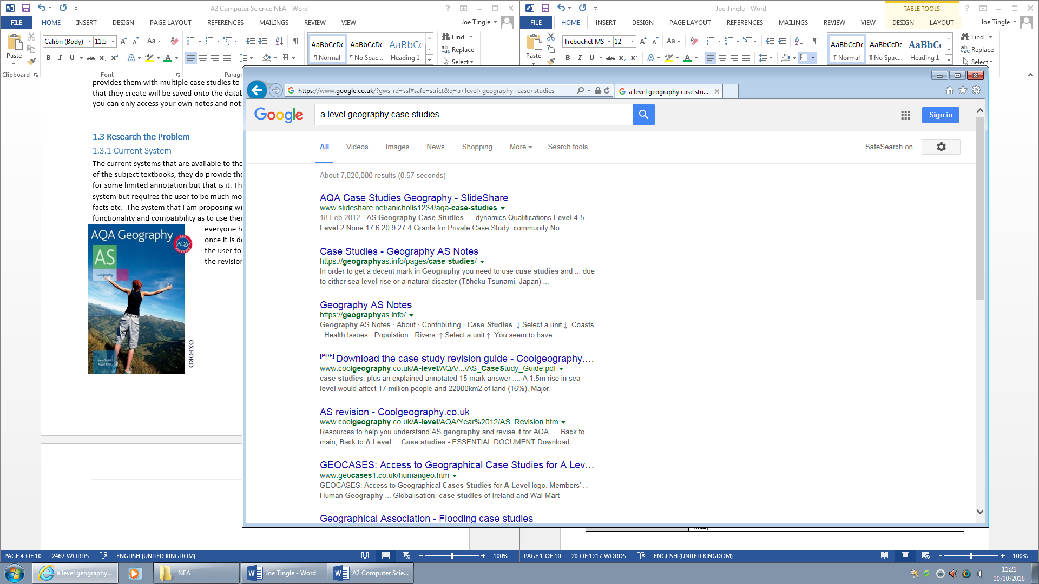Here is how the user on the current system is able to search for information on the internet, in this case using the Google search engine. To use this effectively you first need to know specifically what you are looking for or it may become difficult to find the relevant information, due to the vast amount of websites out there now it could take a long time to find the right information. Based off of this my proposed system will improve on this by collecting all of the relevant information to the user, such as the case studies, previous exam questions etc. and put them all into one place within the program. This means that they are much easier for the user to access, saving time which can be spent actually revising the content. However using the internet on search engines will give a much larger amount of information as the information on the proposed system will be limited, for many reasons such as keeping the storage requirements low, and making sure the information is relevant and detailed enough.

*Source - https://www.google.co.uk/#safe=strict&q=a+level+geography+case+studies*

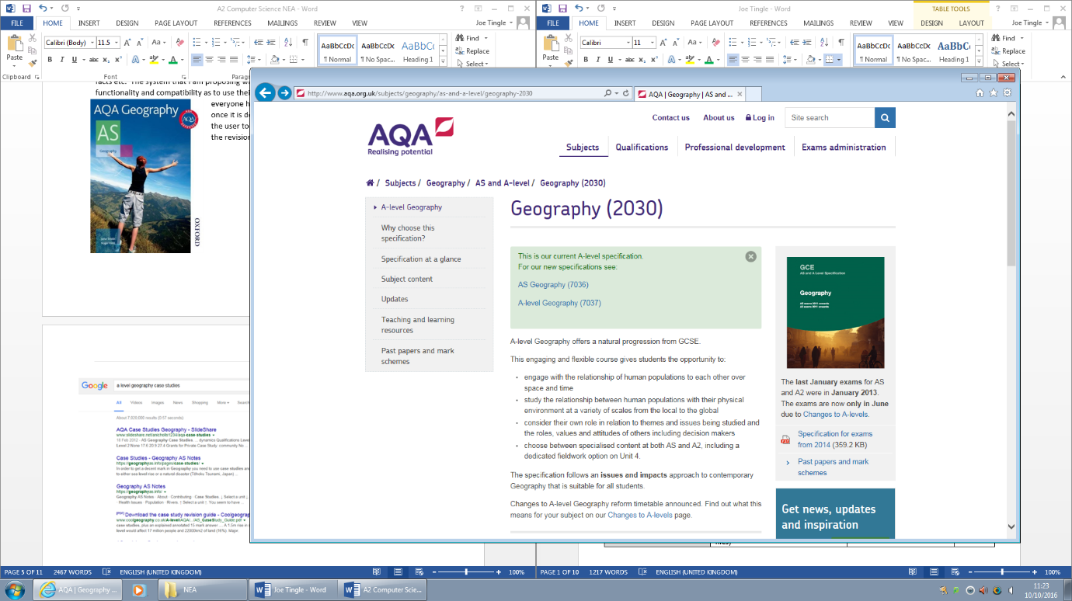Here is another place where the user is able to gather their information from for revision, the exam board specification and topic information. This is useful as you can directly see what the exam board expects you to know and you are able to adjust your revision around that to make sure you are not revising items which may not be useful for the exam. Based off of this my proposed system will be able to improve by actually providing the information for the user to revise from. In the current system they only tell you what they expect you to know about and don’t actually give you anything to revise from, where as the proposed system would.*Source -* <http://www.aqa.org.uk/subjects/geography/as-and-a-level/geography-2030>

## 1.3.2 Essential Features

The software that I am proposing will allow the user to log into or create their own account which will store all of their revision notes/ topic information etc. After they log in they will be greeted with a main menu, where they can choose from a selection of options such as a Quiz, Case Studies, Individual Topic Information and Revision Notes. Each section will contain all of the relevant information and as well as having their own unique features. For example the case studies section which have two different tabs with human and physical case studies, this is to make it easier for the user to identify.

I am considering using either the bubble sort or quick sort algorithm for sorting out the highest scores from the users. All this sorted data should then be displayed in a table, presented within the active window.

I am considering the bubble sort algorithm for sorting out the highest scores from the users, which is a comparison-based algorithm in which each pair of adjacent elements is compared and the elements are swapped if they are not in order. This algorithm is not suitable for large data sets as its average and worst case complexity are of Ο(n2) where **n** is the number of items. An example of bubble sort in pseudo code can be seen below:

procedure bubbleSort

loop = list.count;

for i = 0 to loop-1 do:

swapped = false

for j = 0 to loop-1 do:

/* compare the adjacent elements */

if list[j] > list[j+1] then

/* swap them */

swap( list[j], list[j+1] )

swapped = true

end if

end for

/*if no number was swapped that means

array is sorted now, break the loop.*/

if(not swapped) then

break

end if

end for

end procedure return list

I am also considering the quick sort algorithm for sorting out the highest scores from the users, which is a highly efficient sorting algorithm and is based on the partitioning of an array/ set of data into smaller arrays. A large array is partitioned into two arrays one of which holds values smaller than the specified value, say pivot, based on which the partition is made and another array holds values greater than the pivot value.

Quick sort partitions an array and then calls itself recursively twice to sort the two resulting subarrays. This algorithm is quite efficient for large-sized data sets as its average and worst case complexity are of Ο(n2), where n is the number of items. An example of the pseudo code can be seen below:

function partition

leftPointer = left -1

rightPointer = right

while True do

while A[++leftPointer] < pivot do

//do-nothing

end while

while rightPointer > 0 && A[--rightPointer] > pivot do

//do-nothing

end while

if leftPointer >= rightPointer

break

else

swap leftPointer,rightPointer

end if

end while

swap leftPointer,right

return leftPointer

end function

procedure quickSort(left, right)

if right-left <= 0

return

else

pivot = A[right]

partition = partitionFunc(left, right, pivot)

quickSort(left,partition-1)

quickSort(partition+1,right)

end if

end procedure

However I think that I am possibly going to use quick sort as there is the possibility that It may be dealing with a large data set, depending on how many accounts there are, as quick sort which is faster which bigger data sets.

The quiz section will give the user 10 random questions based on all of the topics required for the Geography specification, and at the end it will give their score along with an in-depth description of the answers for each one. After the user has completed the quiz once the program will then save that score to the database, and the next time the user attempts the quiz the question difficulty will be determined by the previous score. This is so that it adapts to the user and makes sure that they are not presented with very easy question, this would not help their revision at all.

## 1.3.3 Hardware and Software requirements

The requirements for this are a computer system, any web enabled desktop or laptop as well as; access to the NetBeans IDE for development, if animations are used then Adobe Flash for their creation, as well as a good system in terms of components within it. The program itself will not be very resource intensive due to it only really needing to display the GUI and some image assets but it is good to have a fair amount of RAM in case other programs are running at the same time. I would recommend that the system has 4GB of RAM overall as a minimum, of course the system will not use anywhere near this but you have to take into consideration other programs running and the requirements of the operating system as well.

The end user will only need to have a web enabled device, to be able download the executable file, and a java runtime environment to be able to use the program, if I end up coding it in Java. They need to have a java runtime environment installed, as java uses the java byte code which is only understood by the runtime environment, this is what makes it multi-platform as it is only dependant on the bytecode and not on anything OS specific.

I estimate that the program itself will only utilise a maximum of 400MB of RAM meaning nearly all systems can run it. This is because the most intensive element the program will have to display is the GUI and then a .gif. Most of the windows that are displayed by the user are a maximum of 800 x 600 which fits in the centre of the screen well, with a 1440 X 900 monitor. The only exception to this is the quiz section which should be compatible so that it can be maximised fully without any image stretching/distortion, but this will depend on how it is implemented as there are various ways to do it.

One of the huge advantages of using the Java, if I do indeed choose to go down that route is that it complies in Java byte code which is then understood and run by the JRE. This means that as long as the user has installed a JRE on the system it can run on almost all operating systems, so Mac OS/Windows 7,8,10 etc. This means that the proposed system will be multi-platform, due to it being able to run on multiple operating systems.

The program will be designed to be run on a PC as that is where the majority of the targeted audience will be and there is also the opportunity later on in development to port it to a mobile platform for portability, so the dimensions etc. will be taken into consideration based off of the most common resolution for monitors which are 1920 x 1080. So this means that the program will run on a tablet or phone, but the dimensions may be off so it could appear and fill up the whole screen on a phone. To solve this I could have different versions for each device, so a mobile version where all of the dimensions are changed to fit correctly and on tablet.

## 1.3.4 Data Sources/volumes

The data stores for the software will be a database which will store all of the users log in information as well as other information such as revision notes. The type of interface will need to be an easy to use menu system allowing the user to select a specific option. The inputs for the program will be username and password for the login as well as the choice for what topic they want. The outputs will be animations, if used, diagrams as well as the relevant information and the menu itself.

All of the data that the user creates, for example the quiz scores, their account, notes etc. will be stored on the database where it is all stored under the users name.

For the proposed program there will be multiple users, hence the login option for the user, and it may require quite a bit of storage space as there a lot of assets. These assets may include pictures/scripts etc.

I estimate that the program itself will take up a maximum of 100MB of local storage space on the primary storage device. The program will use an installer to make it easier for the user, this of course increases the file size slightly, but the actual executable file will be fairly small. However it will al depend on the implementation of certain items within the program, so for example if I utilise a fully use a database then it will reduce the amount of information needing to be stored locally.

## DFD – Current System

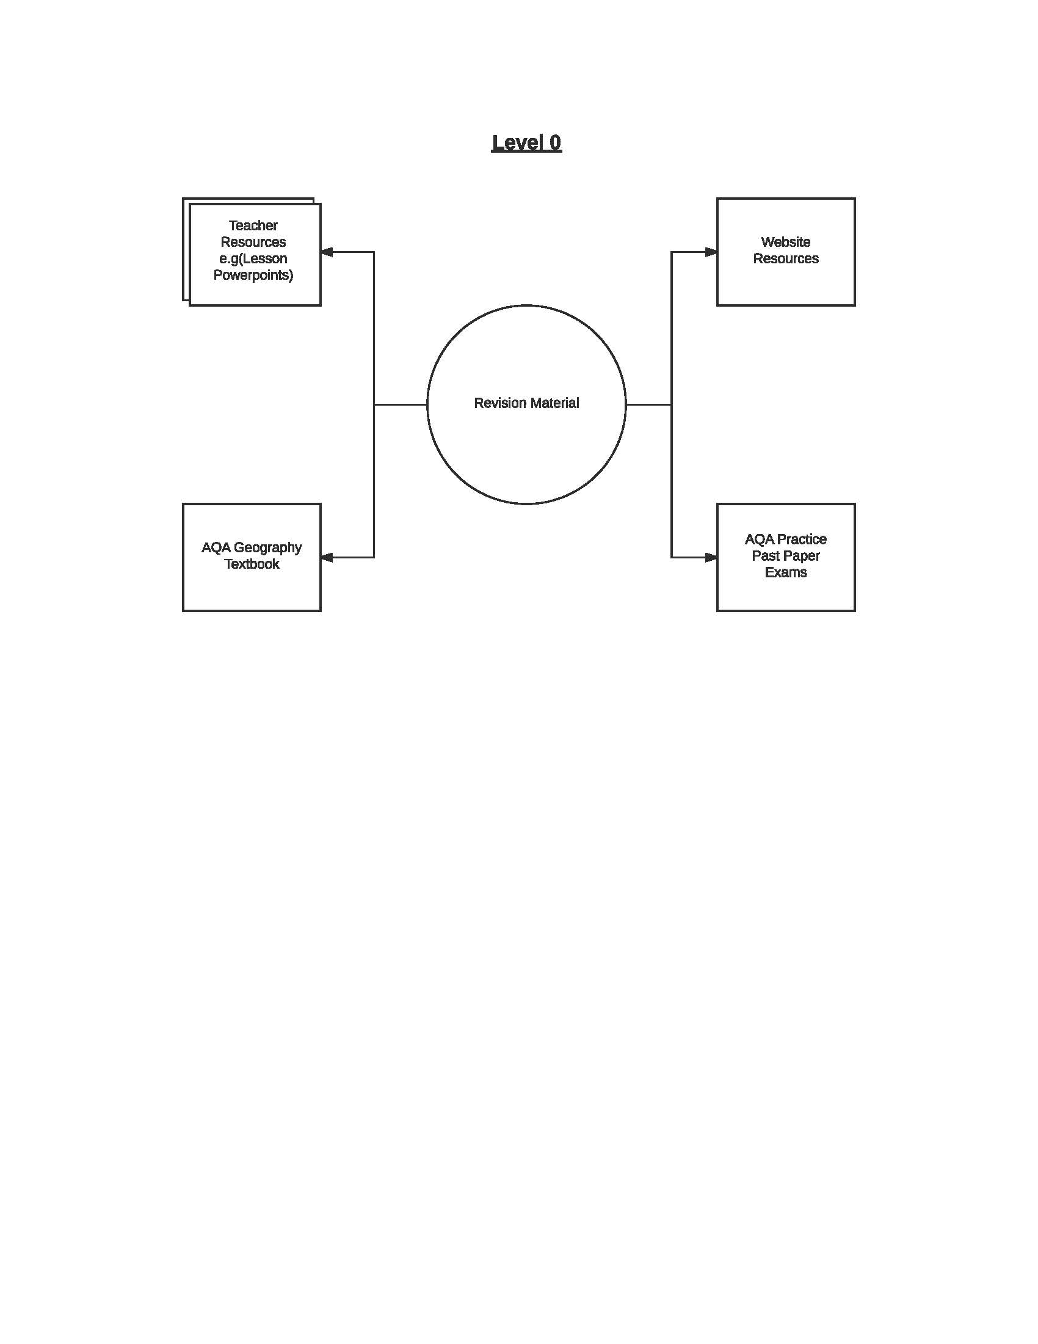

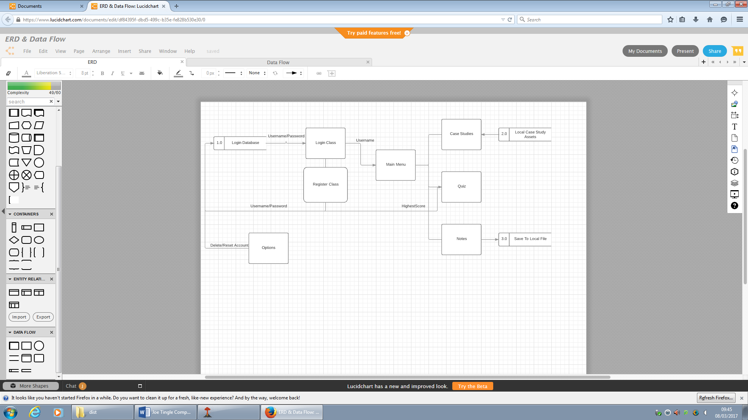Shown above is the DFD for the current system, it is a visual representation of how the user utilises the current system. Below is the DFD of the proposed system.

## 1.3.5 Research the problem and analyse other solutions

There are a quite a few other solutions or advancements to the current system, for example the BBC has its own website called Bitesize which is full of revision material for various subject, this does include geography but only at GCSE. Also the page has been archived and is no longer updated so most of the information may not relevant anymore, the advantage to a software based program using databases is that it can easily be updated. Which is why in my proposed system I am going to be making sure that the information is relevant and kept updated through the use of the database which will be implemented into it. But one idea that I like about this is that all of the information is split up into sections, categorised so that it is very easy to navigate around. So this is a good centred place for revision which is what I want my proposed program to be. But of course the main issue here is that it is only at a GCSE, so what I would like to do based off of this research is use the same format, so split it up into sections, but I will not be able to use any of the information off of here so I will swap the information out for some other source.

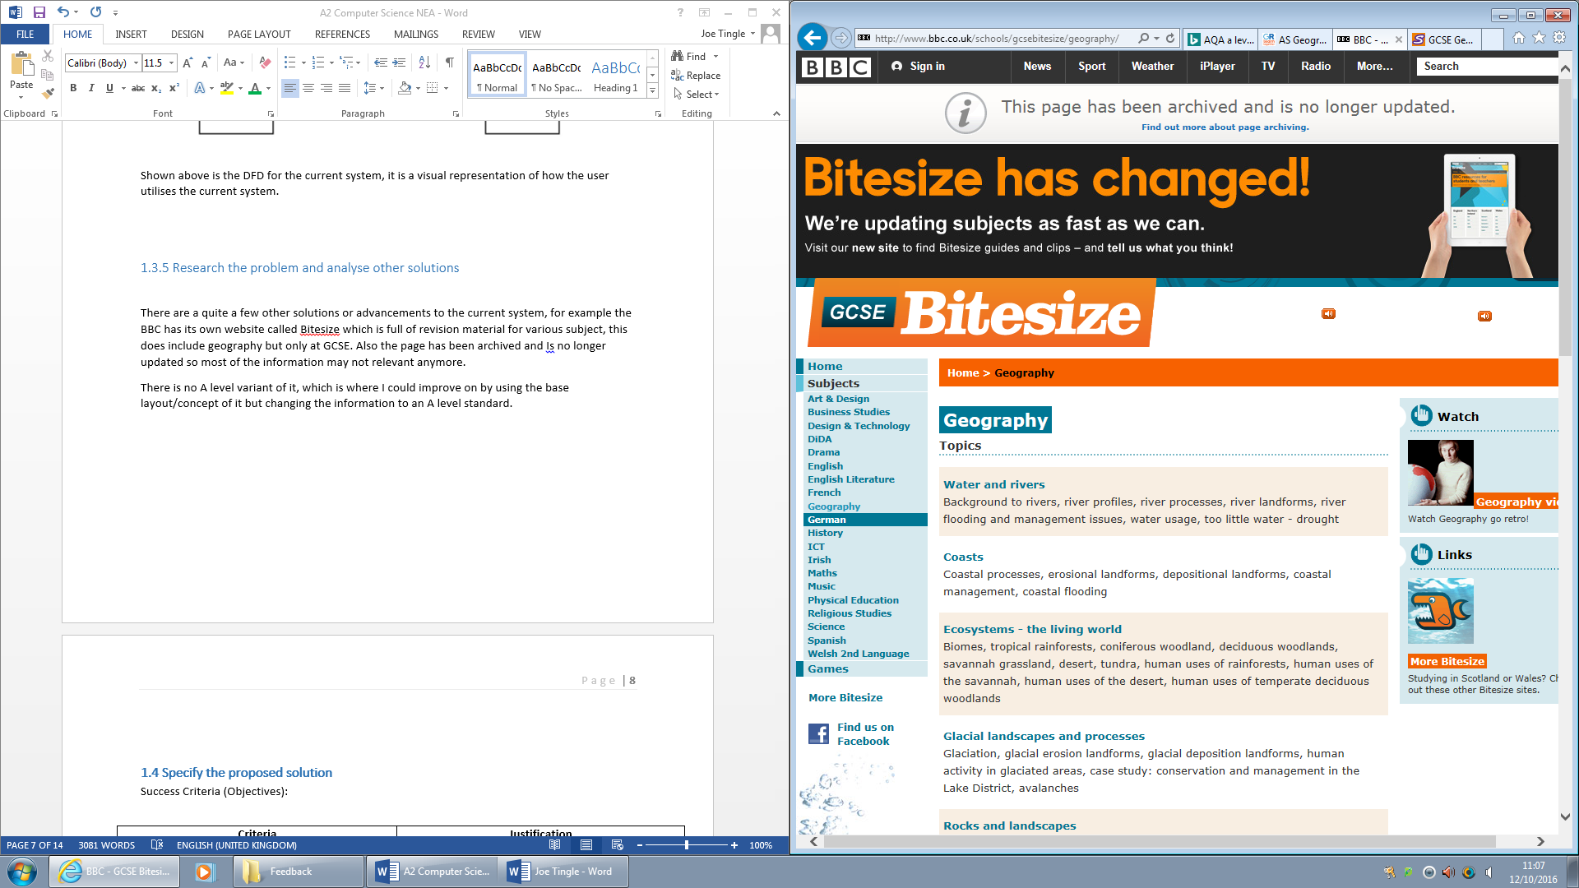

*Source - http://www.bbc.co.uk/schools/gcsebitesize/geography/*

There is no A level variant of it, which is where I could improve on by using the base layout/concept of it but changing the information to an A level standard.

Another example is the S-Cool revision website which offer a geography revision section alongside a multitude of other subjects. Unlike the BBC bitesize this offers both a GCSE and A level section for each subject, which I could potentially incorporate into my proposed solution, it would increase the user base. The ideas that I like from this example are that it has the relevant information at both an A level standard and GCSE, which means that the information is more than likely good and relevant for the AQA specification. Also there is a forum in which the users are able to communicate and talk to each other about whatever they like, so for example specific revision tips etc. this is a very good feature and I think that I may implement some similar system into my proposed system. This is so that the user base is able to communicate with each other and not feel separated. Another feature I like in this example is the timetable which allows the user to plan out there revision so they are more likely to stick to it and follow it, to be able to get more revision done. I will try to implement this in some different form into my proposed program so that it tells the user when the best time is to revise, or if it is too late in the night to be revising.

However one thing I do not like about this is the overall theme of the website, it has lots of contrasting colours and just generally does not look nice to use. Also there are big advertisements to register which in my opinion would actually put me off using the website. In my proposed software I will not be advertising like that at all within the program itself. Another thing to note about this example is that it is online only, so the user must always have an internet connection to be able to revise, which I think is unnecessary and the big drawback to it being web based, which is why my proposed solution will not be web based and not require an internet connection all of the time. So based off of this research there are a couple of ideas I have taken from this and may implement into the proposed solution, and there are also items that are bad about this and will not be considered.

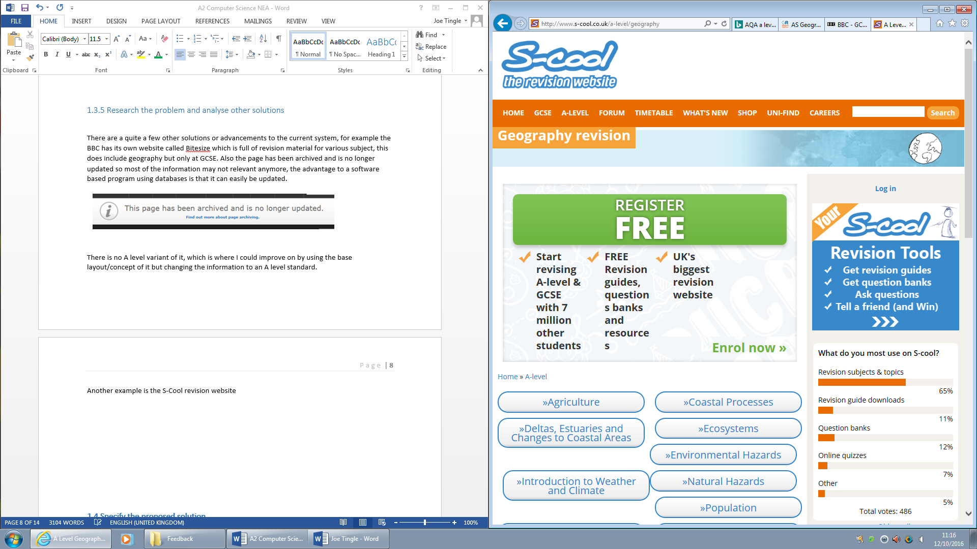

*Source - http://www.s-cool.co.uk/*

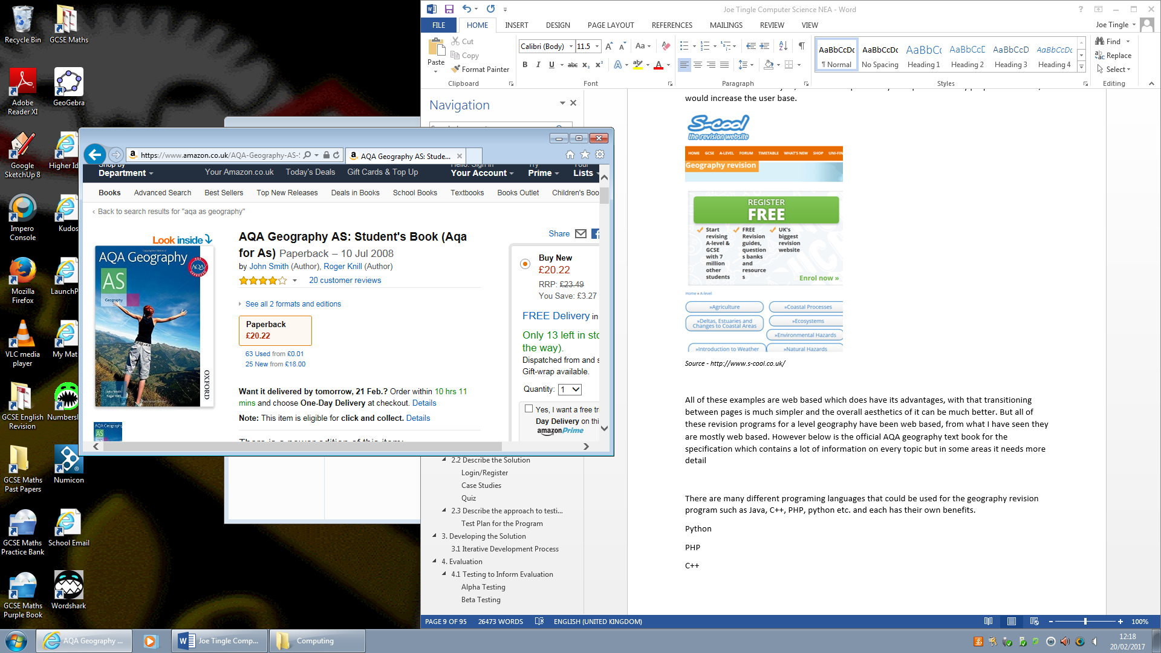All of these examples are web based which does have its advantages, with that transitioning between pages is much simpler and the overall aesthetics of it can be much better. But all of these revision programs for a level geography have been web based, from what I have seen they are mostly web based. However below is the official AQA geography text book for the specification which contains a lot of information on every topic but in some areas it needs more detail. This is a very good example of all of the information being centred into one place so that you do not have to put in any extra effort to find the information, however this is implemented poorly in this example as the information is simply not up to standard which I feel is necessary for A-level revision. But the good things about this are that the information in it, however limited it may be, is completely relevant as it is published by the exam board so I can use this information if needed. One idea I do not like about this is that it is physical, so if you want to revise at any point you first have to find the book. This can be an issue, as what if you spend 10 minutes looking for it which could otherwise be spent revising, this is why based off of this research my proposed solution will not in any way have physical copies on CD’s etc.

*Source -* [*https://www.amazon.co.uk/AQA-Geography-AS-Students-Book-x/dp/0748782583/ref=sr_1_3?ie=UTF8&qid=1487593101&sr=8-3&keywords=aqa+as+geography*](https://www.amazon.co.uk/AQA-Geography-AS-Students-Book-x/dp/0748782583/ref=sr_1_3?ie=UTF8&qid=1487593101&sr=8-3&keywords=aqa+as+geography)

There are many different programing languages that could be used for the geography revision program such as Java, C++, PHP, python etc. and each has their own benefits.

**Python**

+ Easy to read, so it benefits the developer and helps you think more clearly when writing programs, also helps other who maintain the program, requires less effort to write a program compared to c or java.

- However the above only benefits the developer and not the end user. Also in some cases it can be slower compared to other languages such as C++. Python is mainly suited and most commonly used as a network tool.

**PHP**

+ Stable, since it is maintained by many developers, so when bugs are found, it can be quickly fixed. Also it is open source so it is developed and maintained by a fairly large group of developers. Another advantage is that it has built in database connection modules where you can connect to a database easily using PHP.

- Security, because PHP is open source everyone is able to view the source code, so if there are any bugs in that source code then people can explore it to finds weaknesses in PHP. Also it is not suitable for large applications and is quite hard to maintain since it is not very modular.

**C++**

+ C++ is object oriented and is a very portable language, so you are able to write a program irrespective of OS or hardware requirements. Also is very performance and memory efficient compared to other languages such as python and PHP, and Java.

- There are not many disadvantages to C++ apart from that it can be complex in very large high level programs and is usually developed for particular operating systems. C++ is also not very secure because it has a pointer, friend function and global variable with no support for threads built in.

**Java**

+ Java is object oriented which allows for the creation of modular programs and reusable code. It is also platform independent giving the developer the ability to move easily from one computer system to another. Java also is multithreaded to allow for the capability to perform several tasks simultaneously within a program.

- However the disadvantages of using Java is the performance cost as it is significantly slower and more memory consuming than natively compiled languages such as C++. Java is a single paradigm language.

Coding the solution is very beneficial as it allows for automation of many of the different areas, for example the randomised questions based on the previous scores on the quiz could only be achieved through coding of the solution. It may be possible to do it physically but it is not practical or efficient.

## **1.4 Specify the proposed solution**

My approach to the proposed system is to first break up the problem into several different sections to allow for much better development tracking as well as troubleshooting with errors. I will be developing the proposed solution in the Java programming language using the NetBeans GUI, I have chosen Java as I am already familiar with it and it also allows for great graphical applications. I also chose to use the NetBeans IDE as it offers great user ease of access, for example it will point out any potential errors and the main reason I am using it which is the built in GUI tools. It utilises the swing API to allow me to create user interfaces.

The first section of the proposed solution is the user Login/Register section which can be developed in a variety of ways, the first being the use of variables to store usernames and password but this is very inefficient and will eventually lead to problems. This is why I have decided to go with another option which is the use of a MySQL database connected to the program allowing for external editing as well as SQL statements being executed within the code.

However the proposed system will have some limitations to it, the main one being that it requires an active internet connection for the user to use it. This is due to the program needing to make the connection to the database through the internet to check the user credentials, it won’t be able to do this without the internet connection. A solution to this limitation could be the implementation of some sort of guest system, where by the user could log in as a local ‘guest’ account bypassing the database connection and just utilising the local assets. However this would mean that the user would be severely limited to the available content, as the quiz would only work on the tutorial as the difficulty scaler would not be able to update.

Also another possible limitation is that the proposed system will at the moment only include information relevant to the AQA specification and not any other exam boards. This means that the audience for the proposed system is smaller, but this could be extended by adding in some sort of option where the user is able to choose their current exam board and the information would dynamically change depending on this choice.

**Qualitative | Quantitative | General**

Success Criteria (Objectives):

|  |  |  |
| --- | --- | --- |
| **No.** | **Criteria** | **Justification** |
| 1 | The system must help the end user to revise the AQA A level geography specification | The is because the whole point of the proposed system is to help the user to revise, if it does not accomplish this then it has failed and it is redundant. |
| 2 | The system must allow the user to login to their own account | The user must be able to login to their own account so that all of the information such as notes and quiz scores, is stored under their names. It also enables multiple users to use the proposed program. |
| 3 | The system must allow the user to create their own account | This is so that the user is actually able to create an account instead of logging into an already existing one. This allows for theoretically and infinite amount of accounts to be created. |
| 4 | The system must display all of the windows correctly. | This means that all windows such as the main menu/quiz etc. must display without error and must be the correct dimensions. |
| 5 | The system must change the default java icon to a volcano bitmap image when launched | This is for the aesthetics of the program as the default java icon will not represent a geography program, where as a small icon of a volcano might do. |
| 6 | The system must censor the user’s password | For privacy reasons it must be censored in case the software is being used in a public space, you don’t want anyone else to know your password |
| 7 | The system must display both an image and a map for each case study on the case studies page. | The specification usually requires the student to know where exactly the case study is and an image on the page as well will help the user visualise it. |
| 8 | The system must allow the user to log in and out of the program without restarting it. | This is mainly for ease of use as you don’t want to have to close the program and reopen it just to log into a different account for example. |
| 9 | The system must exit fully when the exit button is pressed on the displayed window. | If the exit button is pressed then the program must exit fully to ensure that it is not still running in the background without the user knowing. If it was then it could hog system resources over time, potentially slowing the system down. |
| 10 | The system must take the user to the login screen when the logout button is pressed. It must also close all other displayed windows when the process occurs. | If the user wants to logout then it should close all other windows, not make them invisible and then display the login window. When this happens no other windows should be open as they may have that users notes on them. |
| 11 | The system must display the correct information for each case study on the case studies window. | The correct information must be displayed on the case studies page as students need to know case studies in great detail, mixing up the information or adding incorrect information could harm the user’s revision. |
| 12 | The system must allow the user to open a blank notes page and save them for use at a later time. | The user needs to be able to store their notes somewhere and with this system it will allow them to save them to the database. |
| 13 | The system must alter the difficulty of the question on the quiz based on the users previous score | To ensure that the questions remain fairly difficult for the user, to make them think about it, the questions need to scale in difficulty depending on their previous scores. The user does not want questions that are too easy or else that makes the whole program redundant. |
| 14 | The system must display the answers to the quiz at the end. | The user needs to know if they have gotten the questions correct or not, therefore a list of the questions with answers by the side should be displayed once the user has answered all of the questions presented. |
| 15 | The system must allow the user to access help at any point during the program. | If the user requires any help during the process of the program then they should be able to click on a small question mark icon, which will them display some help text for them. |
| 16 | The system must exit fully once the user presses the exit button | If the exit button is pressed then the program must exit fully to ensure that it is not still running in the background without the user knowing. If it was then it could hog system resources over time, potentially slowing the system down. |
| 17 | The system must only allow the quiz window to be maximised. | The quiz menu will not have any external assets, for example images off of the internet, it will just be a plain colour. This means that to allow for maximum compatibility the window can be maximised. None of the other windows will be allowed to be maximised as the images used are only a certain size. |
| 18 | The information presented to the user must be correct and relevant to the section they are in | This is so that they are not wasting time learning information that is not relevant to their revision etc. |
| 19 | The system must display two tabs on the case studies page, human and physical | To ensure that the human and physical topic of the specification don’t get mixed up there must be two separate tabs. This also helps to user to quickly identify the topic in which they need to revise in. |
| 20 | The system must display randomised question from a pool of them stored. | The questions for the quiz will be stored within the database or locally so that the random function can display them completely random with not bias. It also enables it to cover a variety of topics and the questions will differ each time the program is run. |
| 21 | The system must only take up a maximum of 100MB disk space. | To ensure that the program is lightweight it should only take up a maximum of 100MB of storage space. This also allows for maximum compatibility with nearly any device as 100Mb is not very much space. The majority of personal computers have 500GB of disk space. |
| 22 | The system must not utilise more than 400MB of RAM. | To ensure the program is not a resource intensive I am setting a limit of it only using a maximum of 400MB of RAM this allows the user to open other programs and the system will not slow down. |
| 23 | The system must ask the user 10 questions each time | This is so that the amount of questions is consistent and the high score can be relevant based off of their score on the 10 questions. |
| 24 | There must be at least (minimum) 4 case studies for each section | This is so that the user has enough information and case studies to be able to go into the exam and write at least 20 marks about it. |
| 25 | There must be a minimum of 10 Quick facts. | These facts will then be randomly grabbed from a pool of them to give the user when they click on the button. It should be at least 10 to give a good variety and reduce the chance of duplicates. |
| 26 | The system must display a clock for the user to check the time, keeping focus on the program | The system will display a clock so that it keeps the users attention onto the program itself, meaning that they won’t get distracted trying to check the time. This also means that there is the possibility to tell the user later on if the current time is not suitable for revision. |

## Data Dictionary – End User

|  |  |
| --- | --- |
| **abrasion** | the way rocks in rivers or glaciers scrape and erode the rocks they are moving over |
| **attrition** | the way that rocks in rivers are worn down by rubbing against each other |
| **corrosion** | the way which rivers use the rocks that they carry to batter the land |
| **delta** | an area of alluvium at the mouth of a river when it has split up into distributaries |
| **deposition** | the dropping of rocks and other materials by e.g. glaciers and rivers |
| **erosion** | the wearing away of soil and rocks by e.g. rivers and glaciers |
| **flood plain** | a wide valley, usually in the lower course of a river |
| **glacier** | a mass of ice flowing down a valley |
| **Ice age** | the long, cold period when ice and snow covered most of northern Europe |
| **mouth** | the end point of a river where it reaches the sea or a lake |
| **oxbow lake** | a former meander of a river |
| **transportation** | the carrying of rock particles |
| **tributary** | a smaller river which flows into a larger one |
| **V-shaped valley** | a valley that has been eroded by a river |
| **air pressure** | the force exerted by air on the earth's surface |
| **Evaporation** | The process by which liquid water is transformed into water vapor. |
| **Evapotranspiration** | The total amount of moisture removed by evaporation and transpiration from a vegetated land surface. |
| **Fall Velocity** | At this velocity, the particle will be deposited. |
| **Falling limb** | The decrease of fischarge on a hydrograph. |
| **Grade** | The theoretical long profile for a river. |
| **Gradient** | Steepness of slope |
| **Groundwater Flow** | The slowest transfer of water in the drainage basin, through the underlying rock strata. |
| **Hjulstrom Graph** | The corkscrew flow inside a meander, responsible for moving material from the outside of one bend to the inside of the next. |
| **Hydraulic Radius** | Cross sectional area divided by the wetted perimeter Incised meander Caused by rejuvenation, a meander that has cut deeply into the flood plain creating steep cliff like banks. Entrenched=Symmetrical, Ingrown=Asymmetrical |
| **Infiltration** | The downward movement of water into the soil from the surface. |
| **Interception** | The process by which raindrops are prevented from directly reaching the soil surface. |
| **Kinetic Energy.** | Energy due to movement, generated by the flow of the river. |
| **Lag Time** | Delay between peak rainfall and peak discharge. |
| **Lateral erosion** | Erosion of width |
| **Levées** | Naturally occuring - material deposited along the banks. OR Artificial - created by humans to stop floodplains flooding. |
| **Load** | What the river is carrying |
| **Long Valley profile** | The profile of a river from source to mouth. |
| **Meanders** | Bends causing sinuosity within the river. The outside of the bends is eroded, and there is deposition on the inside, sue to difference in velocity. |
| **Ox-bow Lakes** | Horseshoe shaped lakes formed when a river erodes through the meander bend forming a new straight channel. |
| **Peak rainfall** | The highest amount of rainfall. |
| **Percolation** | The downward movement of water through the soil or rock until it reaches an impermeable layer or saturated material. |
| **Potholes** | Holes within the riverbed carved into rock. Turbulent, high velocity water loaded with pebbles 'drills' into the rock. Pebbles become trapped in the rock. |
| **Primary data** | Data that is collected first hand |
| **Random Sampling** | Samples are selected without bias. |
| **Rapids** | If there is a sudden change in gradient, the river becomes more turbulent and has more erosive power. |
| **Through fall** | the water that drips off leaves during a rain storm |
| **Through flow** | the movement of water down slope within the soil or rock layer |
| **Traction** | Rocks are dragged/rolled along the river bed |
| **Transpiration** | The process by which water is lost into the atmosphere from a plant through stomata. |
| **Velocity** | Rate of water movement |
| **Vertical erosion** | Erosion of depth |
| **Soil Storage** | The total volume of water held within the soil. |
| **Soil Moisture Recharge** | When precipitation is greater than evapotranspirtaion, any empty pores in the soil will be filled with water. |
| **Secondary data** | Data collected by somebody else |

# **2. Design of the Solution**

## **2.1 Decompose the Problem**

My proposed solution is going to be developed within the NetBeans IDE, using its GUI editor as well as utilising the java swing API, the program can be broken down into multiple sections for development and design to make it easier to plan out and then implement. I have chosen to use the NetBeans IDE as it includes lots of useful debugging tools as well as a syntax checker for all the code, making it much easier to identify any potential errors. The debugging tools included are the profiler which allows me to monitor RAM or CPU usage to ensure that there are no memory leaks or very inefficient code, another tool is the debugger which allows me to place breakpoints into the source code and see which pieces of code are currently being executed. However, the main reason I have chosen the NetBeans IDE is due to its integrated GUI building tools, which allows me to quickly and efficiently build a professional looking GUI. To actual start with the GUI building though I first must choose an API to base it around, for Java there are quite a few to choose from, such as AWT, Swing, SWT, SwingX, JavaFX etc. Each have their benefits and drawbacks and would be very effective to use in my proposed solution but firstly I will outline what each API is about.

**AWT** or Abstract Window Toolkit is the very foundation of Swing and performs well at the basic level of GUI programming but is slightly lacking in the advanced components that it provides. AWT is not designed for feature rich applications as is more for basic GUI functionality, as it is a very stable framework.

The **Swing** API is based on the previous AWT framework and was regarded as slow and buggy with older versions of Java, but with more recent versions of java (Java version 8) it has become a widely-used framework for building new and modern interfaces. Swing has a variety of basic and advanced components.

Next up is **SWT** which was created by IBM for the Eclipse IDE initially but there are lots of methods to get it working correctly with other development environments using plugins. SWT by itself is very low level and uses the platforms widgets to be run through virtual machines. A big drawback to SWT is that its API is ‘clunky’ and not that advanced. It is the common opinion now that SWT should not realistically be used in new prototypes.

The inputs to the proposed system will mainly be from the user entering information into text fields, a big example being in the quiz where the user will input their answer. This could be in the form of a multiple choice selection or an actual sentence based answer. These inputs will then be stored in local variables and marked within that specific class, as there is no need to pass the quiz answers to another class, only the overall score. Other inputs may include their login credentials on the login class, which is the username and password. To add some extra security to the program it will only store the password in a variable temporarily but the username will be a global variable which all sub classes can access.

The main output of the proposed system will of course be the GUI itself which will be displayed on the users monitor/display, but within the GUI there are outputs. For example on the main menu there is the quick facts, and on the quiz itself the output will be the question itself and whether the user has answered it correctly.

With concern to the storage requirements I expect it to only take up a maximum of 100MB of storage space, most of this will be the locally stored assets such as the images which will need to be installed alongside the program itself. 100MB is quite a reasonably storage requirement as the standard on laptops and desktops is a 500GB HDD approx. which would mean that the proposed software would not take a big chunk of this.

**Class Diagram of Proposed System**

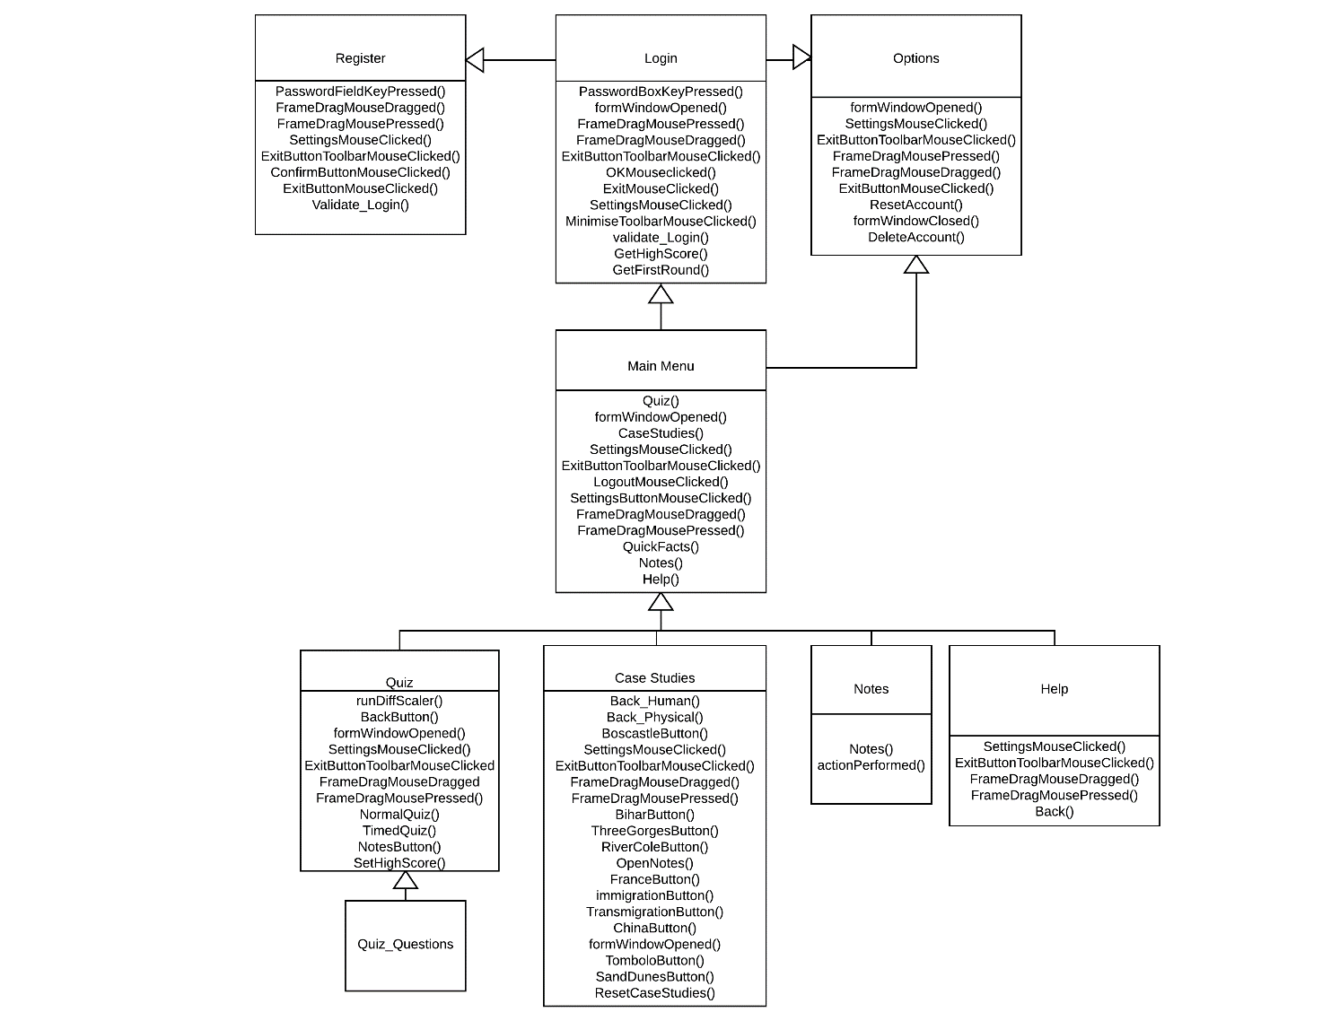

Here you can see the design of the object and inheritance diagram, this shows all of the potential methods and functions of each class. So for example you can see on the login screen that it will have getHighScore and getFirstRound functions. You can also see the inheritance shown with the arrows below the classes. An example of the inheritance is the main menu which is a sub class of the base class login. Also the Quiz_Questions is a sub class of the super class quiz, which is subsequently a sub class of the main menu and then of the base class Login.

The above diagram can also show which other parts of the program the user will be able to access from the current window they are on. So for example if the user was on the notes page then according to the diagram they will only be able to get to the main menu. Then on the main menu they will be able to access the quiz, case studies, notes and help but not the register section directly.

The following diagram and list shows how the program can be broken down.

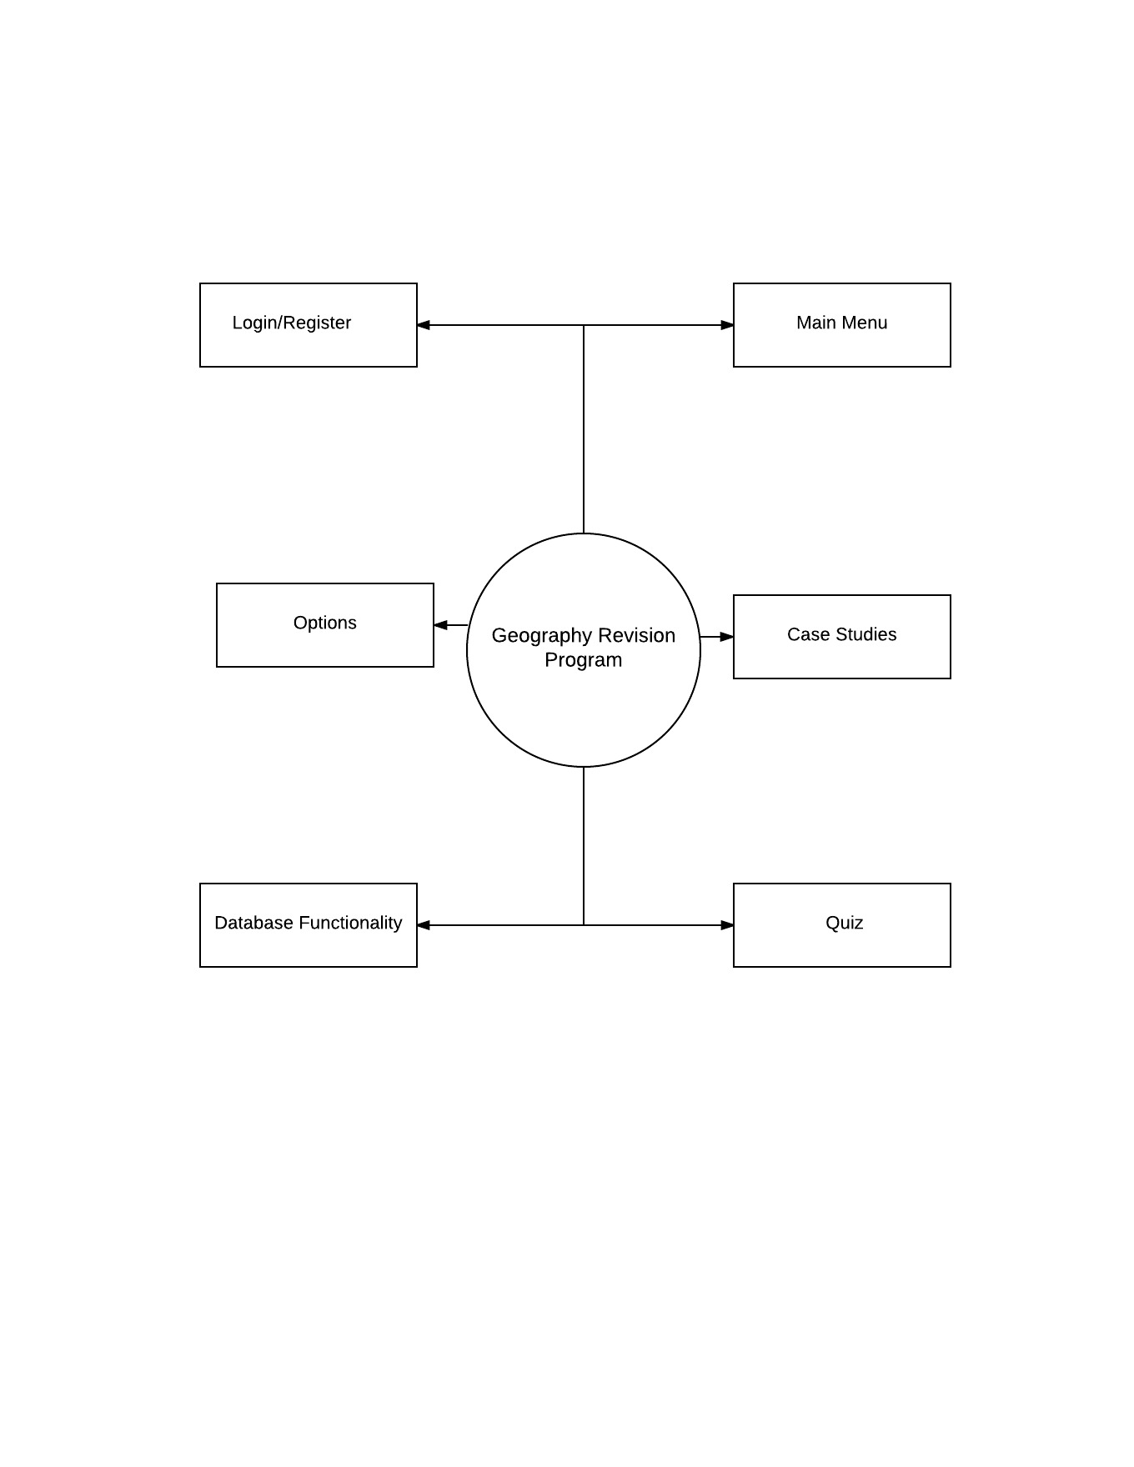

So the six main areas of the program are the:

**Login/Register section**, where the user is able to create their own personal account and then log into it, this will also store all of their notes.

**The main** menu is next which will act as the main navigation menu, which provides the user with access to the other sections as well as the options menu to alter various settings.

Then there is the **case studies section** which will contain the most information and assets within the program, it will have a two tabbed sections called human and physical and will contain the relevant case studies within them. Each case study will need to have the correct information alongside an image and a map with the location of it.

After that is the **Quiz** which will provide the user with randomised questions to test their knowledge, the questions for these will increase and decrease in difficulty depending on the users score after each time they complete it.

But the main part of the program which encompasses all of it, is the **database functionality** which controls how each section operates. The database will be on a free 24/7 hosted site so that there is no downtime and allows for constant access to it in case any alterations need to be made internally, but the NetBeans IDE allows for database editing directly within it so I shouldn’t have to go outside of it. Firstly the database will store all of the login information for the user such as username and password and it will check the database every time someone attempts to login. A smaller part of the database is within the main menu which will simply display a message at the top right of the window saying ‘Welcome User’ replacing user with whatever the user’s username is. The database will have no effect on the case studies section as all of the information and images will be stored client side, but the user has the option to open up a blank notes page as save that, which then gets stored into the database under the users account.

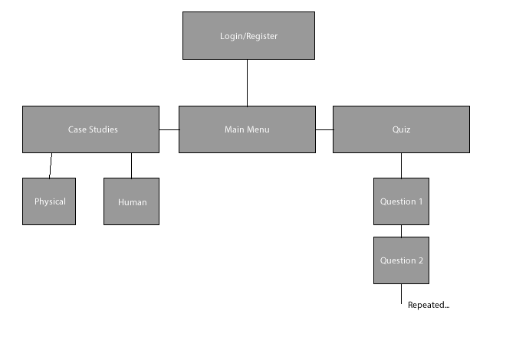

Below is the design of the entity relationship diagram showing how each section and attribute stored within the database will be moved around. So for example the user will have a one to one relationship with the quiz, this is because the user will only be able to take one quiz at a time. Then there is a one to many relationship between the quiz and the quiz question as the user will take one quiz which consists of 10 (many) questions.

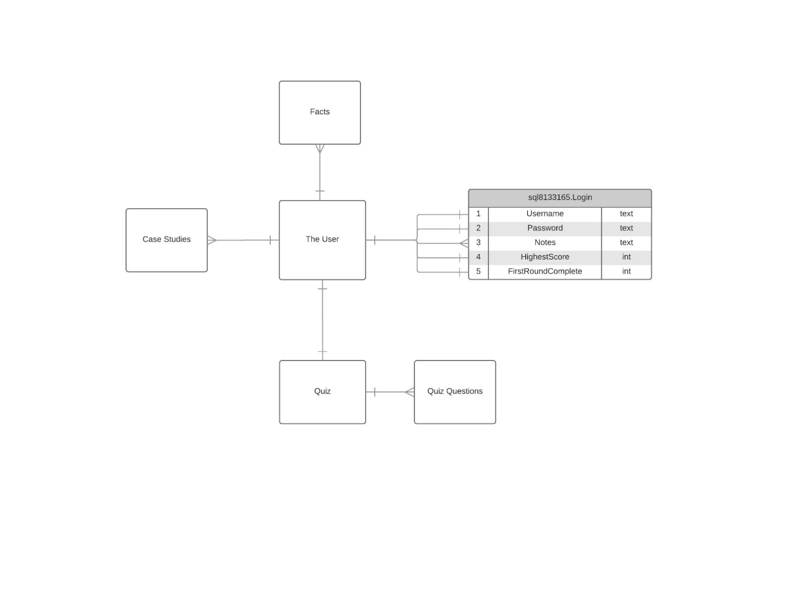

### **Usability Features and HCI**

The proposed system will have some usability features to ensure that the user is able to use the program to its full potential with ease and as little effort as possible. This is because if the user feels that they have to put in a lot of effort just to navigate around it for example then they simply won’t use it, so the program will not have achieved its purpose. But the main usability focus is the ease of use, which is why the proposed system will be designed so that it is easy to navigate, has a help menu which is accessible anywhere on the program and the ability for the user to change and reset certain attributes on their account such as score etc.

But when designing an interface you need to consider HCI, human computer interaction, so how the end user will interact with and use the interface itself. To design an interface you first have to consider the perception, as this will vary between developers and the end user. For example the end user will not be aware of the finer details that has gone into the GUI or the great importance of the positioning of items or the colour scheme. Whereas the developer would see it differently, and if there is a different designer they would see it in a different way as well. You also have to take into account and consider:

Colour – The utilisation of colour in the interface is crucial when designing and implementing the interface. For example Office utilises a light grey colour scheme with a blue for the menu such as drop down menus and the highlighting of text. Most end users would see grey as a dull and attractive colour, but it is easy to look at and won’t be uncomfortable after long periods of time. The use of colour is important as sometimes people can be affected by colours in various ways.

Luminance – When using a trichromatic system, so with three different colours each colour would be detected and identified by a separate cell on the retina within the eye. The signals that these receptors generate take the form of red-green, yellow-blue and black-white, these are called luminance. So when designing the interface and when trying to achieve the best quality you should always use luminance colours which contrast with each other.

Pop out effect – Giving one image a different shape, colour or position makes it stand out from all of the other images/objects close by. This is known as the pop out effect. Our eyes see colours using the trichromatic system which contains red/blue and green. DayGlo colours have some value but if used incorrectly, they can be irritating to the eye and could even cause effects on people with health issues. The interface needs to be credible and any overuse of extreme colours will reduce its professionalism and the overall quality of the finished product.

Pattern – The word pattern would have a different meaning and understanding to the end user as it does to the designer or developer of the interface. The user would most likely think it refers to the picture whereas the designer may refer to pattern as the template or master layout of the interface. An example is where Microsoft uses templates for its text and dialog boxes to create consistency.

It helps the user connect with the interface and helps greatly with the user-friendliness of the interface and how easy it is to use. Consistency will help the user familiarise themselves with the interface, and it will make it easier for them to navigate around. The templates include colour, format, layout etc. Pattern perception is an essential process in the perception of interfaces and displays. A set of laws known as the Gestalt laws have been formulated to help describe our pattern perception.

Proximity – We view things which are close together as a group

Continuity – Smooth continuous lines are more easily interpreted than rapidly changing lines

Symmetry – We see symmetrical shapes more easily than unsymmetrical shapes

Similarity – We see similar objects as a group. Dissimilar objects ten to be viewed as individuals (An alteration of the pop out effect/)

Fate – We see objects that move together as a group

Region – We see objects that are enclosed together, in some ways, as a group

Connected – We see objects connected by continuous lines as related to each other

Objects – GUI’s are built using a number of separate objects. The images are layered as it is essential to be able to see which image appears first and the subsequent images which overlay the first image. If there are images sat behind other images, the whole interface will not be visible. An example of this would be that the GUI should appear in front of any text on the desktop. If the positioning of the objects in the GUI hasn’t been done properly, the GUI may appear behind the main screen meaning the user may not be able to access some of the features. Also, if the GUI appears too far to one side of the screen, parts may be cut off causing some features to not be seen.

Geon’s and gross 3D shapes – Geon’s and gross 3D shape are used to create consistency when reproducing an image. Geon’s are objects that have been created from a range of properties that enable the viewer to see the object from many different angles. They are simpler to make and are easier to recognise than 3D shapes. 3D images are easier to misinterpret due to the perception of the viewer. Gross 3D shapes are used in video games and are fairly cheap to make. They don’t require extra reproduction and they transmit images in real time. The time taken to produce an image also must be considered along with the price of producing the image.

Once all of this is considered and implemented into the interface, then you will know that it will be usable for the user and they won’t be afraid of using it.

### **Login/Register**

The first section of the program is the login and register section where the user can create their own personal account.

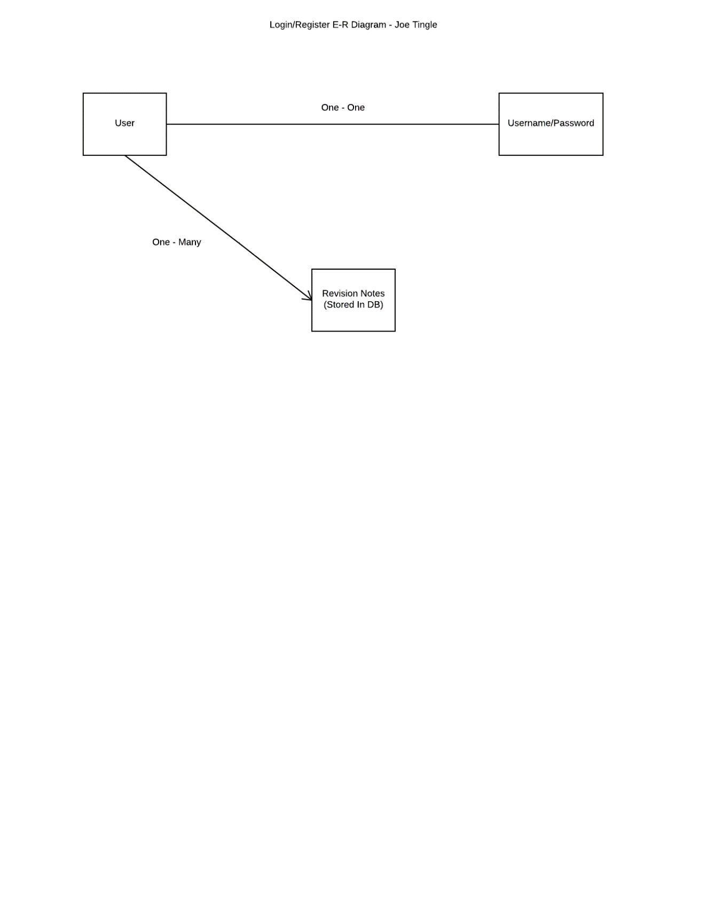An input relates to the supply of information going through the system, where the user will usually supply information to the program such as a username. The inputs for the login section of the program come purely from the user, as they are required to enter their username and password into the relevant fields. Once the user has entered the information and has clicked on the submit button (The program will not store the information in variables or do anything until the user has clicked on the submit button, this is because all of the code will be executed within the event button pressed method for the button. the code will be executed.

**Login Pseudocode:**

IF Length(Username) == 0 THEN

PRINT (“Empty Field Detected! Please Enter Information into all Fields”)

ELSE IF Length(Password) == 0 THEN

PRINT(“Empty Field Detected! Please Enter Information into all Fields”)

ELSE

User = Username

Pass = Password

IF ValidateLogin(User, Pass) returns TRUE THEN

PRINT(“Correct Login Credentials !”)

Close JFrame

Open MainMenu

ELSE

PRINT(“Incorrect Login Credentials !”)

The above pseudo code is used for the login, to first determine if any of the credential fields such as the login or password are empty. If they are empty then it needs to tell the user that the fields are empty and there needs to be some sort of entry into it, this is because you cannot have an account without a password and vice versa you cannot have an account with a password but not a username. But if the user has entered something into all of the fields then it will set them to a new set of global variables which can be accessed from any other methods. It then prompts the validatelogin method to run and if it returns true, so if a successful connection has been made and it returns true stating the username and password match those records on the database. Then it will output a message to the user telling them that the credentials are correct, it does this so that the user has some visual feedback and knows they are correct. If there was no visual feedback for this then it would just take them straight to the main menu, but I believe it is always good to give the user some sort of feedback, to let them know what is happening.

It will then close the current JFrame, which would be the login window, and then open up the main menu. But if the validatelogin method doesn’t return true, so it returns false, then a match has not been found on the database and it gives the user some feedback stating the credentials were incorrect. The above pseudo code essentially allows the user to log into their own account and will prevent anyone without an account from logging in. This is also essential to the rest of the program as it provides other classes with the account username, stored as the global variable, which can then be used.

**ValidateLogin Pseudocode:**

CREATE SQLDatabase Connection

Statement = SQL(“Select * from Login where username=? and password=?”)

EXECUTE Statement

IF (User & Pass match == true)

RETURN TRUE

ELSE

RETURN FALSE

Here is the pseudocode for the validatelogin method which is called in the previous part of the pseudocode where it acquires the username and password typed in by the user and converts them to the global variables. Here it will first attempt to create the connection to the database, this database is of course the database which I have previously mentioned and is a 24/7 online hosted SQL database. I have chosen this as it is very reliable and hardly has any downtime which is good as the users are going to want to log in at any time. It also allows me to execute SQL statements on the table within the database to change certain attributes about it, which is what I am going to be doing in the validate login method shown above. Once it has created a successful connection to the database it will then create a new variable called statement which will store the SQL statement to be executed, which is the “Select * from Login where username=? and password=?”. This statement simply selects everything in the table called Login, which contains usernames/passwords/scores etc. and checks if there is a username and a password that matches the ones passed through to the method. This statement is then executed on the next line and return true if there is a match, and false if there is not.

This validatelogin method is essential to the whole program as it either allows the user to log in if a match is found and there is an account stored, or doesn’t allow them to log in if there is not an account.

**Login Interface Design**

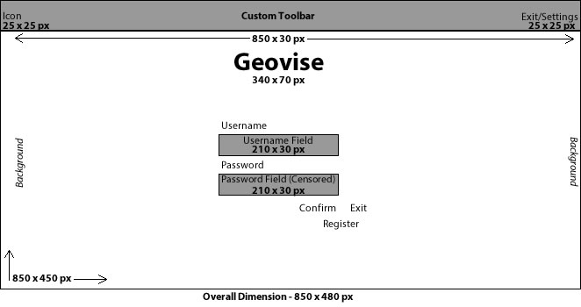

Above is an image created within Adobe Photoshop and is a visual representation of what the interface for the Login Section of the program will look like. I have made it simplistic as all the user needs to do is enter their username and password into the relevant boxes or click on the create account button. The custom toolbar will be present on the whole program and will replace the default windows (or whatever operating system is being used on the client system) toolbar as shown below.

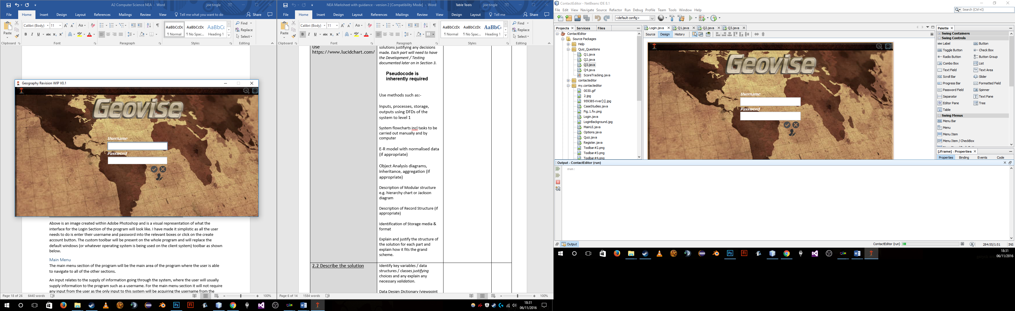

### **Main Menu**

The main menu section of the program will be the main area of the program where the user is able to navigate to all of the other sections.

An input relates to the supply of information going through the system, where the user will usually supply information to the program such as a username. For the main menu section it will not require any input from the user as the only input to this system will be acquiring the username from the database, by using an SQL query. This query will obtain the username from the database and then store it as a variable to then be displayed on the main menu, greeting the user.

For the main menu their will not be any particularly complex code, just a few IF statements attached to the various buttons such as Case studies or Quiz, this is because this acts as the navigation menu between the different sections of the program, so opening and closing JFrame will be the main purpose of this.

**Pseudocode for Case Studies Button on Main Menu:**

IF(CaseStudiesClicked == TRUE) THEN

CLOSE JFrame

JFrame(CaseStudies) visible = TRUE

On the main menu window, there will also be the option for the user to logout, which will simply close the current window and set the login window’s visibility to true. It must also display the user with a dialog box saying Logout Successful so the code will be slightly different.

**Pseudocode for Logout Button on Main Menu:**

IF(LogoutClicked == TRUE) THEN

CLOSE JFrame

PRINT(“Logout Successful !”)

JFrame(Login) visible = TRUE

Here is the pseudocode for the logout button which follows the same format as the case studies button shown above which checks to see if the button is clicked, most likely with an action event, if this is true and the button is clicked then it will close the currently active JFrame and then give visual feedback to the user in the form of a massage telling them that the logout was successful. It logs the user out by closing the JFrame meaning they have to retype the username and password in. After it displays the visual feedback it then opens up the login screen.

**Pseudocode for Quick Facts Button on Main Menu:**

IF(QuickFactsClicked == TRUE) THEN

factNum = new Random(1, MaxFactNum)+1

switch(factNum)

case(1)

{

jLabel.setText(“Insert Fact Here”)

break

}

case(2)

{

jLabel.setText(“Insert Fact Here”)

break

}

Etc….

Above you can see the pseudo code for the quick facts button which when clicked should present the user with a new random fact gathered from a pre-selected pool of them. To randomly generate them It will use a random function and then a switch case. I have decided to use a switch case instead of an if statement as they are much more efficient and easily implemented with a large data set, and because I am not sure how many facts there will be in total it is the right choice. Firstly it will check to see if the button has been clicked, most likely using an action event, and if it returns true then it will run through the following code. It will generate a random number between 1 and the maximum number of facts, and store this as the integer variable factNum which is used later on in the switch case as the switch. It then does the switch as puts the variable factNum in as the parameter, and inside of the switch are the cases which consist of all of the facts.

As you can see in the pseudo code above in the case it will set the text on the fact jlabel, which will most likely be located on the bottom right of the main menu frame, to whatever the fact may be. It will then break from the switch case and only run again once the user clicks on the button.

**Pseudocode for Notes Button on Main Menu:**

IF(NotesClicked == TRUE) THEN

JFrame(Notes) visible = TRUE

Here is the pseudo code for the notes button which slightly differs from the rest as it doesn’t close the currently active jframe, in this case being the main menu, it instead leaves it open as the notes section is designed to be left open on the side so that the user is able to navigate through and use the program with the notes on the side in case they what to keep note of anything. But if the notes button is clicked then it will open up the notes jframe and not close the currently active one. This will take up more memory as more than one jframe will be open but I believe it is necessary for the user.

**Pseudocode for Help Button on Main Menu:**

IF(HelpClicked == TRUE) THEN

CLOSE JFrame

JFrame(Help) visible = TRUE

Here is the code for the help button on the main menu, which is used to open up the help menu on a separate jframe. It will close the currently active jframe so that the help menu is the only one open, saving memory. Firstly in the pseudocode it will check if the button has been clicked or not, it will most likely use an action event to do this, if this returns true then the button has been clicked and it will close the currently active jframe, in this case being the main menu and open up the help menu jframe.

**Main Menu Interface Design**

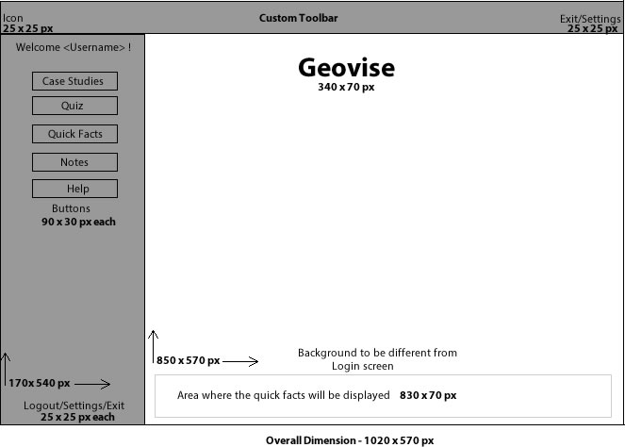

Above is an image created within Adobe Photoshop and is a visual representation of what the interface for the Main Menu Section of the program will look like. This will look different to the login screen but keep the same ‘master’ layout of the toolbar and icon set for example. The main menu window will contain a case studies and quiz button which execute some code when clicked on to take the user to the relevant sections.

### **Options**

The options menu within the program will enable to user to adjust a variety of settings within the program. For example they will be able to reset their current best score on the database, clear or export their stored notes to a specific file type (.pdf or .txt) as well as altering the text size for ease of use. The options menu will also include administrator online options such as buttons which will direct to certain windows without the need to login, this is for debugging purposes so I can easily navigate to the problem instead of logging in each time. The options window will be accessible from the top menu bar by clicking on the gear icon, it is available on all windows in case the program encounters any errors and the user needs to access the menu.

An input relates to the supply of information going through the system, where the user will usually supply information to the program such as a username. The only inputs that the options section will require is the user selecting various check boxes or by using the text size slider. These values will then change the variables on the client side as it will not communicate with the database on this occasion.

The main piece of code within the options menu will be the changing of the text size, which the user can do through a slider. Once the value of the slider changes so does a global variable dictating the size of the text across the program. This option is for ease of access. Below is a preview of what the default swing API slider looks like, as you can see the pre-defined default value is 0 which is why it starts at the far left.

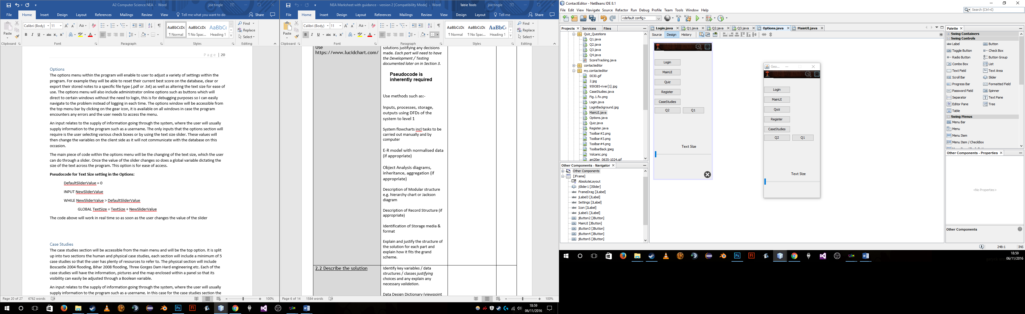

**Pseudocode for Text Size setting in the Options:**

DefaultSliderValue = 0

INPUT NewSliderValue

WHILE NewSliderValue > DefaultSliderValue THEN

GLOBAL TextSize = TextSize + NewSliderValue

The code above will work in real time so as soon as the user changes the value of the slider, the global variable changes, so that the text size will change. This could cause some compatibility issues and may cause a severe drop in performance if the user continuously changes the value of it. So a far better solution to this would to only change the global variable once the user clicks on a apply or confirm button, this way they have the change the slider value and then click on apply to ‘save’ the global variable.

**Pseudocode for Text Size setting in the Options W/ Apply Button:**

DefaultSliderValue = 0

INPUT NewSliderValue

WHILE NewSliderValue > DefaultSliderValue THEN

IF(ApplyIsClicked == TRUE) THEN

GLOBAL TextSize = TextSize + NewSliderValue

Here is the pseudo code if an apply button is to be used which is the most likely case, it is a slight alteration of the previous pseudocode you can see above, but here we add one more line of code checking if the user has clicked on the apply button, if they have and it returns true then it will set the global variable, but if they don’t click on it then it will not update this variable, essentially not updating/applying it.

**Pseudocode for resetting the account score for the user with a button:**

IF(ResetScoreClicked == TRUE) THEN

CREATE SQLDatabase Connection

Statement = SQL("UPDATE Login SET HighestScore =0 WHERE username ='"+USERNAME+"')

EXECUTE Statement

PRINT(“Account Score Reset !”)

Here is the pseudo code for resetting the account score when the user is logged in, now just to note this is one of the reasons why the options will be disabled on the login screen as it will produce a lot of null pointer errors if the user if able to reset or delete and account they are not actually logged in to. But for this pseudo code it will first like most of the other check if the user has clicked on the Reset score button, if they have then it will return true and will run through the rest of the code. It will try to create a connection to the database to start off with and if this is successful it will then create a new variable to store the sql statement to be executed. The statement "UPDATE Login SET HighestScore =0 WHERE username ='"+USERNAME+"' will update the table called login and set the value of the highest score column to zero, essentially resetting it but only if the username and password match. This is so that it resets the right account that the user is logged into. It will then execute that statement and if it executes successfully it will give some visual feedback to the user in the form of a message saying the account score has been reset. I have decided it will not close any of the windows after this as the user may still want to use the options menu afterwards.

**Pseudocode for deleting the user’s account with a button:**

IF(DeleteAccountClicked == TRUE) THEN

CREATE SQLDatabase Connection

Statement = SQL("DELETE FROM Login WHERE username ='"+USERNAME+")

EXECUTE Statement

PRINT(“Account Deleted !”)

EXIT PROGRAM

Here is the pseudo code for deleting the user’s account, another reason why the user must be logged in to use the options menu as it simply won’t know which account to delete. Firstly it will check to see if the user has clicked on the delete account button, if this returns true and they have clicked on the button then it will firstly attempt to create a connection to the database, if this is successful then it will store the sql statement and then subsequently execute it. The statement "DELETE FROM Login WHERE username ='"+USERNAME+" will delete a row from the table called login but only when given the username of the users account. It will get this from the global variable created from the login class at the very beginning. If the statement is executed successfully then it will give the user the message Account Deleted and then as the final line in the pseudo code it will exit the program. It will exit the program as the user has deleting their account so can no longer be logged in else it will give a lot of errors when connecting with the database and adjusting values.

**Options Menu Interface Design**

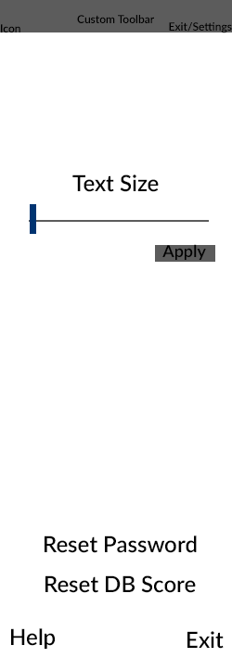

Above is an image created within Adobe Photoshop and is a visual representation of what the interface for the Options menu Section of the program will look like. As you can see it is a completely different dimension to the login and main menu sections, this is because the options menu is designed to open at the same time as another menu and not get in the way.

### **Case Studies**

The case studies section will be accessible from the main menu and will be the top option. It is split up into two sections the human and physical case studies, each section will include a minimum of 5 case studies so that the user has plenty of resources to refer to. The physical section will include Boscastle 2004 flooding, Bihar 2008 flooding, Three Gorges Dam Hard engineering etc. Each of the case studies will have the information, pictures and the map enclosed within a panel so that its visibility can easily be adjusted through a Boolean variable.

An input relates to the supply of information going through the system, where the user will usually supply information to the program such as a username. In this case for the case studies section the inputs will be the user selecting which case study they want to revise, as that initiate a method to change the visibility of the panel in which it is stored in. Another input will be the notes that the user may want to create. The notes can be accessed by pressing the notes button within either the case studies page or the main menu which will display all of the previous notes. If the user choses to input anything into the notes section and then press save it will be inputted into the database under a notes section, if it detects that the first notes column is not null then it will try the next notes column and so on. This is so that no important revision notes for the user are deleted.

**Case Studies Interface Design**

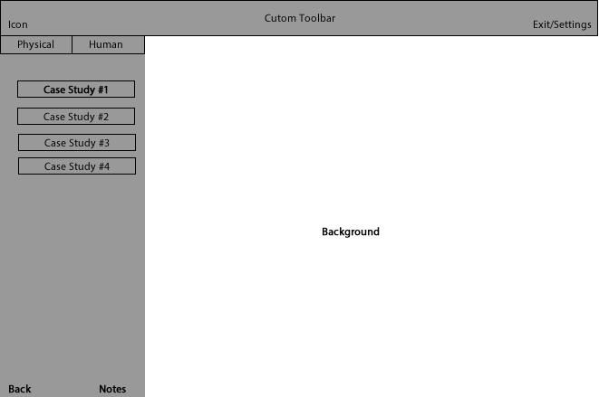

Above is an image created within Adobe Photoshop and is a visual representation of what the interface for the Case studies Section of the program will look like. The case studies menu contains a tabbed pane with the physical and human case studies which the user will be able to switch between.

**Pseudocode for Choosing a Case Study and Accessing the Information:**

**IF CaseStudy_1_Selected == TRUE THEN**

**resetCaseStudies()**

**SET CaseStudy_1 to Visible**

**IF CaseStudy_2_Selected == TRUE THEN**

**resetCaseStudies()**

**SET CaseStudy_2 to Visible**

**IF CaseStudy_3_Selected == TRUE THEN**

**resetCaseStudies()**

**SET CaseStudy_3 to Visible**

Here is the pseudocode for the case studies and how each individual button will give the correct case study information. Because all of the case study information will be stored within an image it will be relatively simply to make it visible for the user. Firstly in this code it will check to see which case study has been selected, now this will be within an action event and whenever the user clicks on a button it will set a Boolean variable for that case study to true. It then checks which variable is true and will first run the resetCasestudies function, this simply sets all of the jLabel’s visibility to false so that they are not visible to the user. It then sets the relevant case study to visible.

### **Database**

The database will be the main backbone of the program as it will allow for all of the advanced features within it such as the login and register for the user as well as the randomised questions scaling in difficulty. The database will be on a free 24/7 hosted site so that there is no downtime and allows for constant access to it in case any alterations need to be made internally, but the NetBeans IDE allows for database editing directly within it so I shouldn’t have to go outside of it. Firstly the database will store all of the login information for the user such as username and password and it will check the database every time someone attempts to login. A smaller part of the database is within the main menu which will simply display a message at the top right of the window saying ‘Welcome User’ replacing user with whatever the user’s username is. The database will have no effect on the case studies section as all of the information and images will be stored client side, but the user has the option to open up a blank notes page as save that, which then gets stored into the database under the users account.

### **Quiz**

The quiz is where the user is able to complete 10 random questions chosen from a pool of them within the database. However the first time the user runs the quiz they will not have a score (The highest score column in the database will be null) so the program will just choose 10 random questions of varying difficulty. Once the user has run through the full 10 questions at least one the program will then adjust it to make them more challenging or easier for the user, their highest score will be stored under their account within the database.

The quiz section of the program consist of lots of different windows (questions) so the inputs will vary for each one. For example on the first question the input will be whether the user chooses true or false, as the program will decide if the answer is correct or incorrect depending on the users input. Another example of the inputs for the quiz questions are on question 3 where the user has to enter a fully worded answer within the provided text area. Once the user has entered an answer and clicked on submit, the text area (the user input) will be converted into a string variable. It is stored in a variable so that it can then be scanned for certain key words and that is how the question is marked by the system. It will check for certain key words within the strings such as earthquake or seismic movement for the causes of tsunami waves question.

**Question 1 Flowchart:**

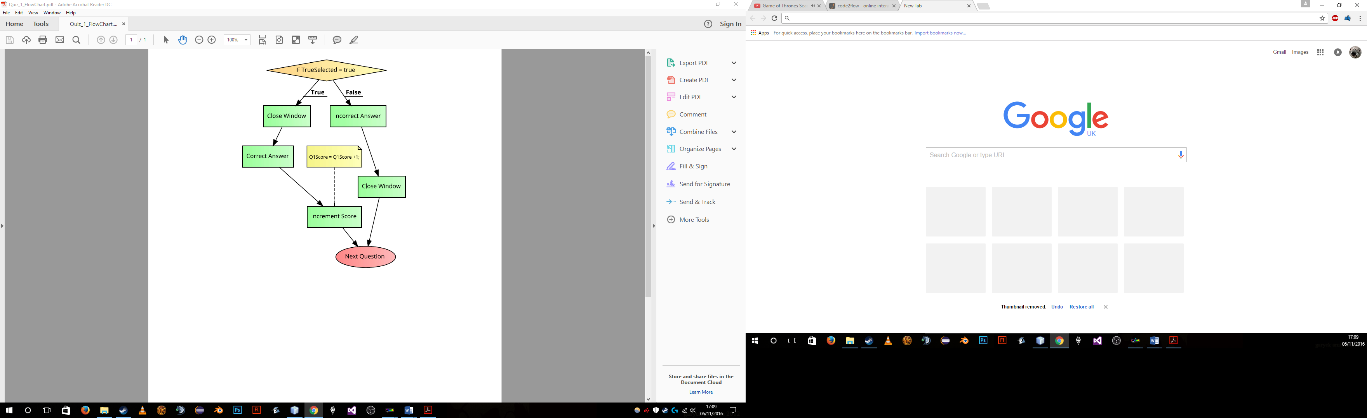

**Question 1 Pseudocode:**

IF (TrueSelected == true) then

OUPUT “Correct Answer! (+1 Point)”

CLOSE Window

Score = Score + 1

ELSE

OUTPUT “Incorrect Answer!”

CLOSE WINDOW

OPEN Q2

Here is the pseudocode for the first question on the quiz, the tutorial round. This is a relatively simple question as it is only the first and is a multiple choice question. So the user will have to choose between one of two options, in this case it will most likely be a true or false question. I have chosen to make this question fairly simple as it will then scale up drastically in difficulty as the user progresses through the tutorial round. The above code will be executed as soon as the user clicks on the next/submit button to confirm their answer and go to the next question. Firstly it checks to see if the user has selected true as an answer, so have they clicked on the true button. If it returns true, so they have selected true, then it outputs a message to the user telling them the answer is correct, it then increments the users score by 1 and closes the current JFrame. However if the user has not selected true then it will output a message to the user saying that it is an incorrect answer, then it will close the currently active frame which in this case is Question 1. Then it will open up the next question, so question 2. This is relevant to the rest of the program as it is the base format for the rest of questions.

**Question 2 Flowchart:**

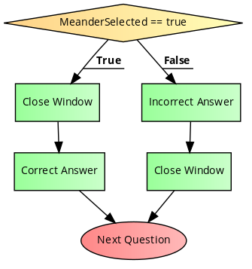

**Question 2 Pseudocode:**

IF (MeanderSelected == true) then

OUTPUT “Correct Answer”

CLOSE Window

Score = Score + 1

ELSE

OUTPUT “Incorrect Answer!”

CLOSE WINDOW

OPEN Q3

Here is the pseudo code for question two, of the tutorial round, which follows the same base format as question one. So it firstly checks to see if the user has selected the Meander answer, so if they have clicked on the meander button, if they have and it returns true then it outputs a message to the user telling them that the answer is correct and increments the users score by 1. It then closes the currently active JFrame which is Question 2. However if the user has not chosen the meander as their answer then it outputs a message telling the user has an incorrect answer and closes the JFrame. Finally it then opens the next question which is this case would be question 3.

**Normal Quiz Selected Pseudocode:**

NormalModeSelected = true

getFirstRound()

IF(FirstRoundComplete == 0)

JFrame(Q1) visible = TRUE

CLOSE Jframe

Else

runDiffScaler()

Here is the pseudocode for the normal quiz selected, so if the user has clicked on a normal quiz on the quiz menu then the following code would be run. Firstly it will set the Boolean variable NormalModeSelected to true, which will be a global variable used by all of the quiz questions to determine which mode is selected by the user. It will then run the getFirstRound() function which will connect to the database and check if the user has completed the tutorial round or not. It will set the variable FirstRoundCompleted to 0 if they have not completed the tutorial round and to 1 if they have. But this can easily be changed to a Boolean variable to make it easier to understand. Next it will check to see what the value of the variable is, of course if it is 0 then it will enter the if statement and runt he tutorial round starting at question 1, remember that question 1- 10 is the tutorial round.

However if the user has completed the tutorial round and the value is 1 then it will run the difficulty scaler which has been explained previously.

**Timed Quiz Selected Pseudocode:**

TimedModeSelected = true

getFirstRound()

IF(FirstRoundComplete == 0)

JFrame(Q1) visible = TRUE

CLOSE Jframe

Else

runDiffScaler()

This is the pseudocode for the timed quiz which is almost identical to the previous normal quiz selected pseudocode. The only difference being the change in the variable names of course or else they would conflict. So first it will set the Boolean variable TimedModeSelected to true to indicate that the user has selected the timed mode, and then it will run the getFirstRound() function to check if the user has completed the tutorial. The tutorial round will have both a normal and timed variant for more variety and making the user feel as though there is more content. It then checks the value of the FirstRoundComplete and if they have completed the tutorial it will run the difficulty scale but if they haven’t then it runs the tutorial round.

The one thing you have to note on both of these pieces of pseudo code is the first variable it declares, so NormalModeSelected and TimedModeSelected, which are both global variables. Now every question will have an event on it so as soon as the user opens up the window it checks to see which one of these variables is true. Then it will either activate or deactivate the timer based off of this. So for example if the user has chosen a timed quiz then the variable TimedModeSelected is set to true and it will open up either the tutorial or run the scaler, for this case let’s say they run the tutorial . It will then run the event and see that the TimedModeSelected variable is true and make the timer visible to the user and enable all of its subsequent code.

**Difficulty Scaler Pseudocode:**

bandIdentifier = 0

ScorePercent = HighestScore*10

IF(ScorePercent >= 80)

bandIdentifier = 3

IF(ScorePercent >= 50 && ScorePercent < 80)

bandIdentifier =2

IF(ScorePercent >= 0 && ScorePercent < 50)

bandIdentifier = 1

IF(Question < 10)

IF(bandIdentifier == 1)

nextQuestion = Random(11, 21)

IF (nextQuestion == CurrentQuestion)

runDiffScaler()

else

SWITCH (nextQuestion)

CASE 11: JFrame(Q11) visible = TRUE

break

CASE 12: JFrame(Q12) visible = TRUE

Break

ETC…

IF(bandIdentifier == 2)

nextQuestion = Random(22, 32)

IF (nextQuestion == CurrentQuestion)

runDiffScaler()

else

SWITCH (nextQuestion)

CASE 22: JFrame(Q22) visible = TRUE

break

CASE 23: JFrame(Q23) visible = TRUE

Break

ETC…

IF(bandIdentifier == 3)

nextQuestion = Random(33, 44)

IF (nextQuestion == CurrentQuestion)

runDiffScaler()

else

SWITCH (nextQuestion)

CASE 33: JFrame(Q33) visible = TRUE

break

CASE 34: JFrame(Q34) visible = TRUE

Break

ETC…

ELSE

IF(HighestScore < Score)

sethighScore()

Question = 0

Score = 0

OUTPUT “Quiz Complete !”

Here you can see the pseudo code for the difficulty scaler which is to be used once the user has completed the full 10 question tutorial round. This will be called after every question to generate another random question.

Firstly it will declare an integer variable called bandIdentifier and set its default value to 0, this variable will then be used to determine which band the user comes under based off of their previous score. The three different bands are 3 for high band, 2 for mid band and 1 for low band. Each band will have different question catered to that difficulty. Then it will declare another integer variable called ScorePercent, which will simply be a percentage of the highest score for the user. I have chosen to base this off of percentages because most mark schemes do it off of percentages and it is and easy way to group the user into different categories. It works out the score percentage by getting the highest score of the user and then multiplying that by 10, this is because the highest score the user can get is 10, as they are only asked 10 questions at a time. So let’s say that the user has a high score of 6 that means their percentage will be 60%. After that it will then group the user into the relevant band using some if statements. So in the case of my example, the user has 60% which would put them into band 2, the mid-tier. It will set the previous bandIdentifier variable to 2. Now it runs another if statement to check if it has asked 10 question yet, this is some validation to check if it has asked the 10th question, this needs to be here or else it will ask an infinite amount of question to the user and won’t stop.

To actually ask the user the questions it first checks which band identifier they are in, so in our case mid-tier, band 2, and it will generate a random integer variable between 22 and 32. Each band will generate a number in between two sets of integers, so band one will be 11-21, band 2 will be 22-32 and band 3 will be 33-44. I have done this so that it will match to the question being asked and to prevent any possible conflicts with the values being the same or getting them confused for different questions. It then checks to see if the next question is the same as the current question, this is again some simple validation to ensure that it does not ask the user to same question straight after it. If they are the same then it will just re run the difficulty scaler.

Then a switch case is run to run the question number that has been generated and will make the relevant JFrame visible to the user. As I have said this is then run every time the user clicks on confirm/next to get the next question until all 10 have been asked and answered by the user.

Once all 10 questions have been asked it then checks to see if the high score for that particular user is less than the current score that they have just achieved in the 10 question they have just answered. If it is then we need to update the highest score, so it will run the setHighScore(). This will just create a connection to the database and run an SQL statement to update the table. Finally the difficulty scaler will then reset the variables score and question to 0 ready for the next round.

**Set High Score Pseudocode:**

CREATE SQLDatabase Connection

Statement = SQL("UPDATE Login SET HighestScore ='"+my.Geovise.Quiz.Score+"' WHERE username ='"+USERNAME+")

EXECUTE Statement

Here is the pseudo code for the setHighScore(), and it is fairly simple as it firstly much like the other creates a connection to the database and then creates a variable called statement. Then it passes in the SQL statement "UPDATE Login SET HighestScore ='"+my.Geovise.Quiz.Score+"' WHERE username ='"+USERNAME+" which will update the tabled called login and set the attribute HighestScore to whatever the current score of the user is, after they finished the 10 question presented by the difficulty scaler, or even the tutorial round. It then checks the username so that it updates the correct account.

### **Notes**

Notes are where the user is able to type out their own notes within the case studies section of the program. It will fully utilise the database and will be stored under the notes column. There will be multiple notes column (Notes1, Notes2, Notes3, Notes 4 etc.)

**Saving Notes Pseudocode:**

IF (SaveClicked == true)

FilePath = File.getPath()

Source = jLabel.getText()

Buffer = source.length()

For (i=0, i<buffer.length, i++)

File.write(buffer[i])

File.close()

Here is the pseudocode for saving notes, locally as a .txt file. This will be used by the user whenever they want to store their notes to use later on. Saving as a.txt file is a good idea as it is very accessible and can be opened on multiple operating systems with ease. The only drawback to this is that it does not offer much formatting, for example colour changes/headings etc.

But the pseudocode firstly will check to see If the user has clicked on the save button, if they have then it will return true and execute the following code. It will declare a new variable called FilePath which will store the local path on the hard drive, as to where the user wants to save the file to. It then declares another variable, this time a string, which stores the source which is any text that the user has entered into the notes, so in a sense the actual notes themselves. A final variable is then created called buffer which is simply the length of the source. Now it will iterate through the source and write it to the file, through the use of a for loop, from the start to the end of the actual notes. Finally it will close the file so that it can be used later.

**Notes Interface Design**

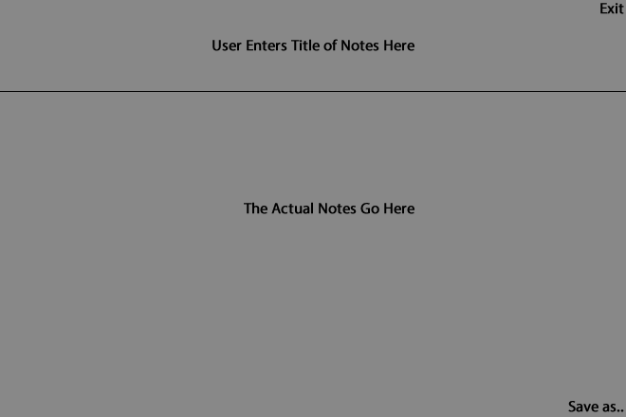

Above is an image created within Adobe Photoshop and is a visual representation of what the interface for the Notes Section of the program will look like. The notes section is where the user is able to enter a title and actual content. The user can click save as to save it to the database under their account, there will be multiple notes columns so the user can save more than 1 page of notes.

**Pseudocode for Saving Notes to Database:**

CREATE SQLDatabase Connection

NotesTitle = Contents of TextField 1

NotesContent = Contents of TextField2

Notes = NotesTitle + “” + NotesContent

GET Username

Statement = SQL(“INSERT INTO Login where username=Username and NotesSection1=Notes”)

EXECUTE Statement

Here is the pseudocode for saving the notes to the database, as opposed to the previous which saves the local file. Firstly it creates a connection to the database and then it declares two variables, NotesTitle and NotesContent, both of which do what they say so the NotesTitle contains the title that the user would like to save the notes as and NotesContent stores the actual notes. Then a third variable is declared which combines both of these together. It then grabs the username for the user, which of course is the global variable from the login and then runs the SQL statement. The SQL statement “INSERT INTO Login where username=Username and NotesSection1=Notes” will add into the table called login, the notes and store them under the users account.

### **Master Layouts**

The master layouts will be a group of items within the program that will be present on all of the windows. So for example on of the master layouts is the toolbar itself and the code which allows the user to move the JFrame. Of course we need this code as I am not using the default operating system functionality that allows the frame to be moved.

Another master layout will be the digital clock that I have decided to implement into the program, by using a clock it means that I will be able to implement other items based off of this such as the timed quiz. It will be located on the toolbar in the left hand side so that it doesn’t distract the user too much.

**Pseudocode for Digital Clock:**

rightNow = Calendar.getInstance()

hour = rightNow.get(Hour)

min = rightNow.get(Minute)

AMorPM = rightNow.get(AM_PM)

IF(AMorPM == 1)

IF(min < 10)

Clock.setText(hour + “:” + “0” + min + “ ” + “PM”)

ELSE

Clock.setText(hour + ":" + min + " " + "PM")

ELSE

IF(min < 10)

Clock.setText(hour + ":" + "0" + min + " " + "AM")

ELSE

Clock.setText(hour + ":" + min + " " + "AM")

Here is the pseudocode for the digital clocks which is one of the master layouts, present on all of the windows. It will work in real time and update in time with the operating system. It will first grab an instance of the Calendar which will contain all of the information needed for the clock such as time zone, hours, mins etc. It will then store this as the variable rightNow, which is relevant as later on you can call rightNow hour, so ask the question what is the hour right now. It then grabs the hour and minute and stores them in the relevant variables. It also acquires the AMorPM variable which is a simple integer determining if it is currently am or pm.

**Pseudocode for Toolbar Movement:**

IF(FrameClicked)

xMouse = getX()

yMouse = getY()

IF(FrameDragged)

xCoord = getXOnScreen()

yCoord = getYOnScreen()

JFrame.setlocation(xCoord – xMouse, y - yMouse)

Here is the pseudocode for the movement of the toolbar, another master layout which will be present on all of the windows. There will be two separate events which I have combined to explain them. They are the clicking on the frame and then the actual dragging of the frame. So firstly it will check if the user has clicked on the frame, so they are about to start dragging the frame expecting it to move. It will then get the x and y coordinates of the mouse, so where the user clicked and store them in the relevant variables. Then as soon as the user starts dragging the frame, it will store a second set of x and y coordinates, the coordinates of the frame on the screen. It will then set the location of the location to the location where the user has finished dragging using the x and y cords as offsets.

## **2.2 Describe the Solution**

### Login/Register

The Variables and data structures of the Login/Register section of the program are as follows:

|  |  |  |
| --- | --- | --- |
| Data Type | Variable Name | Description |
| Integer (int) | xMouse | These two integer variables are used for the movement of the whole window. In the default windows bar the code for moving the frame around is pre-defined within the operating system, removing this and using a custom toolbar means I have to add my own custom code. It takes the current x and y coordinate values of the mouse in real time and whenever the user clicks and drags the window location is changed to the mouse coordinates. |
| Integer (int) | yMouse |
| String (String) | User | This variable contains the username of the user, it takes the contents of the first JTextField in the window and then converts it into a string |
| String (String) | Pass | This variable contains the censored password of the user, it takes the contents of the second JTextField within the window and converts into a string. This JTextField will be censored (or converted into *****’s) to keep the password private. |
| Prepared SQL Statement (PreparedStatement) | pst | This variable will contain the SQL statement to be executed. Select * from Login where username=? And password=?. Checking if the previous two variable are found anywhere within the database. |

Below is the data design dictionary for the login/register section:

|  |  |
| --- | --- |
| Name Of Data | Description |
| A Variable | A variable is a symbol or name that represents a value. Variables can represent numeric values, characters, Strings or current memory addresses. |
| SQL | SQL or structured query language is a set of instructions used to interact and manipulate with a relational database. |
| SQL Statement | An SQL statement is where by you use some code to manipulate the database. |
| Username | The username will be the data that the user enters into the first text field. It will represent their name of the account. |
| Password | The password is the data that represents the unique value that the user can log into their account with. |

### Case Studies

|  |  |  |
| --- | --- | --- |
| Data Type | Variable Name | Description |
| Boolean(Boolean) | CaseStudy_1_Selected | These variables determine whether the user has clicked on, or selected, one of the case studies to view. If they have then the Boolean variable has to be set to true. |
| CaseStudy_2_Selected |
| CaseStudy_3_Selected etc. |
| Integer (int) | xMouse | These two integer variables are used for the movement of the whole window. In the default windows bar the code for moving the frame around is pre-defined within the operating system, removing this and using a custom toolbar means I have to add my own custom code. It takes the current x and y coordinate values of the mouse in real time and whenever the user clicks and drags the window location is changed to the mouse coordinates. |
| yMouse |

|  |  |
| --- | --- |
| Name Of Data | Description |
| The information for the case studies is all stored in an image file (.JPEG image format) so that it can easily be set to visible, or set to hidden whenever one line of code is executed. I have chosen to store them in image files as it is much easier and more efficient code wise to make one item visible compared to 3 or 4 which it would be otherwise. | |

### Quiz

|  |  |  |
| --- | --- | --- |
| Data Type | Variable Name | Description |
| Integer (global int) | Score | This is a global variable that keeps track of the score as the user progresses through the quiz. Every time the user clicks next on the question page it will either increment the global variable or leave it depending on if the answer was correct or not. There may have to be some validation on this as the maximum score that the user can achieve is 10, so if it is above this then something has gone wrong. The validation that I would use here is a simple if statement at the end of the quiz checking if it is greater than 10. |
| Array (Answer[]) | Answer (For long text questions) | This variable will be used within questions that the user must input their own answer for. It will convert the text area to an array and then scan it for certain key words. There may have to be some validation here as of course only one of these can be true, as the user can only view one at a time. The validation that maybe used here is maybe the suse of another function that has a sole purpose of resetting the value of the variables |

## **2.3 Describe the approach to testing**

### Test Plan for the Program

I will be using lots of different testing methods to ensure that the program works correctly and in the most efficient way as well meeting the criteria set out by the stakeholder. Most of the testing stages will be completed within the development stage later on. Throughout the testing phase I must ensure that I use a variety of test data, for example just using normal valid data will not allow me to test the program fully with the inputs and outputs. I must use boundary data as well as invalid erroneous data to ensure the program can correctly deal with any user errors.

One of the first testing strategy’s I may be using is dry run testing which is where I use a trace table to work through the program manually, which helps spot any errors in variables and values. This testing will be carried out using trace tables.

Alpha and Beta testing is also going to be used at a later stage to open it up to the potential user base as well as some internal testing. This should be done when the program is very near to completion, alpha is where I will do some internal testing with other programmers and then after the alpha testing is complete and I have fixed any potential bugs in the code beta testing will take place. The beta testing is where the program will be released to a select group of potential end users and I will receive vital feedback to finalise the program. The test data in the alpha and beta testing will be in the form of questions which I will ask them. There will be invalid and valid test data types to ensure that the program in its final form in post development is able to deal with all eventualities.

One form of testing and development I am already using is unit testing whereby the program is broken down into modules making it much easier to track down bugs or anything that does not work correctly. Integration testing fits in here as that is making sure the units work together and link up properly.

One of the last forms of testing will be user acceptance testing, which will be used after the development of the program is fully completed as it makes sure that the program meets the requirements set out by the stakeholder. It tests the program within a working environment to help spot any potential bugs within it and allows for a feel of the interface to make sure it is useable for the end user.

I will be making sure to use validation on all of the tests and during development to ensure that the program is able to deal with all scenarios. Validation is just one of many ways to reduce the number of errors in the data being entered into your system. The validation is performed by the system at the point when the data is entered.  It is the process of checking the data against the set of validation rules which have already been pre defined. I will also be using valid and invalid test data, valid test data is where the data entered is ‘correct’ and expected by the system. So for example in a true or false question the user enters true, this is valid data. Invalid data would be when in this case the user enters anything else that hasn’t been specified for example ‘not correct’.

But below is a short test plan showing how I will test the various parts of the program during the development stage

|  |  |  |  |
| --- | --- | --- | --- |
| Test No. | Section of the program | Testing Method | Test Data |
| 1 | The Login section, can the user log into their own personal account correctly, does the program make a successful connection to the database and execute the SQL statement to check for the login credentials. | Manually input test accounts into the database and then test the login credentials within the program itself. The expected result should be that the program checks the database and if it finds a match, then it displays a dialog to the user and opens the main menu.  I am going to be testing it this way as the register section may not be fully developed yet, and it is much easier if I have direct access to the database. Also testing this section allows me to make sure that it has validation and can deal with any scenario the user presents it with. | (**Valid *Normal data***) The test data that I will be using for this is a test account of admin and password already inputted into the database. I will then use these credentials to test the login functionality.  I could also use some **invalid data**, such as entering credentials which aren’t on the database so an account that doesn’t exist. I am going to be using invalid data as well to test somewhat if scenarios, so what will happen to the user when an account doesn’t exist in the database when the user tries to log in. |
| 2 | The Register section, is the user able to input a new account into the database from within the program and then log into that account without delay or restarting the program. Does the program make a successful connection to the database and execute the SQL statement to insert into the table. | I will test the register section by using the username and password fields in combination with an SQL statement to insert into the table Login within the database. The expected outcome should be that I enter details (the username and password) into the fields and execute the following SQL statement; INSERT INTO Login(username, password) VALUES ('" + user +"','" + pwd +"' ). This SQL statement will input the username and password (the test credentials) into the database, which I can then login to through the login screen of the program. There should not be any delay between the information being added and the login being available.  I am going to be testing the register section this way so that all eventualities can be tested through validation. Also, this means I can track when the account gets added to the database and check all of the values are correct when added. This does mean that I can check if they are added correctly. | (**Valid *Normal data***) The test data for this will be the account I used earlier so admin and password. I will then check the SQL statement executes properly and see if the account appears in the database.  I can also use some **invalid data**, such as not entering any information into the password or username field to test what happens. This will then allow me to test all eventualities and validate it. |
| 3 | The whole program, Does the RAM usage exceed the specified maximum amount. A limit of 400MB of RAM was set during the success criteria in the analysis. | I will test this by constantly monitoring its usage throughout development, using NetBeans built in debugging tools which includes a resource monitor. This resource monitor works in real time so is useful for tracking potential memory leaks within the code. I will be documenting this later on within the development section  I am going to be testing it this way so that I can track the usage in real time and which parts of the program are taking up the most system resources. This is very useful as it means I can track down any potential memory leaks and address them quickly. | (***Boundary/Erroneous data***) I will use the built in NetBeans profiler to monitor ram usage across the program. |
| 4 | The Notes section, is the user able to save a local file of their notes to access later on. | I will test the notes by entering some test data into the text area and then navigating to the top menu bar and selecting file and then save. This should then go through each character in the text area and save it to a .txt file.  I am going to be testing it this way as then I can vary the amount of data I input into the notes and check how long it takes to save, and check if it actually saves correctly. | (***Boundary data***) For this test data I will simply enter a paragraph of random text into the area and test to make sure that it saves. For some boundary testing I will copy and paste the paragraph multiple times to see how much data it can handle. |
| 5 | The Quiz section, does the system store the highest score for the user and then display it within the table. | I will test this by completing the quiz and keep a note of how many questions were correct, then check the table on the quiz screen to see if it has updated.  I am going to be testing it this way, as I can have the database by the side to ensure that the scores are updated correctly and only when necessary. If the database updates and the table do at the same time then it is working correctly and as intended. | (**Valid *Normal data***) The test data for this will be the admin account that I am going to use, as it is a new account it will have the default value of the highest score of 0, so it is easy to tell if the value has changed within the table. |

# **3. Developing the Solution**

## 3.1 Iterative Development Process

### **Introduction**

For the development of the proposed solution I will again split it up into the different sections of the program such as the login, Main menu, quiz etc. Each stage will include the setup stage and the actual development with snippets of the code w/ comments explaining how it works and why I have chosen to do it that way.

Below is the first prototype I will be creating, you can see the layout of the NetBeans, I am currently using version 8.0.2 of the IDE. I am creating a java application as stated before in the analysis and design.

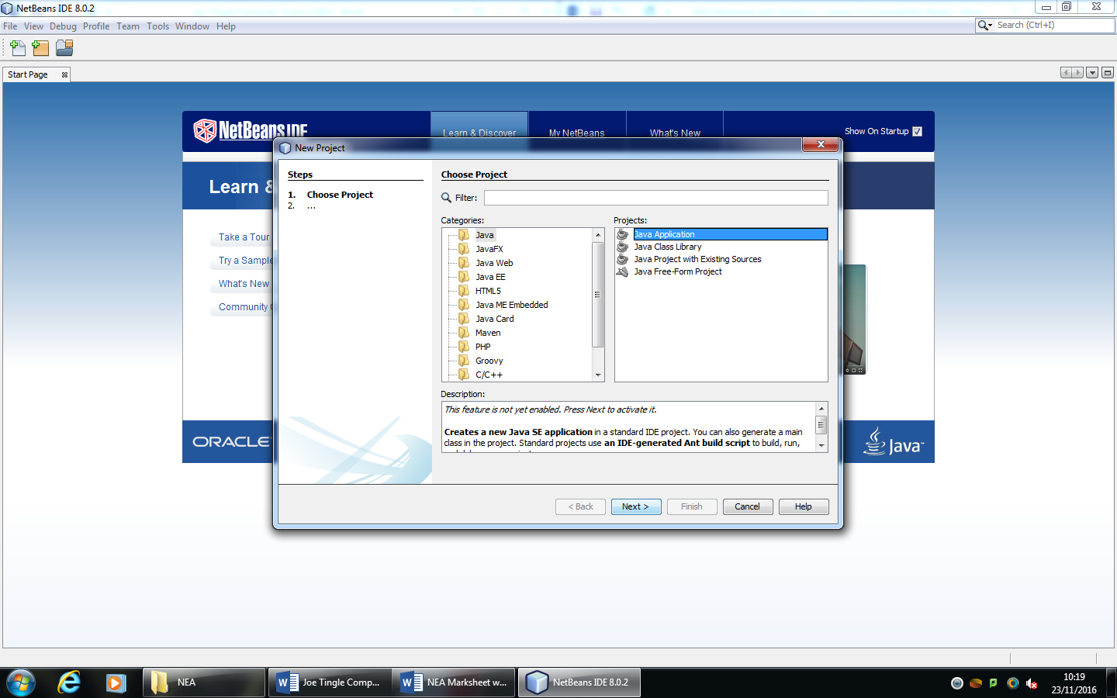

Before I go in detail on the development of the first prototype and of the broken-down sections I will quickly go over the setup of the prototype. It is essential to configure the prototype correctly before beginning to code as it will solve some problems which would otherwise occur down the development line. After this initial splash screen it will then prompt me to choose the project directory and the name of the main class for the program, however as I will mainly be using a JFrame form for the main class this will become redundant later on.

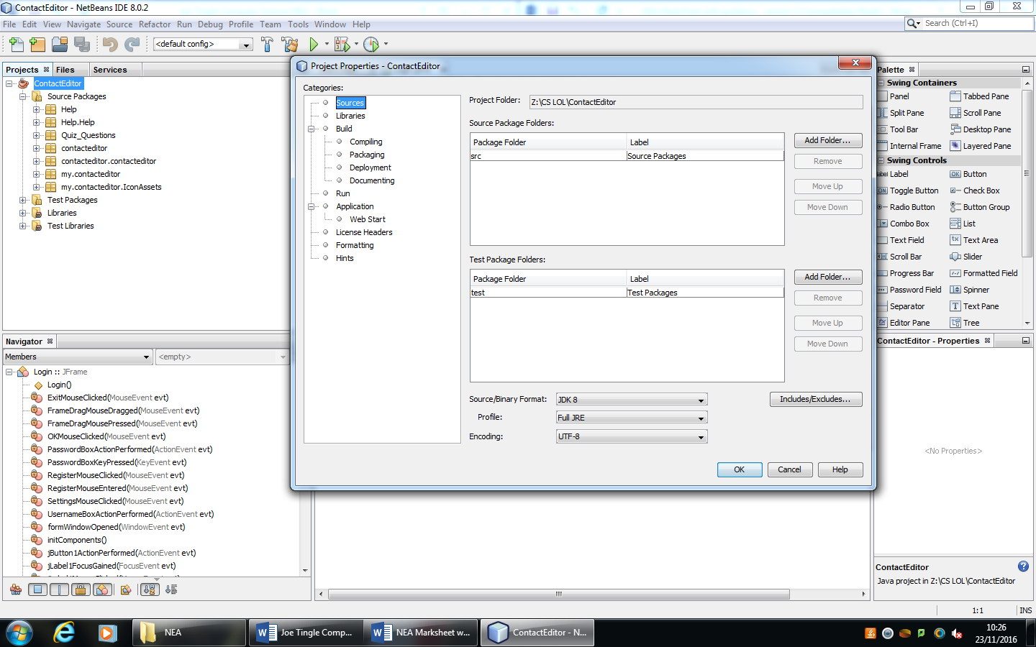

By right clicking on the project (identified by the coffee cup icon) and then navigating to the project properties section, you can see this is where all the configuration will take place. Firstly I have to make sure that the JDK, java development kit, which is the version of java required to code with is set to the latest version of 8. By utilising JDK 8 it ensures that I am able to use all of the latest features included in it which means it is able to run more efficiently on newer hardware. In the next section of the project properties are the libraries, which are a collection of pre-compiled routines which other programmers can use, the default libraries that I will be using including : EclipseLink, MySQL Driver, Absolute Layout and Beans Binding.

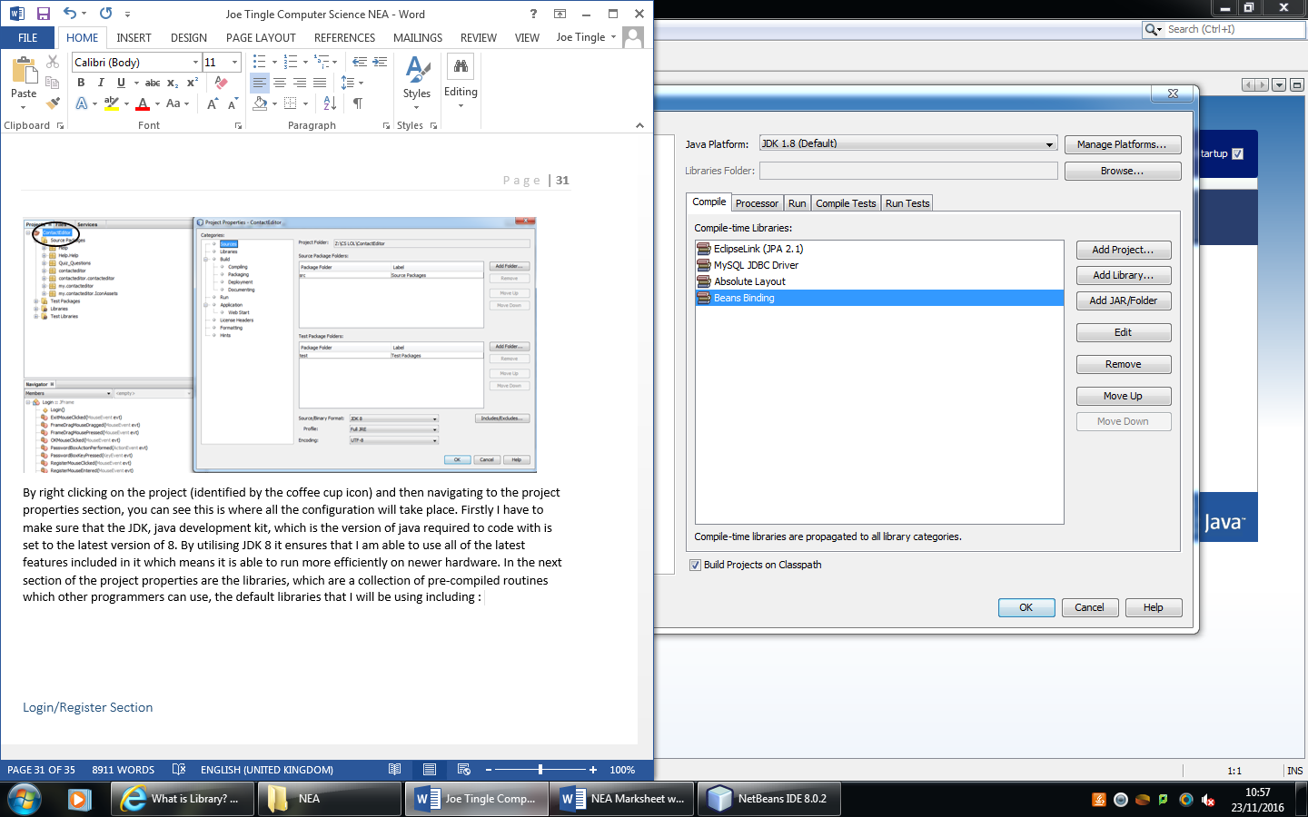

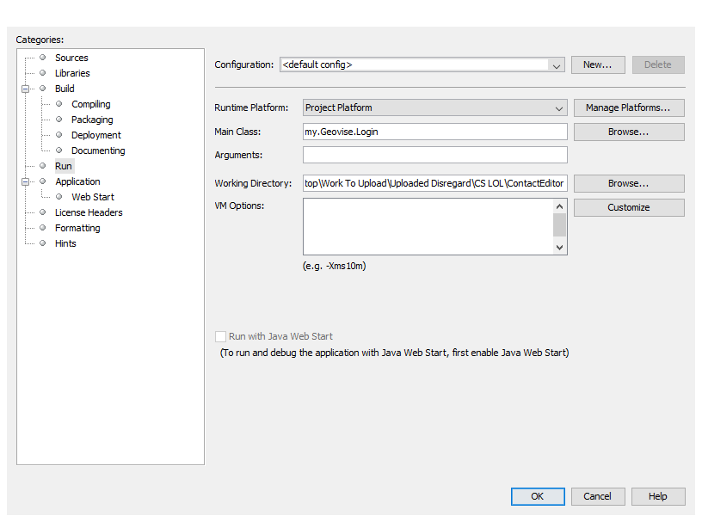One of the last essential configuration settings is in the run section. Here I have set the main java class file that will run when the program is executed. So it will be the first window that the user sees, for development this will be set to the Main Menu file for ease of access so that I do not have to log in each time. But in the final version of the program this will be set to the Geovise Login file.

### **Master Layouts**

The first section of the development will detail the master layouts that will be present on every single window on the program. I believe that this should be implemented as it will make the program feel more unique and stand out from other standard programs that are out there. One of the main examples of one of the master layouts is the custom toolbar which will replace the default windows toolbar at the top. Below is an image of what the default windows toolbar looks like:

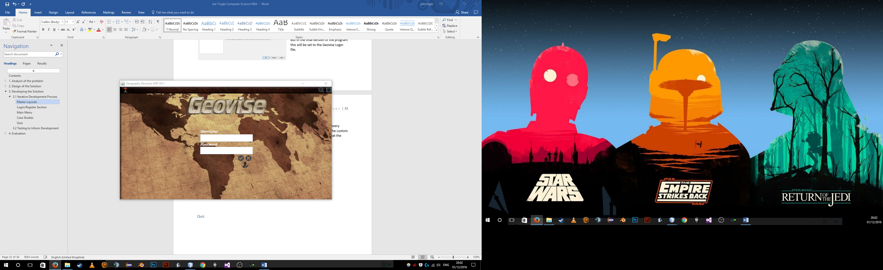

In the design section I decided to go with a custom toolbar as it would fit in with the theme which I have in place more than the default windows theme. Of course to create the custom toolbar I have to create a lot of custom assets within Adobe Photoshop, I chose this piece of image editing software as it has a lot of tools and effects available to put on objects/images. The other option could have been Adobe Fireworks but I believe that Photoshop offers a lot more features for the reason in which I need it for. Most of the windows within the program will be one dimension which is (850 x 480 pixels) but there is also the options menu, (200 x 470 pixels) and the various quiz questions, (1010 x 630). Because there are windows with multiple dimensions that means that I must essentially create 3 different versions of the toolbar, either increasing or decreasing the length on each one.

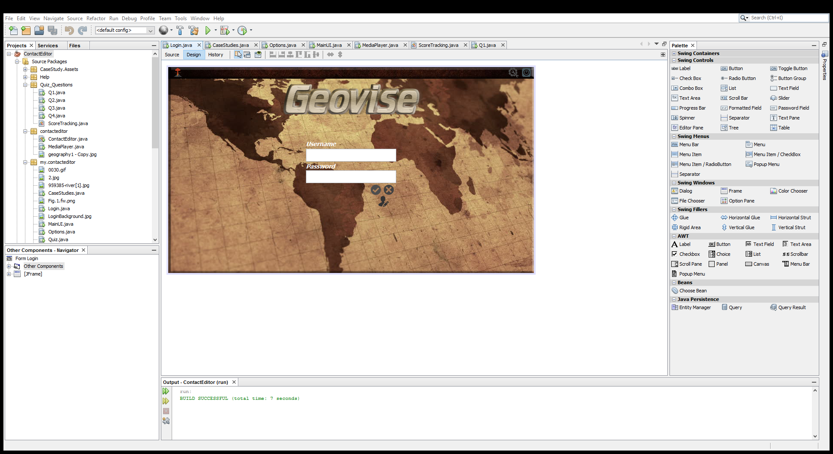

Here is an image of what the toolbar will look like, this is only a small cut of what it is. To create this image I have cropped it from a larger image as seen below. The overall theme that I am trying to achieve is an old geographical map look. This is because it fits perfectly with the overall theme of the program.

Once the toolbar was created within Photoshop I exported it as a .png file format, I chose to export it as a .png format over .jpeg mainly due to the smaller file size as there is the likely chance that there will be quite a few images needing to be loaded. The more images that need to be loaded mean a larger RAM usage and as specified in the success criteria the program must not utilise more than 400MB of RAM. Using .jpeg images would increase file size and then subsequently increase the RAM usage, so effectively this is small bit of optimisation of the program. However, there may be some exceptions to this when it is not possible to find a .png variant of an image.

To get the toolbar displaying within the JFrame I first had to create a JLabel which would then act as a frame for the image. I chose to use a jLabel for this as it is simply the only way to input images into the overall JFrame. For what I need to use it for there is no other way. To add an image to the JFrame I simply have to change the property of the JLabel called icon, to the location of the image file. Because the image file for the toolbar is already imported within the my.Geovise package within the program there is no need to specify a file location. I have chosen to import all assets into their own package as seen below:

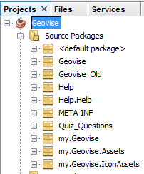As you can see here all of the image assets are located within the my.Geovise.Assets and .IconAssets, this will greatly help with organisation, and just generally making it easier for someone else to see where everything is located. I could’ve chosen to move all assets and java class files into one package but I believe that would then be confusing for another developer if they were to use this.

Once the toolbar was in place on all the windows, including the other variants of different dimensions such as the options and quiz windows, the icons had to be added. In the default windows toolbar the buttons are already coded in so when you click on the exit button, for example it will close the window, but in our custom toolbar no events will take place as there is nothing to click on. Again I have chosen to use a custom toolbar created by myself as in the long run it will allow for many more features compared to the default operating system one. For example on the windows toolbar it will only let you minimise, maximise and exit , where as on my toolbar you can add an extra icon at any time and code for its functionality.

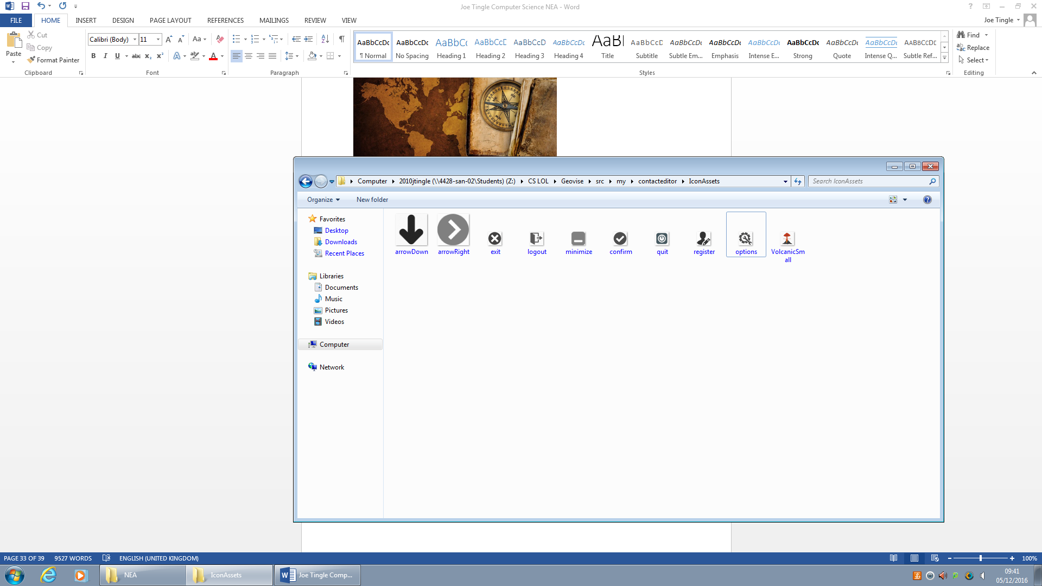So the next step in the custom toolbar was to get all of the necessary icons ready for use. As you can see below which is all of the icons ready for use, including Exit, Confirm, Minimise and Register.

After importing these into the IconAssets package within the program I had to create some more JLabels to contain the icons. However some of these icons are to be used later on in the development such as the arrowDown which will be used within the quiz questions. But again like I have said before all assets will be stored in their relevant package so even though the arrows will be used with the quiz questions, they will not be stored in the quiz package, but instead in the IconAssets package.

One final piece of framework that needs to be implemented into the toolbar is the movement of the window. Let me explain as with the default windows toolbar the functionality to move the whole window is built in, let’s take windows explorer for example, it allows you to click and drag on the toolbar at the top and the window will follow the mouse in real time. But in our toolbar there is no functionality for that and the window will not move from where it was generated at the start of the program.

Firstly to get the toolbar to move we must first declare two variables, which will be integer variables called xMouse and yMouse. These variables will store the x and y coordinates of the current location of the mouse. So in the end we will be able to compare the location at the start to the new location for the frame.

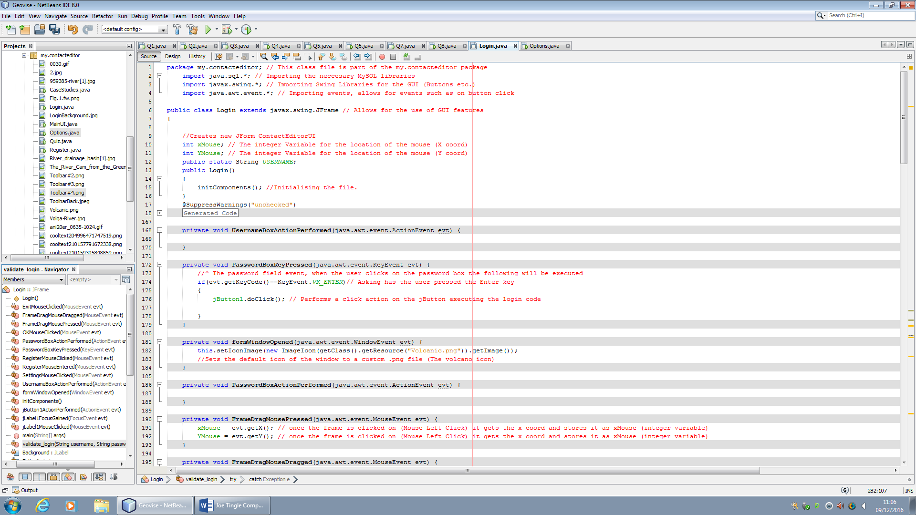

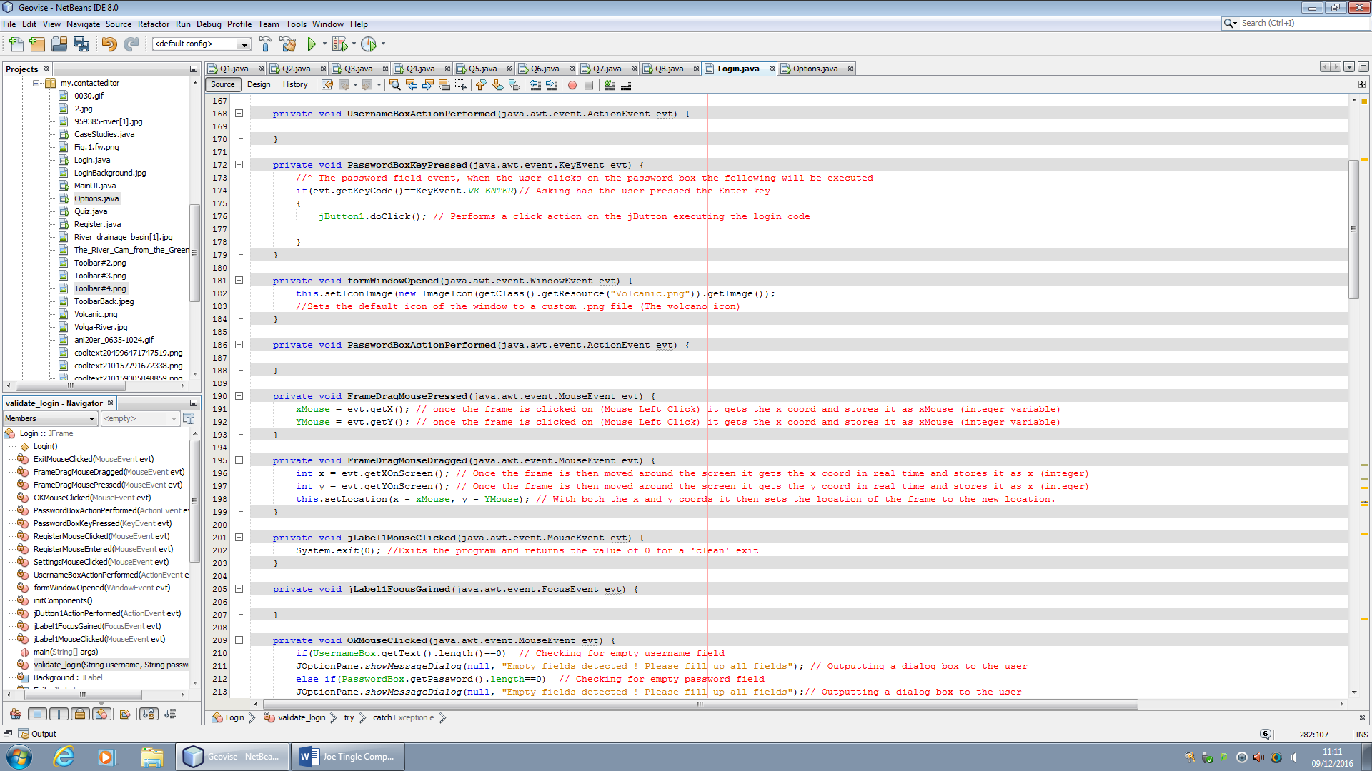Next we need to create an event which says when the user clicks on the frame drag area, a JLabel which is invisible, get the x and y coordinates. So as you can see in the code below it gets the coordinates of where the user has clicked on the toolbar frame and stores that in the relevant variables.

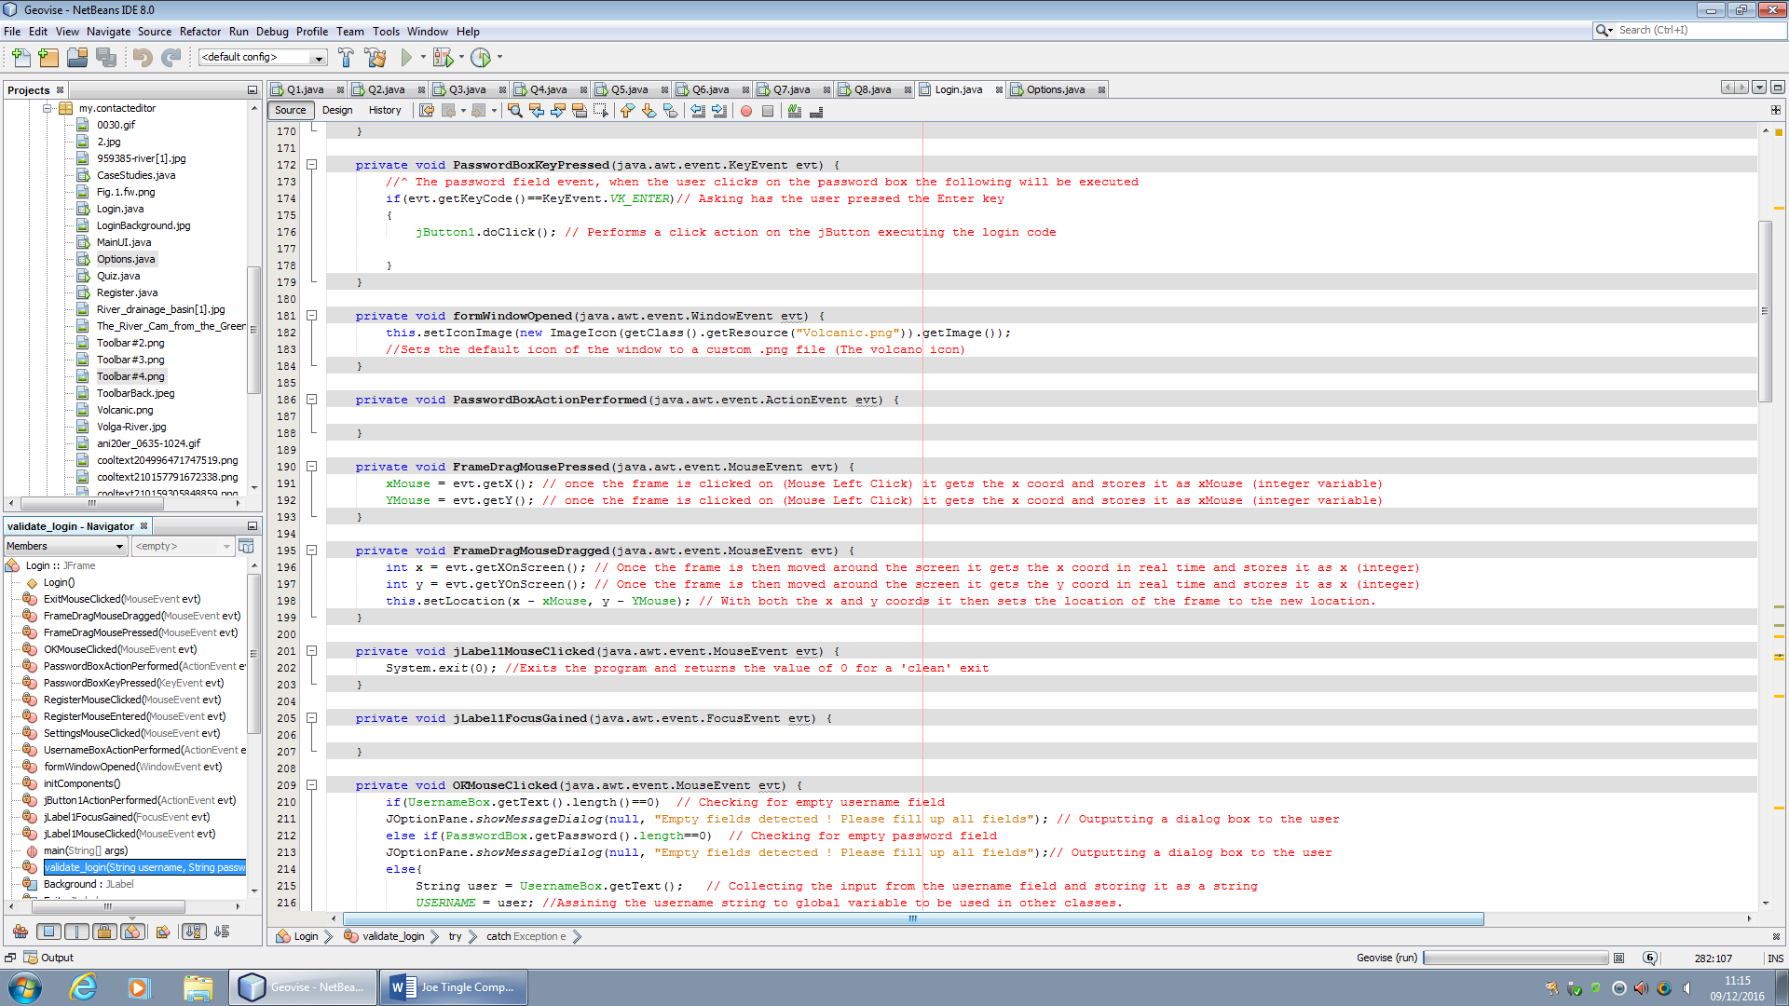The next event that is required for the movement of the frame is when the user drags the frame

So when the user starts to move the move (drag it) from the current location to another it will set the x and y integer variables to the current location that the cursor is on. These events are updated and run very quickly so the actual movement of the frame is smooth and does not jump around. After setting the x and y variables it will then set the new location of the frame, it does this in the line of code “this.setlocation()” this means the current frame so the login window. Then it sets the location of this, the login frame, to the new x and y cords. However we first have to offset it so that it goes in the correct direction which is why the parameters of the this.setlocation() include the x – Xmouse and y – Ymouse.

Here is what the current prototype version of the toolbar looks like running in the program:



As you can see all of the components are in place and it follows the designs which I had set out previously. You can see the program icon on the left, which is what nearly all programs do, and on the right is all of the utility buttons such as the help, settings, minimise and finally the exit button. Each do exactly what you would expect them to do, for example the settings would open the settings menu, minimise would minimise it to the operating system taskbar at the bottom of the screen etc.

Now I am going to get some feedback from the stakeholder to ensure that it is following the success criteria and the needs of the stakeholder. I have asked the stakeholder the following questions:

**In its current form does the prototype meet your needs? :** “Yes, in its current form this meets all of my expectations and furthermore the interface looks very easy to use and navigate around. Also the colour scheme is very nice and if you continue to use this theme it will turn out to be very good. ”

***Testing Toolbar:***

|  |  |  |  |  |  |
| --- | --- | --- | --- | --- | --- |
| Test No. | What to Test? | Expected Outcome | Test Data/Outputs | Actual Outcome  Success / Failure | How to Improve |
| 1 | Can the user move the whole frame around by clicking and dragging on the toolbar? | The user should be able to click anywhere on the toolbar and then drag it to any spot, on any monitor if it is multi monitor. Once the user begins to drag the mouse the frame should move with it. | To test the actual coordinates of the frame and mouse, I have added two lines of code which are going to output the coordinates as seen below. | Once I had opened the program up, I clicked on the toolbar and it then, because of the line of debug code, outputted the x and y coordinates of the mouse as you can see below. Then as soon as I began dragging the mouse it would relocate the frame to its location, it would do this even when I only moved it one pixel as you can see in the test data output below.  So this test was successful and the toolbar works as intended | I think that the toolbar works very well in its current stage and cannot see it being changed in future prototypes of the program. However I could maybe try and set some of the variables to global and then utilise them, as currently the frame will reset itself to the centre of the screen whenever another frame is opened. |

***Test Data/Outputs:***

***Test 1:***





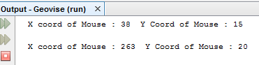

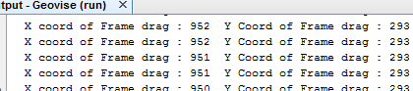

Now after testing I am going to refer it back to the success criteria, to ensure to I have met them, leading to the program achieving its purpose. The success criteria that is relevant to this section is criteria **number 4** which states that the system must display all of the windows correctly. I have met this criteria during development because as soon as you run the program it will display for the user to see. If I had not met this criteria then nothing would display when the program is run.

Another master layout or function that will be in the program is a digital clock, which will be present on top of the toolbar on every window. This feature was not included on the design but I feel that it should be added early on during the development as it will allow for me to implement more features based off this. For example, with the clock in place I can now implement different variants of the quiz, for example alongside the normal quiz there can be as timed variant which will only give the user 10 -15 seconds to answer a question, the quicker they answer the more points the user gets.

Here you can see an altered design of the login frame with the clock added.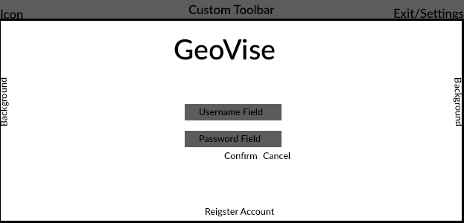

Clock (24 Hr Format)

To start off with the development and implementation of the digital clock I first have to utilise two imports, the javax.swing.Timer and the java.util.Calendar. However we have already use the javax.swing.* import before and because there is an *, which means include everything in that package the Timer is already imported. In have included it below to show what it would look like without importing the whole of the swing package.

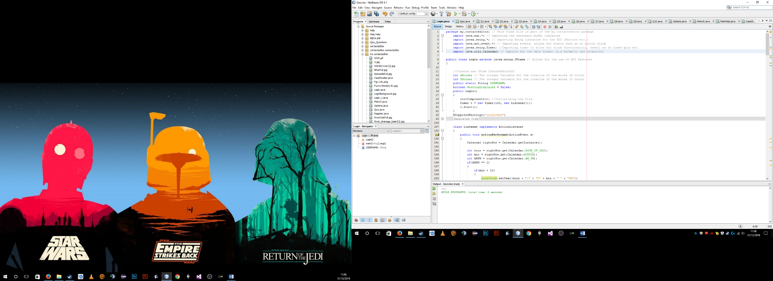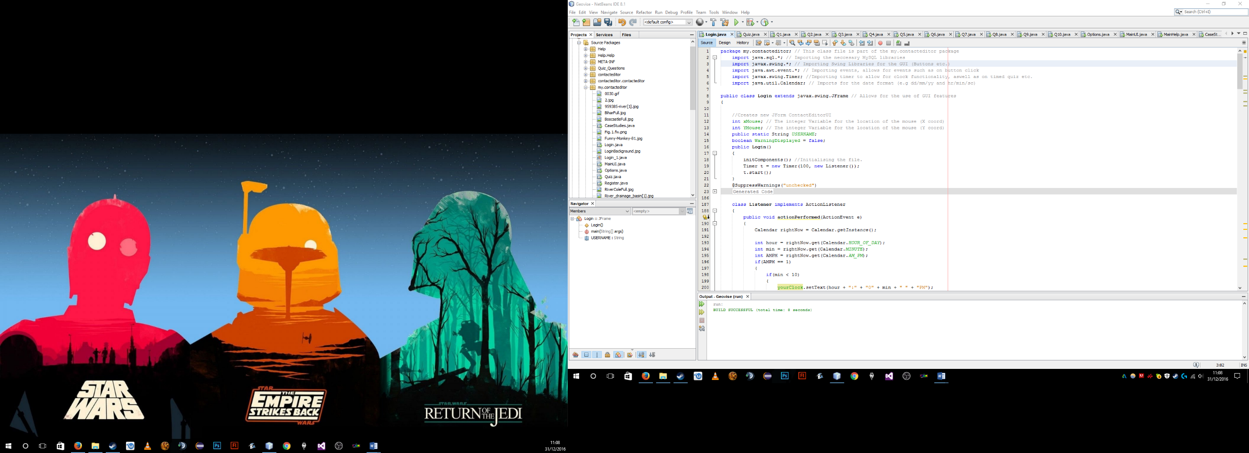

The first “Timer import” will be used for getting the clock functionality so we can then store it as local variables. The “Calendar” import allows us to format these new local variables which will store the hour, minutes etc. I have decided that the clock will be in the format hr:min AM/PM.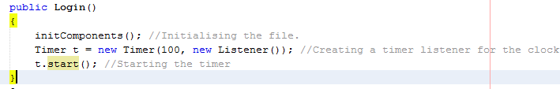

The first piece of code is done within the main class method Login() and after all of the components have first been initialised it will create the timer for our clock and then start it. It grabs the current time (in whatever time zone you are located in) so it is very accurate. Below is an example of it working in real time:

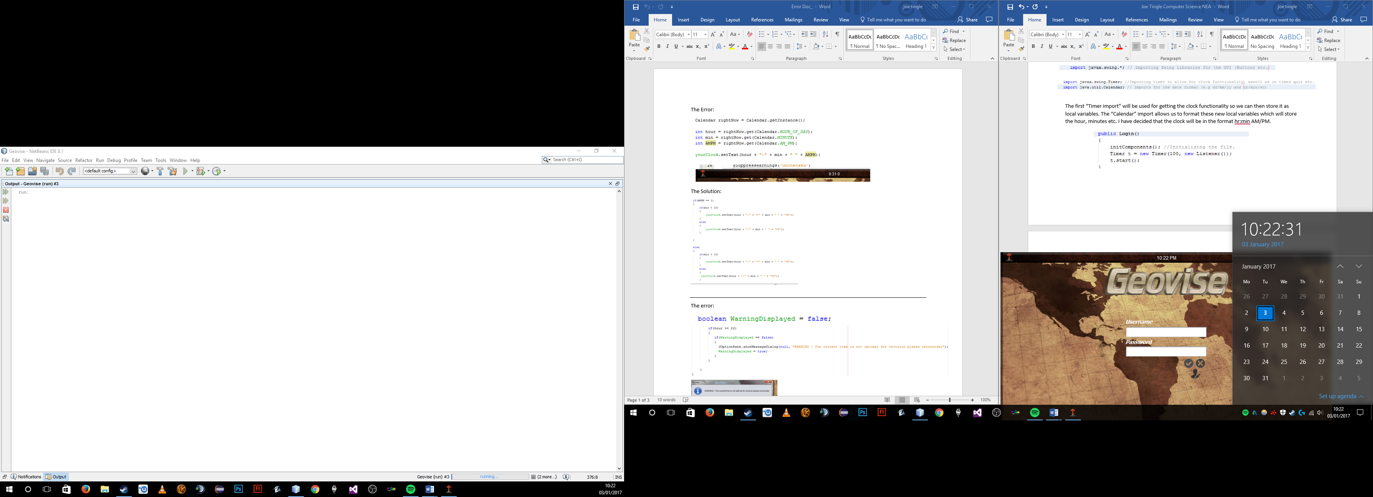

As you can see it shows the correct time according to the OS’ clock, so as soon as it ticks over to another minute in this case it would be 10:23, Geovise would also tick over at the exact same time.

Now we have to create a listener class to output the time every second, we want it to output and change the contents of a JLabel every second so that the user can see the seconds if need be.

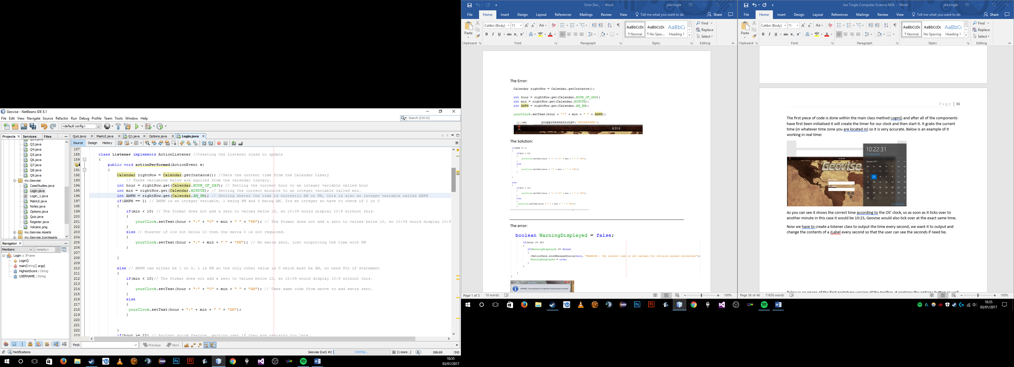

Here is code for creating the variables for the time and dealing with the PM section. Firstly we have to acquire the current, real time, time from the calendar library which we do but creating a variable called rightNow. It is a Calendar data type as it uses the calendar library.



So by getting the instance of the calendar library and assigning it to rightNow it now contains lots of data. We are able to debug and see this by simply adding a print function.

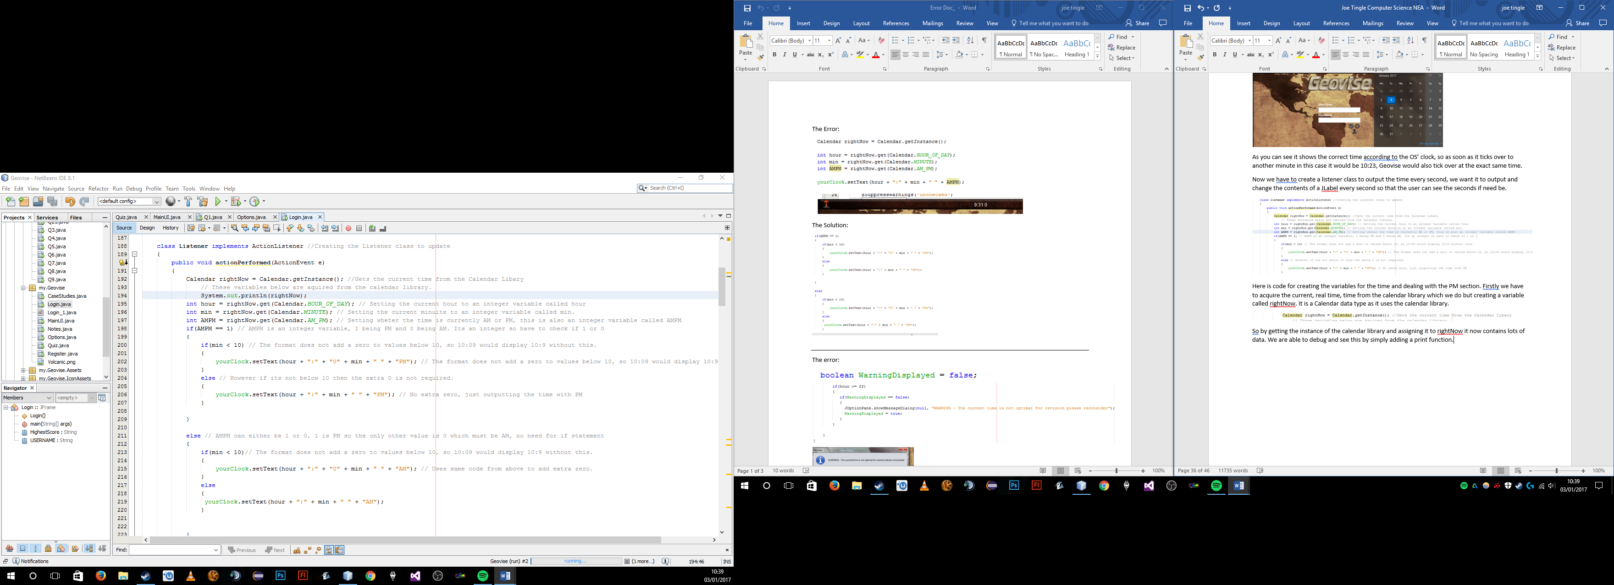

Now when we run the login window we can see the following output which is the contents of the rightNow variable, and because it is in the listener class it updates every second.

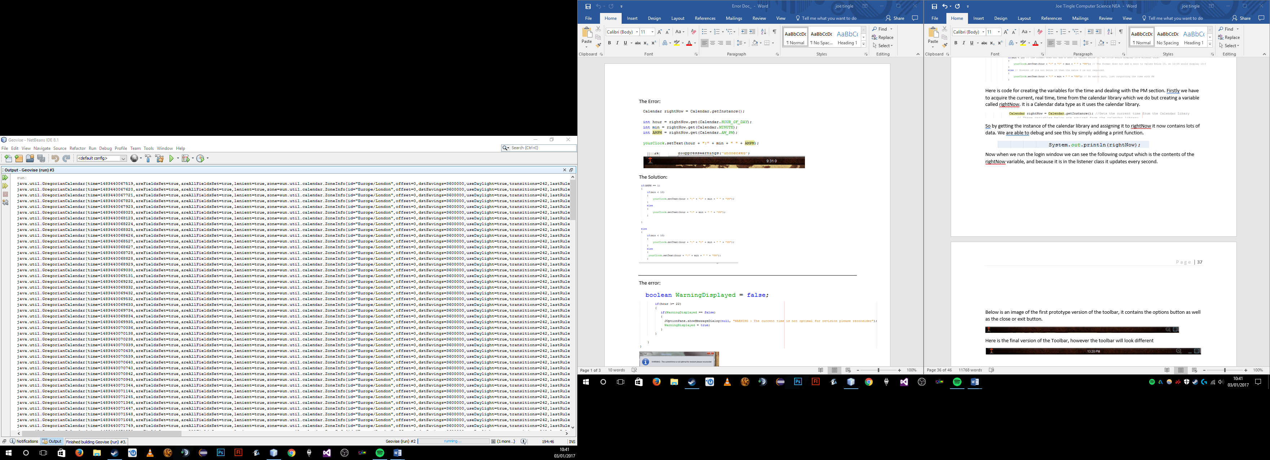

It contains information such as the current time zone information, if it is daylight saving and of course the actual time.



In the next piece of code we are grabbing certain pieces of information from the rightnow variable and then storing them as different variables so each one only contains one piece of information.

So we are declaring the hour, minutes and whether it is AM or PM, and as you can see it grabs it from the rightNow variable, rightNow.get(Calendar.HOUR_OF_DAY), now this is getting the hour and is important to note the HOUR_OF_DAY.

Now below is the contents of the rightNow variable which contains all of that information and if we look closely at the end of it we can see it shows the HOUR_OF_DAY, so now we know where it grabs it from. Also next to it you can see the Seconds, and AM_PM which is what we are grabbing for the next two variables of min and AMPM.

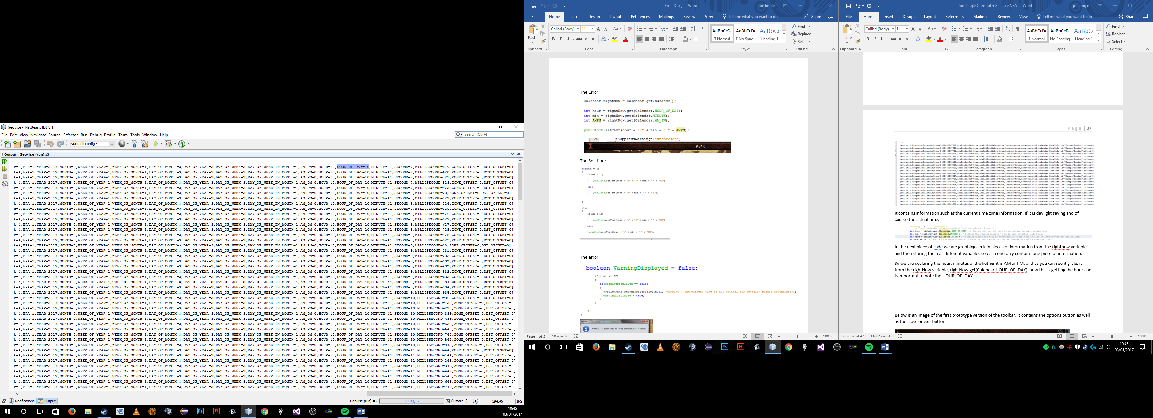

There is a lot of functionality with this clock just because of the amount of information that this one variable contains. But once we have declared all of the variables we must deal with the formatting as in its current state the variables will output like so :

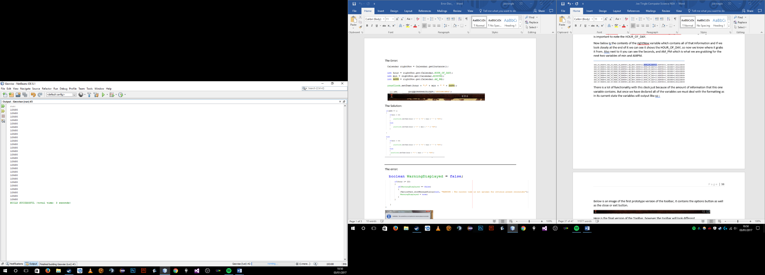

Where as we want to format it so that it appear like, 10 : 50 AM.

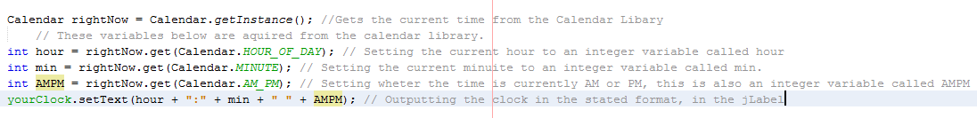

Here is the code for our formatting as you can see the line yourClock.setText() outputs the hour with a : and then the min alongside whether it is AM or PM. However, this gives us an error. It outputs like this:

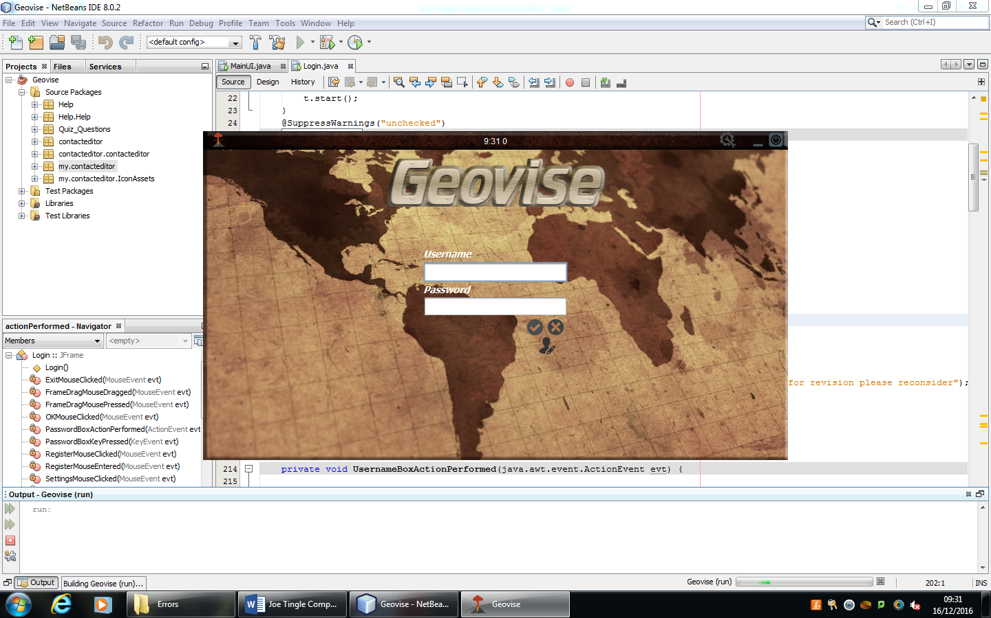

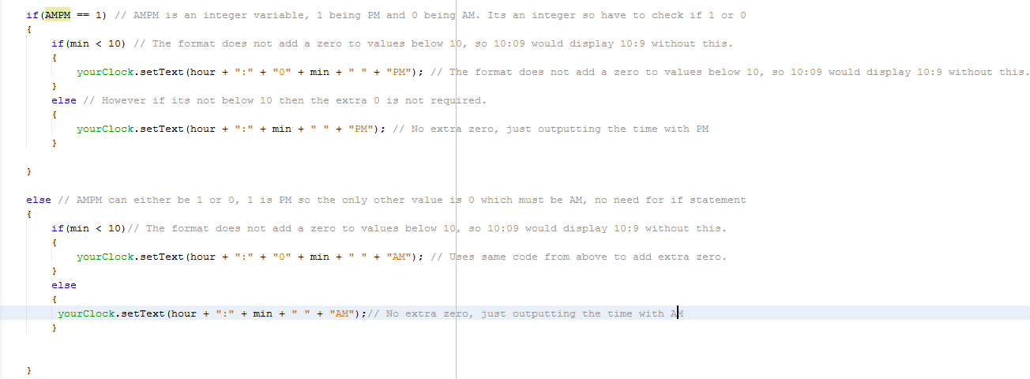Now there are a couple of errors in this, which all is part of the formatting of it. Firstly because the current hour is below 10 it outputs 9, which theoretically is correct but this is a time so it should be 09:31 not 9:31. This is a simple fix which just requires us to check if the current hour or min is below ten, and if it is add an extra 0. The next is more obvious in the fact that because AMPM is an integer value it outputs 1 or 0 depending on whether it is AM or PM. So we have to interpret this and say if AMPM is equal to 1 then it is PM else it is AM. Below is the fixed code:

As you can see with the if statement it asks if the integer variable of AMPM is equal to 1, so is it PM, if it is then it goes to the next if statement which asks if the minute or hour is below 10 if it is then it requires the extra zero which it adds alongside the PM tag at the end. But if AMPM is not equal to 1, then it is AM and it goes through another if statement to check if an extra zero is needed and adds the AM tag to the end.

So, the final output for the clock is below:

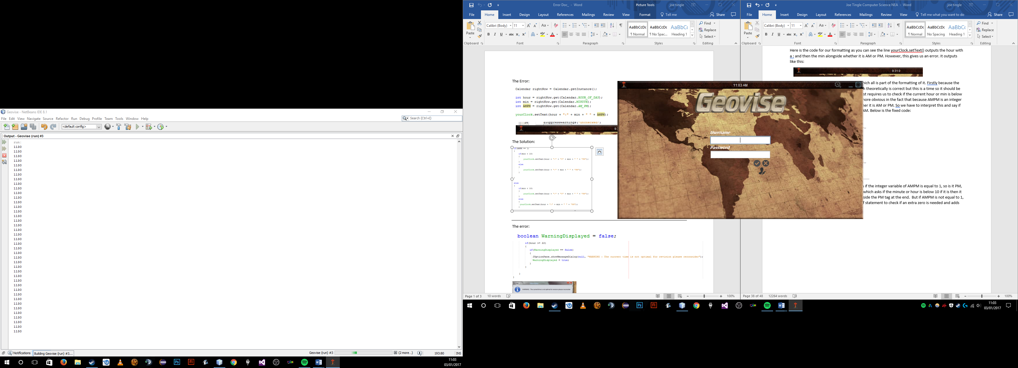

But there is one final feature which I decided to add using the functionality of the clock which is that if the time is above 10 o clock at night then it will warn the user that it may not be suitable to revise now as revising too late in the night may not help

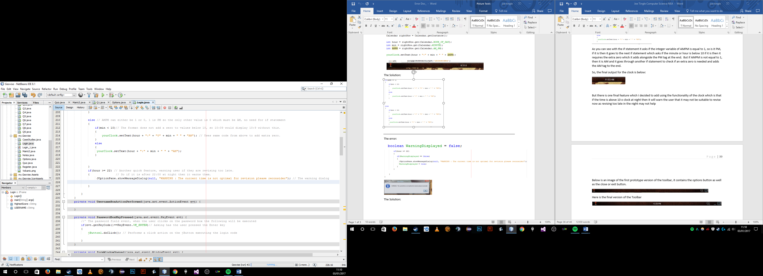

To start off with I thought that a simple if statement would be sufficient checking if the hour variable which we declared earlier on was greater than or equal to 22, or ten o clock at night, then it would display a dialog box warning them. However this code produced a big error which stopped the user from being able to access the program at all after 22:00.

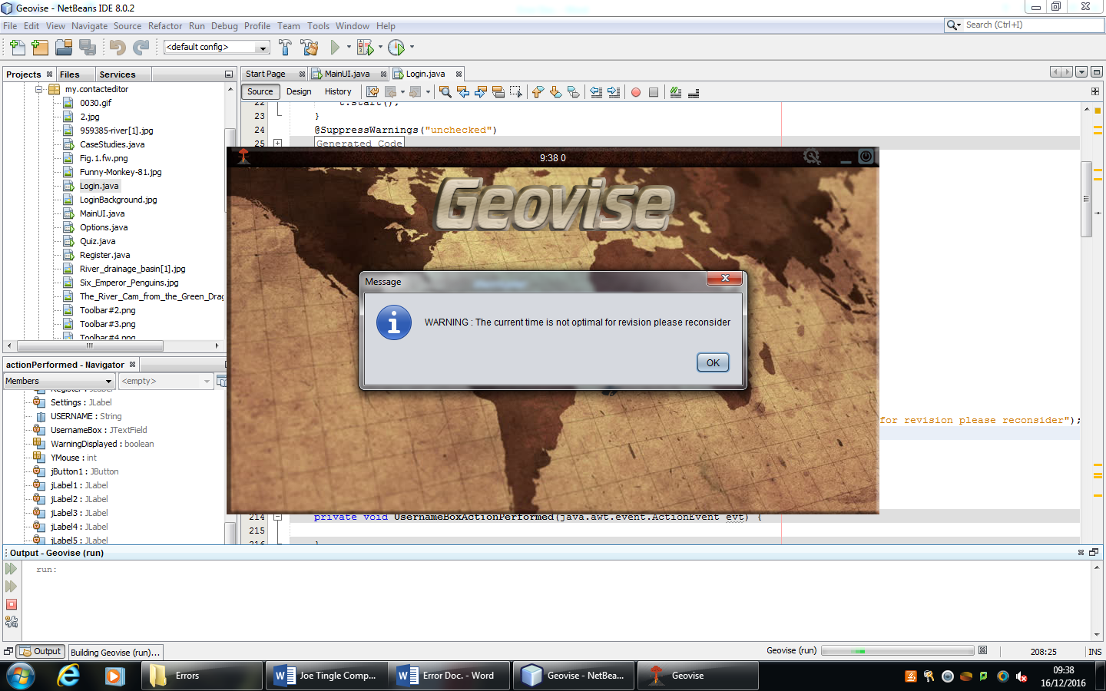

Because it checks to see if the hour is 22 or later it would constantly display an error message and essentially spam the user with dialog boxes because there was not break condition in the loop which would reset it.

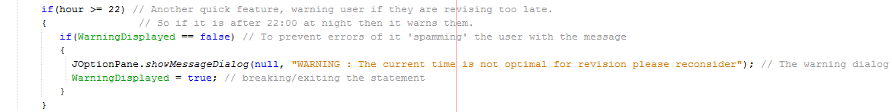//The solution to this was to add a Boolean variable as a flag checking if the warning has already been displayed or not, so the default value will be false and when the dialog box is shown the first time the variable is changed to true which breaks the if statement.

Below is an image of the first prototype version of the toolbar, it contains the options button as well as the close or exit button.

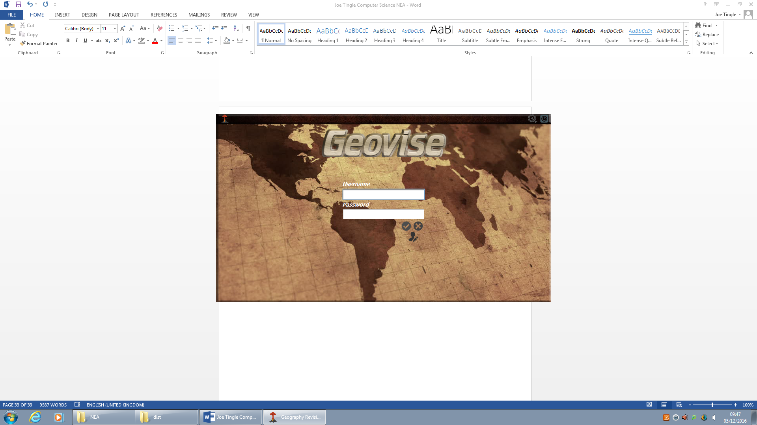

Here is the final prototype version of the Toolbar

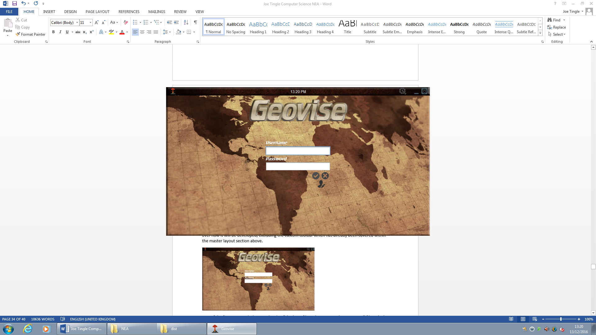

You can see that from the previous prototype version the digital clock has been added to the centre of the toolbar. It displays in 24 hour format with the hours, minutes and whether it is AM or PM. It will update in real time alongside of the operating system clock.

Now I am going to get some feedback from the stakeholder to ensure that it is following the success criteria and meets the needs of the stakeholder. I have asked the stakeholder the following question:

**In its current form does the prototype version with the clock meet your needs? :** “I think that this version of the prototype is great and the addition of the clock completes it for me. The interface again looks easy to use and navigate around, and the clock allows me to stay focussed on the program.”

***Testing Digital Clock:***

|  |  |  |  |  |  |
| --- | --- | --- | --- | --- | --- |
| Test No. | What to Test? | Expected Outcome | Test Data/Outputs | Actual Outcome | How to Improve |
| 1 | Does the clock output in a 24 hour format for the user, and adjust to their current time zone? | As soon as the frame is opened, the clock should start and be displayed as white text on the centre of the toolbar. It should update around every second or so, and should match up with the OS clock. | N/A | Once the user runs the program it will initialise the clock and it will being to update, as you can see below it outputs the time correctly, and does update exactly with the operating system clock. | I don’t think there is any way in which this could be improved in future prototypes of the program. It functions correctly and is efficient. |
| 2 | Will the clock update if the actual time goes over to the afternoon, so will it change the AM to PM when it is time? | Once the clock goes over 12:59 it should then display 13:00 PM, changing the prefix from AM to PM. | You can see the piece of code below which controls whether or not it is AM or PM. Adding another line of debug code will show exactly when it changes the value of this variable to change it to PM | As the program was open I waited until 11:59 to check that it was not ticking over to PM early, and with the debug line of code which kept outputting the value of AM_PM I could see if it changed or not. As you can see below it works perfectly in AM, as at 11:57 it would output the value of 0 meaning AM.  Also at exactly 12:00 it started to output a value of 1 as seen below, so I can conclude that this feature works as intended | I don’t think there is any way in which this could be improved in future prototypes of the program. It functions correctly and is efficient. |
| 3 | Will the program alert the user if they are using the program too late in the evening? | As soon as the clock ticks over to 10 o clock at night (22:00) it should display a dialog box warning the user that it may not be ideal to revise at this time. Once the user then confirms this is should disappear and not display again. | N/A | With the following code below, it contains a simple if statement, running this would correctly prompt the dialog box to display at 10 o clock at night, but as soon as the user confirmed the dialog box another would open so it would be stuck in a constant loop. | To fix and improve on this I simply needed to an exit to the if statement as it was checking to see if the time was greater than 22 and if it was open a dialog box, but it would do this every second. So as you can see in the below code I have included a Boolean variable and added in another if statement. This will firstly create a Boolean variable called WarningDisplayed and sets it default declaration to false, meaning at the start of the program the warning has not been displayed to the user. Once the time is above 22 it will then check to see if the warning is false, if it is then it gives the dialog box and then sets the variable to true, essentially exiting the loop. |

***Test Data/Outputs:***

***Test 2:***

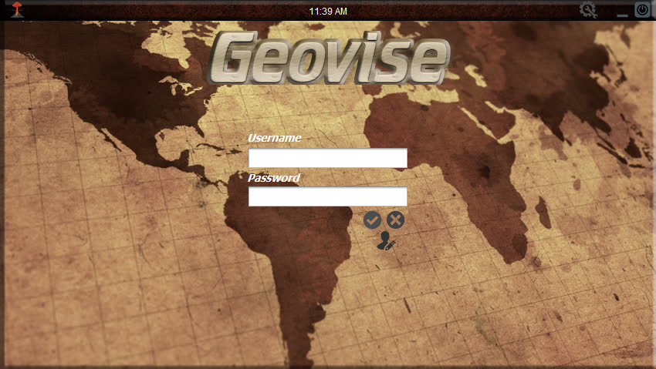





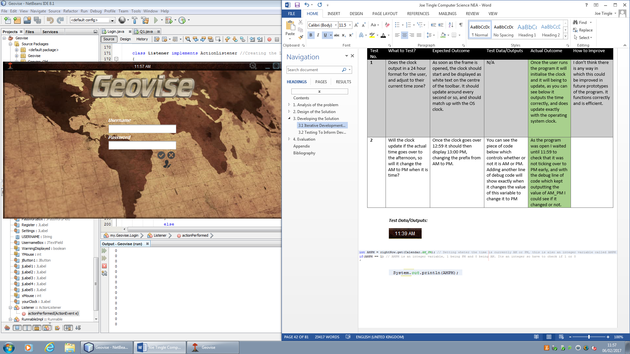

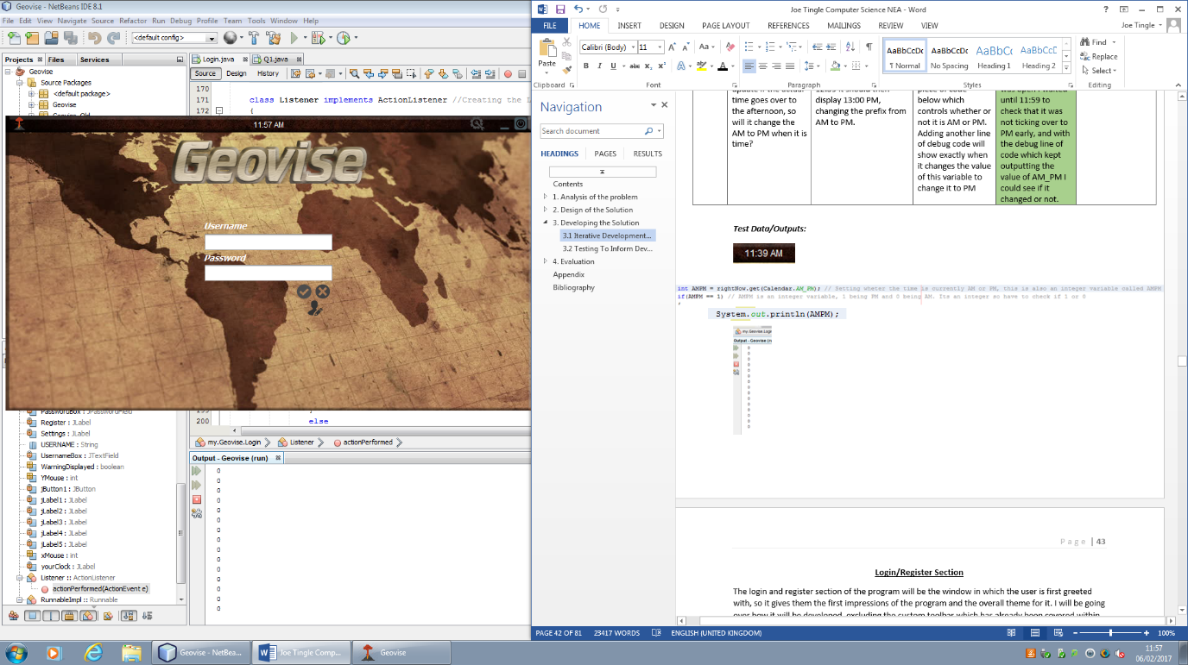

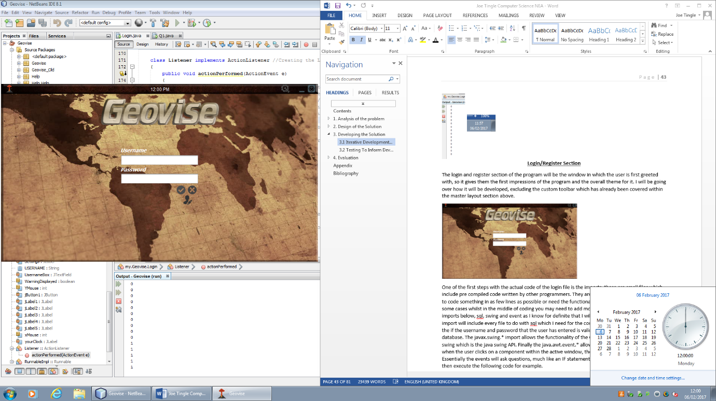

**Test 3:**

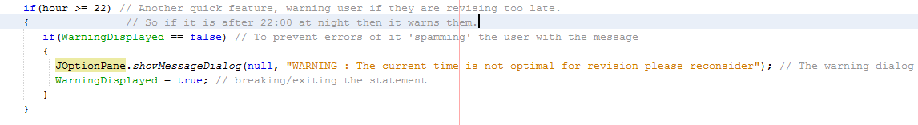

Now at this stage I am going to refer back to the success criteria to ensure that the program is progressing and achieving its overall purpose. The success criteria that Is relevant here is **number 26** which states that the system must display a clock for the user to check the time, keeping focus on the program. I have achieved this during this stage in development as currently when the user runs the program the clock will display as soon as the window is open and update in real time. An example of this is as soon as the operating system clock ticks over to another minute so does the clock on the program at the exact same time. This is useful for the user as it mean they will not get distracted and their sole focus will be on the program.

### **Login/Register Section**

The login and register section of the program will be the window in which the user is first greeted with, so it gives them the first impressions of the program and the overall theme for it. I will be going over how it will be developed, excluding the custom toolbar which has already been covered within the master layout section above.



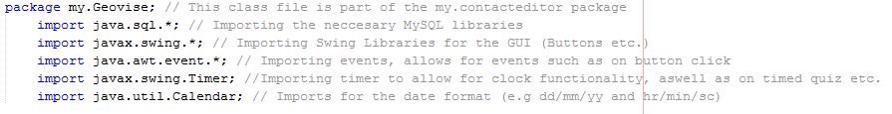One of the first steps with the actual code of the login file is the imports, these are small files which include pre compiled code written by other programmers. They are very helpful for when you need to code something in as few lines as possible or need the functionality of someone else’s code. In some cases whilst in the middle of coding you may need to add more imports but I have added these imports below, sql, swing and event as I know for definite that I will need to use these. The java.sql.* import will include every file to do with sql which I need for the connection for the database to check the if the username and password that the user has entered is valid and matches the records on the database. The javax.swing.* import allows the functionality of the GUI, you may note the key work swing which is the java swing API. Finally the java.awt.event.* allows me to code for events such as when the user clicks on a component within the active window, then it will execute some code. Essentially the events will ask questions, much like an IF statement, so if the user click on a JLabel then execute the following code for example.

Another short piece of code as shown below will allow for the program to look a bit more professional, this specific piece of code will be run on every single window as it will change the default java icon which is displayed when the component or JFrame is shown to a custom icon.

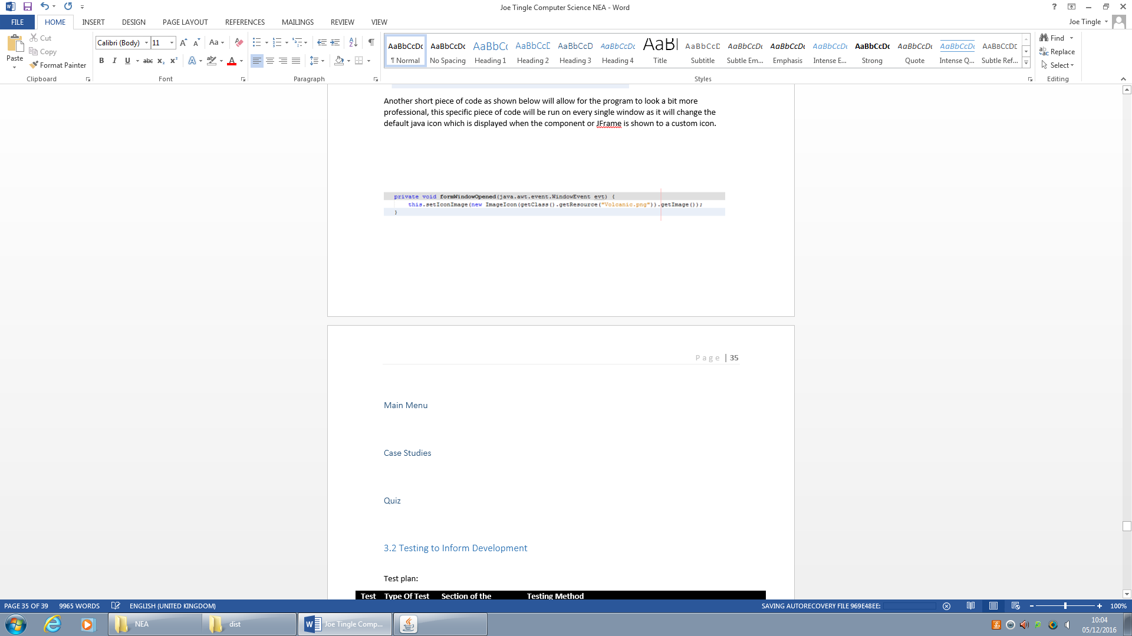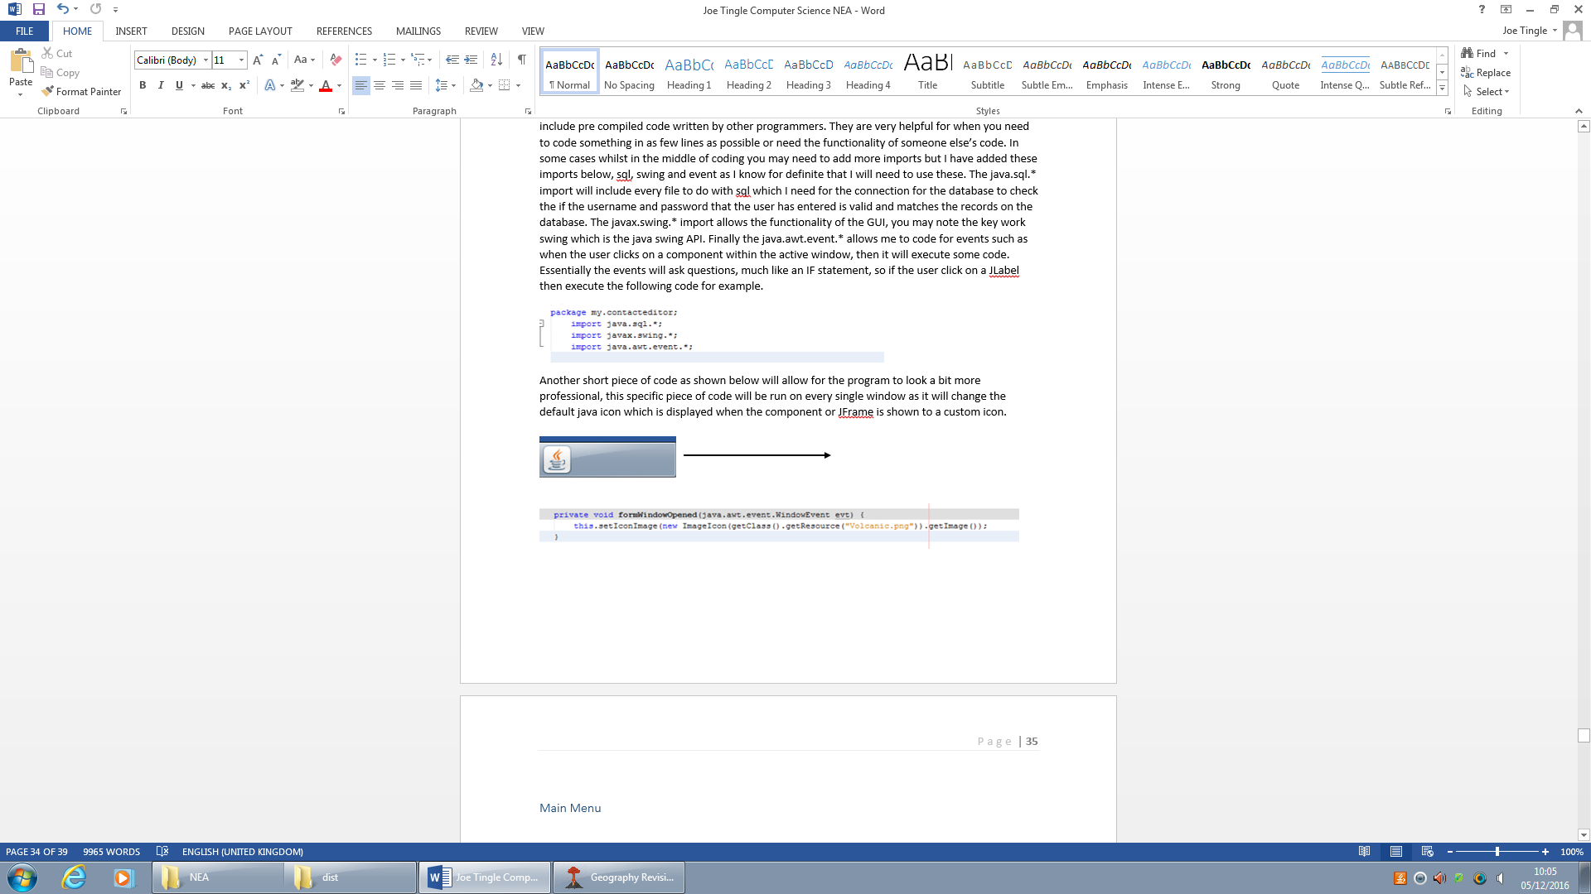



Notably the code above utilises one of the imports, specifically the event import (java.awt.event.*) as you can see by the formWindowOpened(java.awt.event.WindowEvent evt). What this is doing is asking if the main form/window has been opened so in our case has the user opened the program, if they have and this is true then the subsequent code is executed which changes the icon.

Now that the base functionality of the program has been created we can move onto the main content of the login window where the user enters a username and password. The username box is relatively simple as it needs a JTextField placed into the window which allows the user to type anything into the box and as they click enter it is converted into a string. With the java swing API there is a built JPasswordField which automatically censors whatever the user types into the box, which is good as nobody should be able to see what the user’s password is. The contents of the JPasswordField are also converted into a string as soon as the user clicks on the enter button.

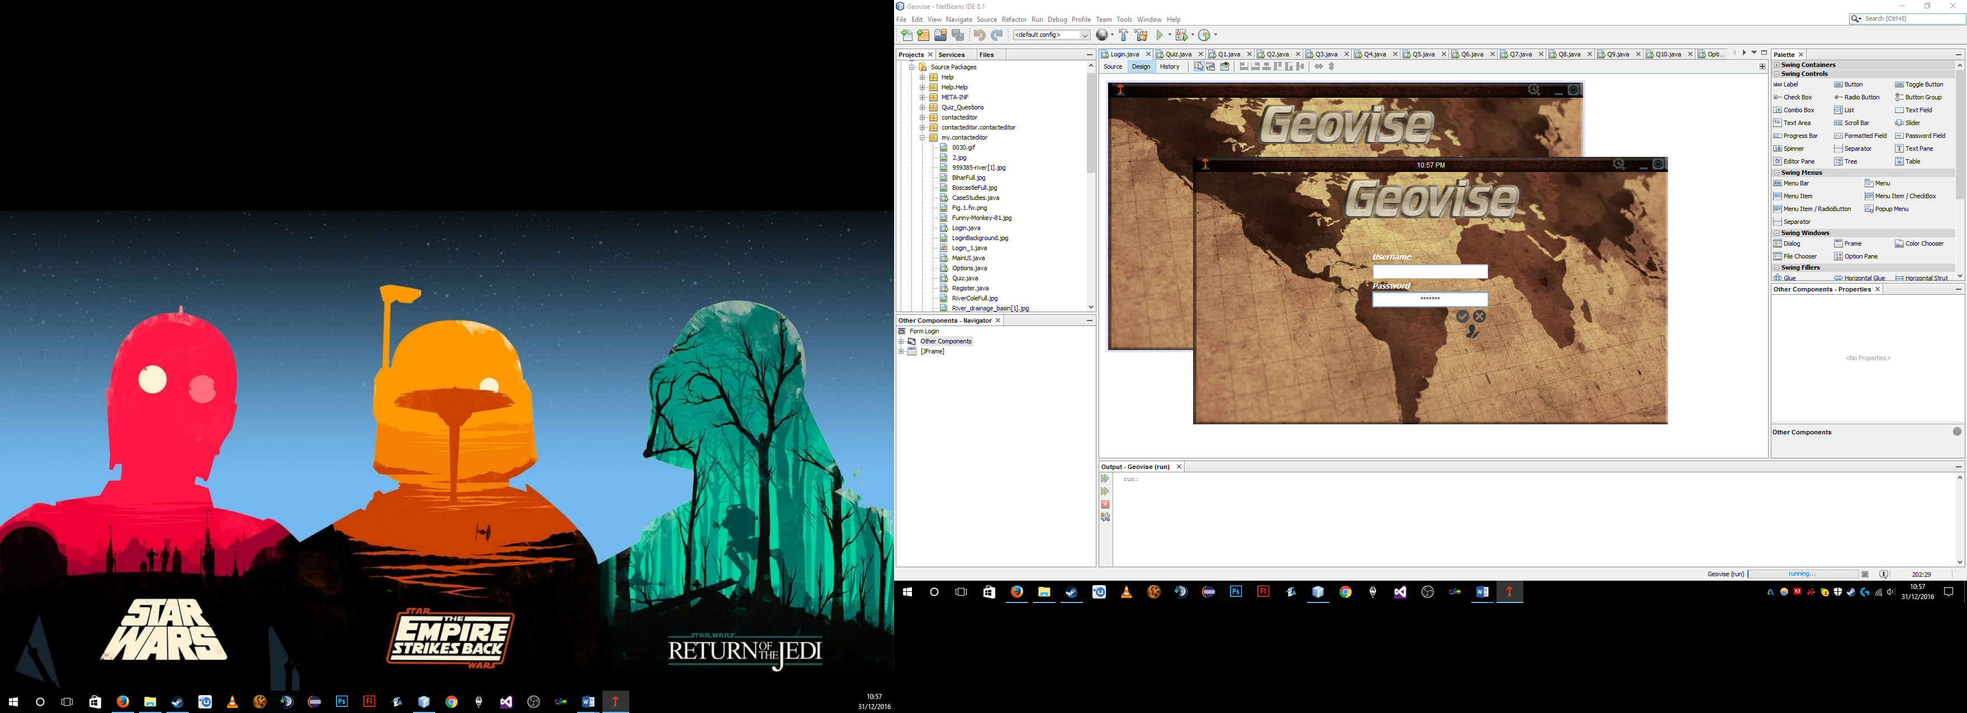

One issue that I did encounter with the first prototpye of the login window is that once the overall layout and aesthetics was finsihed and I ran the program it looked very flat on the screen, it is difficult to see on this image but it looked like it was just an image pasted onto the screen.

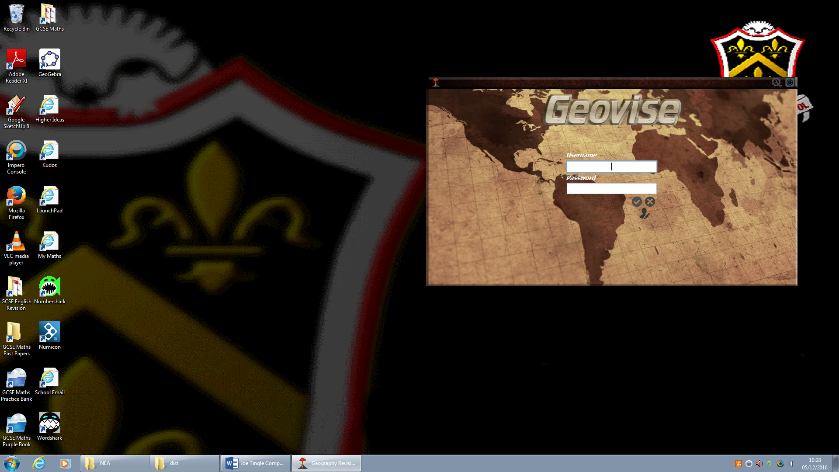

So to solve this I decided to go back to all of the assets within Adobe Photoshop and edit them. To start off with I tried to add some effects to the layers such as a simple glow but in the end decided against that and found the bevel and emboss effect which gave it a sort of 3D look and feel to it, meaning it didn’t look flat anymore. After implementing this to all of the assets within the login screen and running it again I decided that it was the best look.



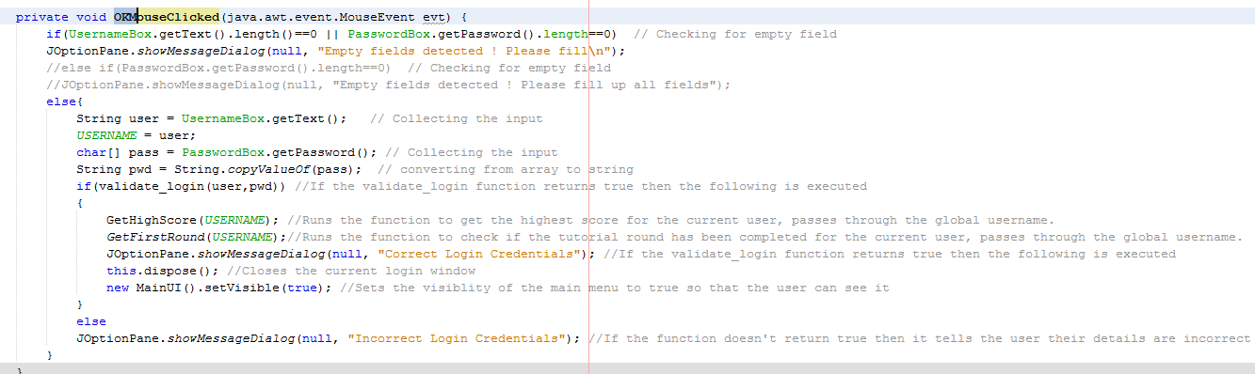After that it was time for the main content of the login section which is the connection to the database, which starts off with an event, so if the OK button is clicked on then it executes the following code.

It starts by first checking each field, in which the user will enter information into so the username and password boxes to see if they don’t have any values in them. So, if there is nothing in the username box then it is null and the user is prompted to enter something into the field. It will not proceed onto the validate login method if either one of the boxes is null.

Once the user has entered information into both of the boxes it converts the values into the variable user which has a data type of a string and pass which is also a string. However it also assigns the value of user to a global variable USERNAME which can then be used later on in the main menu.

After that it calls the validate login method which can be seen below, this controls all of the connection details for the database and will check to see if the information that the user has entered matches the records within the Login table on the database.

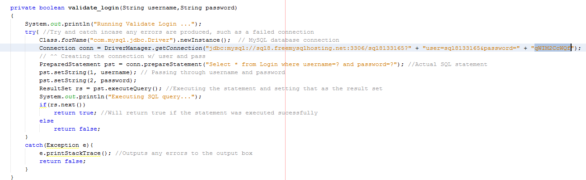

Here is the first prototype of the code for the login validation, in went through quite a few phases mostly due to errors. As you can see it consists of a try and catch so if the connection is not successful for any reason it catches the exception and outputs a brief overview of it to the output log so I can debug it. It also returns false so that the user is not logged in, as if the method returns true then it tells the user their information is correct. So the only place it should return true is if the information does match a record within the database.

In the try it creates a new sql instance for the connection and then gives it the connection address and stores it as the variable conn. It then creates the SQL statement which is Select * from Login where username = ? and password= ?, this will grab all of the information and return true if the username and password variables which are passed through match a record in the table Login.

However this SQL statement is not executed until the next line of code with pst.executeQuery(), then it deals with the return statement. But after testing, see testing table, this version of the login validation does not work and produces the following error in the output log

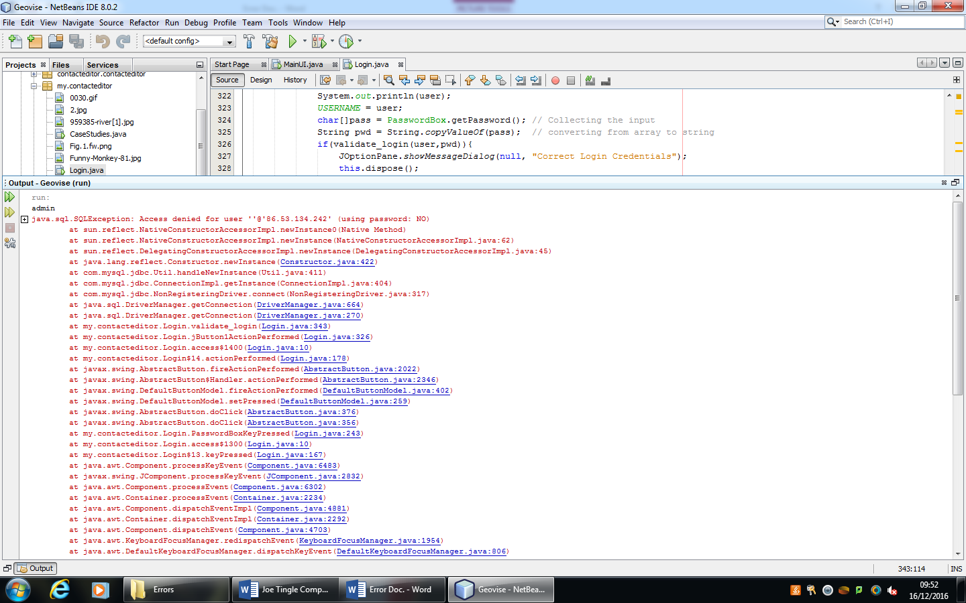

After debugging the error, it is because I have not specified any login information for the database itself. Therefore, it gives the access denied error, below is the correction for the code which then provides all the information for the database to access it.

This then solves the access denied error but then produces another error as seen below :

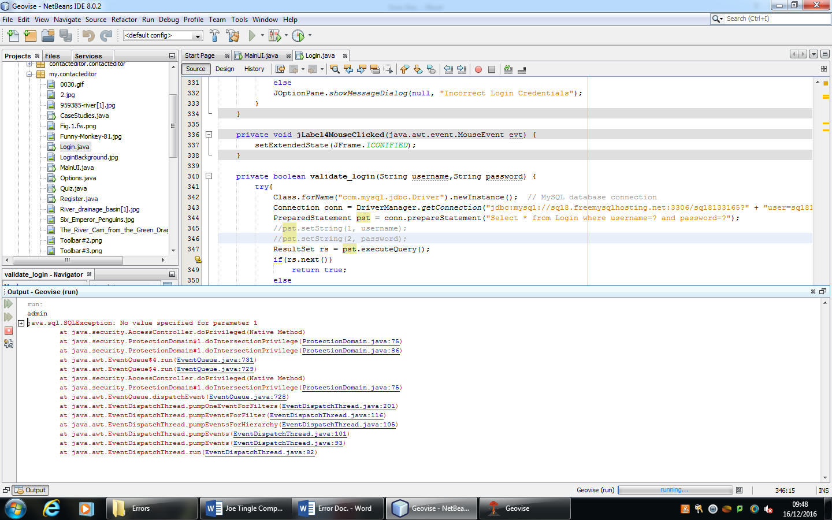

Which states that there has been no value specified as the parameter, we can narrow this down even more as it says that this is an SQL exception. Now after debugging this error I have found that the username and passwords variables have not been inputted into the SQL statement, adding these two lines of code solves the issue and allows for a successful connection to the database.

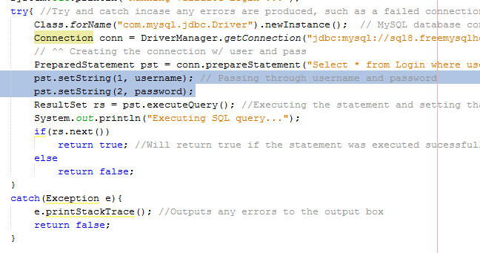

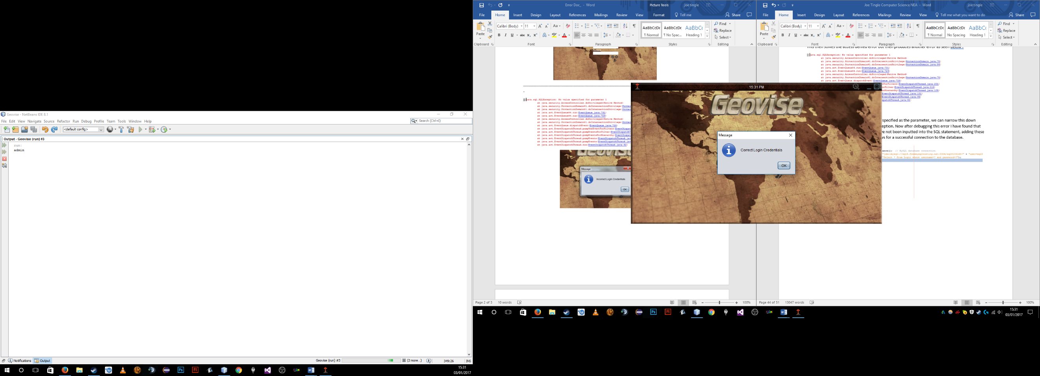

Here is the current prototype of the login section, which in its current state allows the user to log into an account that is already in the database:

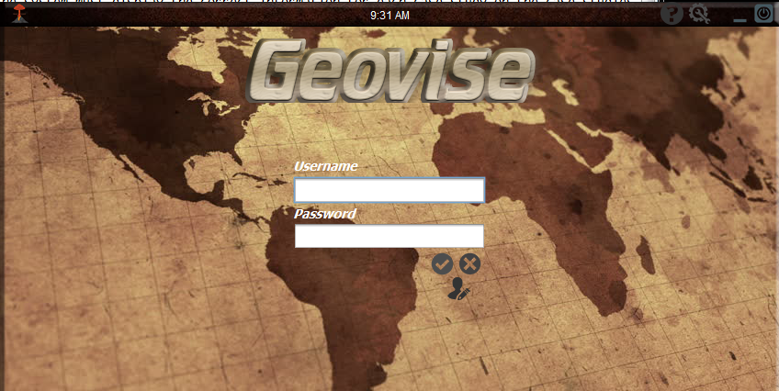

In its current state the above prototype displays all of the master layout from the previous stages of development, such as the toolbar which the user is able to move around the screen to wherever they like and even onto a separate monitor. There is also the digital clock which is present so that the user is able to check the time quickly and whenever they like, alongside of all of the icon such as the help, settings, minimise and the exit button. For the login functionality itself the user is now able to enter a string into the field just below the username jlabel, this known as the Username Field. The same goes for the password which is the text field underneath the password jlabel and known as the password field. However this field is slightly different and censors the user’s password for security. There are also the three buttons below this which are the confirm, cancel and register buttons each do exactly what you would expect them to do. The confirm button simply takes in the information from all of the fields and checks them, the cancel button will close the program and the register button will open the register window.

Now I will get some feedback from the stakeholder to ensure that the prototype is meeting their expectations and progressing to the end product. So I have asked them the following question:

**In its current form does the prototype of the Login section meet your needs? :** “In its current form yes the prototype does meet my expectations, the interface matches the theme of the toolbar which makes the colour of the interface to too dull and nice to look at and is also familiar to use. It also looks easy and simple to use, and the icon are easy to understand. For the actual login itself it is surprisingly quick to run and actually log in. But yes this does meet my needs in the current version. ”

***Testing Login/Register:***

|  |  |  |  |  |  |
| --- | --- | --- | --- | --- | --- |
| Test No. | What to Test? | Expected Outcome | Test Data/Outputs | Actual Outcome | How to Improve |
| 1 | The user, according to the success criteria, should be able to create their own account. | Once the user has opened up the register window, they should be able to then enter in their desired username and password into the relevant fields. This should then open up a connection to the database and execute an SQL statement to add this to the Login table. | I am going to be creating and using an account with the username of Admin, and a password of password.  I have also entered two lines of code so I can see which parts of the code are currently being executed, you can see them below. | Once I had opened the program I had to navigate to the register section by simply clicking on the icon :  When on the register screen I was able to enter the information for the admin account, so admin and then password. Once I had done that I clicked on confirm.  Then from the outputs below you can see that a dialog box was displayed and in the output box my debugging lines of code were run, meaning the function was executed correctly. You can also see that the dummy admin account has been added to the database. | I don’t think there is any way in which this could be improved in future prototypes of the program. It functions correctly and is efficient. |
| 2 | The user, should according to the success criteria be able to log into their own account. | Once the user has created their account in the previous section, they should then be redirected to the login screen and should immediately be able to input their information and it will process that. It will open up a connection to the database and compare records, if one is found then it should allow the user to log in. | Here I am going to be using the account which I created in the previous test, the admin account. So with the username of admin and password of password. | As I opened up the login screen and entered in the admin account credentials, once I clicked on enter it displayed a dialog box saying error. So this test failed and the following error you can see below was produced in the output log. | The error that was produced stated that access was denied to the database, so the connection was unsuccessful. After debugging the error I saw that I had not given the connection any login information such as the username or password. After editing the single line of code below and adding in the username and password, it solved that issue. But then another error was present when run as you can now see below. It now stated that there was not a value specified for parameter 1. To fix this error, I had to add the two lines of code below which set the values of the parameters which were missing, after that it worked perfectly and then redirected the user to the main menu once the login was successful. |

***Test Data/Outputs:***

***Test 1:***

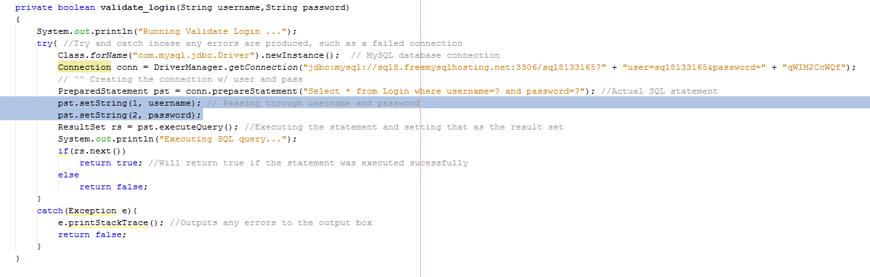

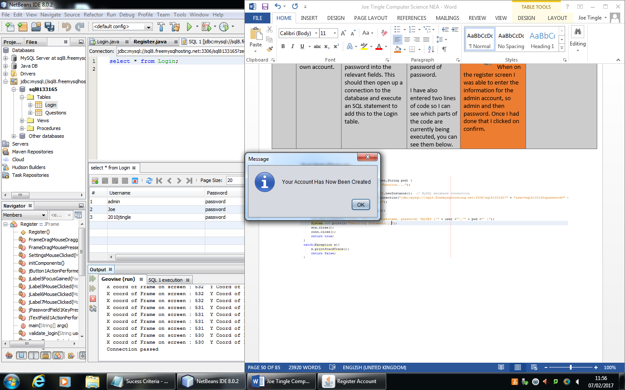

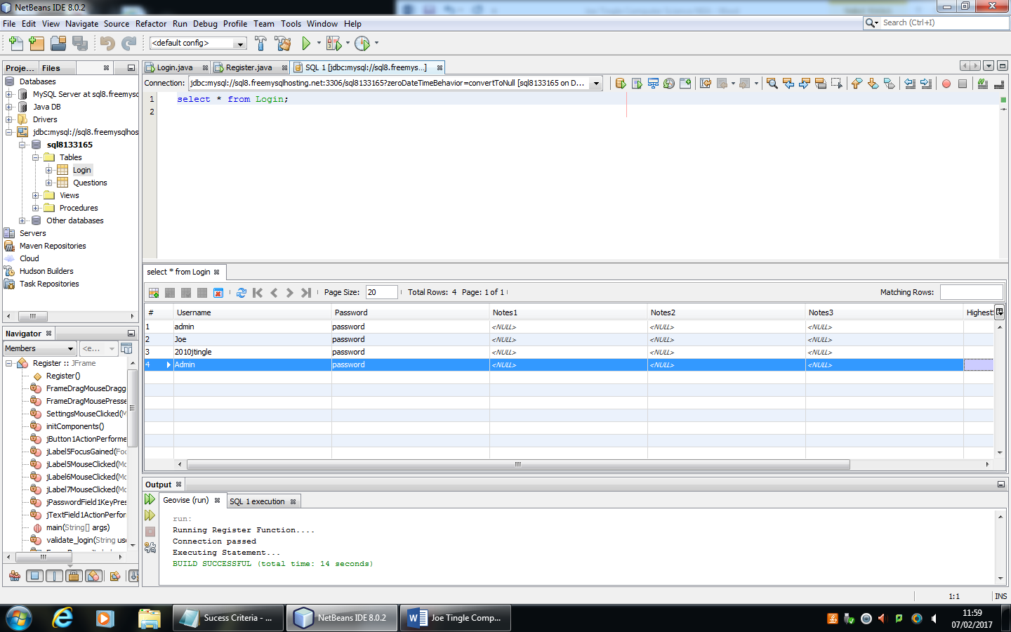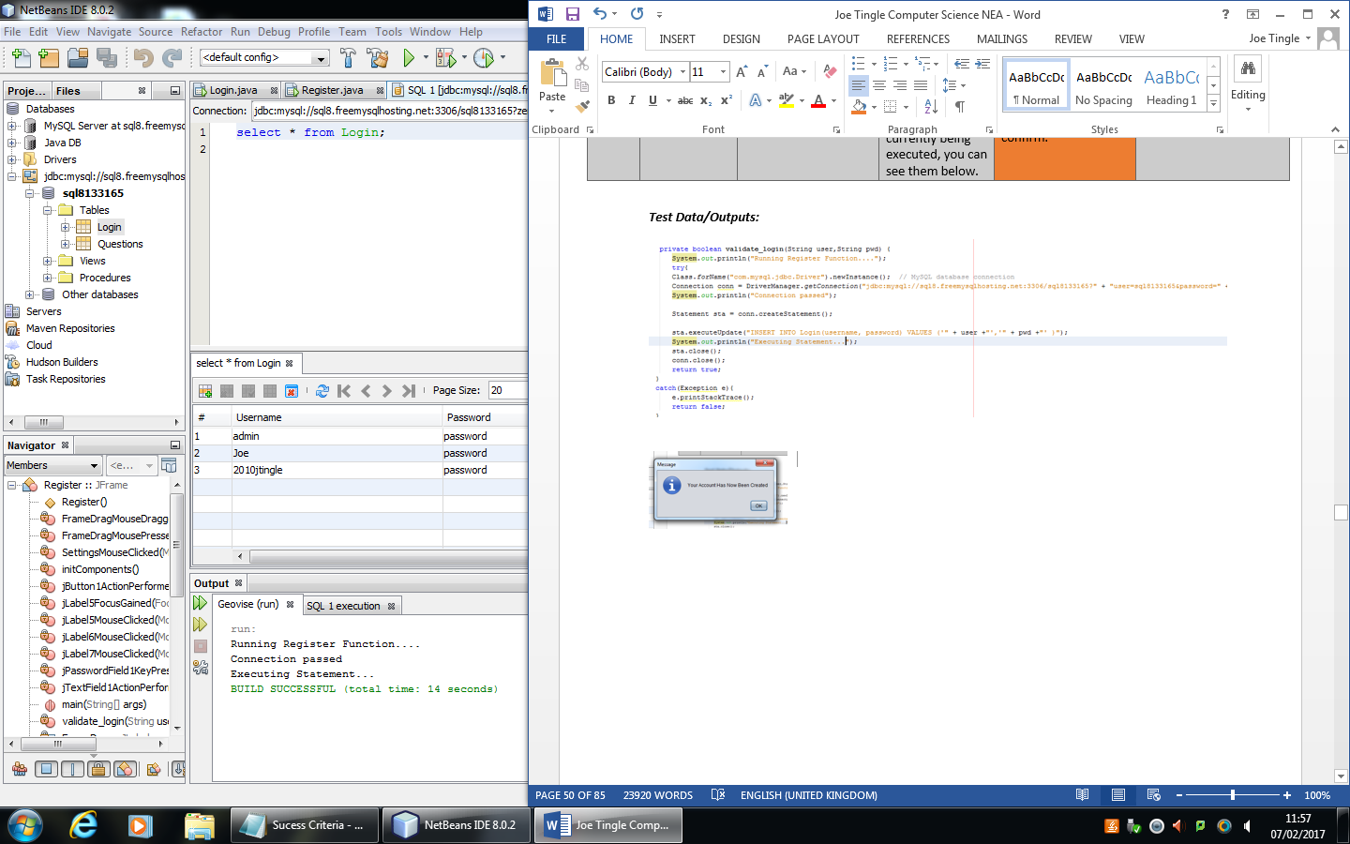

***Test 2:***



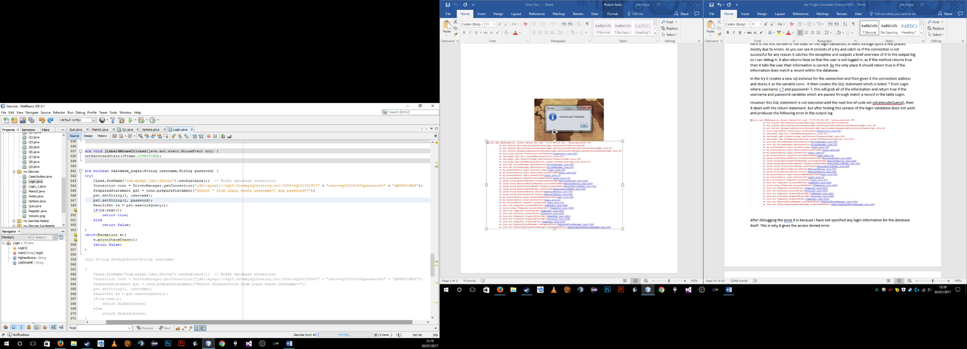



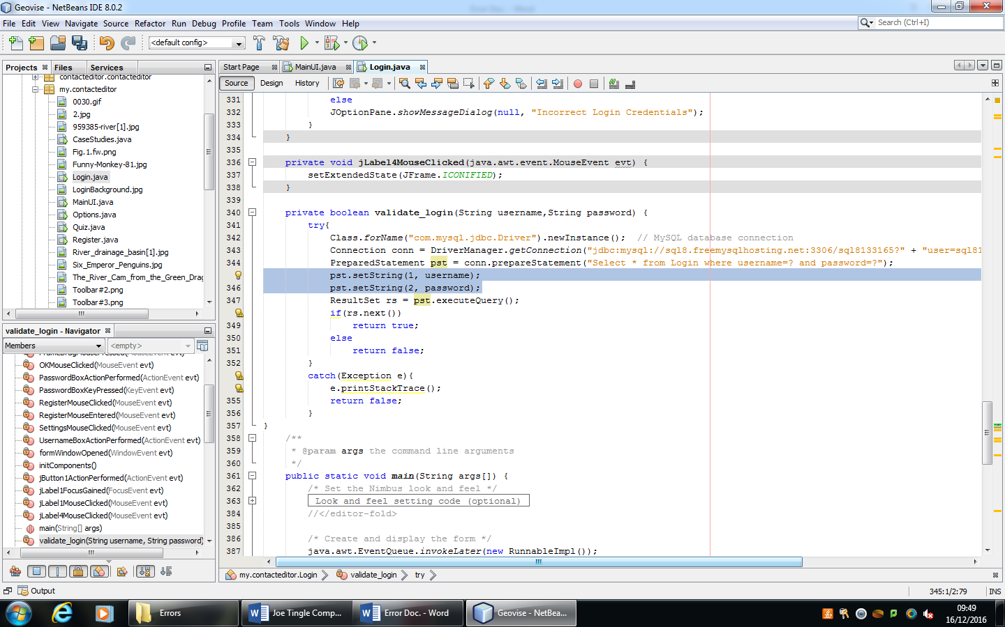

Now I am going to refer back to the success criteria to ensure that the program is progressing and meeting purpose of the program as a whole. For this section there are multiple success criteria which I need to refer back to which are **number 4**, which states the system must display all of the windows correctly, **number 6**, which states he system must censor the user’s password, **number 16**, which states the system must exit fully once the user presses the exit button and **number 8** which states the system must allow the user to log in and out of the program without restarting it.

Firstly, I have met criteria **number 4** as when the user runs the program it will display the login window correctly, in dimensions and where on the screen it generates which is currently the centre of the monitor. All the components are displayed such as the clock and the text fields in which the user can enter their login credentials into. So, this particular criteria has been met, during the development. Next is criteria **number 6** which states that the system must censor the users password, of course this is for security purposes so that anyone watching will not be able to immediately tell what their password is. I have achieved this criteria as during the development I made use of the JPasswordFields which automatically censor the password by default, they change them to circle symbols like so ●●●●. There is also the option to change this in the code so if I needed it uncensored for the user then this could be executed within the code. Another criteria is **number 16** which states that the system must exit fully once the user presses the exit button, this is relevant to the login window as the user should be able to close it fully, exiting the program, when they click on the exit icon/button. This criteria has been met as I have added one simple line of code to the mouse click event on the exit icon which is System.Exit(0) which closes the program. I am not disposing the window here as then it would technically still be open which is why I fully close the program, so this has been met.

Then there is criteria **number 8** which states the system must allow the user to log in and out of the program without restarting it. This includes the main menu as well but this has been partially met, as currently the main menu is just a very early prototype with a JFrame and the logout button. This has been partially achieved as the user can login and once it opens the prototype main menu, and once the user clicks on the logout button it will simply close the main menu and reopen the login screen. This allows the user to essentially log out without having to restart the program.

### **Main Menu**

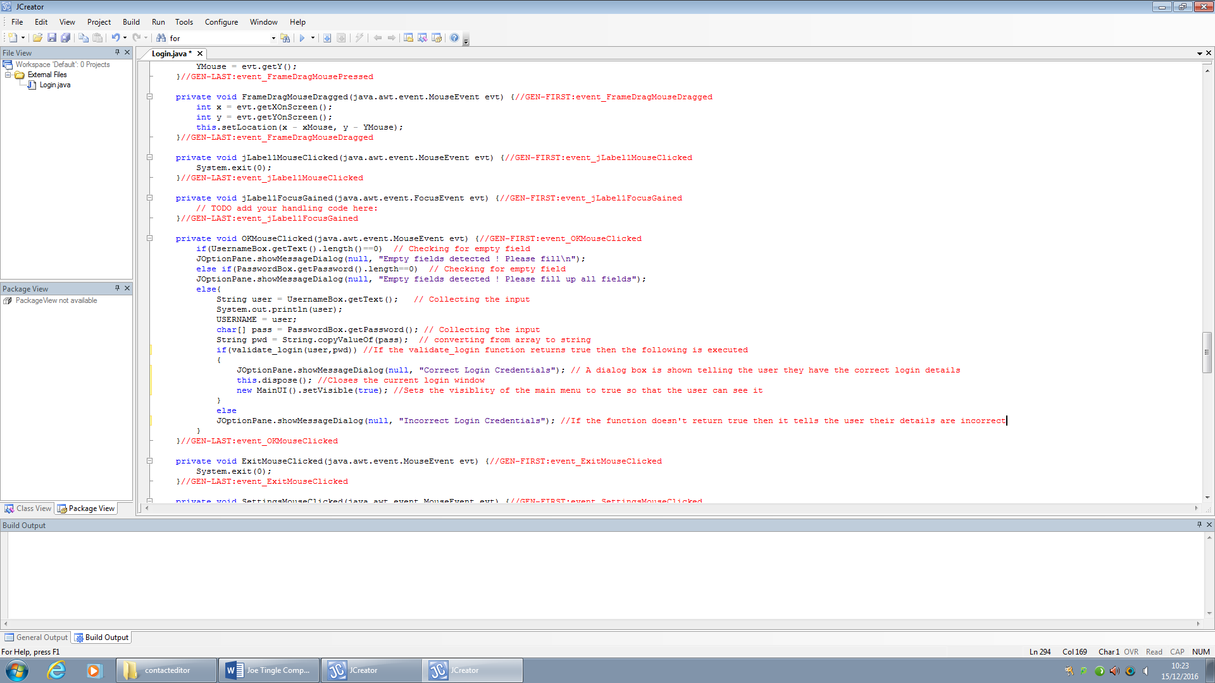The main menu is what will be opened once the user enters the correct credentials into the login screen, once they do that the code within the IF statement executes which sets the visibility of the main menu to true, making it visible, and disposing or closing the login screen.

There will be two parts to the main menu, the left side which will contain all of the navigation buttons for the user to get to the quiz or case studies section in one click. This section will also include icons such as a logout, settings, and exit so that the user has quick access to these features. The other section, the right side, will contain a background image and a title for the main menu, it will also include some features which will be implemented into the quick facts button in the left section.

Essentially when the user clicks on the quick facts button it will change the content of a jLabel in the right section at the bottom to a randomly selected fact picked from a switch case as seen below:

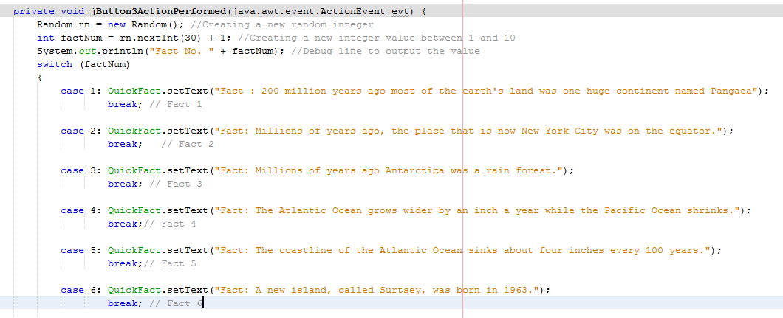

So when the user clicks on the Quick Facts button it changes the contents of the Fact JLabel to a random fact.

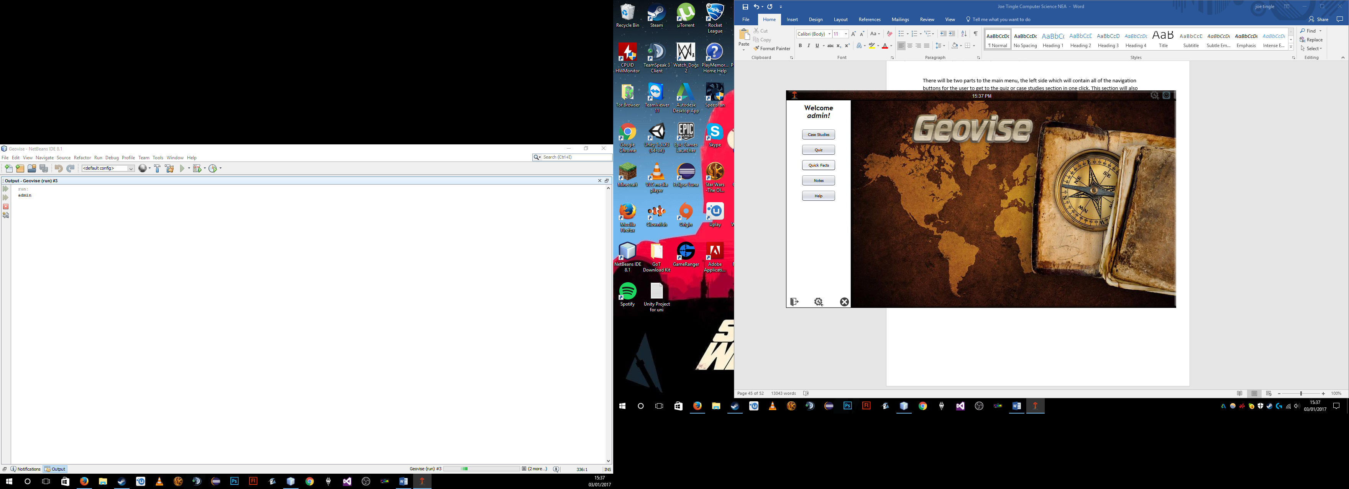

It first generates a random number between 1 and 10 (this is easily changeable as there will be much more than 10 different facts in the final version of the program) and saves that as an integer variable factNum. Then is the switch case which uses the integer variable factNum as the switch and then 10 cases after that that then set the text of the JLabel.

One unique feature of the main menu is the greeting message which appears as soon as the frame is opened, so once the user logs in.

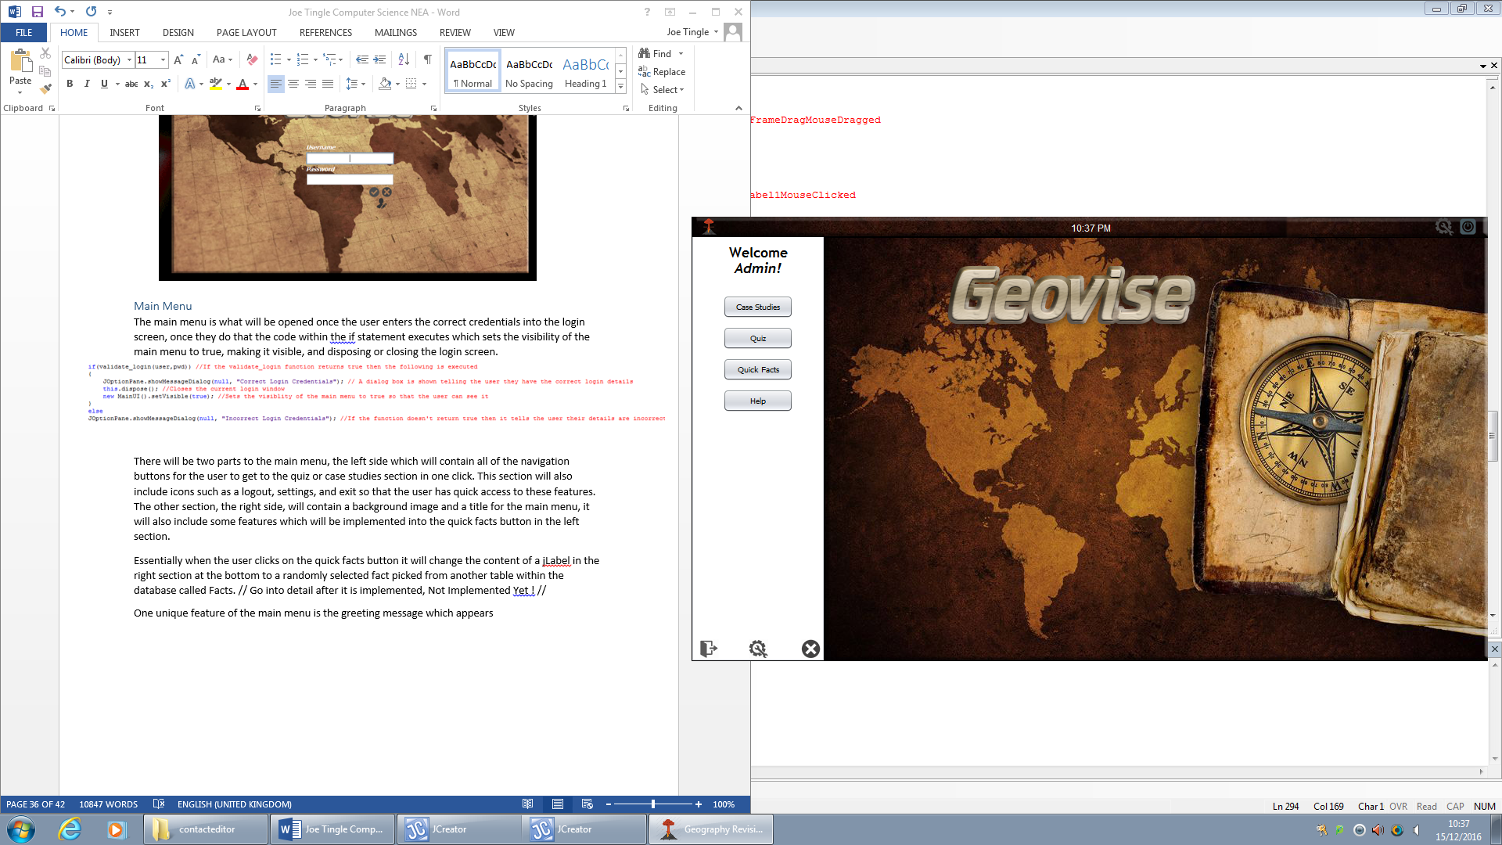

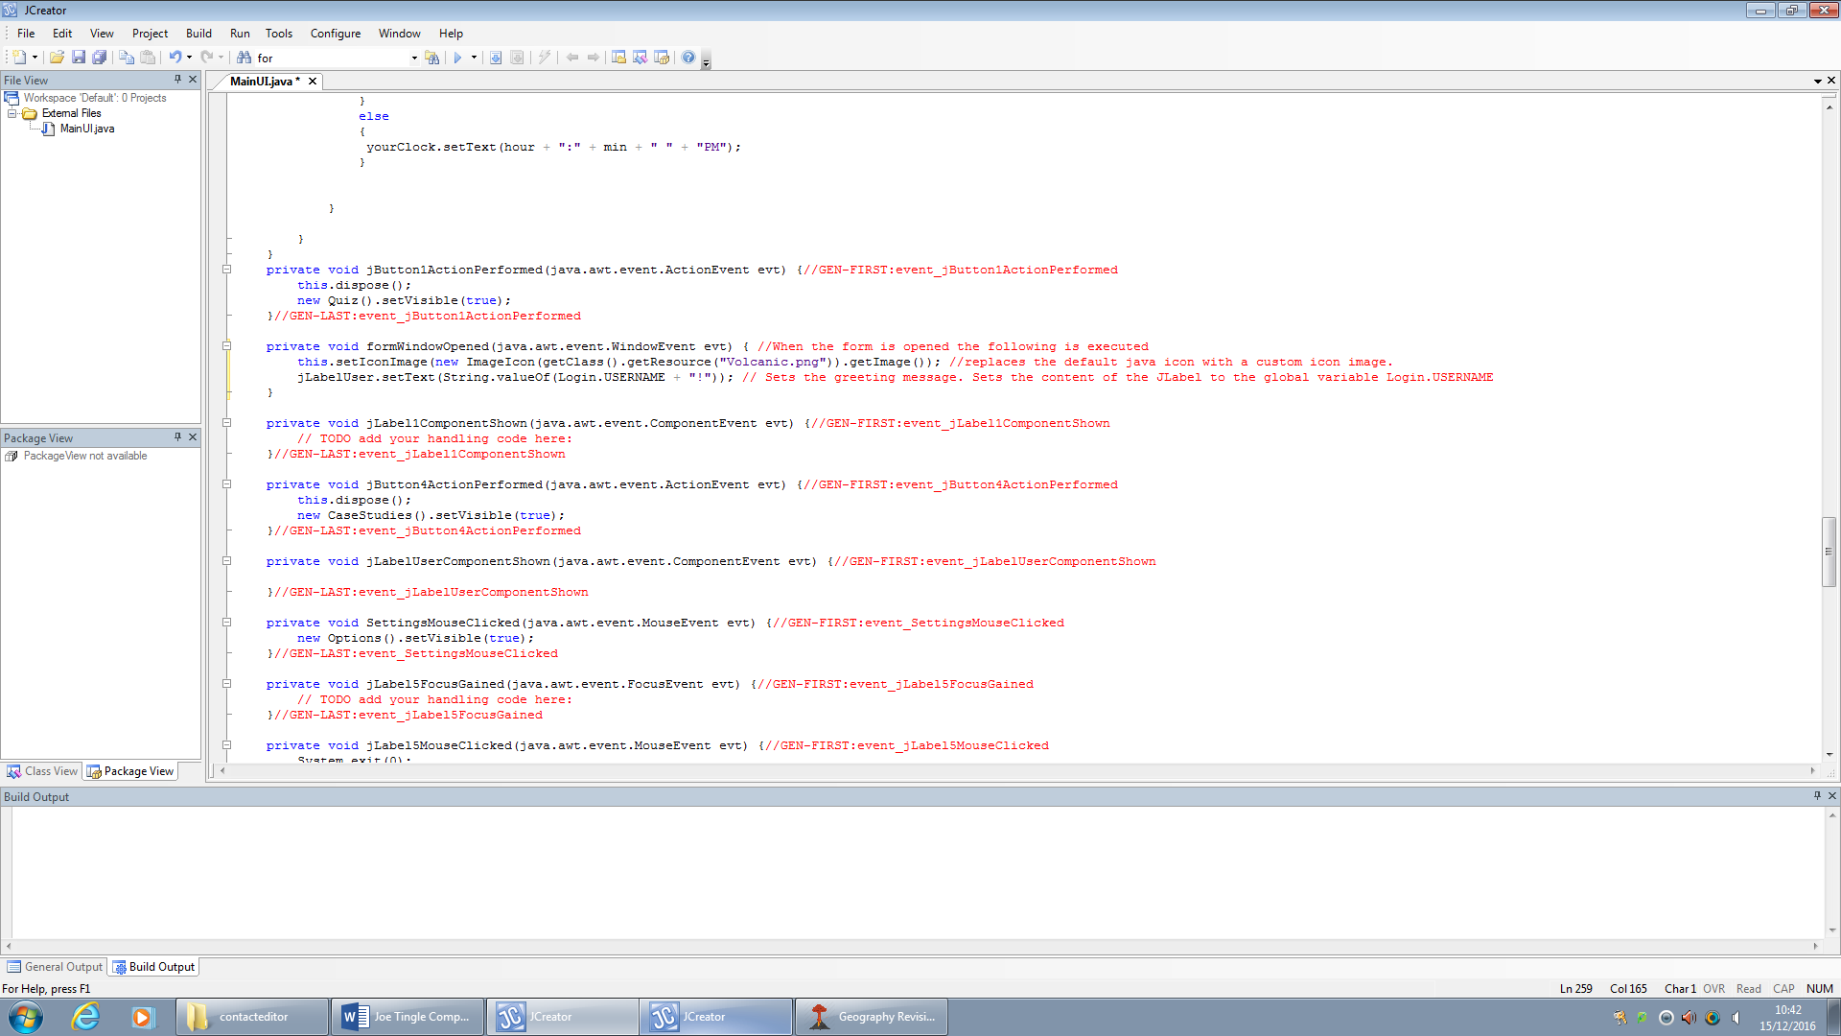The function formWindowOpened asks the question, has the window been opened, so in this case is the main menu open. If it is then it changes the icon from the default java icon to the custom volcano icon. It is essential to make sure this is one of the first lines of code so that there is no delay is setting the new icon. The change should be seamless and the user must not be able to see if, if there is code being executed before the setIcon line then there may be a small delay which could cause the user to see the change.

Realistically because the code is run very quickly the icon should change before the window is fully opened.

After the icon is set it then moves on to set the greeting message for the user. As you can see in the example image above It will displayed the text “Welcome <Username> !” and it will grab the username from another class. jLabelUser is the JLabel or text box that will contain the text and display it for the user to see.

Below you can see the current prototype for the main menu:

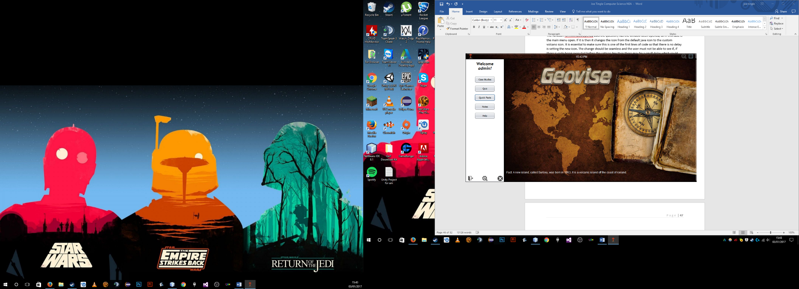

In this current prototype you can see that all of the main components are in place such as the buttons (Case Studies/Quiz/Quick Facts/Notes/Help) and the background with the Geovise logo is there. Each of the buttons will open up the correct files but because they have not been developed yet they are simply just blank JFrames with back buttons. But everything here is functional and working as intended. Now I will get some feedback, in the form of a question I will ask, from the stakeholder about the prototype of the main menu to ensure that the program is developing along the lines of what the stakeholder expects.

**In its current form does the main menu prototype meet your needs as the stakeholder:** “This prototype exceeds my expectations and is exactly what I expected it to be. We can still see all of the master layouts from previous version of developments, and as I hoped the theme has continued and the interface looks easy to use and the colours are great. However I feel as though the quick facts at the bottom of the frame looks slightly out of place with its current font and colour, perhaps that could be changed.”

I have then adjusted the main menu based off of this feedback and the quick facts now is now what you can see in the image below:



As you can see I have changed the font so that it is bold and increased the font size by 8, so that now it is much more readable. I have also changed the colour so that it fits in more with the theme and the interface now all looks good and easy to use for long periods of time.

***Testing Main Menu:***

|  |  |  |  |  |  |
| --- | --- | --- | --- | --- | --- |
| Test No. | What to Test? | Expected Outcome | Test Data/Outputs | Actual Outcome | How to Improve |
| 1 | Is the user presented with a random fact every time they click on the quick facts button? | If the user clicks on the quick facts button then the jLabel at the bottom of the frame should be set to a certain piece of text based on a random number which is then used in a switch case. There should be over 20 + facts. | For this test I have added a simple line of code to output the fact number, which will be generated from the random integer called one line above it, as you can see below. | As I clicked on the quick facts button located on the main menu, it executed the switch case, and as you can see from the output log below I was presented with a variety of different facts, so this feature works as intended. | I think to improve this even more I could implement an array, as to make sure that there are no duplicate facts. So for example as the fact was displayed it would then be added to the array, and each time it would check if the next fact is in the array, if it was then it would generate another number that was not. |
| 2 | According to the success criteria, the program should fully exit whenever the use clicks on the exit button within the displayed window | Once the user clicks on the exit button located in the top right hand corner of the toolbar within the main menu it should execute one simple line of code which exits the program and closes it fully. | As you can see below , the one simple line of code System.exit(0); will fully close the program when executed | As I opened up the main menu and clicked on the exit button at the top right of the frame it executed the one line of code correctly which then closed the program immediately. I then had to open up the program again and log back in. | This works as intended and I don’t feel as though any improvement can be made to this. |
| 3 | Again, according to the success criteria, the program must redirect the user to login screen when they click on the logout button located on the main menu. | Once the user clicks on the logout button is should immediately close the current active window, that being the main menu, and then it should open up the login screen, essentially logging the user out. | For this test, the only output will be a dialog box that should pop up telling the user that their logout has been successful. | Once I had opened up the main menu I clicked on the logout button which is located in the bottom left of the frame, as you can see from below. Once I clicked on the icon it then opened up a dialog box saying the logout had been successful and then opened up the login screen. | This works as intended and I don’t feel as though any improvement can be made to this. |
| 4 | Is a new fact presented to the user every time they click on the quick facts button? | Once the user clicks on the quick facts button it should run through a switch case within the code and generate a random fact from within the pool of them. This should then be outputted to the jLabel within the frame | To test this I will be using the admin account and will be randomly clicking the button, the only outputs for this will be the fact actually being outputted to the jLabel on the window. | When I had logged onto the account and navigated to the main menu, I clicked on the button and it correctly outputted a fact onto the jLabel. I then clicked on it multiple times to test and it still outputted. However I did notice that it would sometimes give duplicate facts which could be an issue. | After testing this I believe that this section could be improved significantly. The main part to be improved would be to move the facts onto the database so that more could then be easily added and would be displayed for the user. |

***Test Data/Outputs:***

***Test 1:***



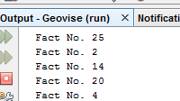



***Test 2:***





***Test 3:***



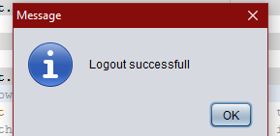

Now after testing this section of the program I will refer to the success criteria to ensure that it is progressing along the lines of what the whole goal of the program is. The criteria that are relevant to the main menu section are criteria **number 4**, which states that the system must display all the windows correctly. Also, criteria **number 10**, which states the system must take the user to the login screen when the logout button is pressed. It must also close all other displayed windows when the process occurs. Criteria **number 15** as well which states the system must allow the user to access help at any point during the program.

Firstly, with success criteria **number 4**, which states that the system must display all the windows correctly. I have achieved this as when the user runs the program and then navigates to the main menu it will display the JFrame to the user alongside all the components such as the buttons and icons. You can see evidence of this in the prototype screenshot above the testing which was taken during the run time of the program, so this criteria has been met. Next is criteria **number 10** which states that the system must take the user to the login screen when the logout button is pressed. This was mentioned in the last section, with the login/register, but has been further developed with the rest of the main menu. Once the user logs into their account and is taken to the main menu there will be an icon along the bottom of the left pane which when clicked on will close the currently active window, so in our case the main menu, and then open up the login screen. Of course, this will then essentially log the user out. Finally, there is success criteria **number 15** which states that the system must allow the user to access help at any point during the program. This has been achieved by adding in another icon to the toolbar at the top of the frame on the program. It has the following icon you can see below:



Once clicked this will then open another JFrame for the help menu and close the currently active one, in our case the main menu. However currently the help menu is not fully developed so is just an empty JFrame.

### **Case Studies**

The case studies section of the program is where the user can pick from a pre-defined list of case studies in both the physical and human section, these are split up into tabbed panels with the physical on one and human on the other. These tabbed sections are good as it is very easy to add in some more case studies into the relevant sections with a new update of the program.

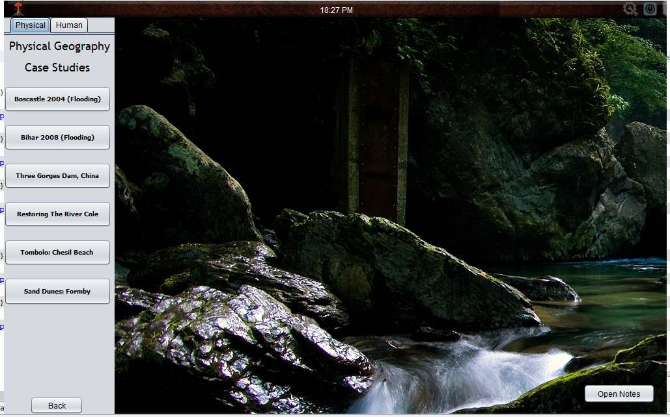

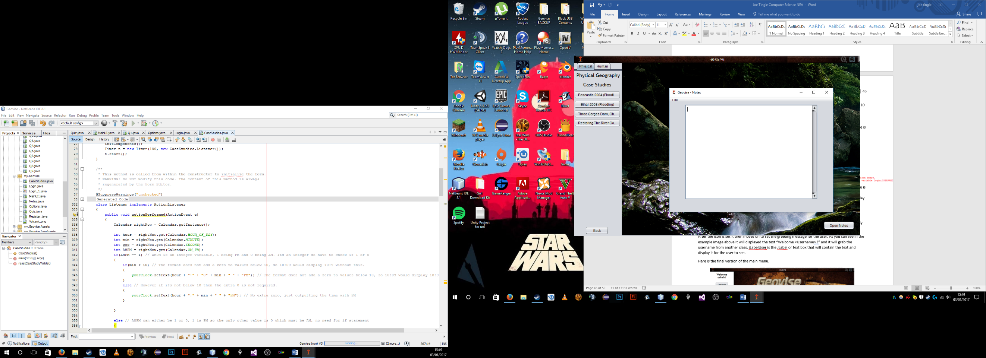The most notable part of the case studies section is the notes which allows the user to type In and format their notes and then in the end save them either to the database (essentially in the cloud) or a local copy as a text file .txt. So this gives the option for the user to save it on the database or as a local file, of course each has their own benefits but it will ultimately depend on the user.

Here you can see the notes section, and it does not have to same theme as the rest of the program this is due to me having to use the existing toolbar to use windows file browser for saving files etc.

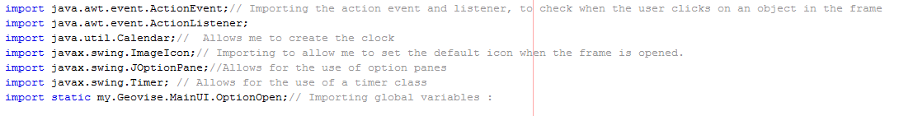

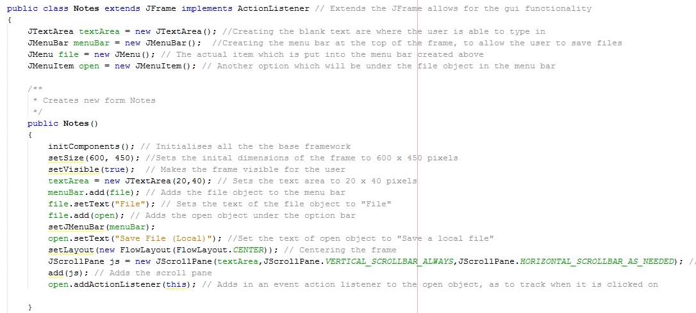Firstly in the code we need four imports, but the main one of the library import for java.io.* which imports all of the relevant libraries for controlling input and outputs so in our case saving and opening files etc.

Because of the way in which it needs to be coded the notes section does not use the gui builder in NetBeans and is manually coded, so for example instead of dragging to resize and element I will have to manually put setSize(600, 400) etc.

So firstly, I had to extend the class to use the ActionListener, and then define and create the TextArea which is where the user will enter all their notes, the JMenuBar which is where the user can click on file/save to save their notes. Also defined is the two menu items file and open.

Most of the code here is creating the base framework for it to display and setting the correct size etc. so after it initialises it then sets the size of the frame to 600 x 450 pixels and then sets the Boolean variable of setVisible to true so that it is visible to the user.

After that I then creates a new JTextArea of size 20 x 40 pixels and calls it textArea, this is where the user will be able to enter their own notes and then save them. Then it creates the menu bar and adds the drop down selection called file. Much like in word the user should be able to click on file and then save which will then prompt them with a dialog to choose where the save the file.

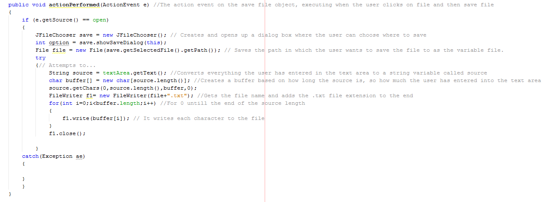

Here is the actual saving of the notes as you can see it is within an event called action performed. Firstly it checks to see if the notes are actually open and if there are any errors there is a catch statement which will subsequently output the error to the output log.

Within the IF statement it creates a new JFilechooser, which is where the user is able to navigate to a section on their primary storage device and choose a location to save to. It calls this File Chooser save and then creates an integer variable called option which simply displays the save dialog.

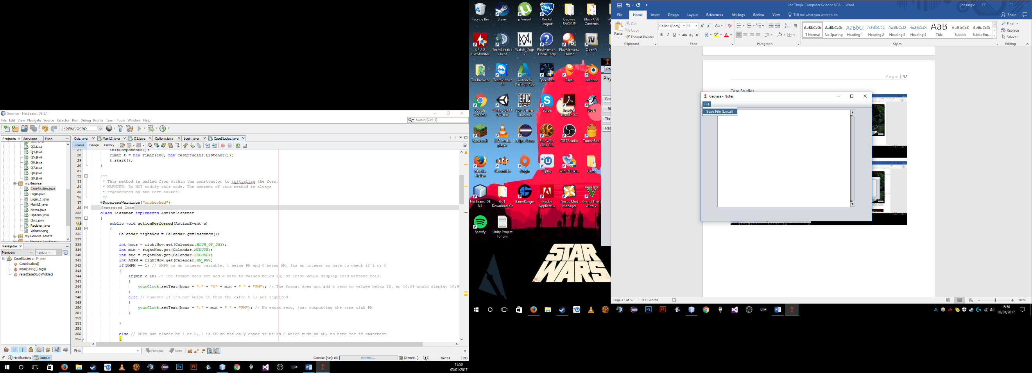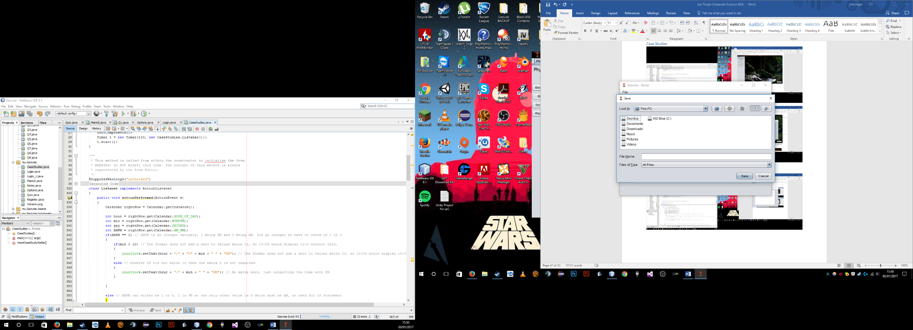

After that it creates a variable called file which is of the File data type which will store the location of where on the primary storage device the user wants to save their notes as well as the actual name of the file in which the user will enter into the box as seen above. You can tell this by the line of code .getSelectedFile().getPath, mainly the getPath part.

After that, the rest of the code is contained within a try statement, so it firstly creates and declares the variable source which is a String data type and assigns it the contents of the textArea. So whatever the user types in for their notes whether it will be 1 line or paragraphs worth of content, it will be stored within the source data type. textArea.getText() simply converts the contents of the text box to a String data type as we cannot assign any other data type to the variable. Next it creates a buffer used to add each character to the new , locally saved, file by the order that the user typed it in.

After it has completed the declarations of all the variables it then creates a new FileWriter called f1 which is where it gives it the actual file type of .txt. We are saving it as a .txt as it is the most widely available text format which can be edited with notepad, included within all windows operating systems. Using .txt means that it will be available to a much wider target audience as the majority of pc users have a windows operating system

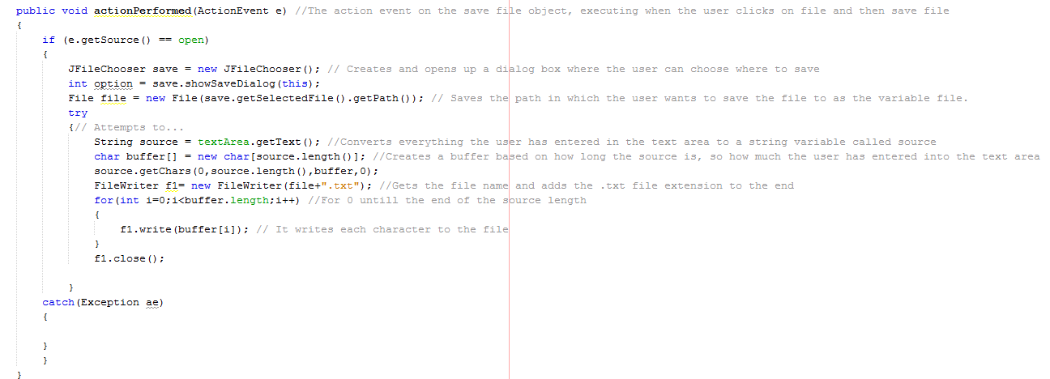

Then a for loop is executed starting from the initial value of the integer variable I which is 0 to the length of the buffer. So essentially this loop will run for as many characters there are in the users’ notes.

This for loop will write each character to the new file until it has reached the end of the length of the file.

Now below you can see an image of the prototype for the case studies and notes section:

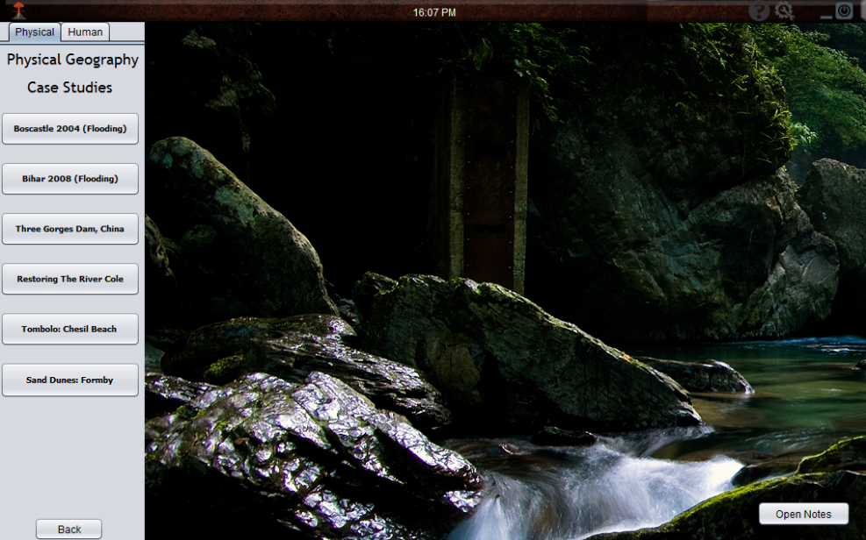

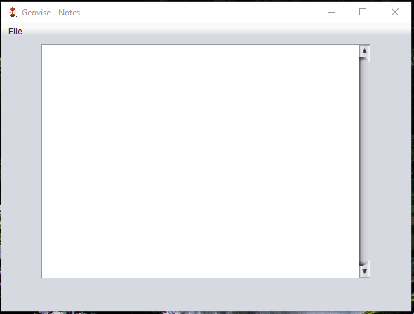

Currently with this prototype of the case studies section, all the components are functional such as the buttons on each section for human and physical. Each case studies section contains 6 individual case studies leading to a total of 12. Each of the buttons will run a couple lines of code which will hide the current default image you can see in the centre of the frame and replace it will the assets for that particular case study. There is also a function called resetCaseStudies() which is run to make all of the assets not visible to the user when necessary.

Also you can see that there is a button in the bottom right of the frame called open notes, which is fully functional and does exactly what you expect it to do. Once the user clicks on this button it will open up the notes JFrame and will not close the current JFrame, this is because the notes are designed to be run alongside all of the other windows in case the user needs to note anything down.

Now I am going to be getting some feedback from the stakeholder to ensure that it is progressing and meeting their expectations of the program. So I have asked the stakeholder the following question:

**In its current form does the prototype of the case studies section meet your expectations and needs :** “Yes it does meet my expectations as it follows the same basic layout of the main menu with the intractable components in a pane on the left-hand side of the frame, which makes it easy for the user to follow and use etc. Currently all of the buttons work as intended and when clicked on they display the relevant information which is good.”

**In its current form does the prototype of the notes section meet your expectations and needs :** “ Yes the notes section does meet my expectations, I understand why it does not use the custom toolbar and agree with it. I was worried that it would stand out and look bad compared to the other sections but after seeing it I believe it was the best decision. It is simplistic and looks very easy for the user to use.”

***Testing Case Studies/Notes:***

|  |  |  |  |  |  |
| --- | --- | --- | --- | --- | --- |
| Test No. | What to Test? | Expected Outcome | Test Data/Outputs | Actual Outcome | How to Improve |
| 1 | According to the success criteria there should be an image and a map for each case study within the case studies page, and that they should be separated into two sections ; Physical and Human | Every single case study should have its own image asset, created in photoshop, which would have all the information on it. Also, each case study should be categorised into its own section, either Human or physical. | N/A | As you can see below there is a tabbed pane with two tabs called Physical and human, this is where all the case studies are stored. On each tab, there are currently 6 case studies, making for 12 overall.  Once you click on one of the case studies buttons, so in this example Three Gorges Dam, it displays the image by setting the jLabel to visible.  You can also see below that it contains a map as well as an image alongside the information. | This feature works as intended and I cannot see any way in which this can be further improved. |
| 2 | Does the notes allow the user to save their own information to a local file? | The user should be able to open the notes page by simply clicking on the notes button located on the bottom corner of the case studies page. Once they click on this they will open the notes page as seen below. From here they should be able to enter whatever they like into the text area, and once they are finished they should be able to click on file and then save. This will then prompt another dialog box where they are able to choose a location to save the file to. It should automatically save the file to a .txt format. | N/A | Once I had opened up the notes window I type in the following “This is the notes section” and then I was able to click on File, located on the menu bar, and then save local file. This then brings up the following dialog box as seen below, I was then able to choose a path on the storage device on where to save the file. Once I clicked save I navigated to the documents where I could see it had saved properly. | The only issue with this feature is that if you put in over a couple page worth of text it will take a very long time to save, and the file size was fairly big, upwards of 10MB. |

***Test Data/Outputs:***

***Test 1:***

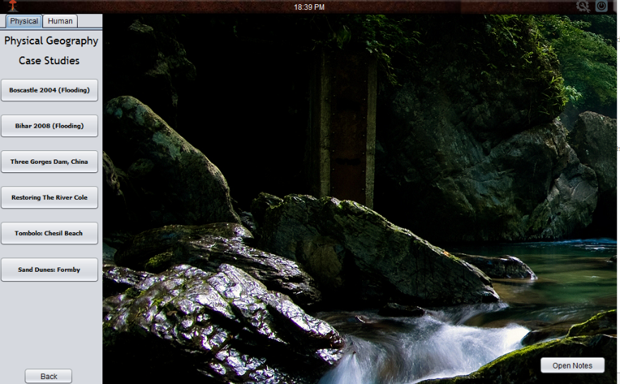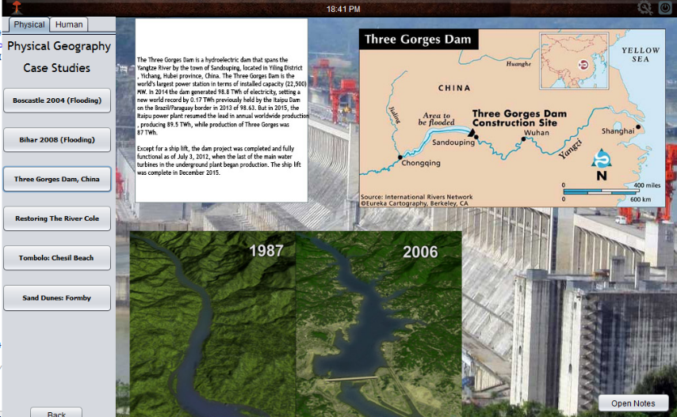

***Test 2:***

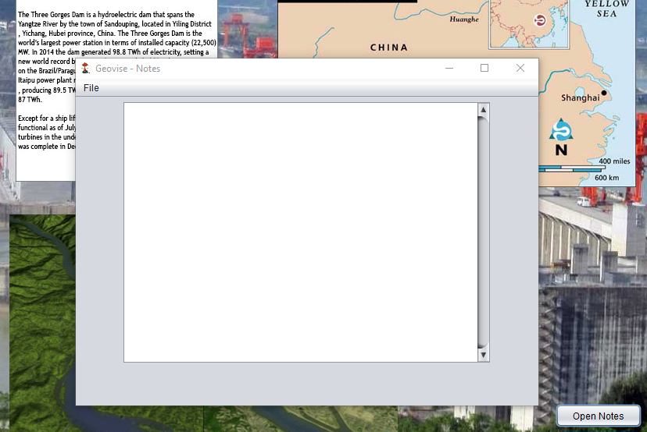-

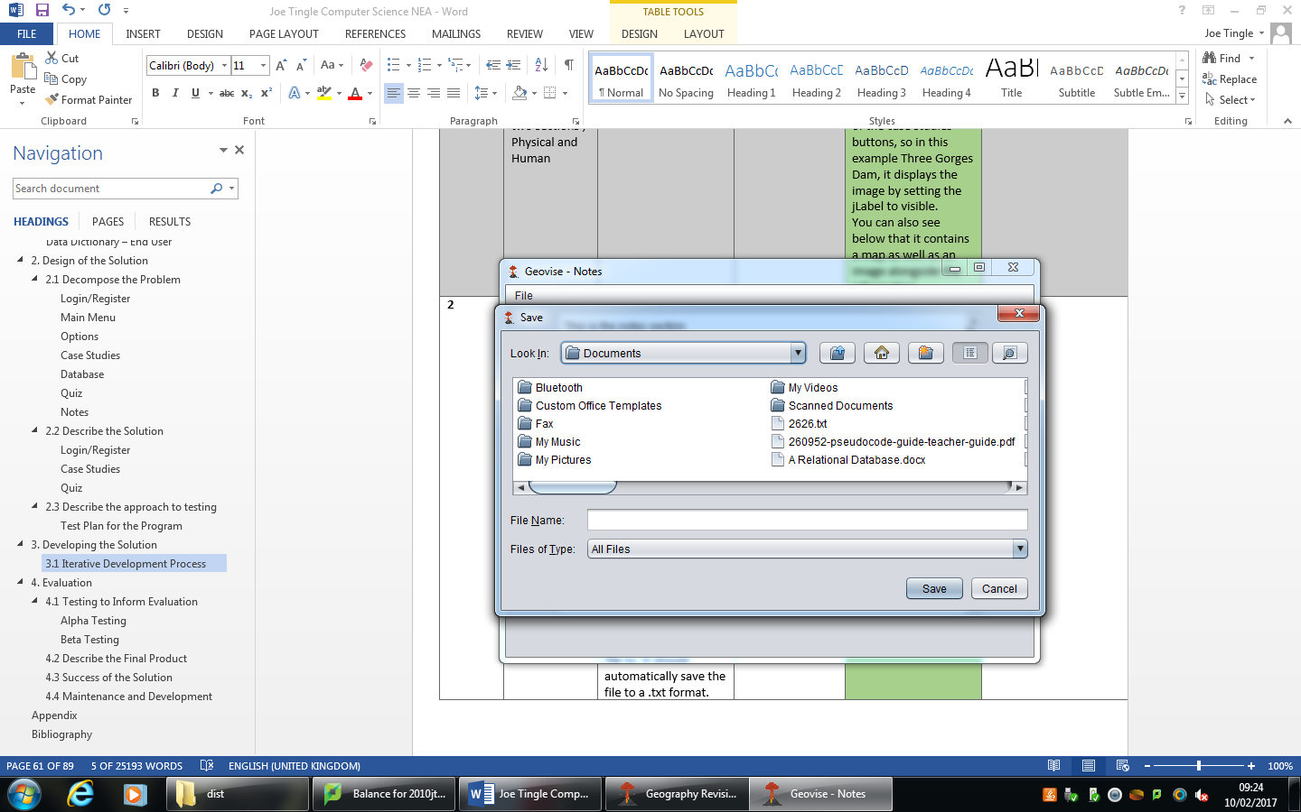

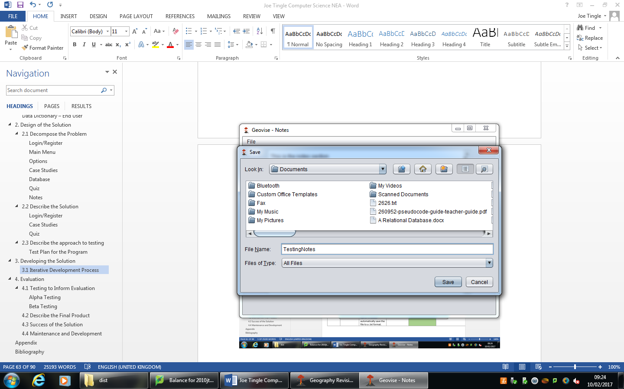

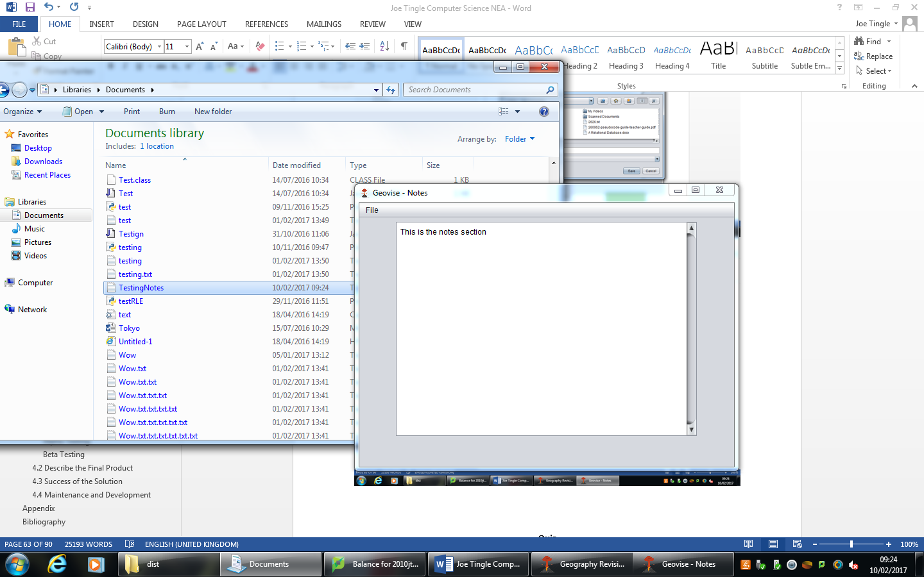

Now I am going to be referring back to the success criteria to ensure that the program is progressing along the lines of what the ned programs purpose is. The case studies and notes section will refer back to the following relevant criteria, firstly **number 7**, which states the system must display both an image and a map for each case study on the case studies page. Then is criteria **number 11** which states, the system must display the correct information for each case study on the case studies window. **Number 12** is also relevant here which states that the system must allow the user to open a blank notes page and save them for use at a later time. Also, **number 17** which says that the system must only allow the quiz window to be maximised. Finally **number 19**, which is that the system must display two tabs on the case studies page, human and physical, and **number 24**, there must be at least (minimum) 4 case studies for each section.

Firstly is criteria **number 7**, which I have achieved as when the user clicks on any case study button it will make the image asset visible to the user replacing the default image, this image asset is one which I have made in Adobe Photoshop and contains an image/map and information for the user to view. So this criteria has been achieved during the development of the prototype. Next is criteria **number 11**, and I have achieved this as all of the information has been acquired from multiple reliable sources and then thoroughly checked against the official exam specification to ensure that it meets the users needs. So the information is very useful for the user. **Number 12** has also been achieved as there is a button on the bottom right of the case studies frame which is called open notes, when clicked this will open up the notes JFrame which the user can then enter any information they want into. Then once they are done they can save it either locally or onto the database. Next up is **number 17**  which has not been met, as during the development of the prototype I realised that it was not possible to let the user maximise the frame with the assets that I am currently using, this is because it would leave big gaps and would ruin the whole interface. So, I made the decision not to follow this success criteria as it simply wasn’t possible without redesigning the whole interface. Then **number 19**, which I have achieved which you can see in the prototype image, there is two tabs, as I have used a JTabbedPane for this which allows me to add as many tabs to it as I like. Each tab has its own separate pane which allows me to change the buttons on each, so this criteria has been met and achieved during the development. Finally **number 24**, which I have also met as there are currently 6 individual case studies on each tab leading to an overall total of 12 exceeding the minimum requirement set out in the criteria.

### **Quiz**

The quiz section is where the user can test their knowledge by choosing between two different modes in which they will be presented randomised question based off their previous score, a difficulty scaler. So, the higher their previous high score the more difficult the question will be and vice versa the lower their previous high score the easier the question will be.

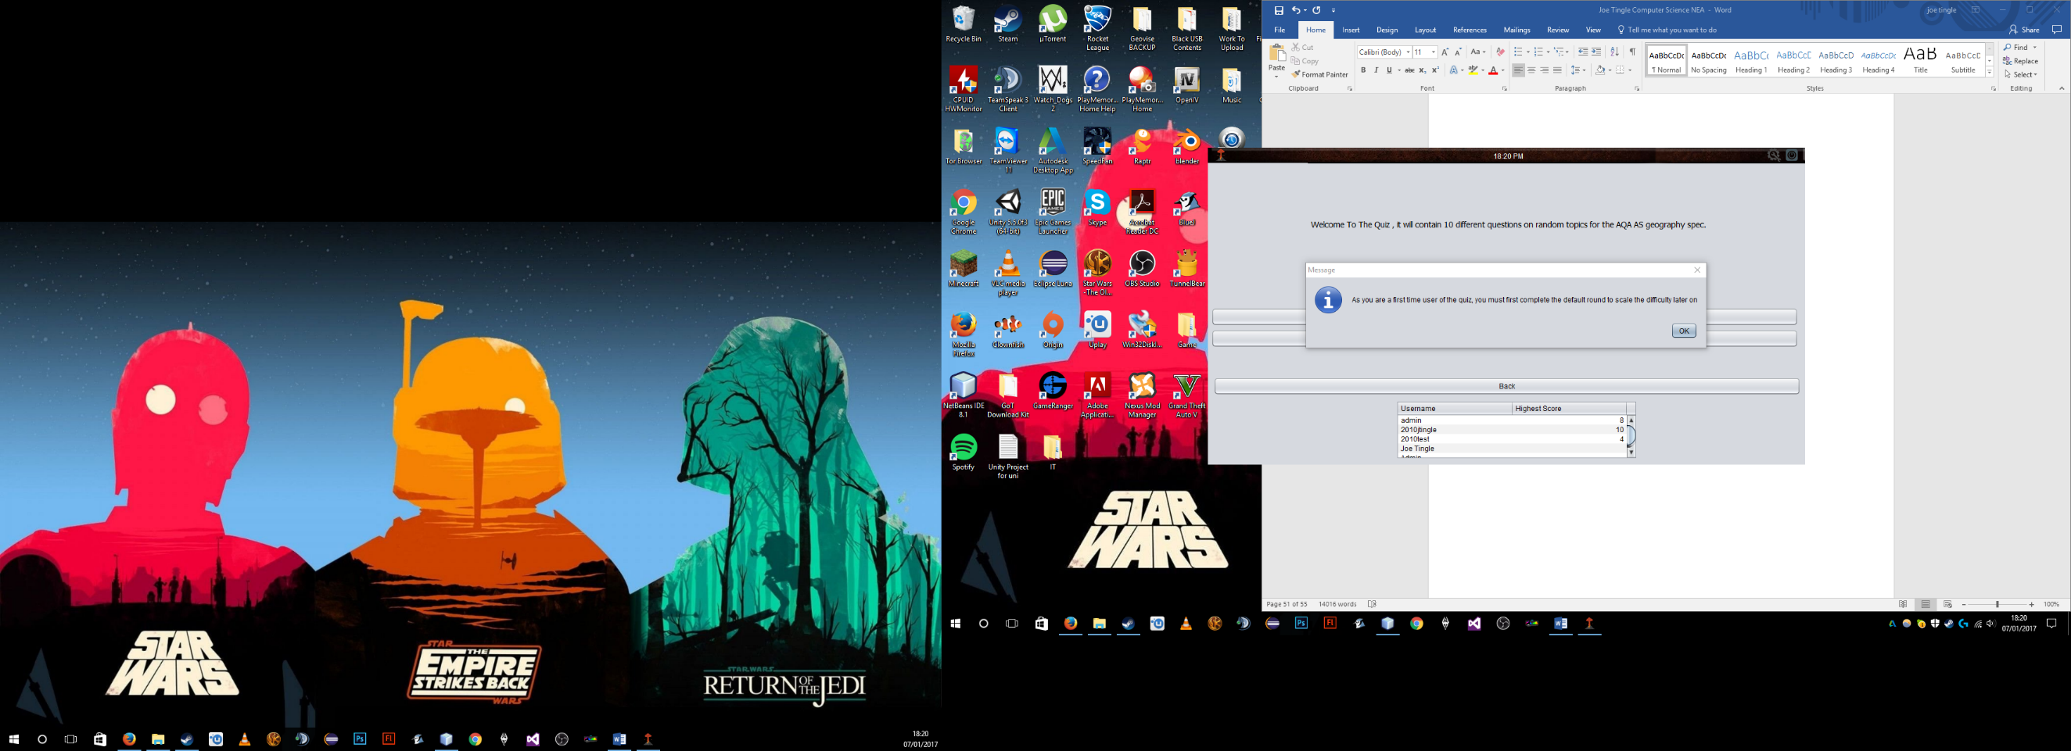As you can see in the first image here the first thing that the user will be greeted with once they click on the quiz button on the main menu is a dialog box stating that they are a first-time user. The first-time user is there because if the user has not previously done the quiz on their account then they will not have a previous high score at all. Therefore, their high score will be null as seen on the image below. You can see that admin has a high score of 8 but the account Joe Tingle has a null value which is why it is blank.

There is also an option to turn off this function completely for the account, which is currently logged in, within the options menu. The Boolean variable, global, named quizFirstTime is created within the options class and is then called upon within the quiz class when the window is opened as seen below. Because it is a global variable we can call it from a different class

The dialog box that tells the user they need to complete a ‘tutorial’ round is within an if statement stating if the Boolean variable quizFirstTime, the variable created within the options menu and set by true as default. If it is true, then it displays the dialog box.

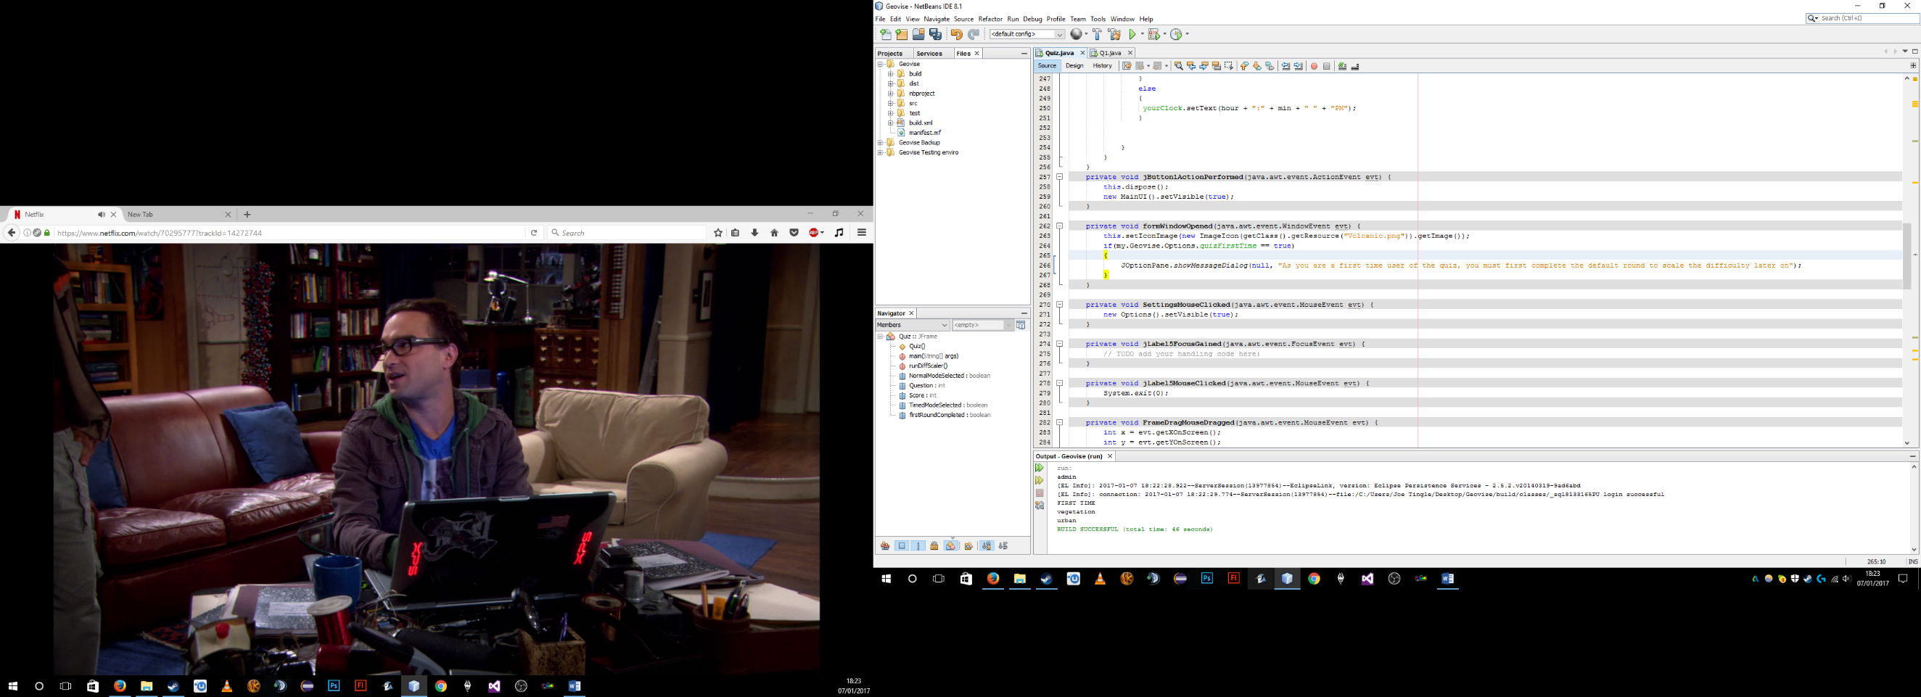

However, this if statement does not reset or change the variable to false, as this is done on the last question of the first round, Question 10. Within question 10 there is the following code:

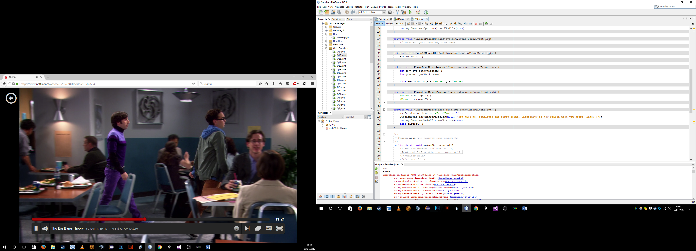

As you can see once the user has answered question 10 and completed the first round it will set the global variable quizFirstTime to false so the dialog will not be displayed anymore for the user. The user will now be able to complete the quiz and the difficulty will be correctly scaled.

Also to note, once the user completes the 10th question it will re direct them to the main menu.

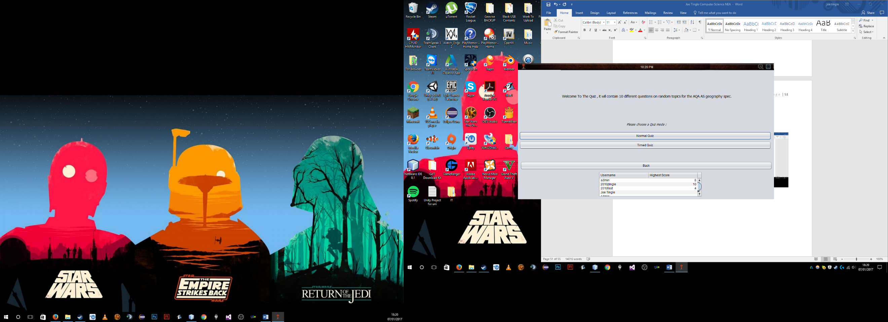

The quiz will have two different modes, normal and timed. The normal mode will simply display the user with 10 randomly chosen question based off their previously high scores. There are three different difficulty bands that I have created, lower, mid and upper band. Each are based off percentages so the upper band is the top 85%, mid is from 50% to 85% and then the lower band is from 0% to 50%. The high score is calculated from an integer into the percentage to work out the difficultly which is run in its own method called runDiffScaler(). So, if the user has a previous high score of 8 out of 10 then they have 80% which would put them in the mid band. Each band will have around 30 questions so that the user will get a varied set of questions each time, meaning 100 questions overall including the ‘tutorial’ round. Below you can see the code for the difficulty scaler:

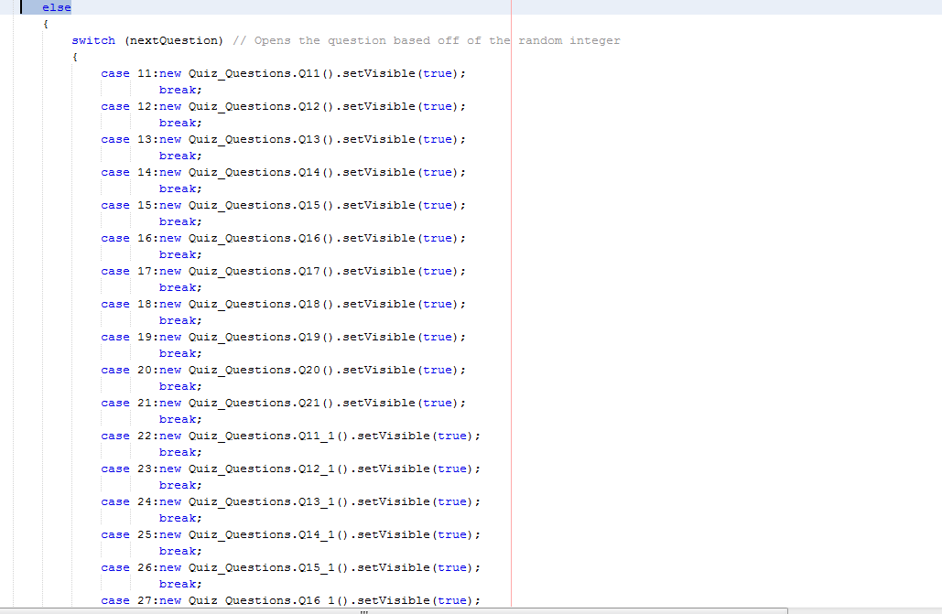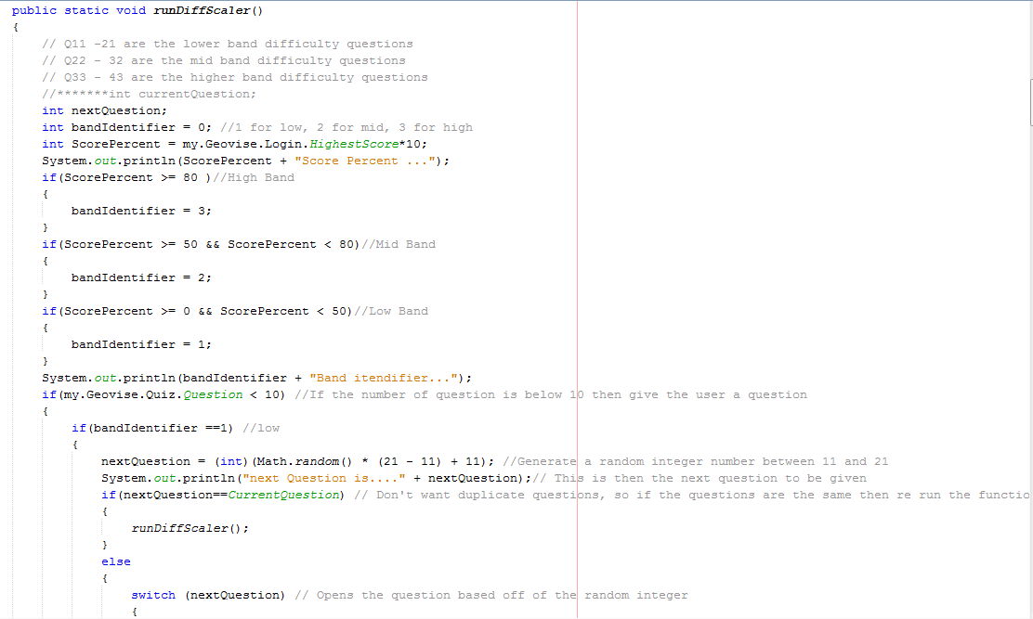

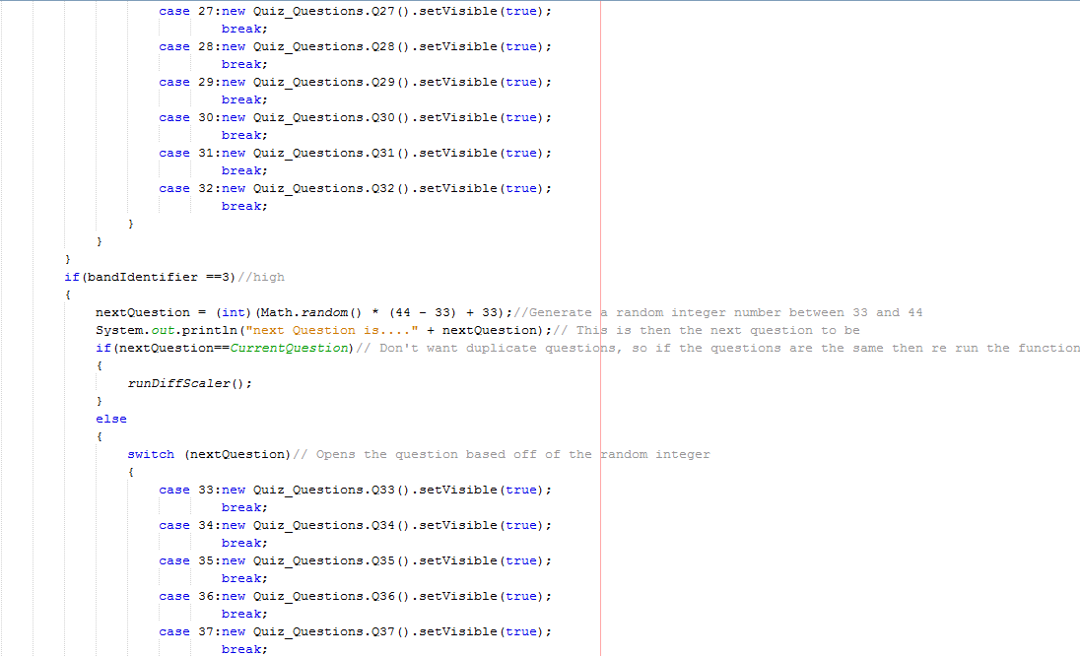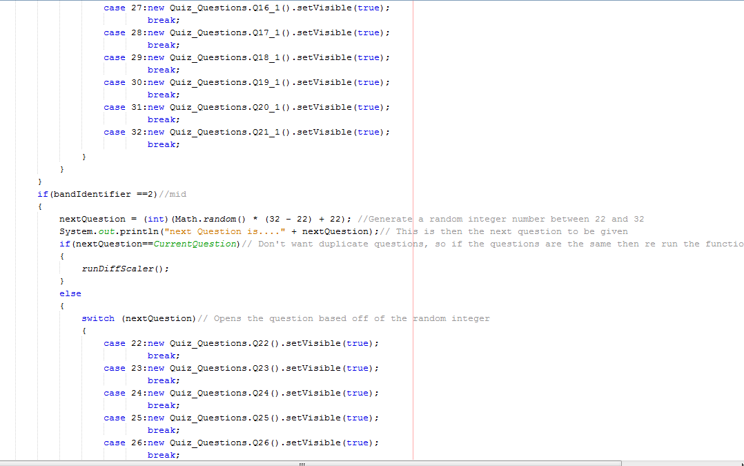

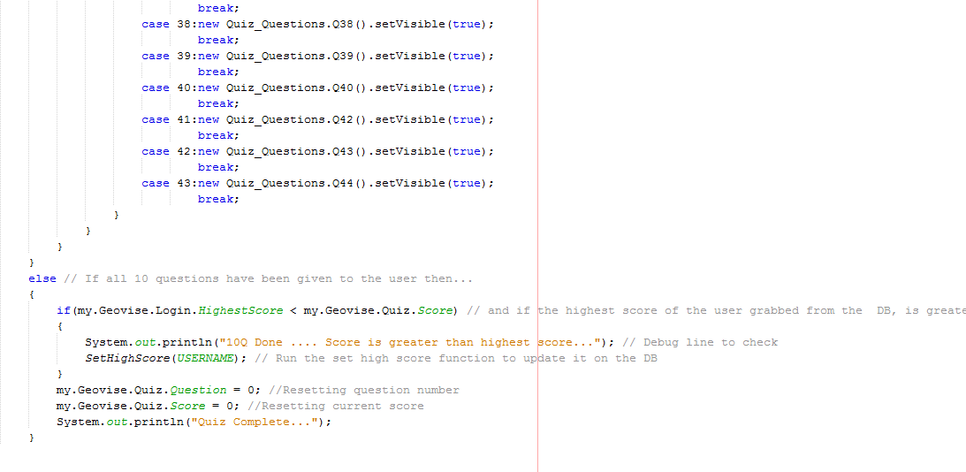

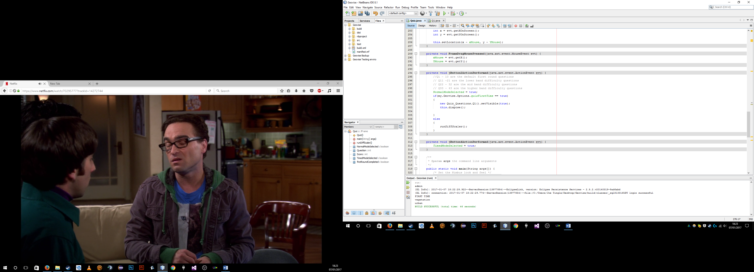Firstly, the normal quiz mode, as you can see in the code comments there is a reminder of all the different bands of lower, mid and high difficulty. This code is within the action event for the user clicking on the normal quiz mode button. Firstly, it will set the Boolean variable normalmodeselected to true which is useful to use and it will change the visibility of some of the functions within the quiz questions. One of the main examples of this is if the NormalModeSelected variable is true then the timer is disabled and hidden on the question, where as if the TimeModeSelected Boolean variable is true then the timer is enabled and is set to visible.

Then a simple if statement is running stating if the Boolean variable quizFirstTime is set to true then it runs the tutorial round however if not and the variable is false then it runs the custom difficulty scaler method called runDiffScaler().

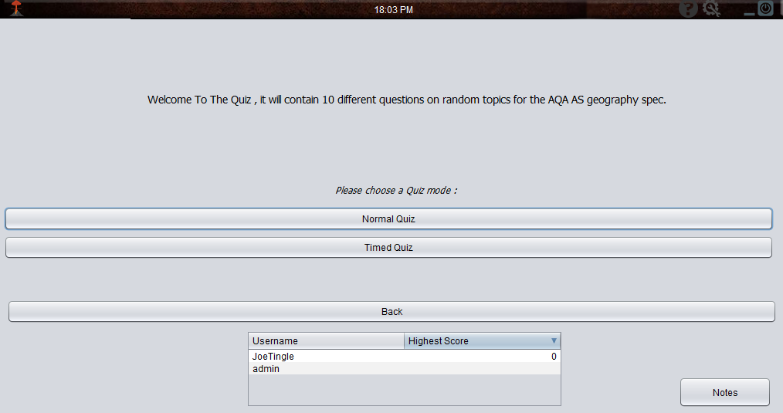Here is the prototype version of the quiz section:

As you can see in the current prototype version of the quiz, it has all of the vital components visible and fully functioning. For example, you can see that there is a JTable at the bottom of the frame which displays all of the user accounts and their highest score, already sorted from highest to lowest. This table will then update every time the user goes onto this window. You can also see that there are 3 main buttons above the table which are the mode selection, with normal and timed buttons alongside the back button. The normal quiz button will select normal and then give the normal set of questions, whereas the timed quiz button will add a ten second timer to the question adding a time limit and extra challenge.

Now I am going to get some feedback from the stakeholder to ensure that the prototype is meeting their expectations and progressing along the lines of it. So I have asked the following question:

**Does the current prototype of the quiz section meet your expectations :** “It does mostly meet my expectations, as the table at the bottom is a very nice addition to keep track of all of the users scores. But I don’t like that this window has a dull grey background, it doesn’t fit in with the rest of the interface or the overall theme. I hope in a future prototype version this can be addressed.”

After reviewing the feedback I have received from the stakeholder I decided to go back and add in an image as the background, instead of the dull grey background which the stakeholder did not like. Also I agree that it did look dull and detracted from the rest of the interface. Below you can see an updated version of the prototype after feedback:

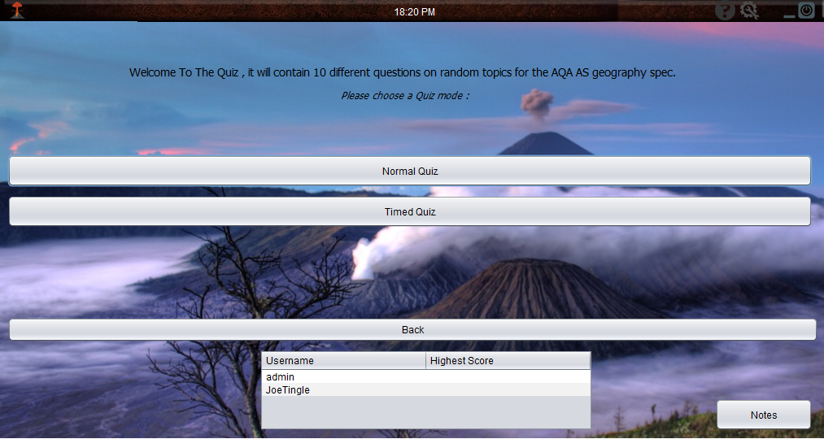

**Quiz Testing**

|  |  |  |  |  |  |
| --- | --- | --- | --- | --- | --- |
| Test No. | What to Test? | Expected Outcome | Test Data/Outputs | Actual Outcome | How to Improve |
| 1 | Does the quiz detect that the user has not completed the quiz yet and presents them with the tutorial round? | When the user logs into their account there should be a value attached to it called firstRoundComplete and the default value should be zero. When the user then opens up the quiz it will check to see if this value is equal to zero, indicating that they have not completed the tutorial round. It should then present them with the tutorial round instead of the randomised questions. | It should output a dialog box to the user telling them that this is their first time using the quiz and then need to complete the tutorial round, as seen below.  To test this I created another account to ensure that the firstRoundComplete was 0, which it is by default on all new entries to the database | Once I created the new admin account I then navigated to the quiz section and the dialog box was correctly outputted to the screen. Once I clicked on ok to confirm the dialog box it then allowed me to choose either a normal or timed quiz, I chose normal and it opened up the first question in the tutorial round as seen below. | I do not believe any improvements can be made to this section as it works as intended. |
| 2 | When the user has completed the tutorial round does it then change the value in the database and enable to difficulty scaler? | Once the user has completed the 10th question in the tutorial round it should take them back to the main menu and then run a function to update the high score and then to set the firstRoundComplete on the database. | At the end of the tutorial round a dialog box should be outputted to inform the user that they have completed the tutorial and difficulty is now scaled based on their score. | Once I had logged into the new admin account, I ran through the normal tutorial questions and as I clicked the next button on question 10 it outputted the following dialog box, as seen below. Now when I ran the quiz again it would give me the random questions based off of the high score stored on the database. | In this section I don’t think any further improvements can be made. |

***Test Data/Outputs:***

Test 1:

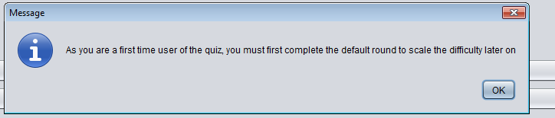

Test 2:

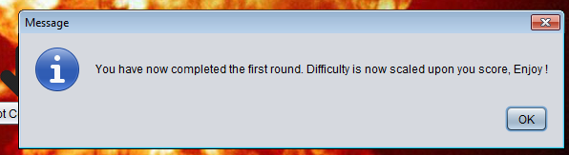

Now I am going to refer back to the success criteria as to ensure that it is progressing well and towards the overall purpose of the program. The relevant criteria for the quiz section are as follows, firstly **number 13**, which states that the system must alter the difficulty of the question on the quiz based on the users previous score. Then **number 14**, which says the system must display the answers to the quiz at the end, and **number 17**, which says the system must only allow the quiz window to be maximised. Also, **number 20** which is that the system must display randomised question from a pool of them stored and **number 23** which states that the system must ask the user 10 questions each time.

Firstly **number 13** which has been achieved as I have made the runDiffScaler() function which gets the highest score of the user by executing an SQL statement and puts the user into a tier based off of this. Then depending on the tier that the user is put it will present the user will randomised questions taken from this tier, and of course the tier can change depending on what score the user gets. So this criteria has been achieved and works dynamically. Next is criteria **number 14**, which has also been achieved as within the difficulty scaler function there is a line of code which will run once the user has answered all 10 questions, it will open up another JFrame with the final score and which answers were correct or not. So this criteria has also been achieved. Criteria **number 17**, has not been met due to the reasons I have explained previously, as the assets do not fit and when the user maximises the frame it will leave a huge gap and ruin the overall look of the interface, so I decided to not meet this criteria. **Number 20** success criteria has been achieved within the difficulty scaler as well where the user is put into a difficulty band based off of their previous score and then it grabs the questions from a set of them within that difficulty band, so this criteria has indeed been met. Finally, is criteria **number 23**, which has also been achieved within the difficulty scaler where all of the code is contained within an if statement asking if the question count equals 10, if it doesn’t it will keep asking the questions until all 10 have been asked, then it drops out of the statement and will open the end of quiz window. So this criteria has been met successfully.

**Overall Testing**

|  |  |  |  |  |  |
| --- | --- | --- | --- | --- | --- |
| Test No. | What to Test? | Expected Outcome | Test Data/Outputs | Actual Outcome | How to Improve |
| 1 | According to the success criteria the program should not utilise more than 400MB of RAM | I would expect each page to use a different amount of RAM, but I would estimate around 150MB for each window. Of course this would be adjusted for some of the more intensive pages such as the quiz with the .gif | For the testing of this I am going to use the built in debugger, within NetBeans as you can see below it gives accurate RAM usage. | Login -  Register –    Main Menu –    Options(W/ Menu Open) –    Notes(W/ Case Studies Open) –    Case Studies–    Quiz - | To improve the overall performance, RAM wise, I could dispose of all of the windows instead of just hiding them. Currently only about half of the windows are being disposed of so technically the rest are still open when the user is using the program. |
| 2 | According to the success criteria the program should only take up a maximum of 100MB of local storage space. | I expect the program to not even be close the maximum storage amount as it is fairly lightweight and some of the information is stored on the database, so I estimate it will take up approx... 50MB | For this test I will simply be compiling the code into a .jar file to see the overall file size in windows explorer. | As you can see when I navigated to the directory of the final .jar file it showed it was 23MB in file size which is much lower than I expected and will be easy and quick for the end user to download and install. | I don’t think I will be able to reduce the file size any further even with more optimisation, and the file size as it is fairly small and it will not take long for anyone, even those with slower internet speeds, to download and install. |

***Test Data/Outputs:***





# **4. Evaluation**

## 4.1 Testing to Inform Evaluation

### **Alpha Testing**

Alpha testing of the software is where it is testing ‘in house’ by a fellow student. This type of testing is conducted at the end of the development cycle and just before it is given out to a select group of potential users with beta testing. Minor design changes can be made as a result of such testing here.

Before testing the program I will first come up with some questions that I need to ask the test participant on each section, so for example what is the end goal of this particular feature? Does the feature work as intended? , what improvements could be made to this section? , What pieces of code could be added?

**Login Section:**

Firstly, is the login section,

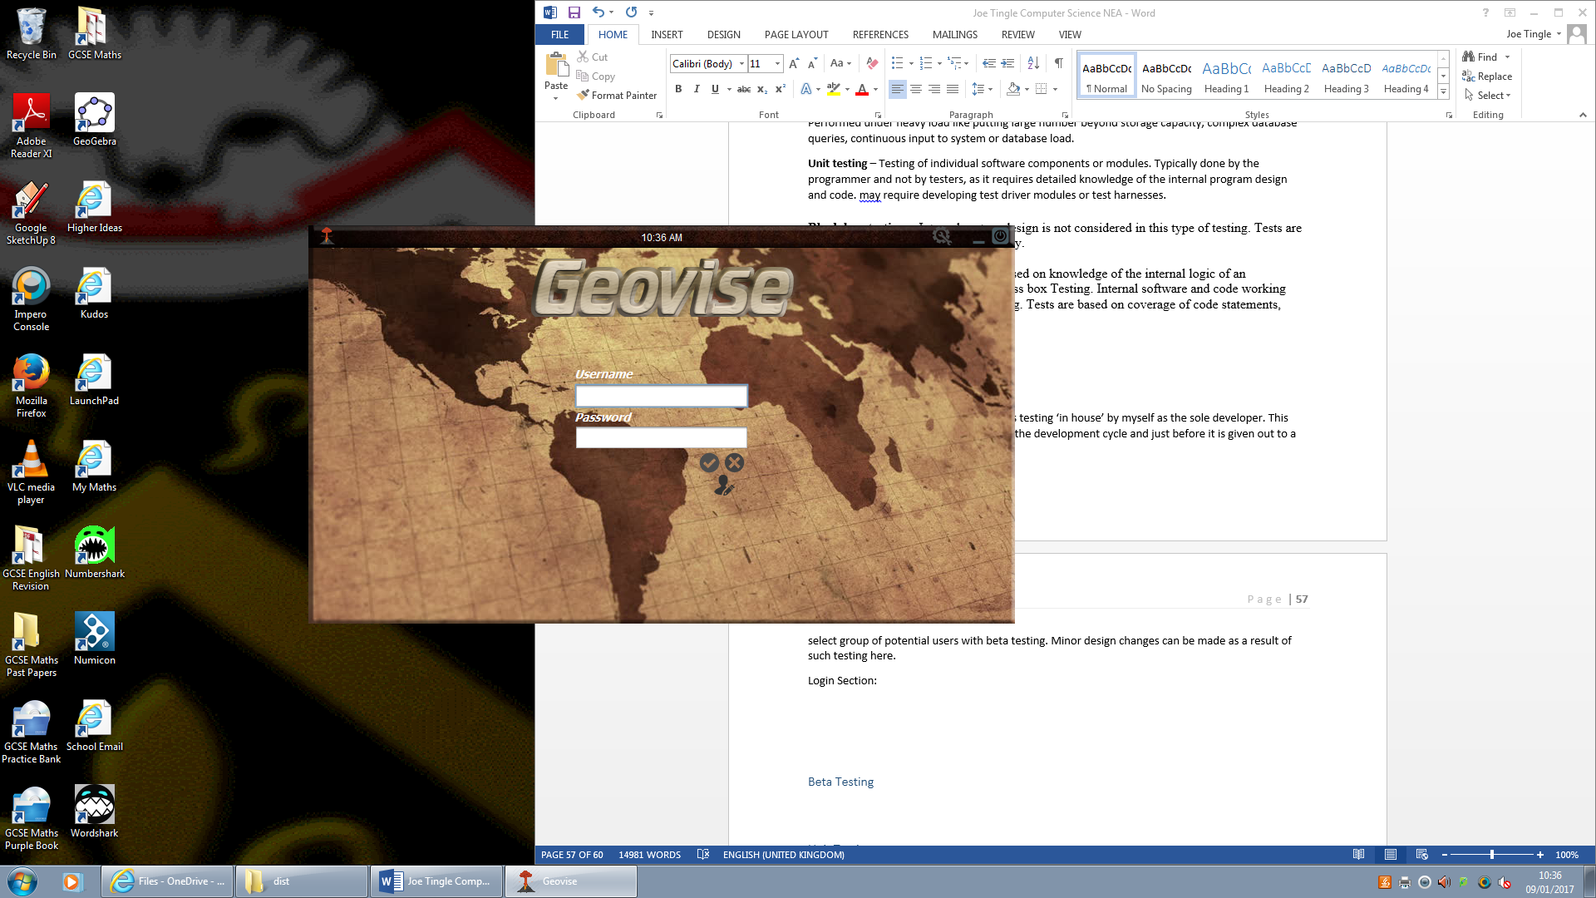Here we have the completed login section with full functionality. With the alpha testing I will be going through each part of the program section by section. The point of alpha testing is to check that the core functionality is in place for the user to use within the beta phase. The knowledge of the code behind the functionality can be used here.

Firstly we can see that the functionality of the toolbar movement is working correctly, the code grabs the coordinates (x and y) of the mouse when the user clicks on the FrameDrag component which is the toolbar. The movement of the toolbar is almost in real time and is very smooth there is no ‘jumping’ in the movement of the frame. The results are very similar to the movement of an actual windows default OS toolbar. All events are working correctly and no unexpected errors are presented, it works as expected.

The next feature is the digital clock on top of the toolbar which is correctly displaying the time, actually in real time, and works at the exact same time as the OS clock. The extra zeros that are added within the nested if statements work correctly so if the number is below 10 then it adds the zero. So that function works as expected as well as the AM or PM part. Another if statement is used here checking if the integer variable grabbed from the calendar import is equal to 1 (1 is PM and 0 is AM), and as you can see it is working correctly.

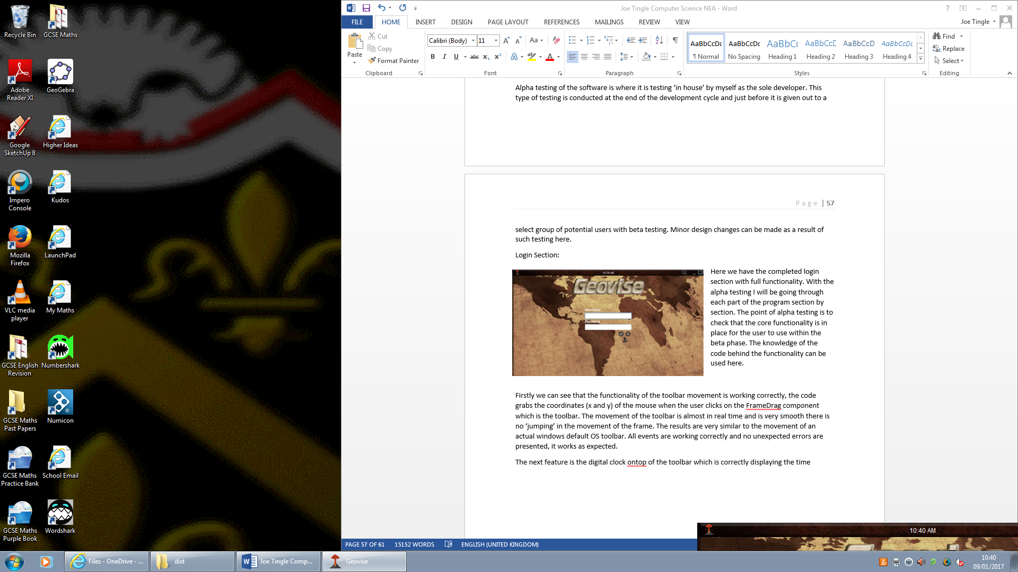

As I have stated before all events are working as expected so all icons are working such as the minimise/exit/confirm etc. Also the options button which is correctly disabled on the login menu is working as it displays the user with a dialog box.

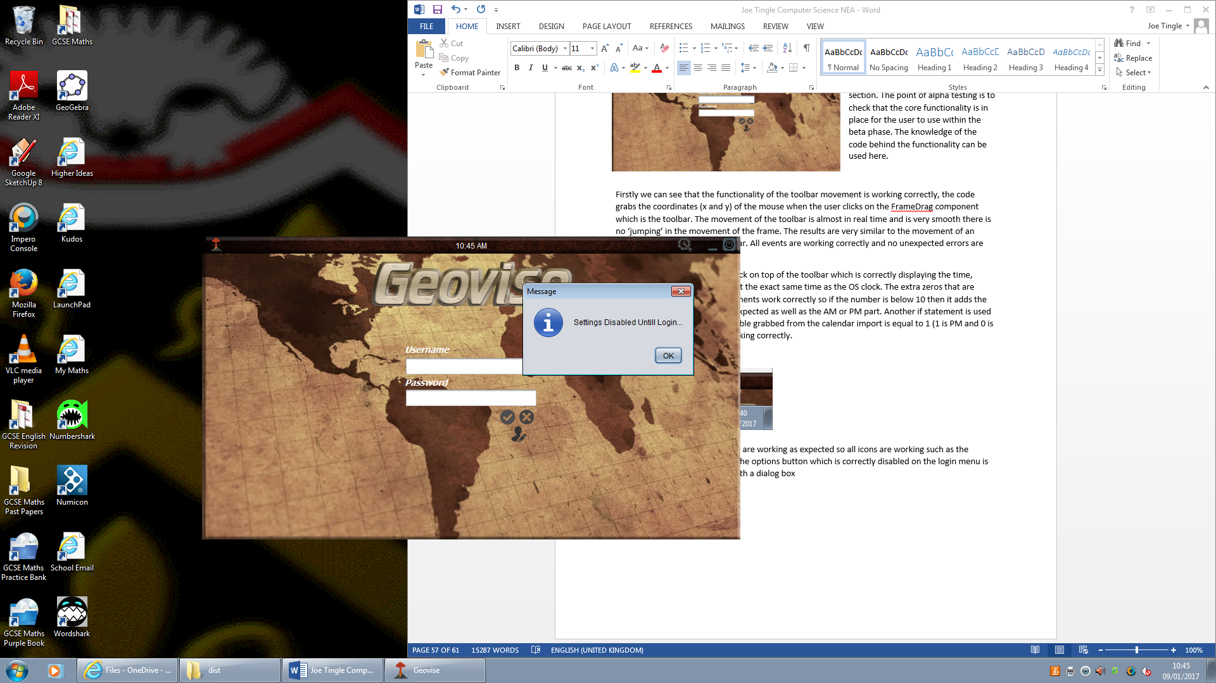

The actual main content of the login section, the connection to the database and the validation check on the username and password works properly. It takes around 1 second for the connection to be made and the user displayed with a dialog box telling them if their login credentials are correct or not.

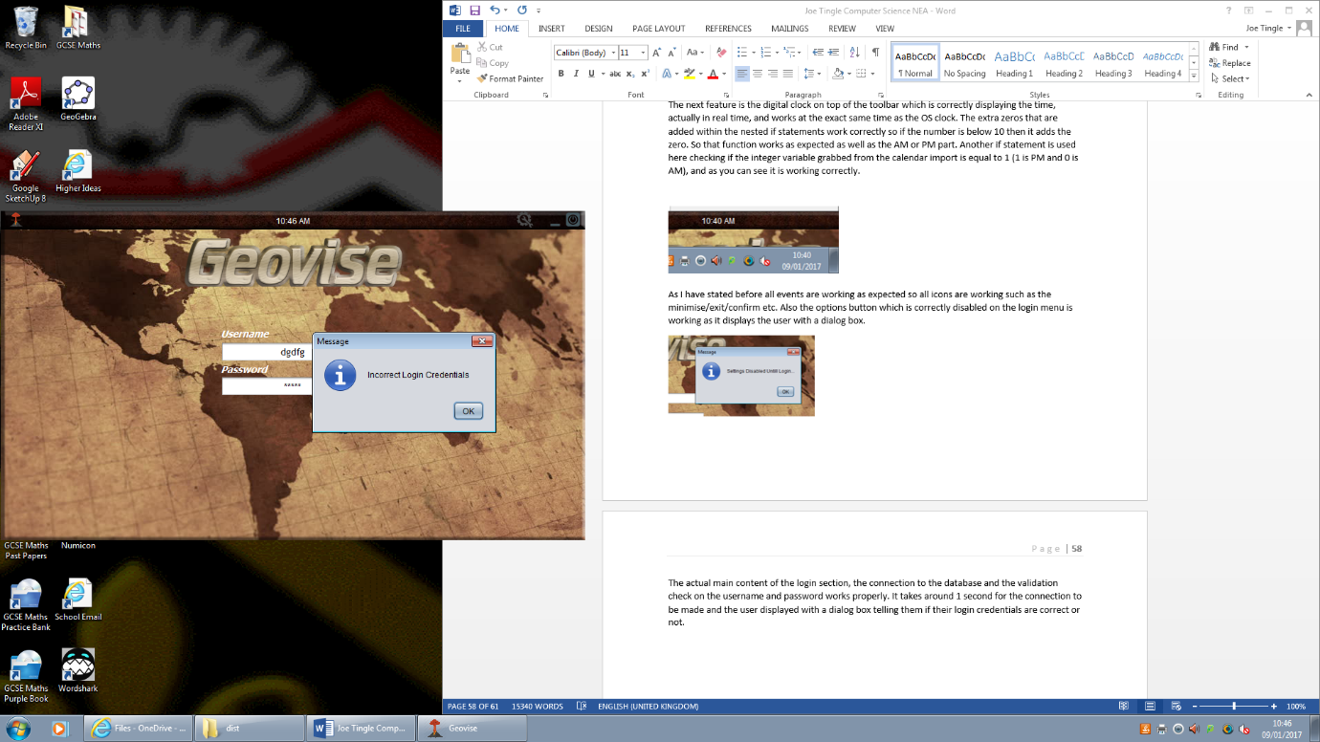Here I have entered some ‘dummy’ information which I know not to be in the login table within the database and it correctly tells me that the information is incorrect.

The validation in place to check if the user has entered information in all fields works, as I recall it is the simple if statement checking if the length of the string contents within the text box is zero, if it is zero then the user has not entered anything within the box.

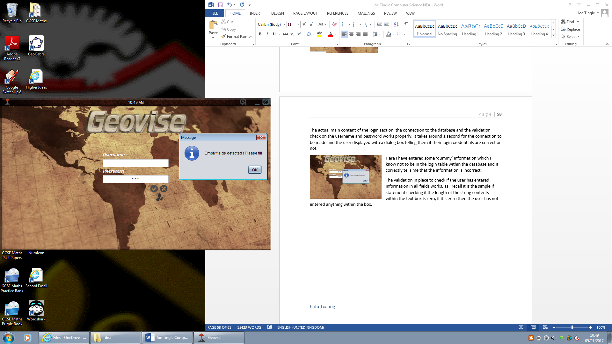  
So here you can see that I have not entered anything within the username field but I have put some text within the password field. It does present me with the correct error message and does not produce an error or think that the information is wrongly correct. Just to make sure that it works correctly I have swapped the inputs to make sure that the password validation works and it does as seen below.

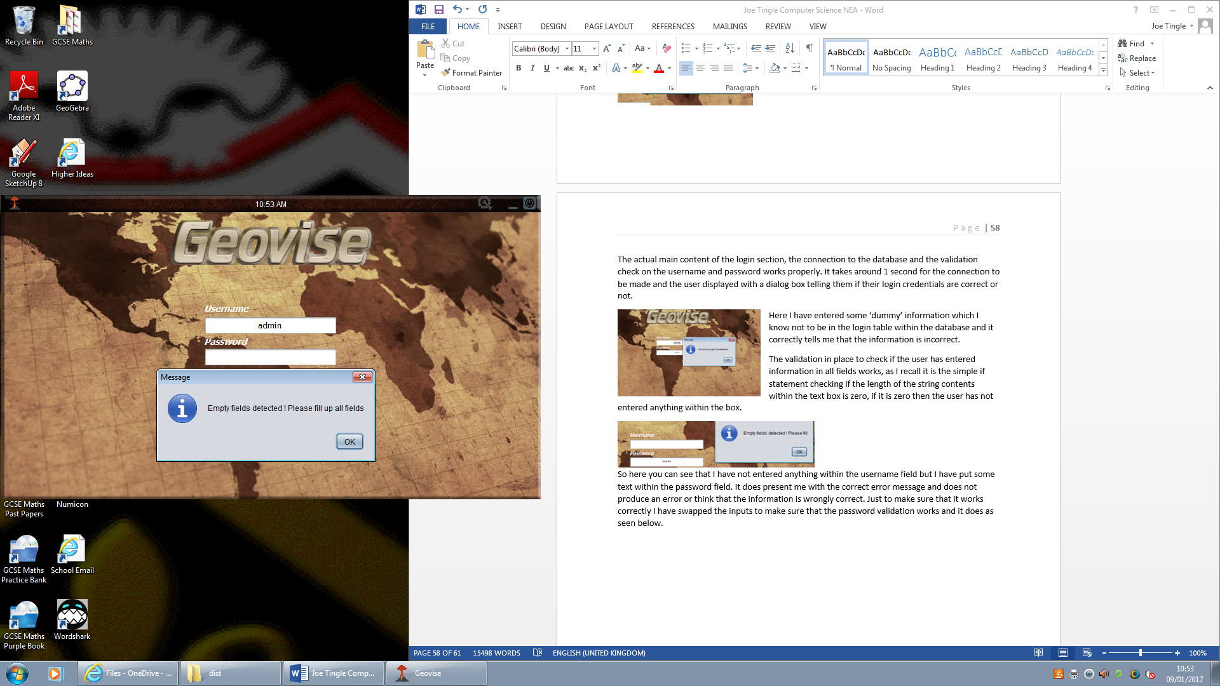However looking at this there is one small error which he has made, as you can see the error message is different for the empty fields. An empty username field prompts the message “Empty Fields Detected ! Please Fill” where as the empty password field gives the dialog “Empty Fields Detected! Please fill up all fields”.

It is obvious that this error is caused by him not fully typing it in within the print statement . In the code it should be System.out.println(“Empty Fields Detected! Please fill up all fields”);

I think that another more efficient way to check if any of the fields are blank is to do the following in the code:

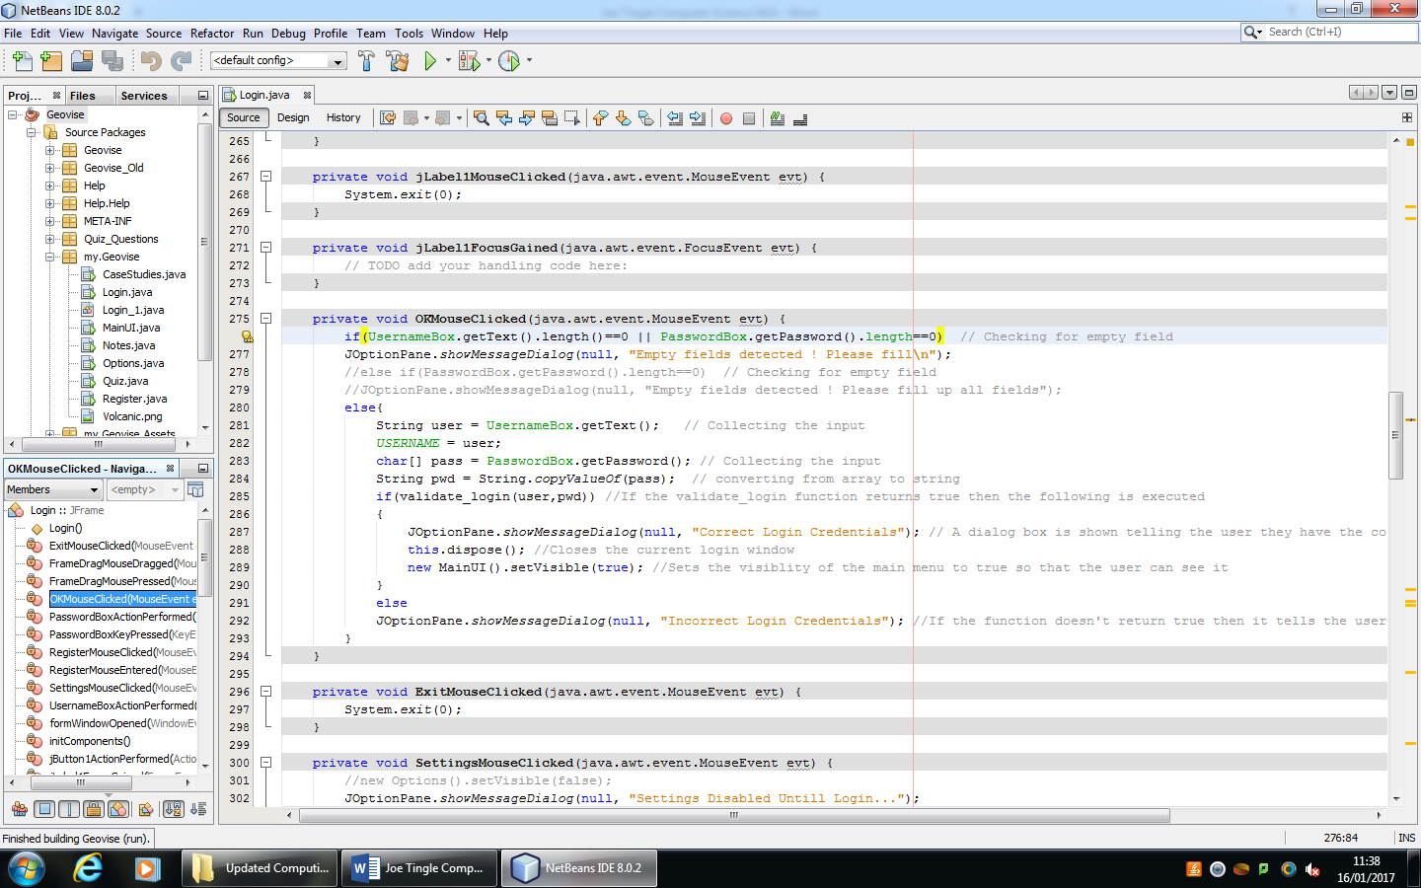

As you can see above which is a copy of the code from the button click event which I have modified. I have combined it into one if statement asking if the username box has a length of 0 OR if the password box has a length of 0. The commented code below it is the older version of its which you have done. This way would just simply make it more efficient by combining the two if statements.

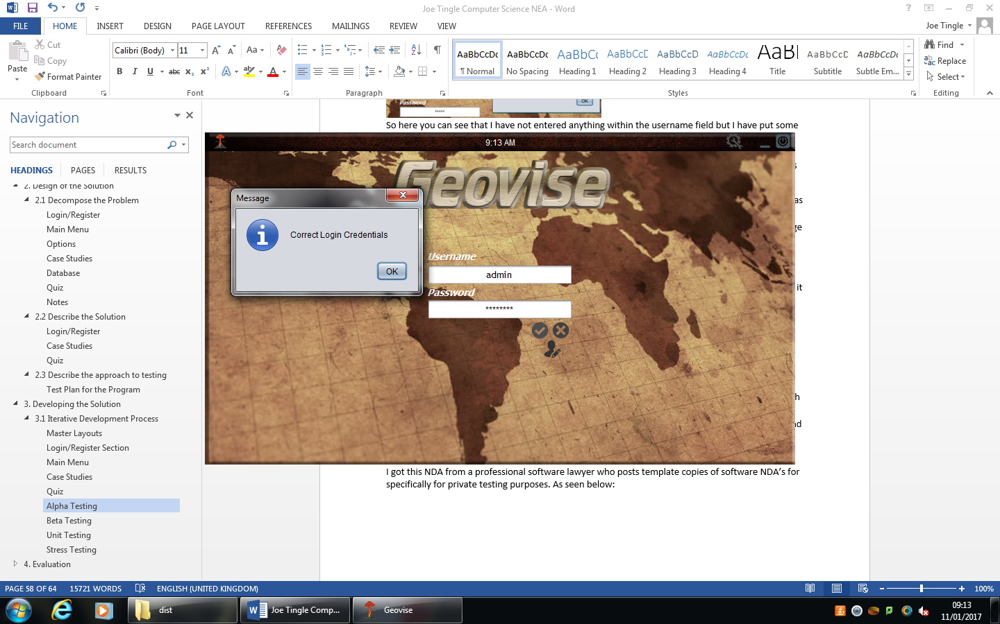Using the test administrator account, with the password set as password, I attempted to make a successful login just to make sure that the user is able to access it they already have an account, else if it did not allow them to access the main menu with their account because the connection was unsuccessful then the program would fail at its objective. However using the test account the connection was indeed successful and it prompted me with a dialog box informing me that the login credentials were correct, and it re directed me to the main menu.

On the custom toolbar at the top there is an icon for the options menu, it does let me access the menu with the option to change the check boxes, with subsequently changes the local variables. However after performing some thorough testing I have come to the conclusion that allowing the user to access the menu before they log in causing some serious errors down the line when the user for example attempts to access the quiz.

The error is present as the global variable USERNAME, which stores the username of the user is currently null on the login screen. The quiz scores/ if they are a first time user etc. are stored on the database under their username, at the moment the connection to the database has not been made so it does not know any values for these causing the errors.

I believe this can be solved by either disabling the settings menu on the login screen or by creating a simple else statement within the quiz menu code which would take place underneath the if statement saying if the user is not a first time user. The else statement should simply run the normal quiz, disregarding the tutorial round

But I think that just disabling it from the login menu would be suffice.

As the register section is dependent on and works directly with the login section I have decided to include it here. The register section currently does not include the final , updated, toolbar as you can see it is missing the digital clock as well as the minimise button. I don’t think this hinders any of the core functionality of the program but it is not very consistent. I recommend that this is updated to include the minimise and digital clock so that user is able to use them.

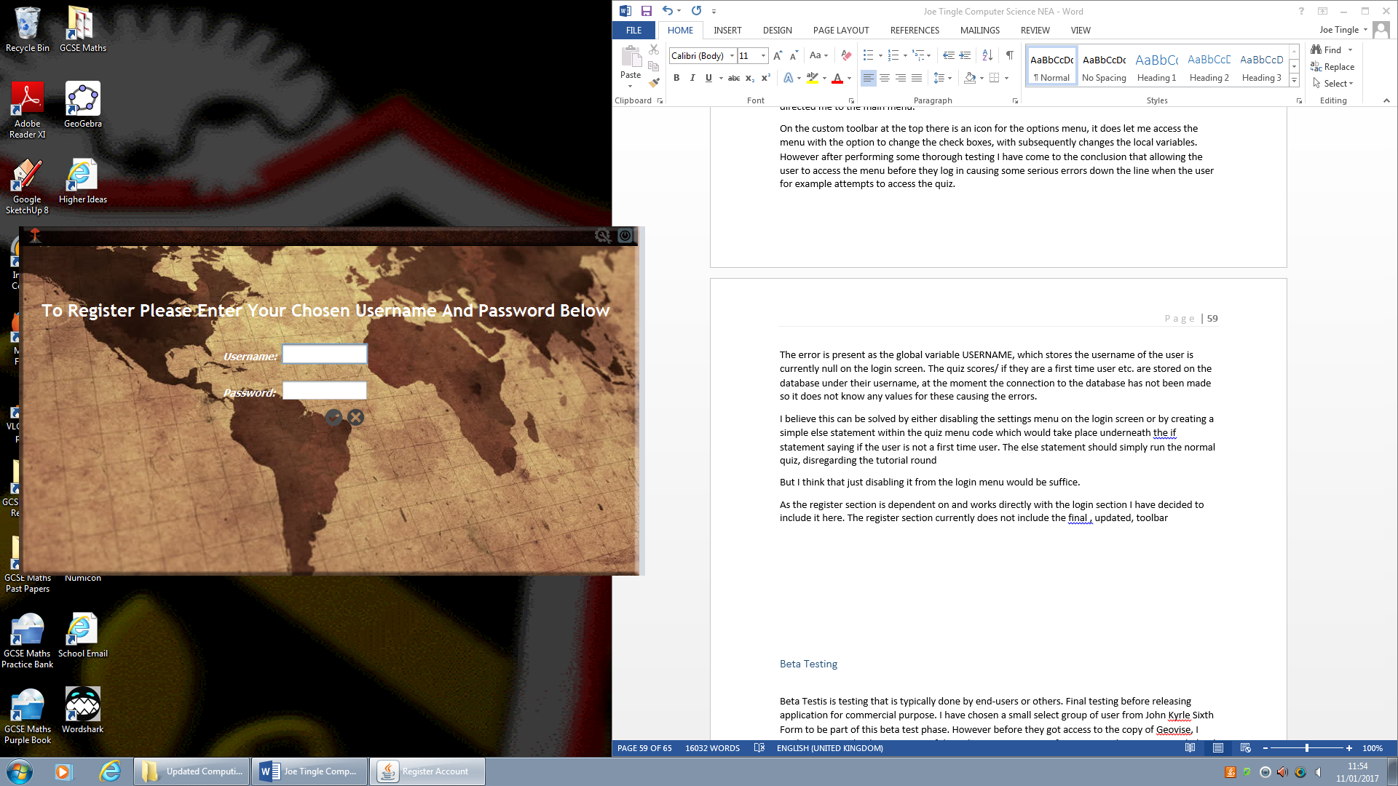

But the main function and purpose of the register section is to make a successful connection to the database and input the username and password into a new record, essentially creating a new account within the program. Upon a brief testing I can conclude that the register section does use the same validation methods as the login section as seen below it notified me if any of the fields are left empty.

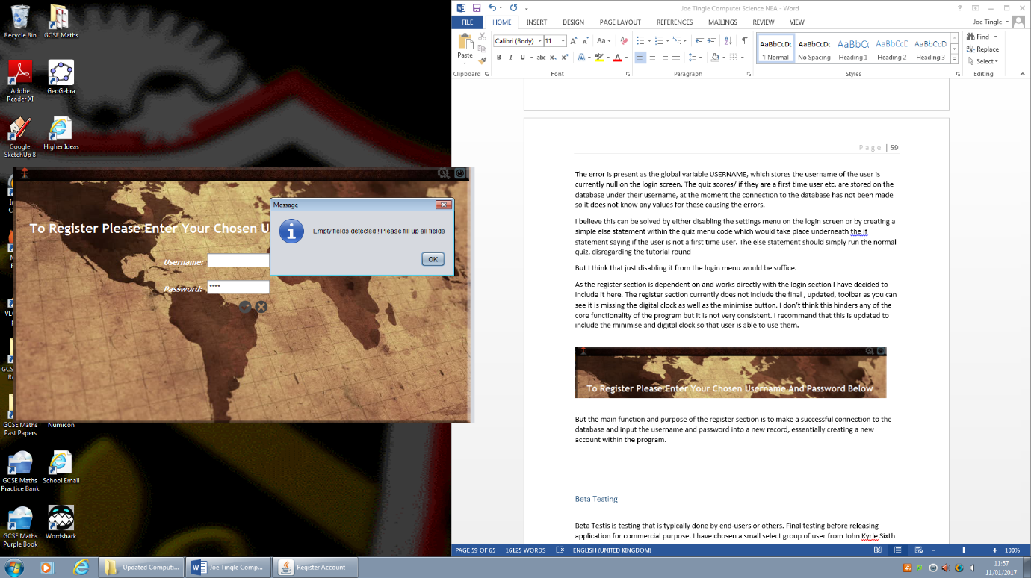

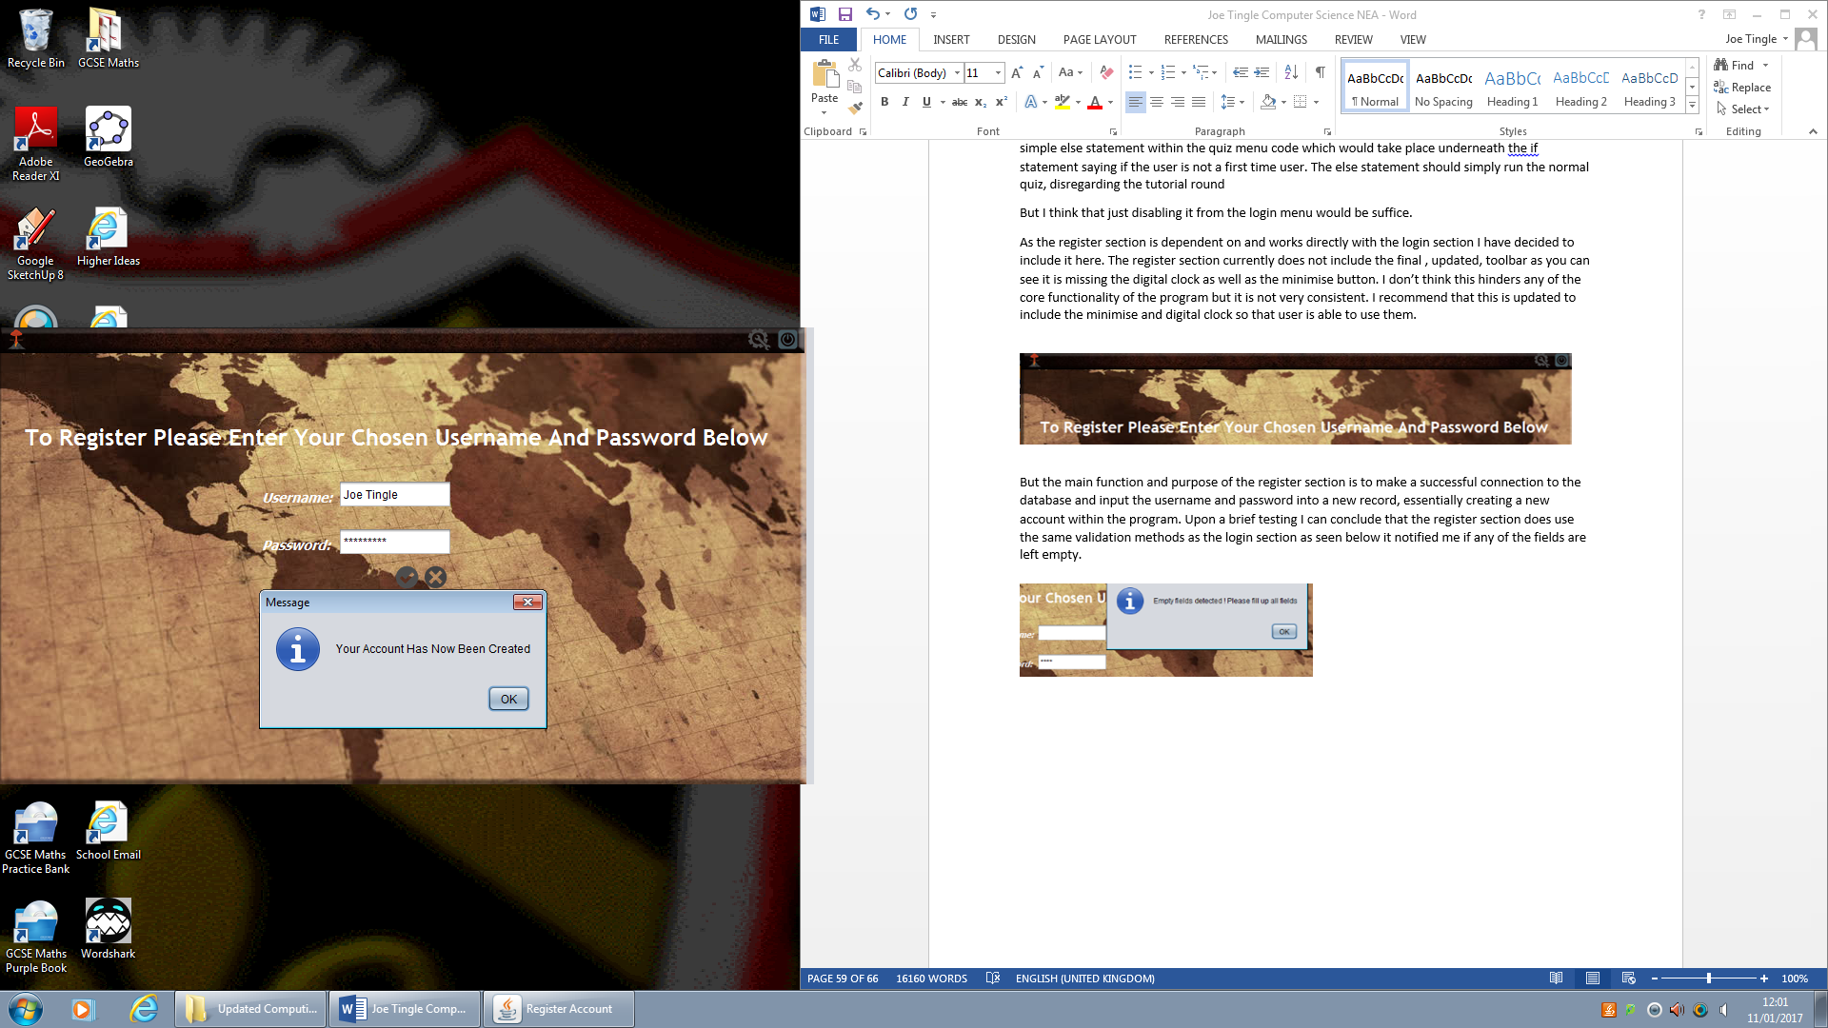

Using the test data, of Joe Tingle and password, I am able to create an account. So we know that the connection has been sucesfull. By the looks of it it uses the same base method of the ValidateLogin() within the login section. To improve efficiency you could solely have a connection method and call it dbConnection() for example which would be a global method that any class could call. Therefore instead of re typing the base code it could just call the method, but the current implementation works just fine.

I chose to use the username Joe Tingle to see how well it deals with spaces as sometimes in my past experience it can confuse itself and add Joe and Tingle to two separate fields. However this is not the case as straight away I click on OK for the confirmation dialog box and I a re directed to the login page, which is a nice feature as it saves the user from clicking the back button, and I am able to log into the newly created account.

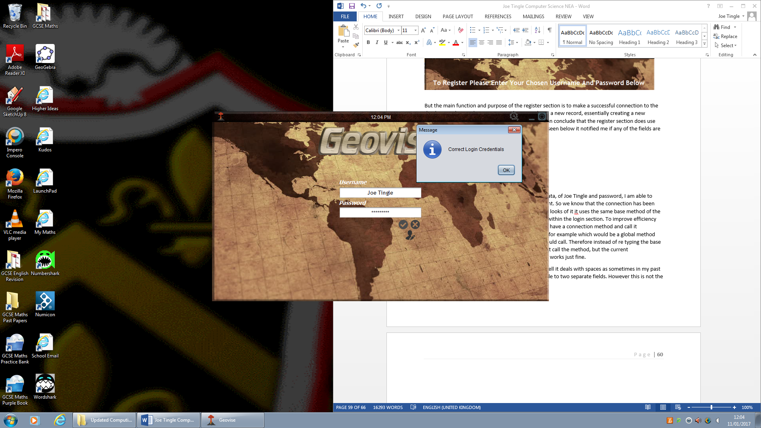So I can see that it adds the record to the database as soon as the code is executed so there will be no errors where the user registers an account and attempts to log in straight away but the database has not updated yet so it produces an error.

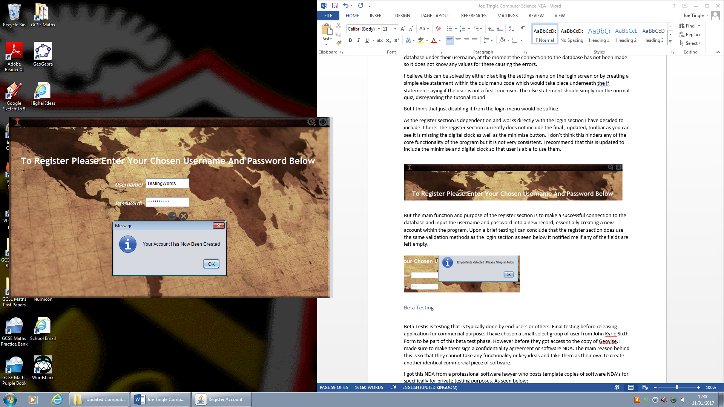One issue that I have found whilst testing the program is that there is no profanity filter, so the user is able to put any word into the username field and it will be accepted. This is only a small issue but I feel that the program would be better off with a filter.

I believe that there are a couple ways in which this could be implemented, firstly you could a big if statement which would say if the username box (which would be converted to a string) contains ‘banned word1’ or (or in java would be ||) ‘banned word2’ then it would display a dialog box asking them to change it.

The statement would look something like so:

If (UsernameBox.contains(“FirstWord”) || UsernameBox.contains(“SecondWord”) etc… )

{

JDialogBox.(“Please Change your Username as it contains blacklisted words..”);

}

Secondly you could create an array called blacklistedwords for example and then compare to see if the username equals any value within the array. Again lots of ways this could be implemented in future versions.

**Main Menu Section:**

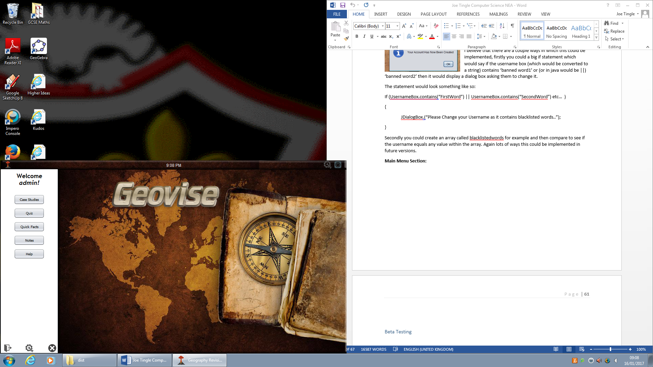The next section of the alpha test is the main menu, as you can see with the picture on the left which is the completed, final version of this section. The first piece of functionality I needed to test in the main menu section was the movement on the toolbar.

Theoretically if the code is exactly the same as the one on the login page then it should work perfectly fine. After testing I could see that it produced the same results as the login page and the movement is very smooth and there is no ‘jumping.

This means that the code is exactly the same, and just to confirm I took a look at the code and it is. I would suggest the use of some global methods, as this movement needs to be on every menu and a method would reduce the amount of code, however this would not be possible as the method uses variables from that specific class so if you called the method from the login page, then it would use the x and y coordinates of that login page instead of the main menu. This would cause a lot of issues as the login and main menu pages are of different dimensions.

The other issue with the global methods solution

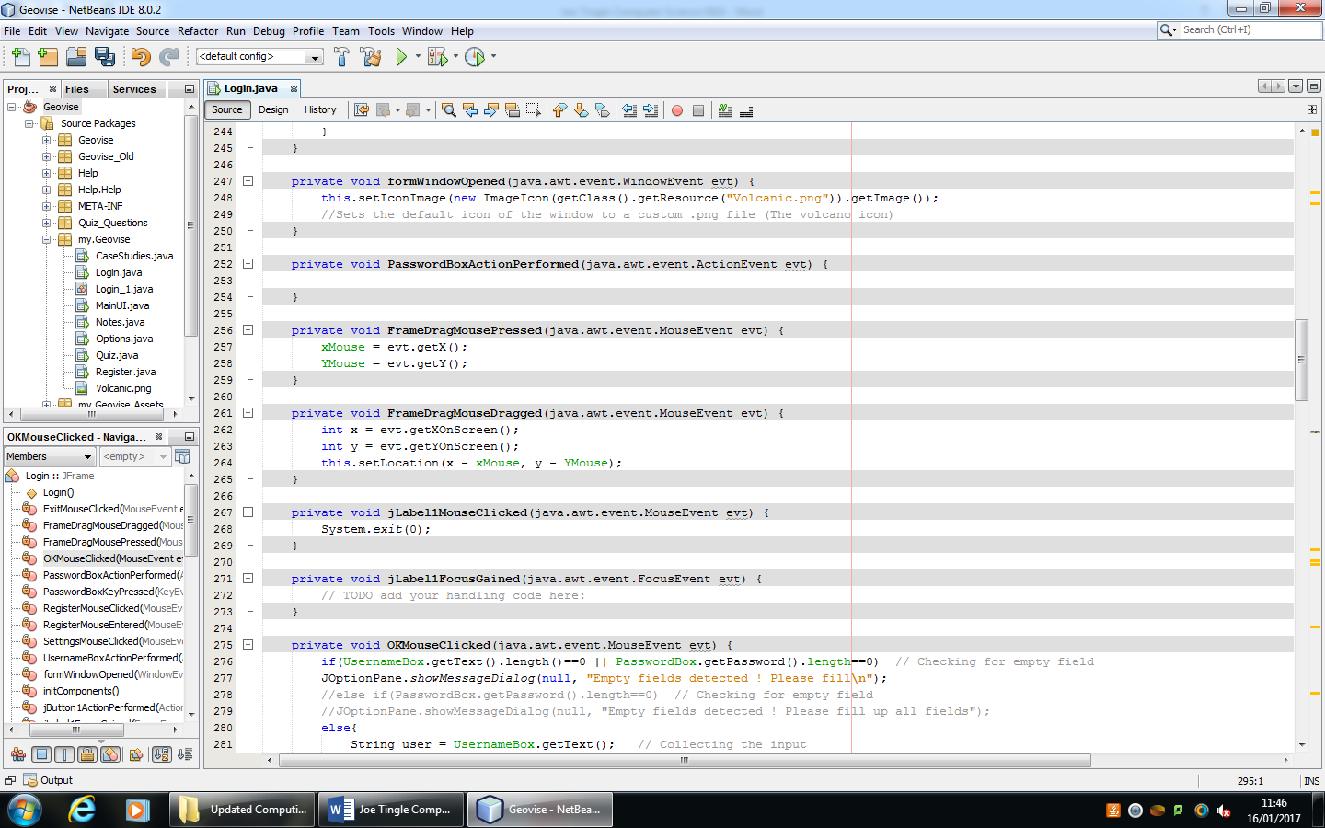

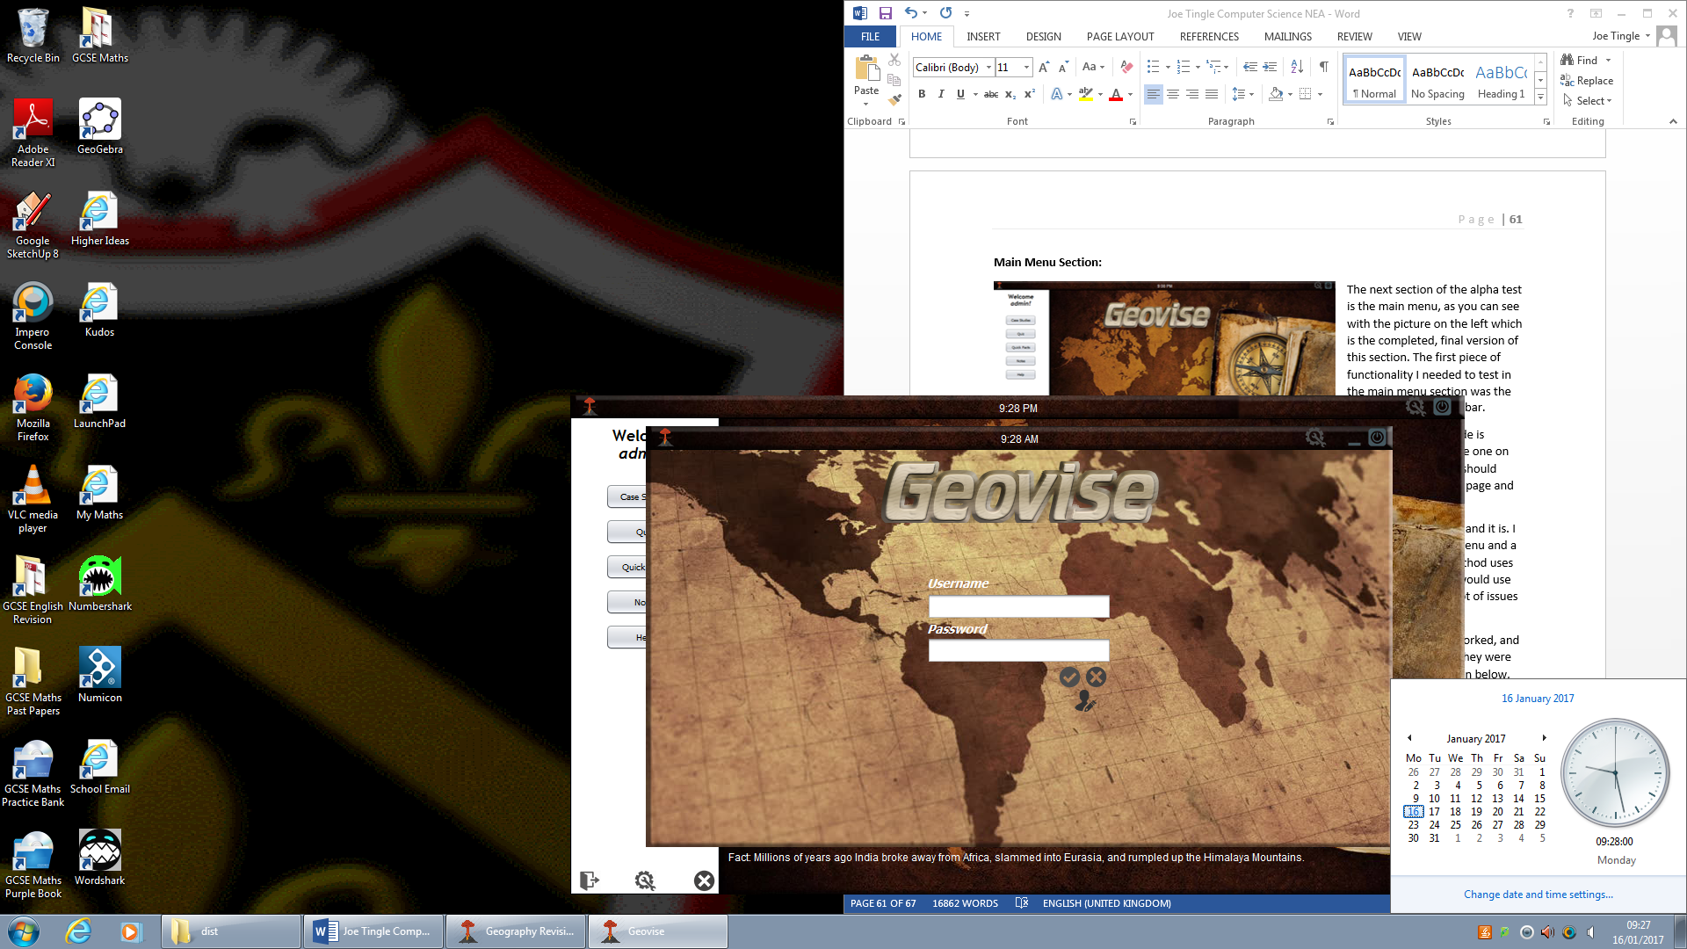After testing the movement of the toolbar, I went on to make sure that the digital clock worked, and of course much like the toolbar movement the code should be the same and to test that they were both using the same code and update frequency I opened up two copies of Geovise as seen below, one on the login page and another on the main menu.

One possible error I did notice was the fact that it displays 9:29 AM and not 09:29 AM, it is missing the extra 0. I am sure this is to do with the if statements being mixed up. So it is essentially swapping them around, meaning the extra zero gets added to the PM and not AM as it should do. This would be very simple to resolve and would only mean changing the value of the if statement from 1 to 0, or from 0 to 1.  
I can confirm that the code must also be the same and is working as expected as the clocks update at the same time, as the OS clock ticked over to 9:28 so did the Geovise clock.

The next feature to test was a simple piece of text, the greeting text which says “Welcome <User>!” and will change the name depending on your chosen username that you have logged in with. Now I like this feature as it makes it more personal and so it feels like your account does a lot more than just let you log in. The code behind this is very simple and is located in the event, formwindowopened, which is very efficient and the code will set the text as soon as the window is opened so there no delay. Using a global variable called USERNAME which is created within the login section where the database connection is made.

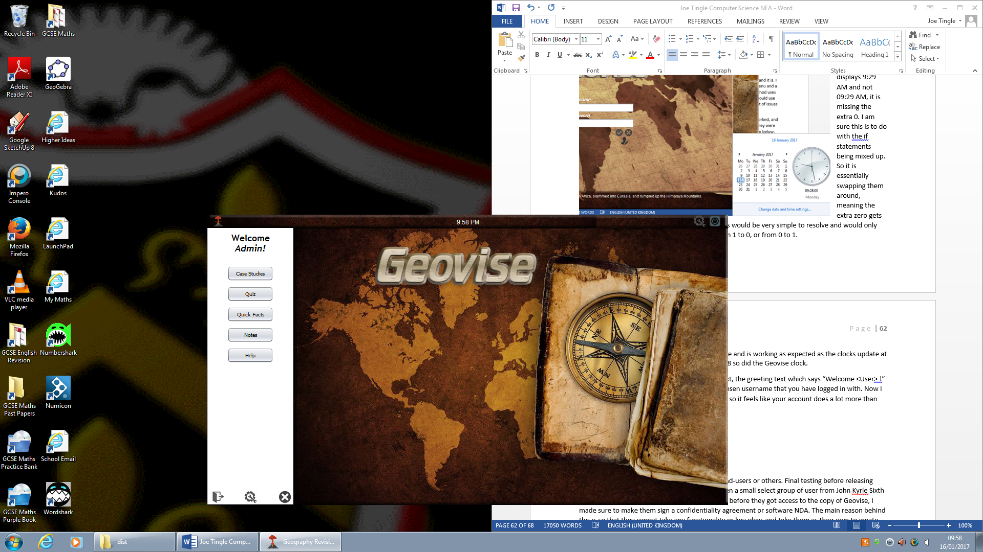

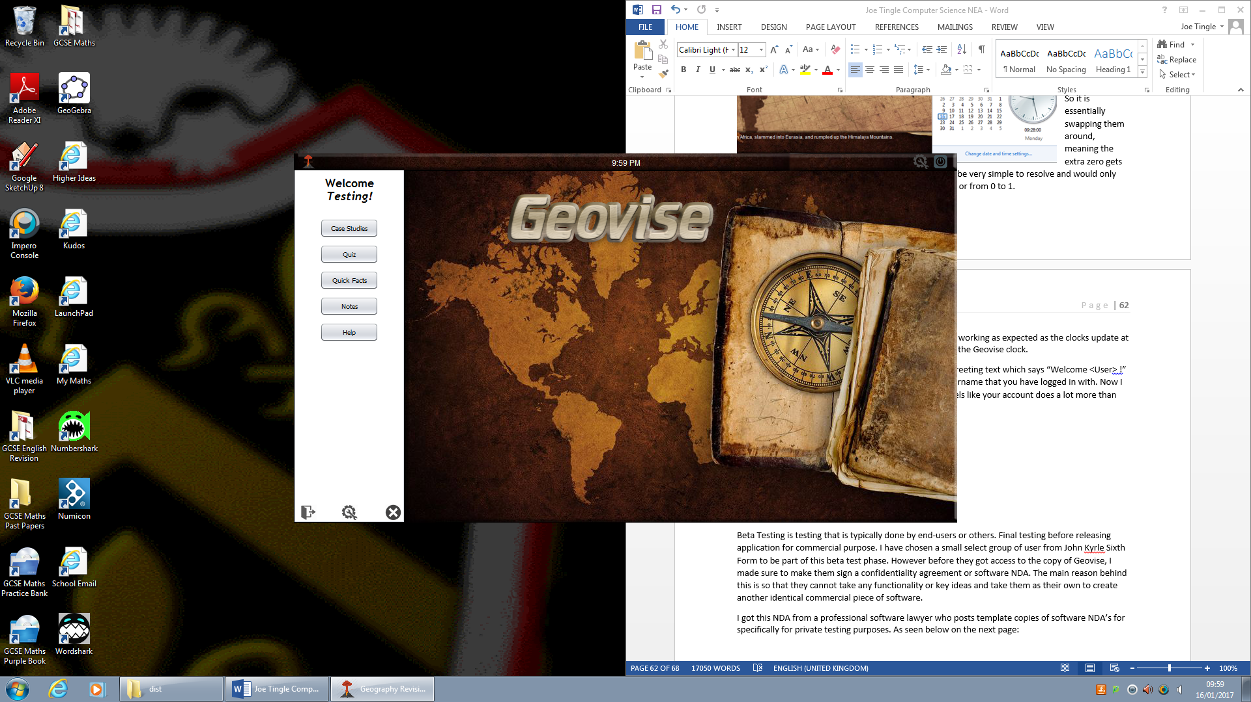 However this presents another issue, as stated before in the login section I noted that there is no profanity filter so the user can enter a word/phrase they want. This can be an issue as there is a global leader board for the quiz in which all users are displayed. So to resolve this all is needed is the blacklist for certain words, but I have stated this before.

Another feature within the main menu is the Quick Facts button which supposedly gives you a random fact each time you click on it. Now I can notice right away that this will use a switch case, and then generate a random integer using the Math function within java. After testing by continuously clicking on the button and noting all of the facts down each time.

I noted that there are around 15 random facts, and this could be an issue as I found that I got a lot of repeats, so it would give me the same fact every couple of clicks. This can be solved by simply adding more facts to the case switch, this would then decrease the probability of getting a repeat.

Another main feature on the main menu is the notes section, this is a fairly big and complex section which is also included in the case studies page but I will be covering it here. The notes section can be accessed on the main menu by clicking on the notes button which opens up the notes window but unlike the other it does not get rid of the main menu. I think this is a good idea as it means you can carry on using the program whilst having the notes at the side of your screen ready to use when needed.

The notes page itself looks different and I believe this is because of the functionality it needs to use, utilising\ the OS for opening and saving files. So this could be a problem as it does not blend in with the rest of the program. This section allows the user to save anything they type into the contents of the text area into a text file (.txt format).

This section works very well, but ultimately the formatting of the text is up to the user, it is up to them to change the font/size etc. But one issue I have found is that there is no limit to the amount of content, so in theory the user can enter an unlimited amount of information into it. I have tested this by copy/pasting huge paragraphs of characters, which would dramatically slow it down. Of course this is to be expected as it is now taking up a lot more RAM space. Eventually the notes section becomes unusable and if the user does manage to save the file it will be huge in file size. In the test I did the file size was around 50MB which is nearly bigger than the program itself.

I believe to solve this issue than can occur, I recommend that you implement some sort of limit to the amount of characters the user can enter. An example of this could be:

IF (Content.length > limit) THEN

OUTPUT “Please Save this file and continue on an empty page”

CanSave = false;

ElSE

CanSave = true;

**Options Section:**

Currently in the options menu there is only one option which the user can change. So of course my first note on this is that there should be some more options, maybe even add a feature that displays current system resource usage. This option could be limited to administrators only by adding a ‘tag’ to all new user accounts.

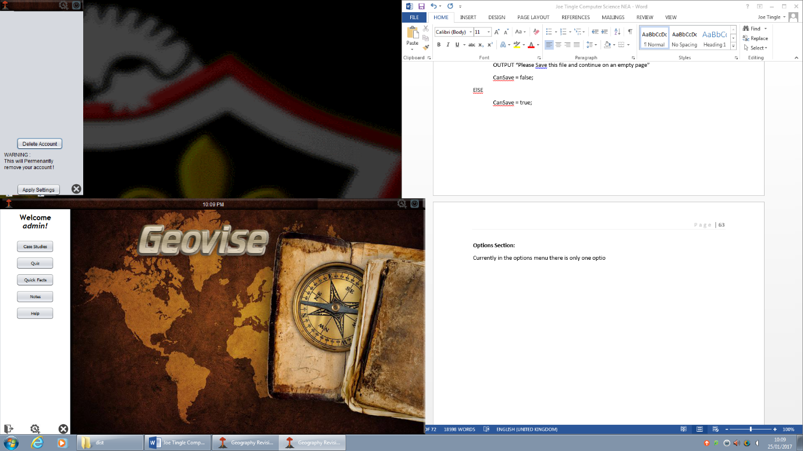But the main feature on this page is the ability to remove or delete the account that is currently logged in, I can know see why the options menu is disabled during the login screen. As if the user has not logged in then the program does not know what the username is and when they click on delete account it will produce an error due to having the USERNAME variable null.

There is also a text warning underneath it which is good as after the account is deleted there is no way to bring it back/ restore it.

However the main issue with this is due to the fact that underneath the delete account button is an apply settings button. Now once this button is clicked it displays a dialog box telling the user that their new settings have been applied, but if the user has already clicked on the delete account button then it is already applied. So this makes the apply settings button completely redundant.

To solve this I think that you should either remove the apply setting button or change the delete account button so that once the code is finished being executed it logs the user out, and closes all windows and opens the login screen again.

**Case Studies Section:**

The case studies section has two tabbed panes on it, which allow the user to switch between physical and human case studies. This is great as it separates them and makes it look much more organised, as know I can navigate to the relevant case study quickly. Currently each section has 4 case studies.

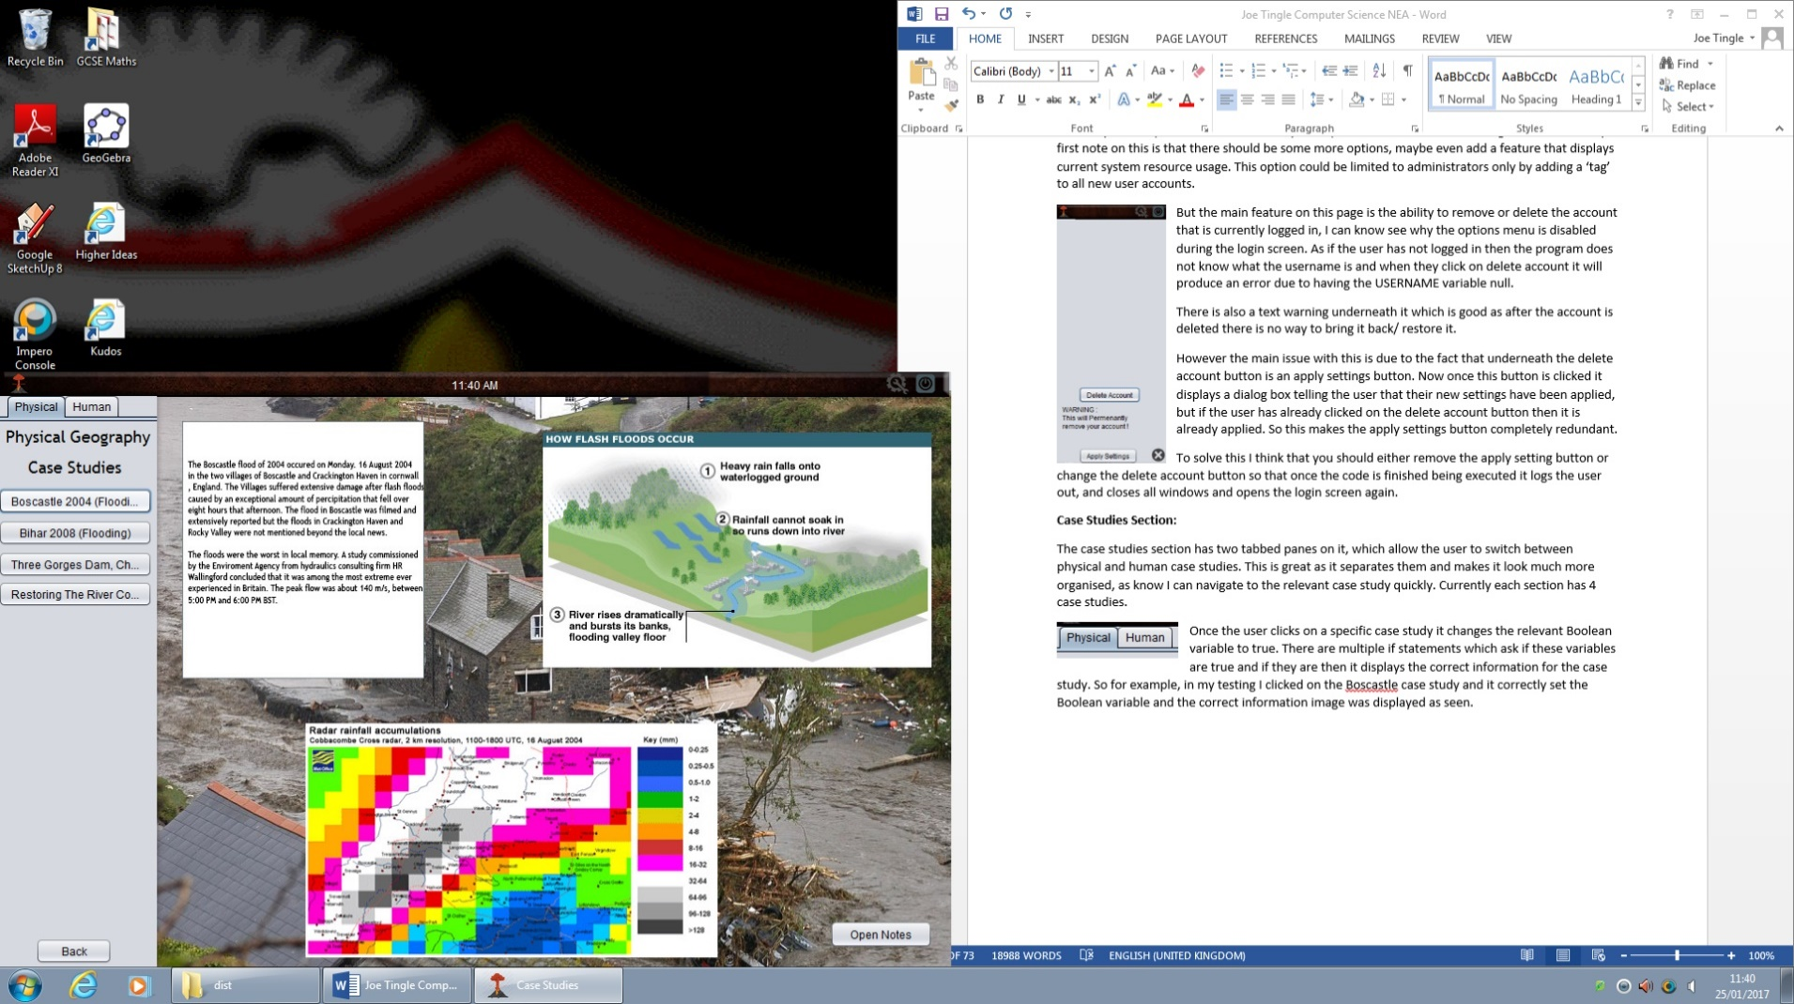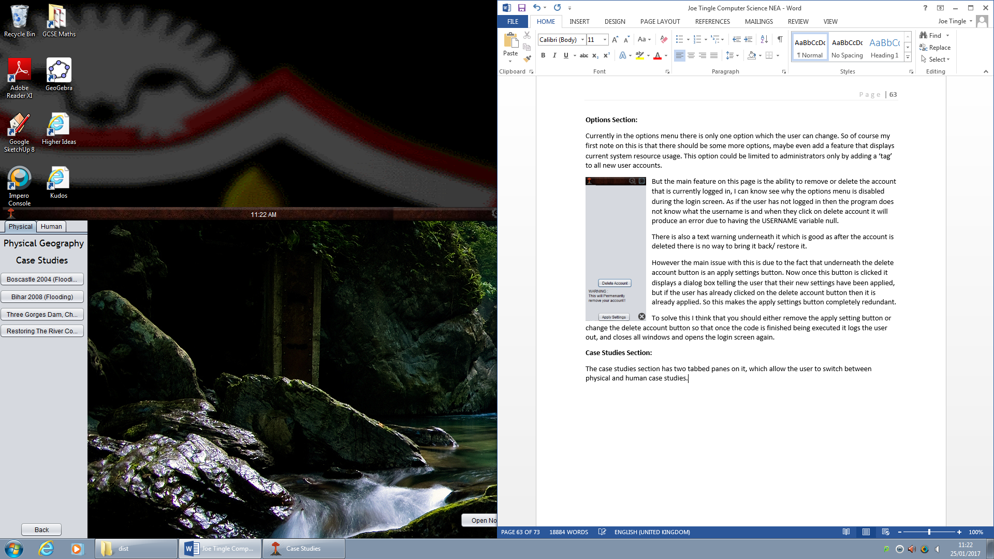Once the user clicks on a specific case study it changes the relevant Boolean variable to true. There are multiple if statements which ask if these variables are true and if they are then it displays the correct information for the case study. So for example, in my testing I clicked on the Boscastle case study and it correctly set the Boolean variable and the correct information image was displayed as seen.

**Quiz Section:**

As soon as I opened the quiz page, I was greeted with the dialog box telling me that I was a first time user for the quiz, and that I had to complete a tutorial round first before the difficulty could be scaled. However later on I realise that this caused some issues with rerunning the quiz, as there is a Boolean variable asking if the user has completed the quiz or not. By default this is set to false and it is not updated to the database, so every time you close and reopen the program it thinks you are a first time user for the quiz. The most efficient way to solve this would be the use of a sql statement adding/updating the column FirstQuiz value. So as soon as the user has finished the 10th tutorial question it should change this value to 0 in the database so it will be persistent.

However on the quiz menu there is a table at the bottom which displays all of the users registered on the program and their highest score. This is a very nice feature and adds a bit of competition to be the top person on this ‘leader board’. After testing I can confirm that this updates every time the window is opened as I created some dummy account and as soon as I opened the quiz page they were displayed in the table.

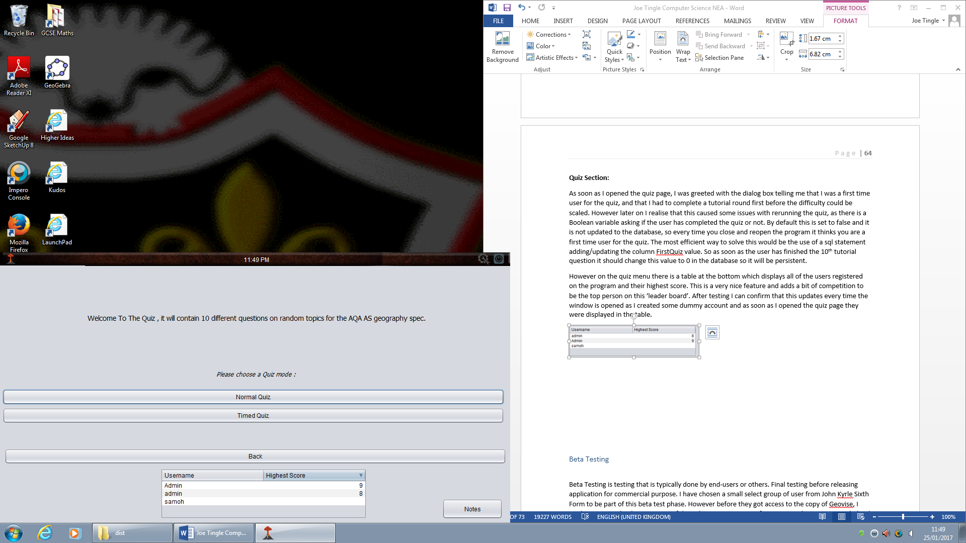Another nice feature with this is that it automatically sorts the values from highest to lowest. So there is no need to actually click on the highest score column to sort the values.

But onto the main content, there are two modes for the quiz normal and timed, to start off with I tested the normal mode.

Because I was a first time user to the quiz I had to complete a tutorial round first to get a basis in which it can scale the score later on. This is a very good concept as if the user has only just created their account then there is no information on them so the program won’t know if they are good or not. The tutorial round consists of 10 ‘set’ questions. It is different to the rest of the ‘scaled’ quiz as these questions are set and range in difficulty and content.

For the first question, it was a true or false question, whether the oceanic crust is newer than the continental crust. Before I go onto how this worked, I have to note that the toolbar at the top changed when I accessed the first question, as you can see below :

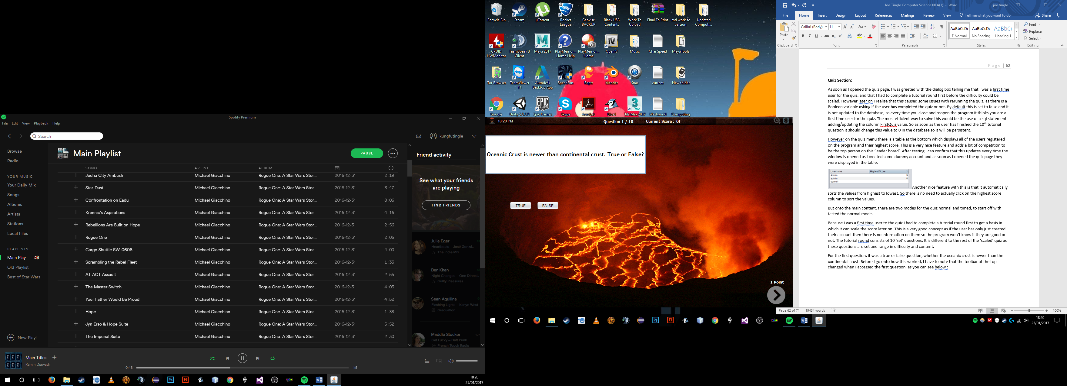

As you can see the time has now been moved to the far left to make way for two new counters. The current question and then the current score. I really like these additions as you are able to track your progress through the quiz. One slight improvement that could be made to this is just simply adding a space to the score as it is 0! Where as it should be 0 !.

But to the question itself I have found one big issue throughout my testing on this question, after going through it once I thought that it worked perfectly as the correct answer is true and I chose true. But I soon realised that it you continuously pressed true and false, it would confuse the program and it would think that false is also the correct answer. So in this case no matter what the user chose they would get this question right.

I am assuming that this is to do with the Boolean variables not resetting themselves, so once you click on true the TrueSelected variable turns to true, but if you also select false afterwards it turns that variable to true without resetting the other.

Adding a simple function can fix this as below:

Public resetAnswer()

TrueSelected =false;

FalseSelected =false;

Then you would call this every time the user clicks on either true or false and then after that make either one of the variables true. This way they both cannot be true at the same time.

The second question is very different to the first as it is not a true/false question. Instead there is a picture in the background of a river and it asks you to name the processes marked with arrows. However, you must get all three processes correct to get the 1 point for this question. One issue I have discovered within this question is that it is case sensitive so because the answer is like so, Erosion/Deposition/Meander, that means that if you have spelt it right but not put the capital at the start it will mark it wrong. This could be a problem as people all type differently so whilst one person may put capitals at the start others won’t and here they would get a wrong answer because of that.

A solution to this would to convert the answer that the user has entered into capitals and then change the answer to capitals, so for example if the user entered erosion or Erosion it would be converted to EROSION which would both then match to the answer EROSION.

The third question is multiple choice and utilises a button group so that you are only able to click on one at a time which is very good. I have found no errors with this question at all. The rest of the question In the quiz also follow this, and I have found no more errors that could cause issues to the end user.

### **Beta Testing**

Beta Testing is testing that is typically done by end-users or others. Final testing before releasing application for commercial purpose. I have chosen a small select group of user from John Kyrle Sixth Form to be part of this beta test phase. However before they got access to the copy of Geovise, I made sure to make them sign a confidentiality agreement or software NDA. The main reason behind this is so that they cannot take any functionality or key ideas and take them as their own to create another identical commercial piece of software.

I got this NDA from a professional software lawyer who posts template copies of software NDA’s for specifically for private testing purposes. As seen below on the next page:

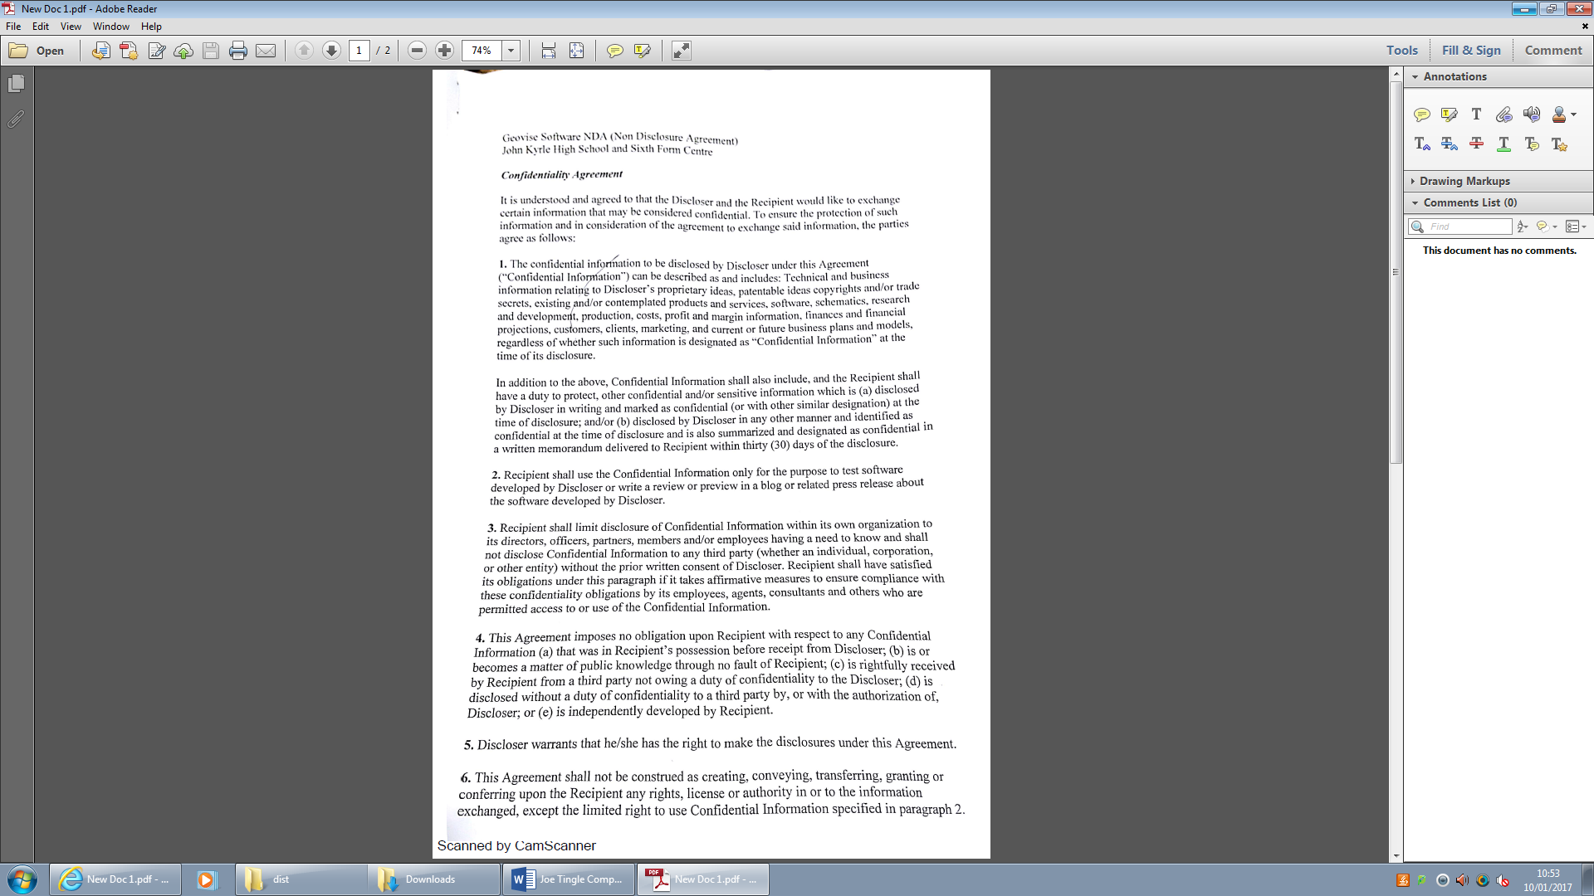

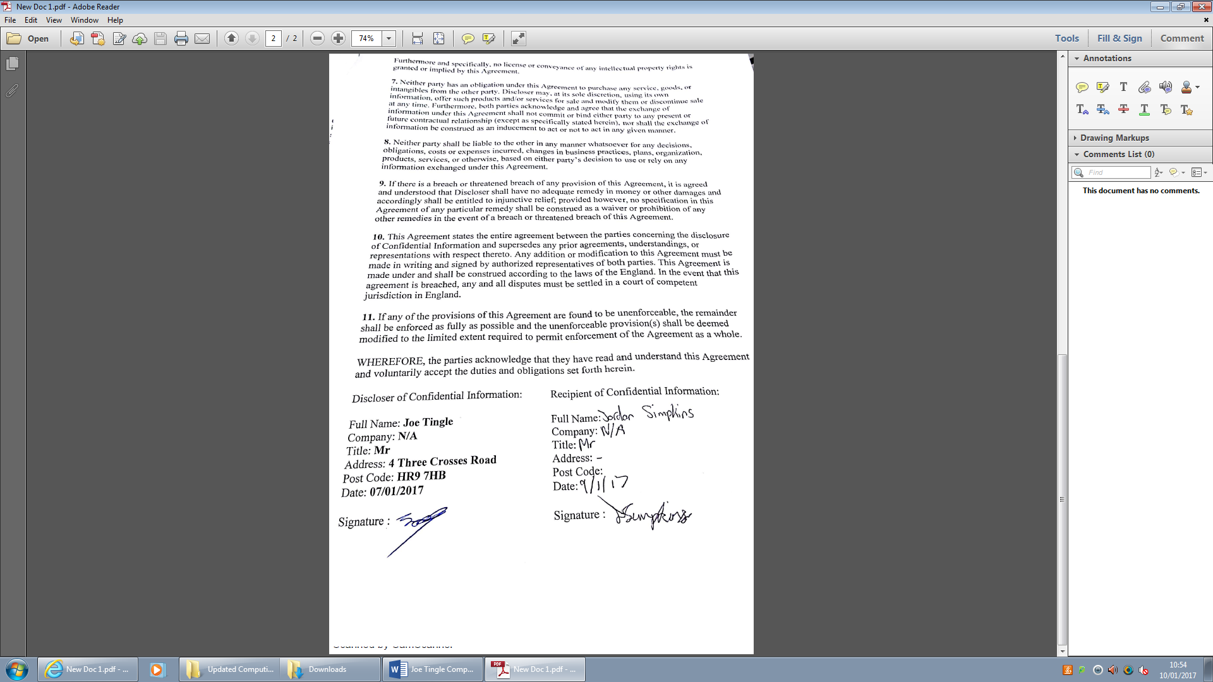

I selected a very small group of current a level geography students (4 in total) and got them to read through and sign the above document meaning they could not speak about the beta version of Geovise. I also asked them to make some notes and feedback on their experience within Geovise and put it into a simple word document, the contents of which you can now see below, however I must note that all of the chosen people do not have much technical knowledge and are not developers in any way.

All of the participants had approximately an hour with the software and I asked them to put their feedback on a word document which you can see in the next couple of pages:

***Geovise - Beta test #1***

The register button functions very well with some very easy to follow instructions then when you log onto the main screen it comes up with “Welcome (your username)” which is a very nice feature in my opinion.

Although at the bottom of the home page the settings button doesn’t actually work so if you want to change some of the settings you can’t actually change it because it’s been disabled.

The help page is very helpful it has GIF’s within it to help with the case studies section and when it tells you how to work different aspects of the program. This helps with the actual usage of the program and how to run certain things. The GIF’s are very helpful for the running of the program.

The quick facts are very interesting at the bottom of the page, although these facts could be in a bigger font size and also a different colour so that they stand out. Also there are certain spelling mistakes within these quick facts that need to be addressed. However the variety of them is very good, I am not sure on the exact number but it feels like there is a lot of them. Which is nice as every time you load up the program you can find a new fact!

In the case studies scree the information on the physical tab are very helpful, it gives facts on the Boscastle flood, Bihar, Three gorges dam and restoring the river Cole which are very helpful pages on learning about these different case studies. This helps me as a geography student because it directly links in with the case studies that I’m currently doing. But I think there should be a couple more case studies on each section, but maybe you can add these in the future although the buttons to click on the case studies need to be bigger because you can’t actually see the whole name of the case study. Also the back button works and is very helpful.

Then when you click onto the quiz section you need to do a tutorial to scale the difficulty which is a very good idea because all different types of ability’s will be using this piece of software. Although the notes page that was on the home page would be more suited to be here because it would prompt you to make notes on this section. I also like the section that updates different users that are using it.

When you are actually using the quiz it is very good at popping up on screen at telling you that you got 1 point. Although on the next page when you get the question right and its meant to be 3 points it actually says you only get 1 point, then on the toolbar it only says that you have 2 points which isn’t adding up the points correctly.

Although when you actually get to question 3 and type in your answer it doesn’t actually say if you got it right it says “it’s being marked” then when you get to the end it doesn’t actually say if you got it correct. Although the score actually does update which is baffling.

Although if you get a question wrong then it should really tell you what the correct answer should be because you got it wrong so you need to know what is the answer.

Also the questions that require you to type answers the answers that you give don’t actually always get you points because you need to give specific words to get the point for the question.

Overall it was a very useful piece of software that I can see myself, as a geography student, using in the foreseeable future

Below is the second participant:

***Geovise - Beta test #2***

**Case Studies Section:**

* Human geographical case studies are slightly ‘buggy’ and sometimes don’t show the correct case studies
* Physical geographical case studies are informative, providing a good balance of descriptions and figures to show the case study
* Addition of notes section is a nice utility to allow users to add their own notes whilst using the program, very useful and seems quite complex.

**Quiz Section:**

* The option of either a timed quiz or a regular quiz is a useful addition for a revision tool, and works very well
* Highest score list allows you to compare scores with other users, I like this feature very much. This also changes based on you highest score immediately after you finish the 10 random questions
* During Quiz, there is a small glitch that causes the program awards a point, regardless of the answer given after changing your answer several time in quick succession
* All question functions beyond that work as intended

**Overall Assessment:**

* Most functions of the program work and are usable but could do with some refining
* Some buttons in some of the sections such as in the quiz are difficult to see but have full functionality
* The Quick Facts button does indeed provide an interesting fact related to Geography, and it seems as though there are lots to choose from
* The addition of a clock and the ability to access previously written notes from the main menu are helpful functions that allow you to keep track of your revision

And next is the third participant:

***Geovise - Beta test #3***

Create account function works well with no errors. It then allowed me to sign in correctly immediately upon creating the account.

Human case studies work fairly well. I clicked on each one of the case studies and all of them opened correctly, however there is a slight issue when it randomly opens the wrong one occasionally. However all of the physical case studies work. The layouts for the case studies is clear to see all information. The picture in the background compliments the layout. The text could be bigger as it isn’t as easy to use as I would have liked.

The back button on the case studies page isn’t in an optimal position as I had to ask where it was.

The quiz opens up well but the page looks very bland and uninteresting. The highest score table at the bottom is a nice feature. The quiz is functional and provides a tutorial round to help me get adjusted to the questions etc.

The GIF in the background of the first question on the normal quiz is interesting and a good feature.

The second question gives you three marks but only if you get all three questions correct. In my opinion, I think that you should get one mark for each correct word instead of getting three marks for all of them correct. The answers are capital sensitive meaning I didn’t get any marks as I put capital letters at the beginning of the words.

Question 3 doesn’t specify how many answers you need to give. After writing the previous sentence I tried to return to the program to have it crash on me. I can no longer click inside the box to type my answer. It has completely crashed and I now need to restart the program.

TAKE 2

The third question still doesn’t work. I can’t click in the boxes at all and it has crashed again. I am going to have to restart it again.

TAKE 3

I have got past the third question. However I don’t like that I have to wait until the end to see if I am correct on that specific question.

Question 5 has an irrelevant background picture. However the question does work properly and is laid out nicely. The program has crashed again but I have now discovered that it is the computer I am using that is causing the program to crash. It would work perfectly fine on a better computer.

I have gone onto question 6 and it is telling me that I am on question 1. However the question does look good with the background. I cannot see the words I am typing in the boxes though.

I have gone onto question 7 and the screen has gone grey. At the end of the quiz it takes you back to the homepage but doesn’t display my final score.

On the home page there is a quick facts button which displays a varied number of facts. However one of the facts there is a typo on the word facts. The typo reads act: instead of Fact:.

The notes button works perfectly and it allows me to save my notes into my personal area. This is very useful as it allows me to learn from the case studies and right it down. It would be very useful if I could load up the notes in the program but I have to go to my personal area to do so. This isn’t so much of a problem it would just be more effective. The notes button also works perfectly on the case studies page which I find extremely useful.

Finally, the help button works very well and it brings up a very aesthetically pleasing page. However, there is no help on the page what so ever and there isn’t even a back button. I am going to have to close the program and reopen it to get back to the home page.

And the final participant:

***Geovise - Beta test #3***

The “create an account” function works great and logging in is easy and non-tedious, however the log-on screen does not address capital letters.

The case study buttons do not show the full name of the case study, an easy solution for this would be to make the buttons bigger. All physical case studies work and link together. A better design choice may be to title each page of the case studies.

Quick facts work well, however could be bigger and there are some spelling errors.

Notes button works.

Help page completely broken, no back button, no text only a title. Forced to close.

Log out button works fine.

Closing buttons work well.

Back button works and links properly. Timed quiz is broken, does not lead to anything.

Question 1: Clearly shows which answer is chosen, works well, question and score is shown correctly at the top

Question 2: Singular points should be given for each correct answer, however does show incorrect, question and score is shown correctly at the top

Question 3: Shows when incorrect, question and score is shown correctly at the top

Question 4: Shows incorrect, can only select one answer, works well, question and score is shown correctly at the top

Question 5: Only able to select one answer, shows incorrect, toolbar at the top completely broken shows no question number or score, text boxes cut off half the word

Once the quiz is completed once you cannot do the quiz again, I don’t know if this was intended.

When choosing another area to go on the program the position of the program resets back to the centre of the screen.

So, that is the views of all the participants of the beta test, I have now read through all of it and created a list of important items that should be addressed which I am now going to go over. This is all based off what has been said by the participants of the beta test:

Firstly, they have stated that the settings icon on the main menu does not work and when clicked on does nothing. After investigating I found that the one line of code, new Options().setVisible(false); was wrong as it was setting the visibility to false instead of true. So essentially instead of making it visible it was creating a new options menu but not making it visible for the user. I addressed this by changing the line of code to new Options().setVisible(**true**);.

However I took this opportunity to make the code better, as I had realised that one thing the testers did not pick up on was then the program allowed you to continuously click on the notes and/or options button and it would open up a new window each time. This would allow the user to essentially ‘spam’ open new windows making the RAM usage spike.

I solved this by modifying the one line of code to the following:

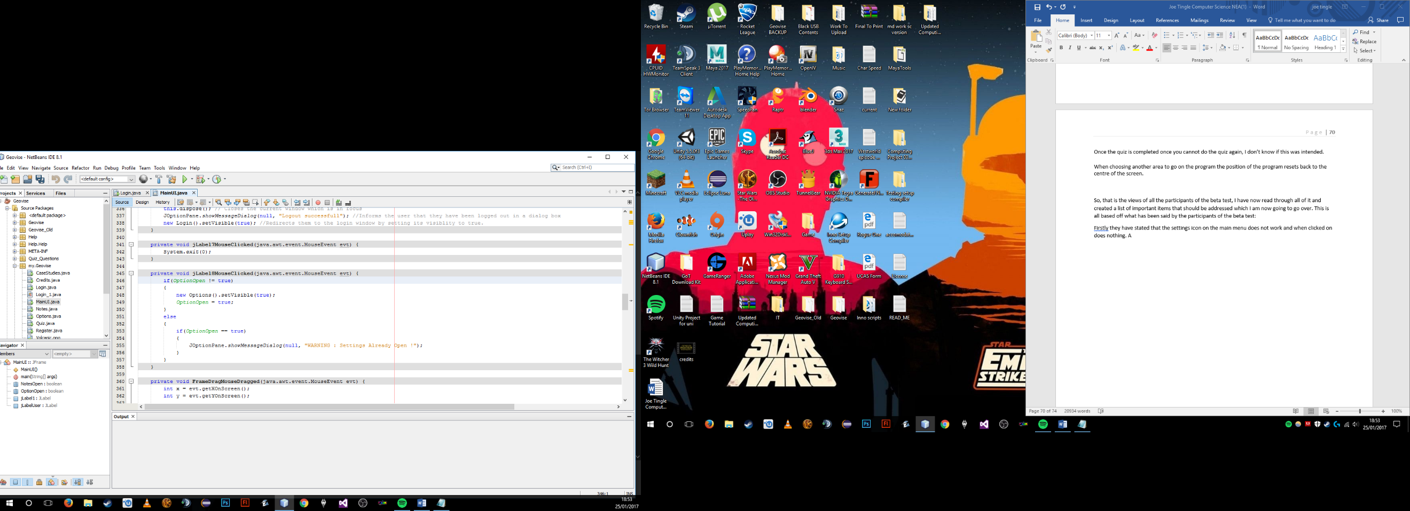

It uses a local Boolean variable declared at the top of the code in the constructor, called OptionOpen and sets its default value to false. So this means that by default the options menu is not open.

Then we move to the event code as seen above which is executed whenever the user clicks on the options button. Firstly it uses an if statement to check if the OptionOpen Boolean variable is not equal to true, so is it false. If it is then it opens up the options menu and then sets that Boolean variable to true, exiting the if statement. Now if or when the user clicks on the options button again, because the Boolean variable is now true it will not enter the if statement, it will instead move into the else and then run the next if statement. This asks if the Boolean variable is equal to true, which it is so it does not open the options menu and instead prompts a dialog box telling the user that the settings are already open.

I have used the above code in the same format for the notes button as well, preventing the user from essentially ‘spam’ opening new windows. I have only changed the Boolean variable to another local variable called NotesOpen.

The second piece of feedback that was made was that the Quick Facts on the main menu needed to be in a bigger size and a different colour to stand out more, there we also some notes on there not being enough quick facts. If I recall the current count of facts from the beta test version was 15, so this can be increased.

I managed to increase the font size to 14 and also made the font bold as you can see below.

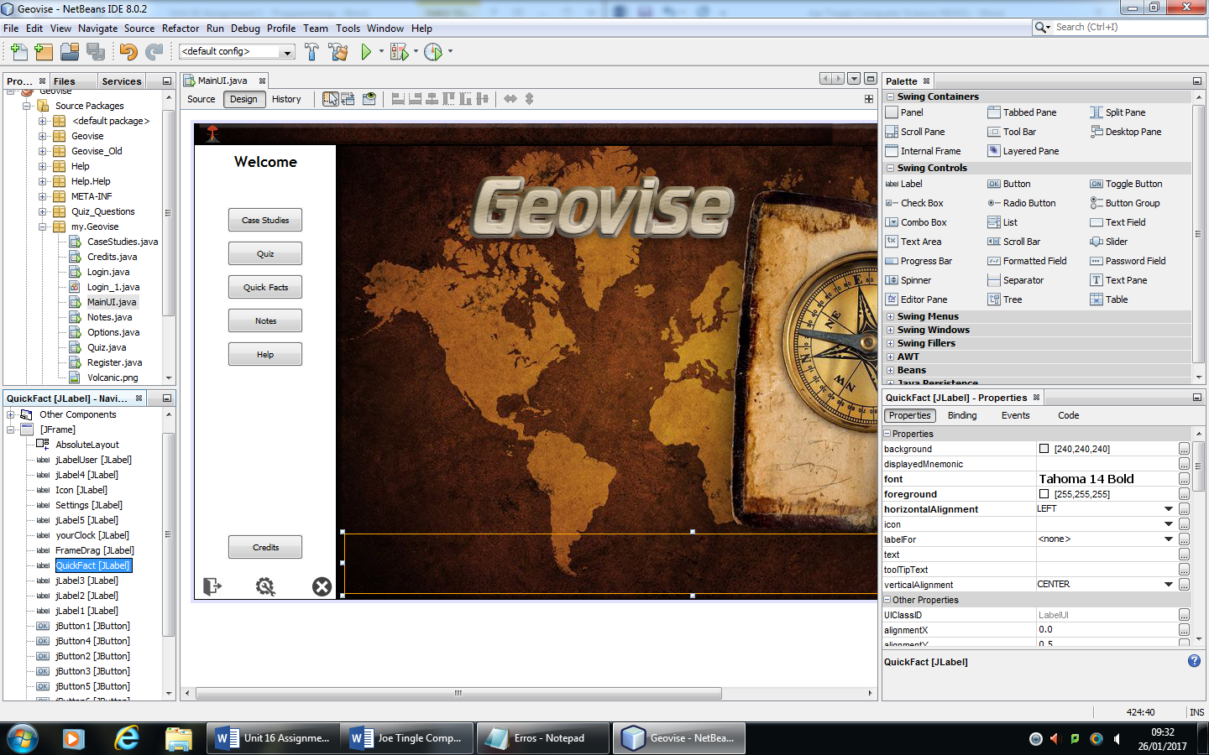

The increase in font size from 10 to 14 as well as adding the bold has made the Quick Facts much easier to read and you can see the result of this below:

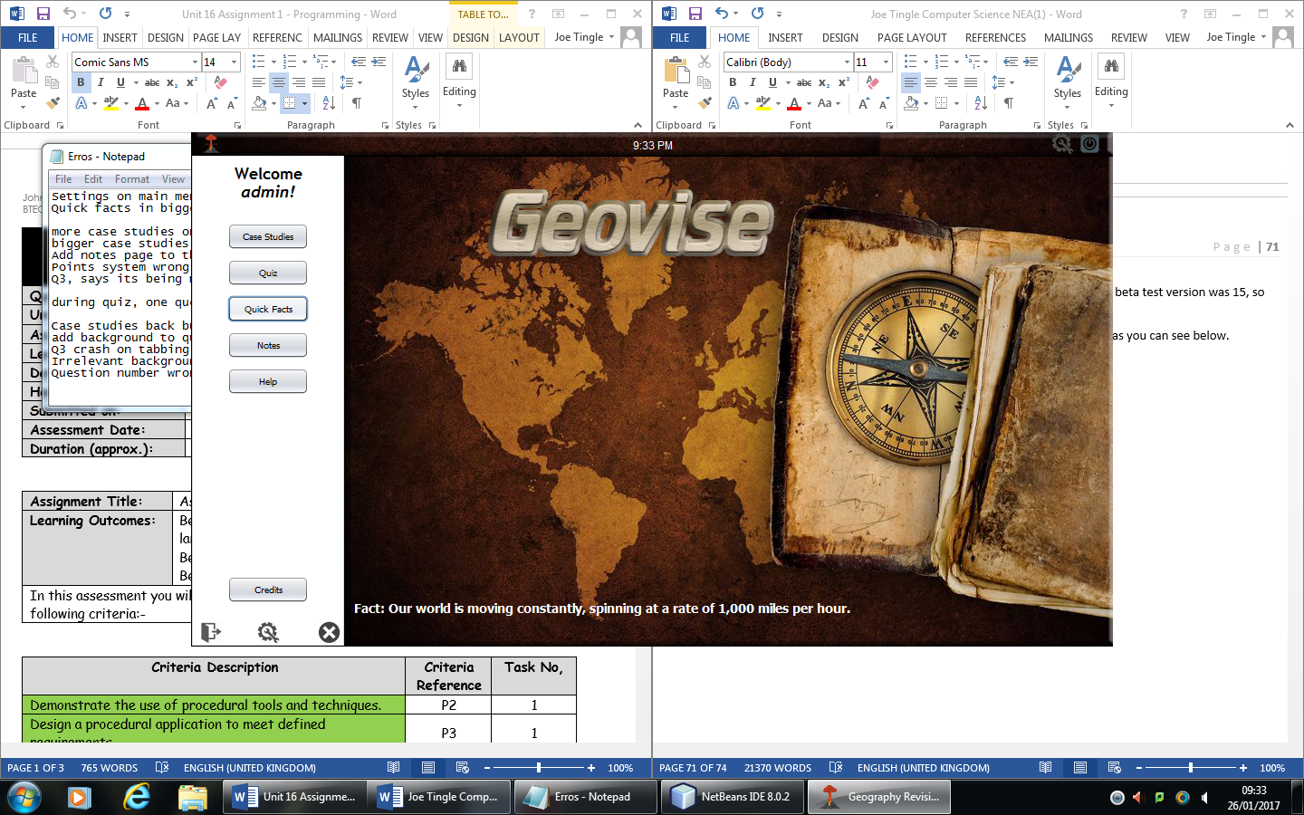

I have also addressed the colour issue and now change it to a colour of #FFCC00, I think this matches with the overall theme of the program even more now.

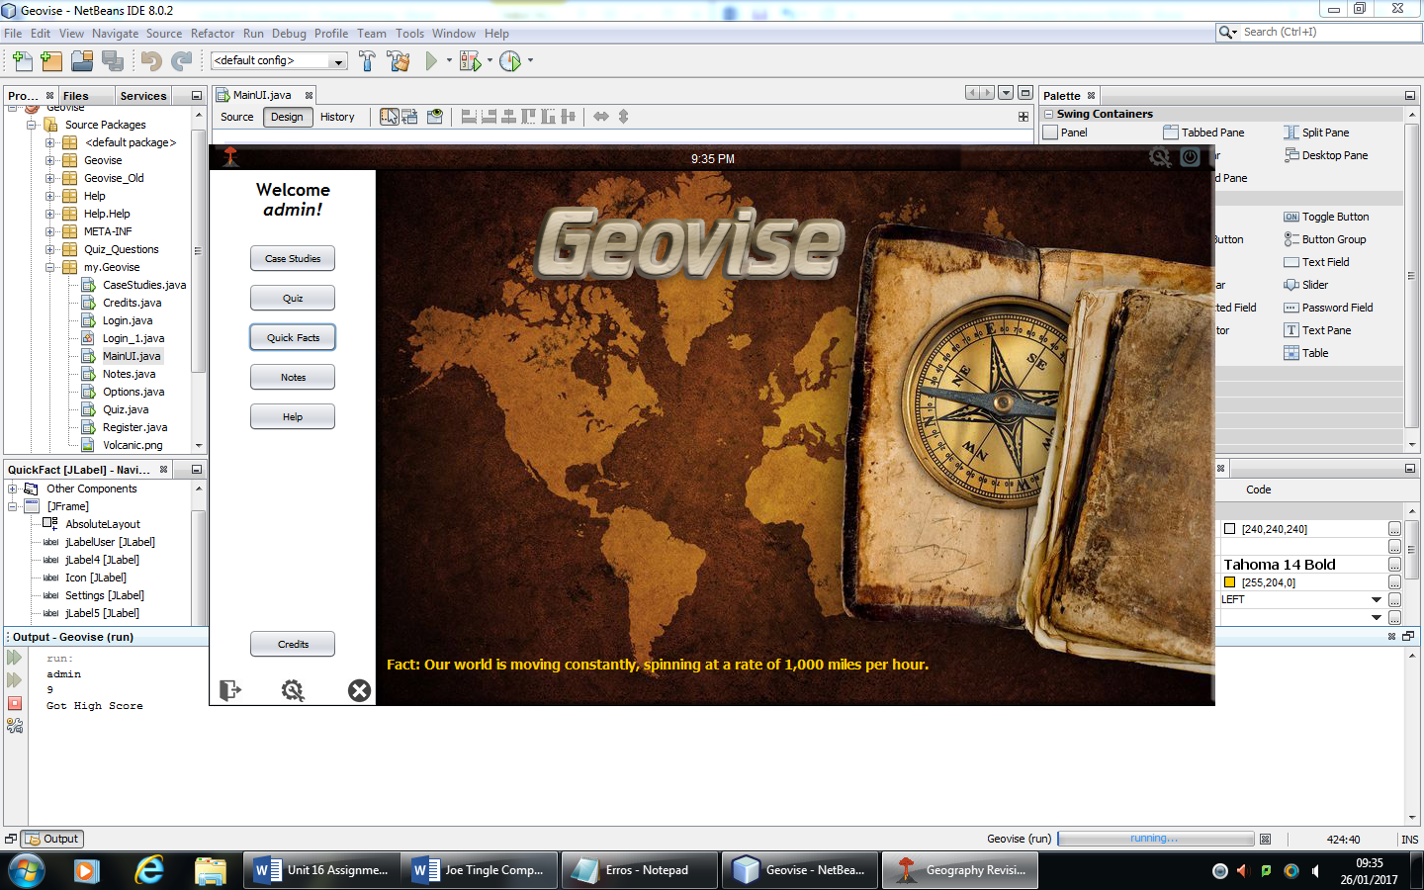

Alongside the noted changes as seen above I have also fixed some grammatical errors within the facts, for example on one of them it said act: instead of Fact: but that is now corrected. I have also increase the number of facts to 30, doubling the amount that was previously on the beta version. This means that there is a smaller possibility of getting repeat facts.

The next note that I picked up on within the test is that the users believed that there should be more case studies on each section. The original plan for this section was to have a base amount of 4 on each section and then I could add more in future updates for the program, keeping it up to data and making sure that the users continue to use it. But after reviewing I think that this is correct and I am going to add two more case studies on each section so there is now 6 on physical and 6 on human bringing the total up to 12 overall.

So I have added the Tombolo: Chesil Beach and Sand Dunes: Formby Beach to the physical case studies, alongside all of the information/notes/maps etc. and inner City Area & Suburbs and Rural area (Isle of Purbeck) to the human section.

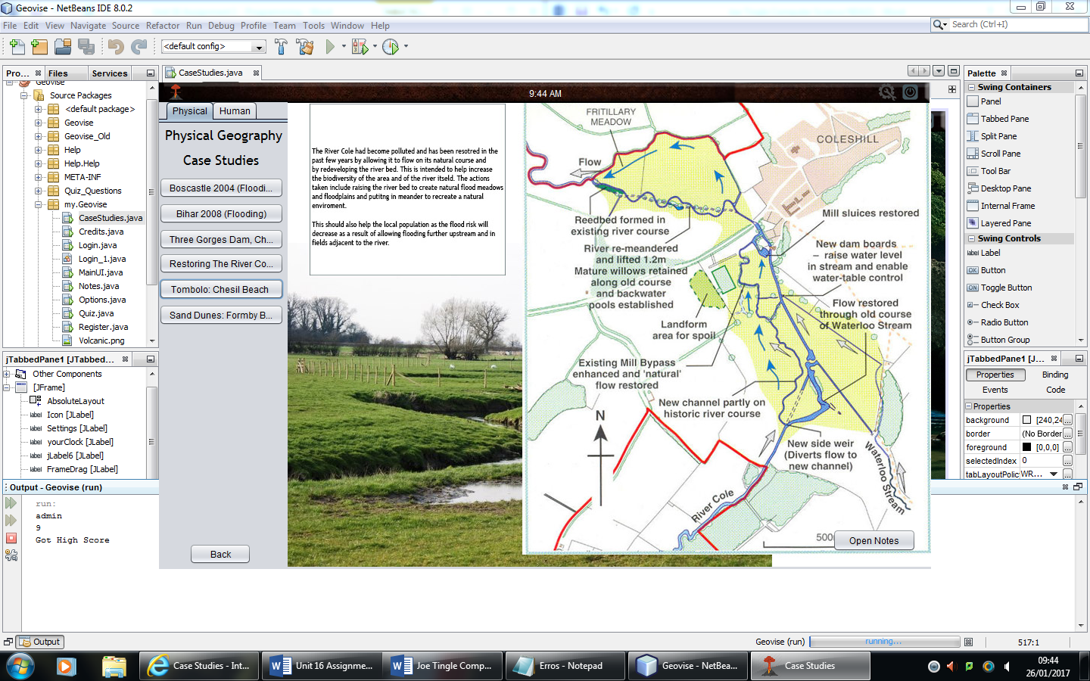

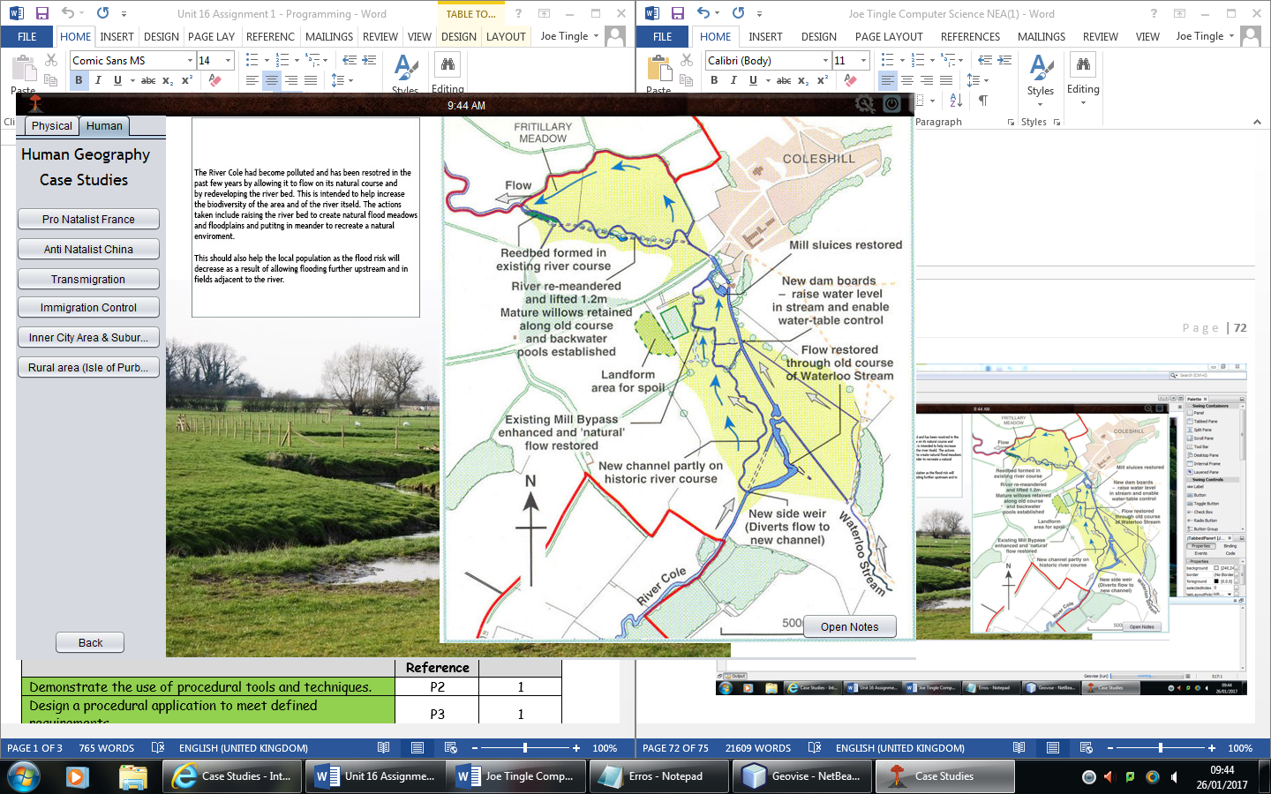

I have utilised the same code from the previous buttons, the restCaseStudyVisible() function as well as setting the relevant jLabel to visible. So overall I have added 4 new jLabels and then added their visibility to the function as well as the actual button event.

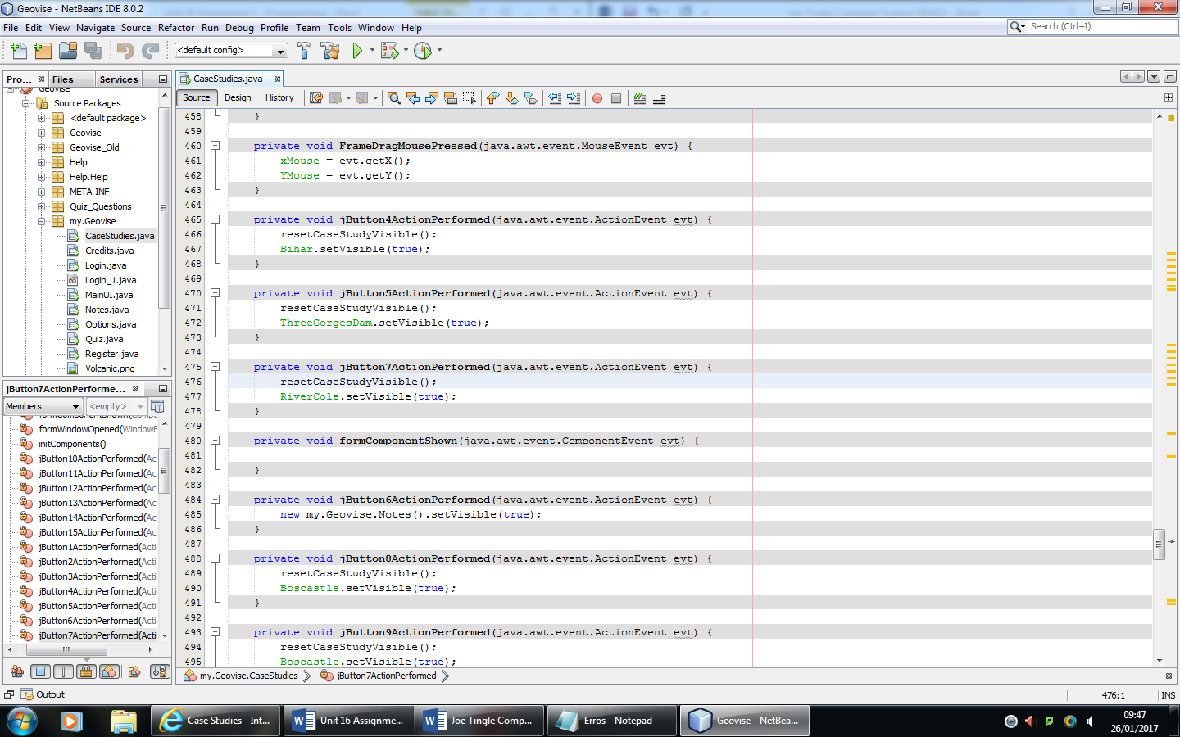

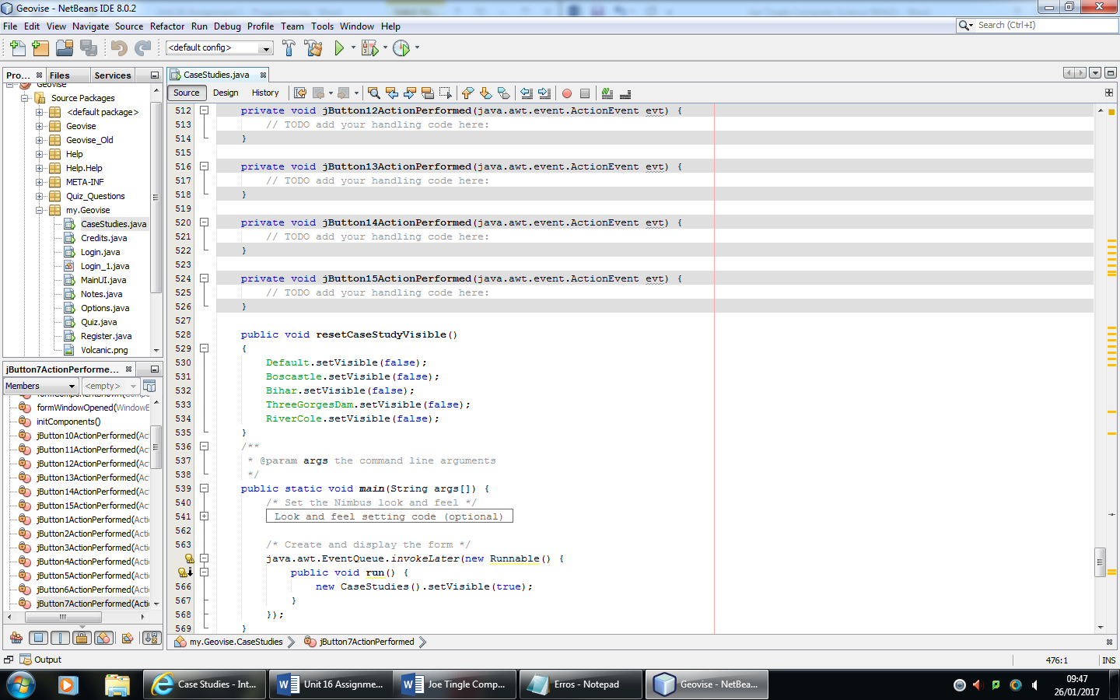

But whilst we are still on the case studies section, another note was that the buttons were not big enough so on some of them the text was getting cut off. You can see a good example above in the new case studies I have now added. So for example on the Inner City Area & Suburbs it cuts off the last few letters on Suburbs.

One solution that I was going to implement was to resize the actual tabbed pane in which the physical and human sections were located within. However because the information asset images for each are set at a certain size. So resizing the tabbed pane could cause it to overlap on the information, making some of it unreadable. So the alternative solution which I have implemented is by changing the font size to 10 and making them bold as well as resizing the actual button, the result of that can be seen below:

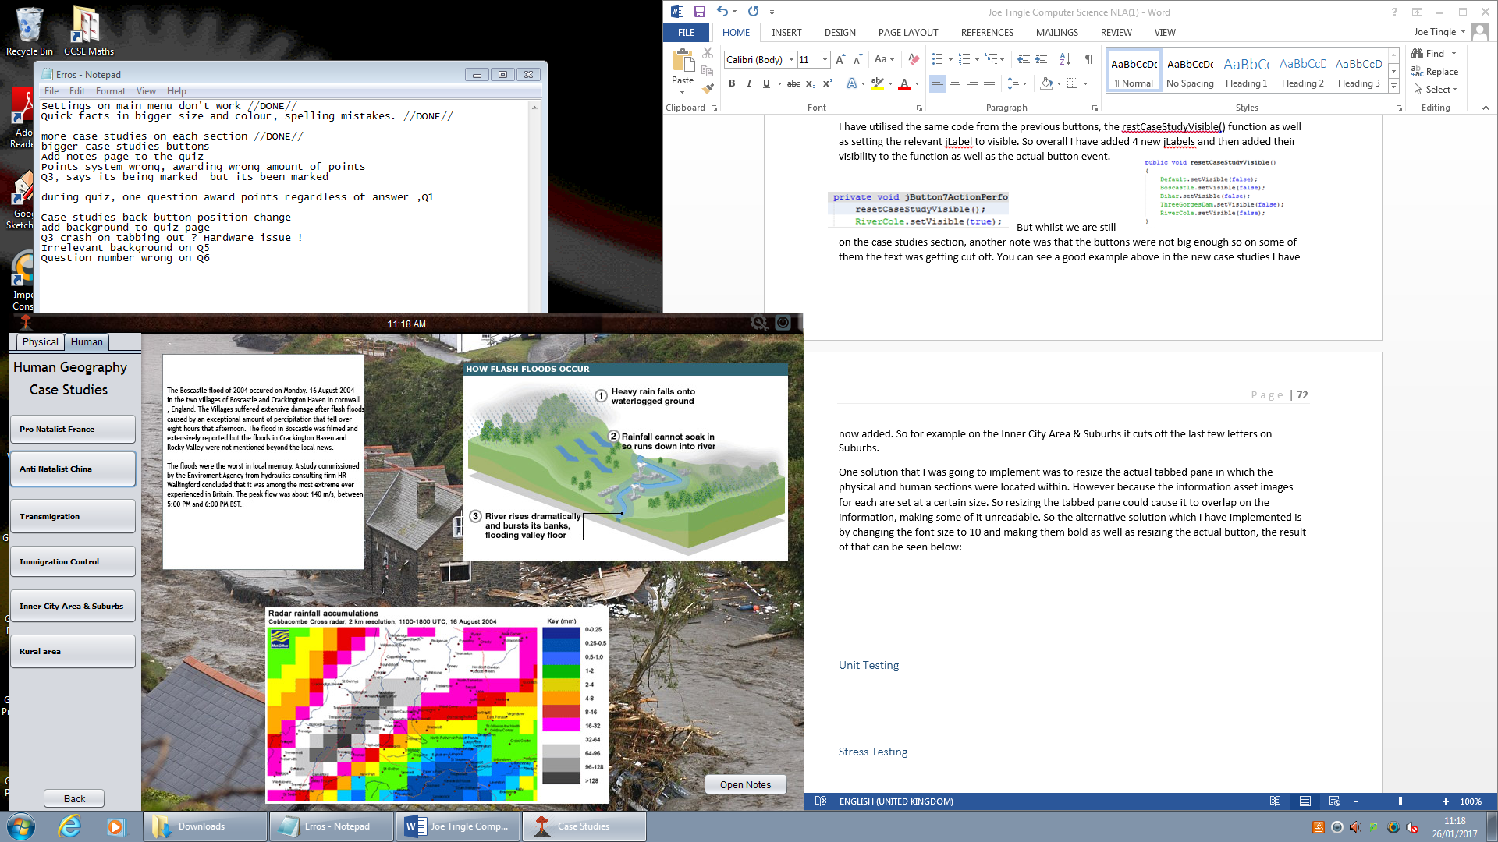So now the user is able to see the whole text on the buttons as they are bigger than the previous version.

The test participants also noted that the notes page button should be relocated to the quiz page, allowing the user to make notes whilst they are doing the quiz such as improvements they could make etc. For this I have decided to simply copy it over from the main menu page to the bottom right of the quiz page as seen below:

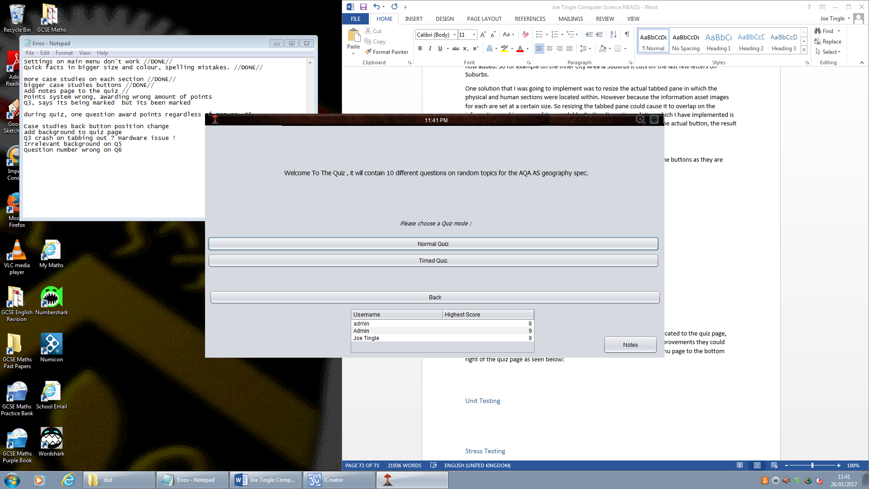So now the user just has to remember to open it up before they begin the quiz, I decided not to add it to each question so that it wouldn’t take up room within the jFrame which could be used elsewhere.

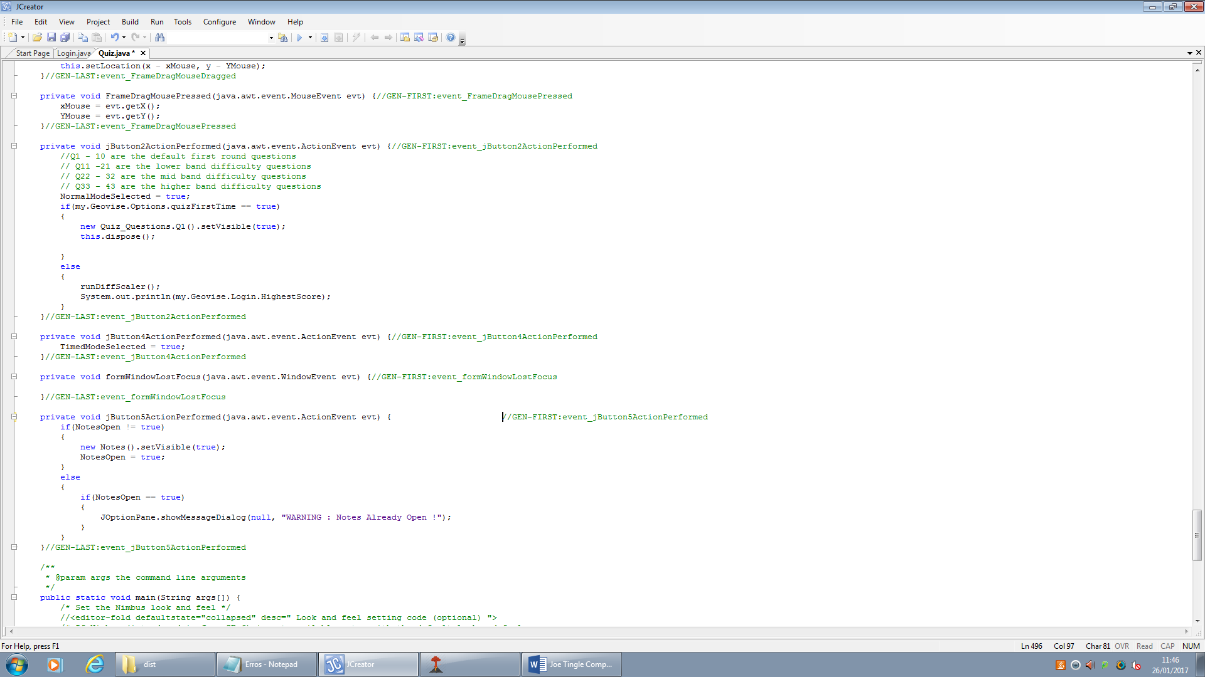

The above code is what is executed when the button is pressed. You may notice that this is very similar to the open option code, this is because it is the same apart from the change in the Bo\olean variable.

Next is the feedback which said that the points system is wrong and it will sometimes award the incorrect amount of points. This issue is because on each question I have a small jlabel next to the submit button which states the total amount of points for the current question.

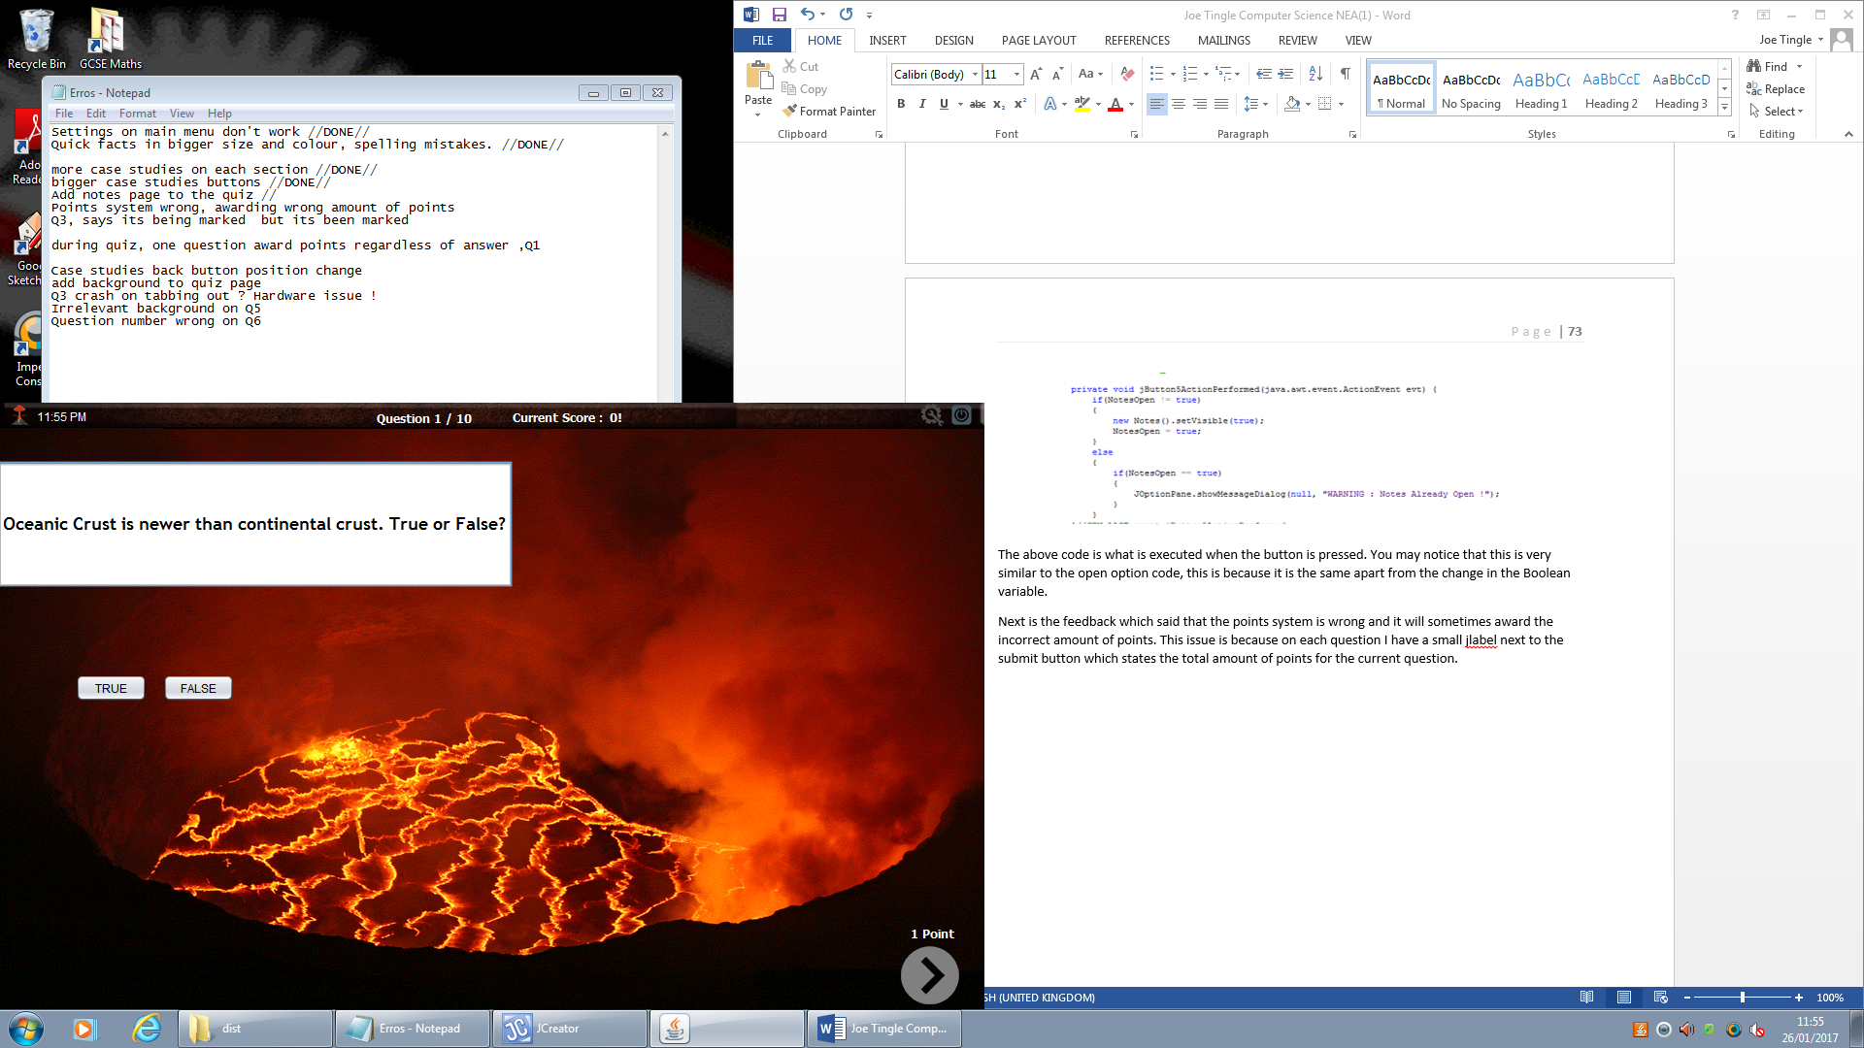 So here is the amount of points for the first question, and it correctly awards the 1 point. As you can see the code will only execute once the user has clicked on the next button,

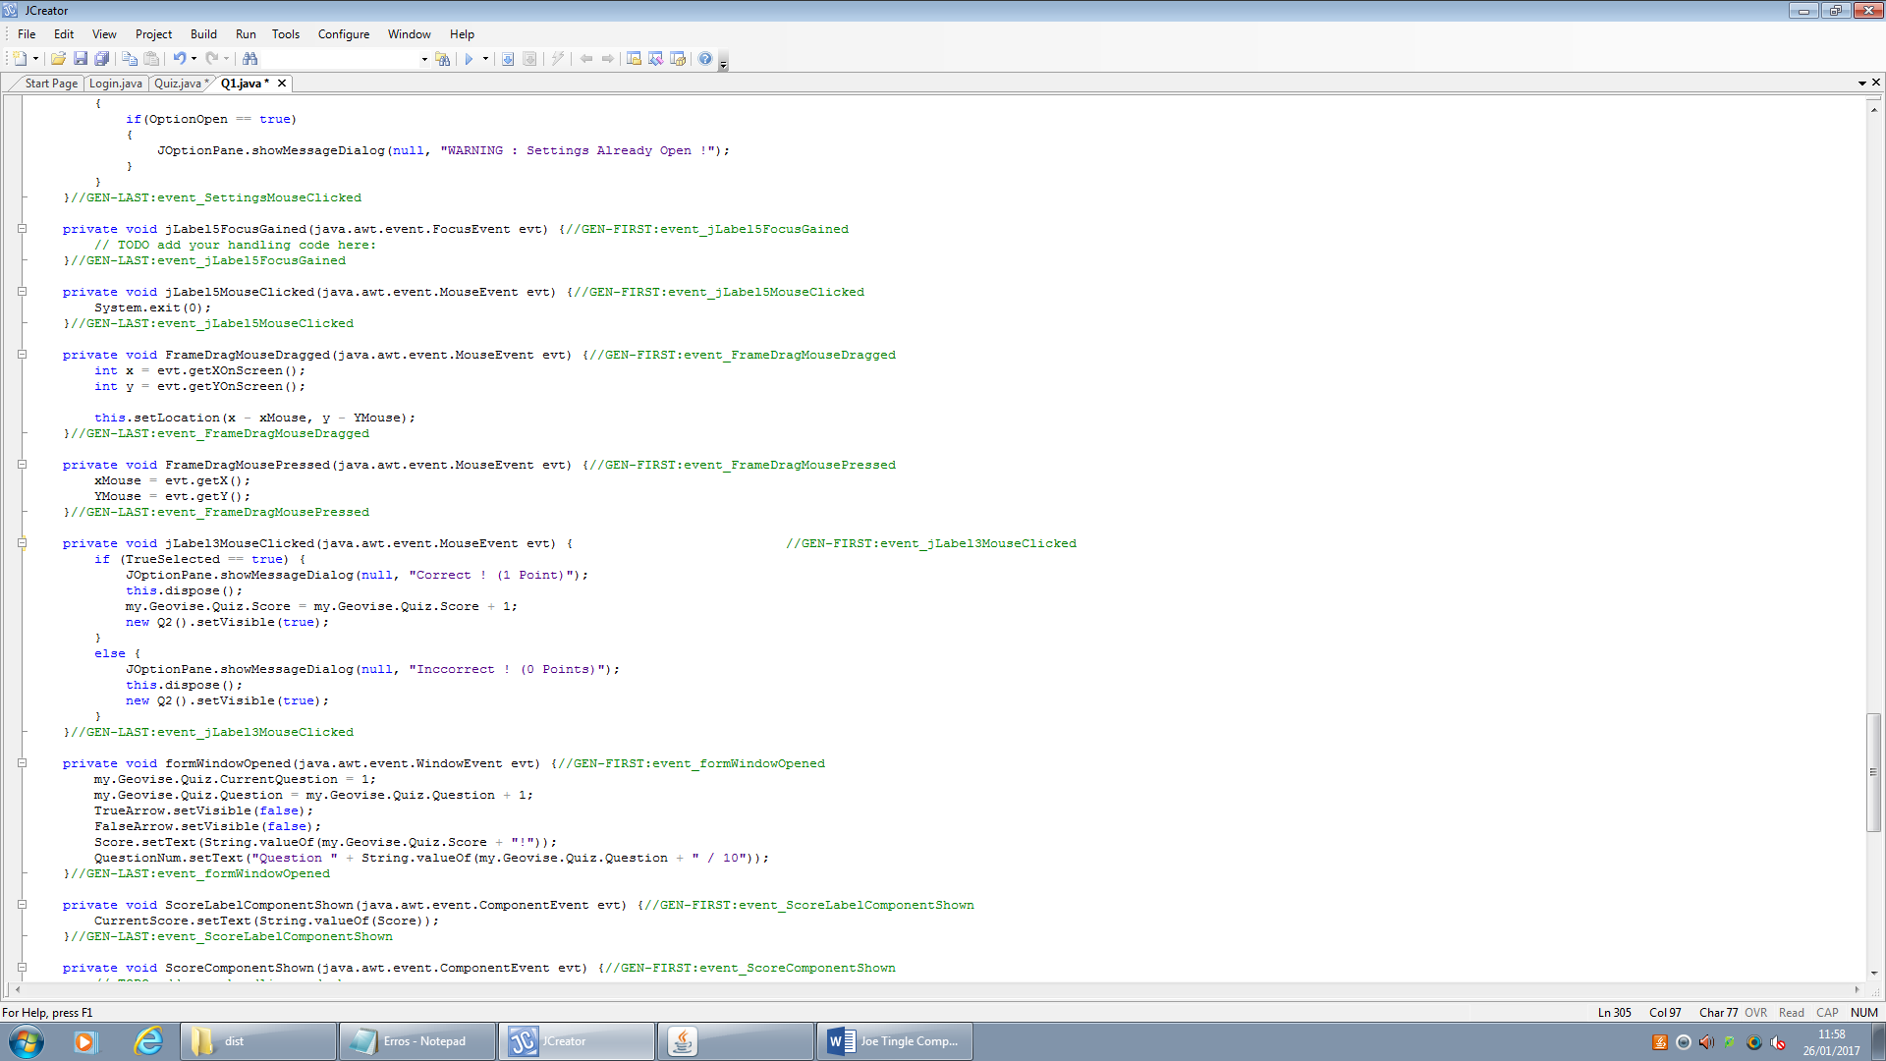

Firstly it checks to see if True has been selected, if the user clicks on the true answer button it sets the Boolean variable to true. If it is true then the answer is correct so it gives the correct amount of points in the below line of code:



So this is what the code should look like, or at least be similar to, for the rest of the questions.

But after reviewing all of the questions on the tutorial round I have found that the marks are not consistent, so on one question it may be 1 point overall, but on another it may be 3. So I have decided to change the amount of points that are awarded on each question to just 1, so from now onwards every question will only award 1 point for consistency.

This means that I have had to change the contents of some of the jLabels, as for example on question three it was 3 marks stated in the jLabel, but only awarded one. So I have changed it to 1 point.

Another note on the quiz was that during Question three once the user had clicked on the next button it would tell the user, that the answer was currently being marked, but then on the score counter on the toolbar it would update adding a point to the score. Now this is simply from me not removing some redundant code, as question 3 was originally planned to be an essay type question but I then changed it to a multiple choice, leaving behind the dialog box text once the user clicked on the next button. I have solved this by simply removing the code so that it will no longer execute once the user clicks on the next button.

Also, a major issue that was brought up by one of the testers was that on question one the user could continuously click on true and then false and it would confuse the program. It would then not reset two Boolean variables, leaving them both as true so once they click on submit to get it to mark the answer they are guaranteed a mark.

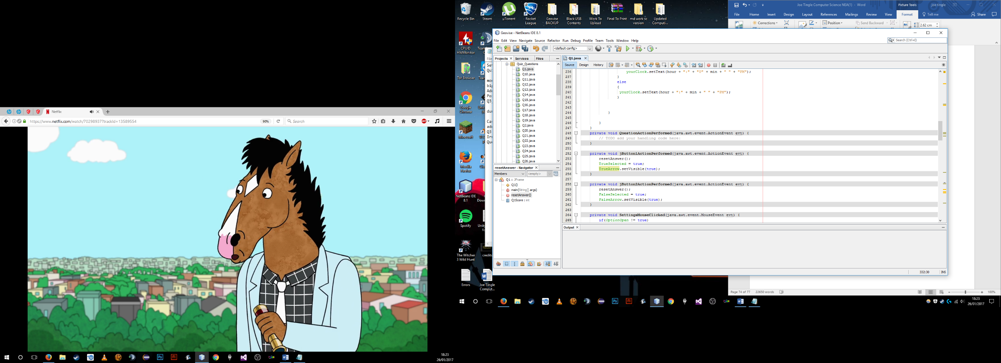This issue was also brought up in the alpha test as well, whereby they provided a possible solution which I have now implemented. They suggested that I create a new function called reset and then simply make the True and false selected Boolean variables to false, essentially resetting them. Then I would call this function as soon as the user clicked on either the true or false button. So, once the user clicks on true or false it would set the variables to false and then the relevant one to true.

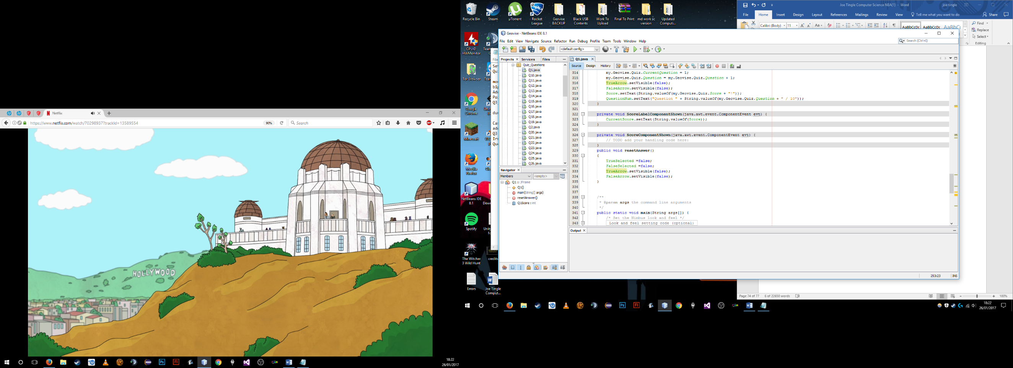

So here we can see the function and where we call it within the code. So once the user clicks on true it will run the resetAnswer() function which resets everything, it then sets trueselected Boolean variable to true and then makes the arrow visible to identify which one has been selected.

## 4.2 / 4.3 Describe the Final Product / Success of the Solution

For the product to be deemed a success it must have met all the success criteria which I have stated in the analysis and design sections. So here I will be going through each one, point by point, to see if the finished product does in fact meet the success criteria and if not why it doesn’t.

1. **The system must help the end user to revise the AQA A level geography specification.**

***Criteria Met ✓***

Of course, this is very broad criteria, as you must consider a lot of different things, but I believe that Geovise does indeed help the user to revise. To prove this, after the beta testing I asked the participants if they thought the software would help them revise as they were current a level geography students. I decided not to ask the developer in the alpha test as they were not a geography student and I required their technical knowledge for the alpha test. But below you can see the answers in which they gave me to the question which are the evidence for achieving this particular criteria:

Jamie: “After going through and having a look at the program I think that I could use this as another source for revision. Mostly due to the case studies section as it can be quite difficult to actually find good detailed sources for them.”

Harry: “In the current version I think that this could help with revision, but it would need a lot of new content for it to be a good source. For example, currently there are only around 12 case studies where as we may need more, but I do have to admit that they are of good quality.”

Jack: “The amount of content in some areas is lacking but overall I think it is a good revision tool”

Jordan: “In the beta version which I was using to test it there were quite a few issues, but when these are solved, this will be a very good source of revision for geography.”

So, as you can see they all have concluded that it could be a good source of revision for the A level geography specification. Although some did say that there needed to be more content, but this can easily be achieved by adding more questions/case studies etc. This could even be introduced into a system where, for example every month or so new questions or case studies are added to keep the users using it.

**2/3)** **The system should allow the user to login to their own personal account.**

***Criteria Met*** ***✓***

I have achieved this criteria as the user is able to register their own account by clicking on the register icon on the login screen, this will then open a connection to the database which is hosted online, and add in the record. Once the user has created their account, so essentially if the connection has been successful and the SQL statement has also been executed correctly without any errors, the user is then able to immediately put the login credentials of the new account into the login screen and be able to login to their own account. These accounts will then store lots of information about them such as the highest score, whether or not they have completed the tutorial round or not etc. So I can easily say that I have completed this specific criteria. It works as intended with no flaws. The next criteria that I set out can be tied to the previous criteria as it stated that the system must allow the user to create their own account, and as I have said before the user is able to login to their account they are able to click on the register icon on the login screen which will then open up the register screen. Then the user is able to enter any username and password and once they press enter or click on confirm it will create a connection to the database and then execute the SQL statement. So I can safely say that I have accomplished the success criteria stated above. Evidence of this can be seen under the testing section on **pg.67/68**

**4)** **The system must be able to display all of the windows correctly**

***Criteria Met ✓***

This means that all of the dimensions and starting positions of the program should be correct. I have achieved this by firstly making sure that all of the buttons link to somewhere meaning if the user clicks on one then it is guaranteed to take them somewhere else, open up another frame. I then made sure to set each frame so that it generated in the centre of the screen so that is was consistent whenever a new frame is opened it generates in the centre of the screen. However I did encounter some errors whilst developing the program, which occurred when I was moving around files and re organising the structure of the assets within the program. Every time a new frame opened it would produce a null pointer error which was due to it not being able to find the location of the assets as they had moved. This had to be fixed by resetting the location of all of the assets so that they pointed to the correct location. But in the end I believe that I have definitely achieved this particular success criteria and all of the active frames do open correctly and are consistent. Evidence of this can be seen under all of the testing sections as they show the test outputs with the windows open and the user is able to interact with them.

**5)** **The system must change the default java icon to the custom volcano bitmap image**

***Criteria Met ✓***

This is as soon as the program is launched or a new window is opened. I have achieved this success criteria by adding one line of code on all of the files such as login, main menu etc. under the form window open event, which runs as soon as the user opens up the window. The code is as follows:



This then gives the desired effect of displaying the custom icon on the taskbar, shown below is on the windows operating system.



Evidence of this can be seen under the Login/Register section on **pg.67**

**6)** **Then the system must be able to censor the user’s password on the login screen**

***Criteria Met ✓***

This is so that other unauthorised users will not be able to see what their password is and access the account. I have achieved this success criteria by using the jPasswordField in the GUI builder as this by default enables the censorship of the password, of course this does not fully protect it as anyone who is capable of intercepting and checking variables will easily be able to see it in the string form. One future development which could be made to improve this is the use of hashing as to protect the password. This way it would be encrypted and only the database on the other end would have the key to decrypt it. However I believe one drawback to doing this would be the response time which would increase due to it needing to process the hash key as well. But currently the system works fine as it is. Evidence of this can be seen under the testing section on **pg.67/68**

**7)** **The system must display both an image and a map for each case study on the case studies page**

***Criteria Met ✓***

I created all of the case study assets in Adobe Photoshop and exported them as a .png image format. I did this so that, in code, it was much easier to load and make visible to the user. For example if they were separate I would have to load the background image and then the map, and then the information etc. which would take multiple lines of code, whereas here it only takes one line of code to load the asset potentially saving compiler time. So in the end I believe that I have achieved this success criteria and optimised it for the good of the program, there are no improvements that could be made here. Evidence of this can be seen under the case studies testing section on **pg.78/79.**

**8)** **The system should allow the user to login into and out of the program without having to restart it by closing and then running the executable file again**

***Criteria Met ✓***

I have achieved this criteria by including a button on the main menu page which when clicked executes the code which will dispose of, and close, the current active window which would be the main menu. Then it would open up the login screen essentially logging the user out. This achieves the success criteria by ensuring the user does not need to reopen the program to log in and out meaning that they are not wasting time trying to log in and out which could otherwise be spent actually revising. Evidence of this can be seen under the Login testing section on **pg.67/68**

**9)** **The system should exit fully whenever the user clicks on the exit button icon on any frame within the program**

***Criteria Met ✓***

The exit button is located on all of the windows on the top right of the toolbar, it is in the same place on each of them for consistency. Then I added one simply line of code to the action event on the jLabel of the exit icon which was System.exit(0). So I have achieved the criteria as it does close the program fully whenever the user clicks on the exit icon. Evidence of this can be seen under the main menu testing section where it shows all of the icons working on **pg. 72/73**

**10)** **The system must also take the user to the login screen when the logout button is pressed**

***Criteria Met ✓***

It must also close all other active windows so that they are not technically still logged. This specific critter was easily achieved as the only logout button is located on the main menu so code wise all I had to do was close the main menu and then open a new login window. I decided to only add a logout button to the main menu as it is the most suitable place for it to be located. Evidence of this can be seen under the Login and Register testing section on **pg.67/68**

**11)** **The system must display the correct information for each case study on the case studies window**

***Criteria Met ✓***

I have collected together lots of information from varying sources and put them into the case studies section, so the sources may well vary for each case study as I have made sure it is the most relevant information. To ensure that it is correct I have also compared the information to the current AQA specification just to ensure the integrity and validity of it. So to conclude I do believe that I have achieved this specific success criteria as the information presented to the user is correct and relevant. Evidence of this can be seen under the testing section on **pg.78/79**

**12)** **The system must allow the user to open a blank notes page and save them for use at a later time.**

***Criteria Met ✓***

This was achieved by firstly adding a button which links to the notes page onto the main menu, which would then load up the notes with a blank jTextField for the user to enter any notes in that they want. Then I added in a menu bar which allowed the user to select file and then either save a local file or a file on the database, so essentially save it to the cloud. Both of these items achieve the success criteria as they are then able to load them back up and look at them at a later time. Saving a local file would bring up a windows explorer dialog box where the user can choose a location to save the file, and then they can also choose a name for the file. The file format in which the local file is stored as is a .txt, which I chose as this is simply the most widely used formats, and is multi-platform so it can be opened on a windows operating system as well as a MacOS system. So I have achieved this criteria as the notes section is blank by default and it allows the user to save a file. Evidence of this can be seen under the testing section within the case studies, which does include the notes and how the user is able to use them on **pg.78/79**

**13)** **The system must alter the difficulty of the question on the quiz based on the user’s previous score**

***Criteria Met ✓***

This I have also achieved in conjunction with the previous success criteria, by simply adding another function to the difficulty scaler, called setHighScore(). This then executes an SQL statement to add the score but only if it is higher than the current score. This function is executed in an if statement so that it is only run if it is needed to update the users score. So to conclude I have achieved this success criteria as it will update the users score as long as it is higher than the current on store within the database under their account.

**14)** **The system must display the answers to the quiz at the end**

***Criteria Partially Met***

I achieved this success criteria by adding in one more window at the end of the quiz, so after all of the 10 questions have been answered, it opens up the Quiz End Window. It contains all of the question numbers and the correct answers alongside the user’s answers. I believe this achieves the set out criteria as it tells the user which questions they have got right and others that are incorrect. Evidence of this can be seen under the testing section on **pg.86**

**15)** **The system must allow the user to access help at any point during the program**

***Criteria Met ✓***

I have achieved this success criteria by adding in another icon to the master layout toolbar, so now there is an exit, settings, minimise and help icon on the toolbar. I have decided to add it there as it is most visible and easy for the user to see and navigate to. Once the user clicks on the help icon it will open up the help window and clos the currently active one, which could be any of them. The help menu then has some information on it relevant to the user, and is essentially a set of instructions on how the use the program. There is also a back button located on this menu which takes the user back to the main menu. Evidence of this can be seen under the majority of the testing sections as it is part of the master layout.

**16)** **The system must exit fully once the user presses the exit button**

***Criteria Met ✓***

This criteria has been achieved by adding a simple line of code to the exit icon on the toolbar, System.exit(0) which gracefully exits the program. This should be the main way that the user closes down the program. Evidence of this can be seen under the majority of the testing sections as it is part of the master layout.

**17)** **The system must only allow the quiz window to be maximised**

***Criteria Not Met✘***

This is one of the success criteria which I have not met, as during development and implementation of the quiz I realised that this was simply not possible if I continued to us the assets I had used for the rest of the program. The main asset is the toolbar, which won’t be able to be resized when maximised so there would be huge gaps and it would look very unprofessional. I could have met this by removing the toolbar, but that would not be consistent with the rest of the program. So I felt that it was a good decision to not achieve this criteria and instead stick to the current theme of the program.

The one way in which this could be addressed later on is creating new assets which fit certain monitor resolutions, so for example one for a 1920x1080 monitor , and another for a 800x600 monitor. Then I would put some code in to determine the resolution of the users screen and then change the assets based off of this when the user clicks on the maximise button. However I fear this would take up a lot more system resources due to more processing time being required.

**18)** **The information presented to the user must be correct and relevant to the section they are in**

***Criteria Met ✓***

This has certainly been achieved as I have made sure to go through all of the other similar solutions which I have commented on in the analysis, and taken information from them relevant to the AQA specification. I have even made sure that it fits in with the specification they have provided.

**19)** **The system must display two tabs on the case studies, one for the physical and another for the human**

***Criteria Met ✓***

I have achieved this criteria by using the jTabbedPanes which are built in with the GUI builder, these allow for multiple tabs and give a different pane for each tab so that they can have different information. So for example I used the human pane to but all of the buttons which opened up and set the information to visible for the human case studies, and likewise with the physical section. So as you can see this success criteria I set out was achieved fully and in its current stage I don’t feel as though any more improvements can be made.

**20) The system must also display randomised question from a pool of them stored**

***Criteria Met ✓***

I have achieved this success criteria with the rundiffscaler() function present on the quiz class. Once the function is run it will grab the high score of the user by calling another function called GetHighScore(), which executes an SQL statement to grab it from the database, and then turns that score out of 10 into a percentage. So for example if the user score was 5 out of 10 then their percentage would be 50%. The reason that it is in a percentage is due to the set bounds I have created which are 0 – 50 % is the lower band, 51 - 80% is the mid band and finally 81 – 100% is the higher band. It then sets the band of difficulty based on this and then generates a random number between 1 and 10 which will be the question it will then do this 10 times for each question to be randomised within the difficulty band. I think the one improvement I could make to this is migrating it to a database, so instead of generating the questions and answers locally on each one, it could all be stored on a database.

**21)** **The system must only take up a maximum of 100MB disk space.**

***Criteria Met ✓***

I have achieved this criteria as the finished file in .jar format only takes up 23MB as you can see from the screenshot below.

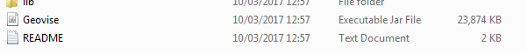

**22)** **The system must not utilise more than 400MB of RAM.**

***Criteria Met ✓***

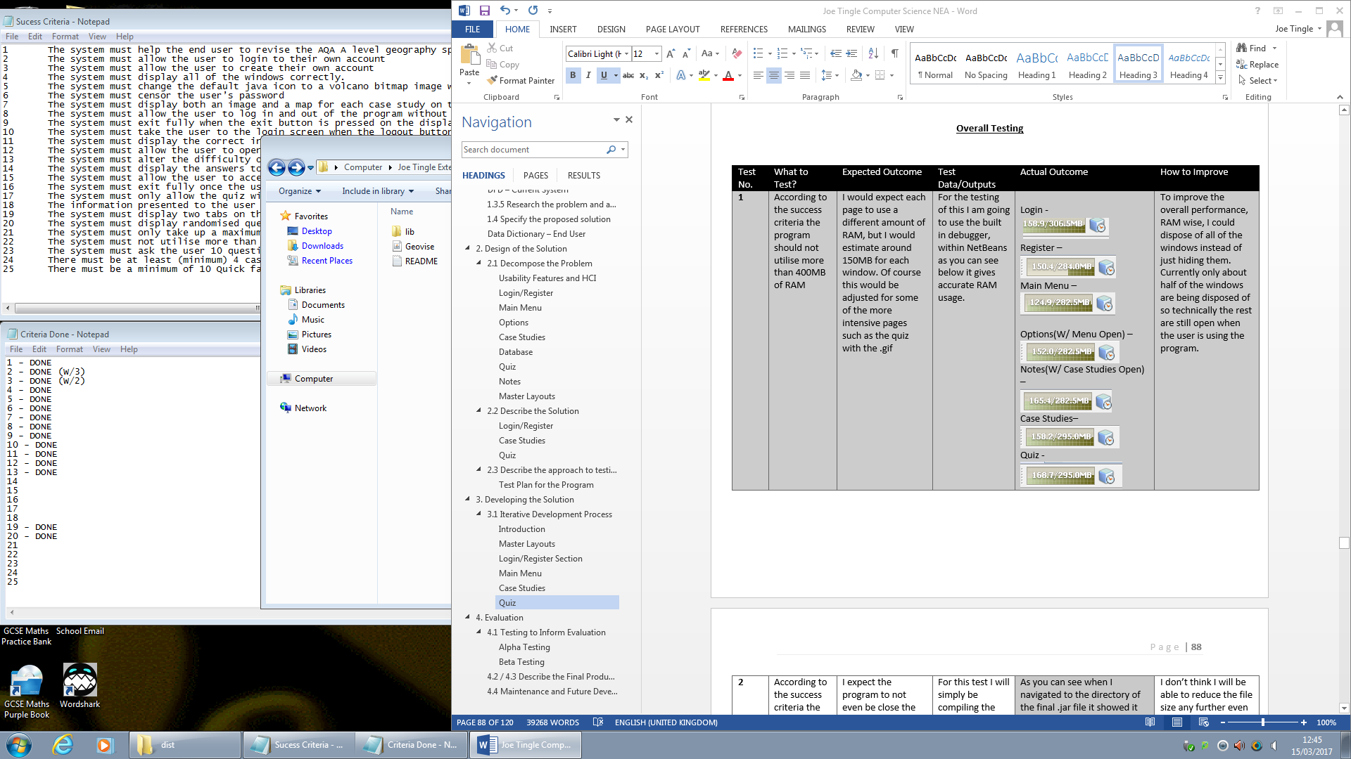 As you can see in the overall testing section under the development I made sure to monitor the RAM usage whilst developing to ensure it did not go over the set limit of 400MB. Here you can see that the maximum RAM usage was in the quiz section with 168.7MB, this was not idle I was actually using the features. The usage was over 100 but I feel as though this is a fairly good figure considering that most of the program has images/assets being loaded in all of the time. So I have achieved this success criteria as it never goes to the set limit.

**23)** **The system must ask the user 10 questions each time**

***Criteria Met ✓***

I have achieved this criteria as the difficulty scaler is run on each question and has some validation in the form of an if statement checking if the questions asked is at 10. If it is 10 then it will not ask any more questions and instead will update the high score if necessary and tell the user that they have completed all 10 questions.

**24)** **There must be at least (minimum) 4 case studies for each section**

***Criteria Met ✓***

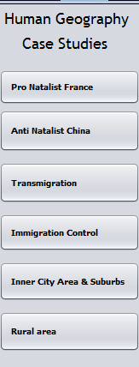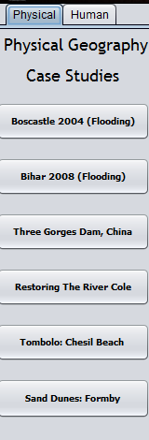 This has been achieved as each case study section, both physical and human, has currently 6 case studies. This comes to a total of 12 case studies overall, well over the 4 minimum set in the success criteria. I thought it was necessary to give the user as much information as possible so that they have the choice in what they need to revise. Below you can see a screenshot of all of the case studies in place.

**25)** **There must be a minimum of 10 Quick facts**

***Criteria Met ✓***

As the final success criteria this has also been achieved as in its current state there are approx. 32. Quick facts and more can be added at any time. The more facts there are the less repeats will be presented to the user and there will be more variety.

**26)** **The system must display a clock for the user to check the time, keeping focus on the program**

***Criteria Met ✓***

This success criteria has been achieved as it is part of the master layouts and present on every window in the program. It is located on the centre of the toolbar and updates in real time which can be seen as it updates alongside the operating system clock. I believe it helps the user keep focus on the program as they don’t have to look away from it to see what the time is anymore, keeping the users focus on it at all times.

So overall I feel as though the program does in fact meet nearly all of the set out success criteria, and in the end does achieve its main purpose of helping the user revise for the AQA A level geography specification.

## 4.4 Maintenance and Future Development

Of course, the main limitation of this solution is that currently it is fixed to the current AQA A Level specification for geography. This means that all questions and case studies are tied to it and all the information is relevant to it, so in the event that the specification becomes redundant or is updated the current information could possibly be irrelevant.

But I can see one good solution to this which would help deal with these limitations, this would be to completely move all information to the database, meaning no local copies of the information. This would then allow me to easily add in any new question or case studies with ease, by simply changing the table. Another huge benefit of this new proposed system would be that there will be no need for the user to update the program, it would be done automatically when the first connection to the database is made.

However, on the flip side there is also a huge drawback, with that this would then make the program online only, meaning the user must have an internet connection to use the program. So if the user does not have an active internet connection then they will not be able to use the program in any way, as the connection to the database to gather the questions and case studies will not have been made successful.

One of the further developments that could be made to the program are, implementing some sort of installer for the program so instead of the user copying files etc. they would only have to run the installer which would then get all of the libraries etc. and copy them to the relevant location. Also a good idea would be to build the project as an .exe file, as well as a .jar. This would be a good idea as an .exe file includes all of the relevant files and libraries, however it does have operating system restrictions as the .exe can only be run on a windows OS.

I have achieved all of the usability features set out in the design on **pg.22** whilst developing the program and it has made the program much easier to use and has made it much quicker to navigate through. For example in the design I stated that whilst developing the interface it had to be **easy enough so that the user did not have to put in much effort** to be able to achieve what they want and easily navigate around, **this has been fully met and achieved** as the stakeholder has stated many times during the development feedback.

**Evidence of the program** achieving this usability feature can be found on **pg.70** where the stakeholder stated that the interface looked easy and familiar to use. So the user would not have to put in much effort to be able to achieve the result that they want, for example this may be that they want to navigate to the case studies menu which they can then do through the buttons on the left pane on the main menu. More evidence can also been seen below which is an image of the prototype that the stakeholder commented on:

I have also taken into consideration the **colour within the program and have adjusted it so that it is consistent and doesn’t hurt the eyes** when using it for long periods of time or in the dark, **I have achieved and** **fully met** this by using the same theme throughout with a brown/old map theme, the stakeholder has said in multiple pieces of feedback that the interface looks good and is easy on the eyes.

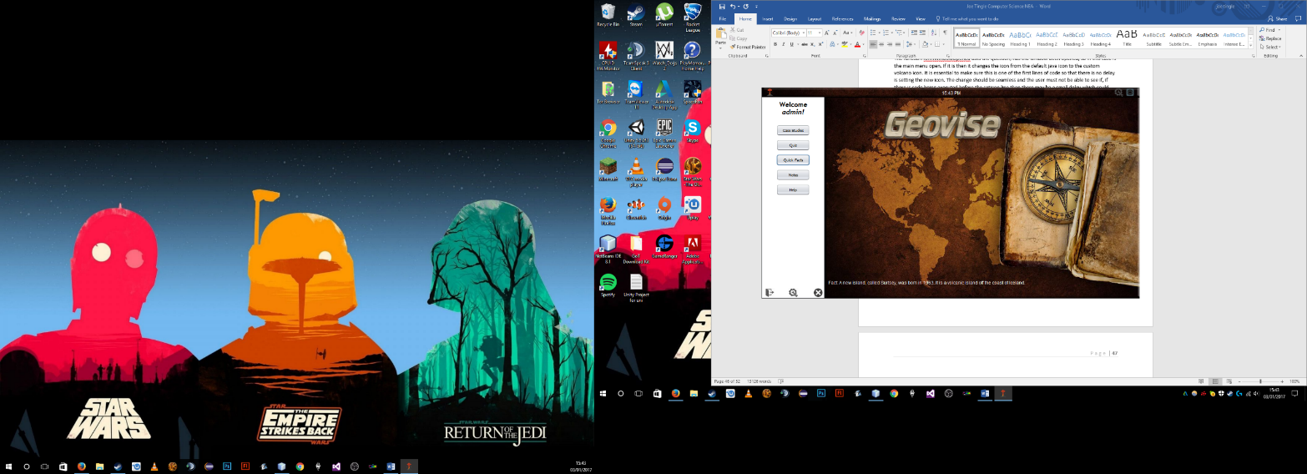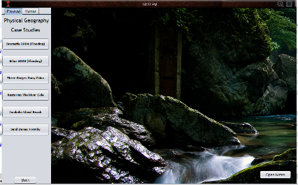**Evidence of the program** achieving this usability feature can be found on **pg.76** where I asked the stakeholder for some feedback on the then current prototype and they stated that the colour and overall theme of the program were great and easy to use which accomplishes the set of usability needs in the design. To test that the colour was good I asked the potential user base and the stakeholder to test it and they rated it an average of 8/10 for the colour, saying that the theme was consistent and the colours were not too bright that they hurt the eyes after long use. More evidence of this can be seen in the prototype image seen below which is a collection of the theme across most of the windows:

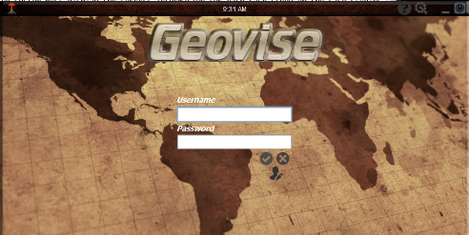

However, one **element I did not implement and achieve** in the program was the use of a **pop out effect** which I mentioned on the usability features and HCI on **pg.22,** I consistently used block shapes such as the rectangle boxes on the interfaces and neglected to use anything else. This meant that there was no variety in shapes and could be seen as dull by the user, which was shown when I asked the stakeholder and potential user base, who rated it a 6/10. I believe I could improve on this by simply changing the look of the box like shapes and maybe an overhaul of the main sections of the program such as case studies and quiz to make the interface stand out more to the user.

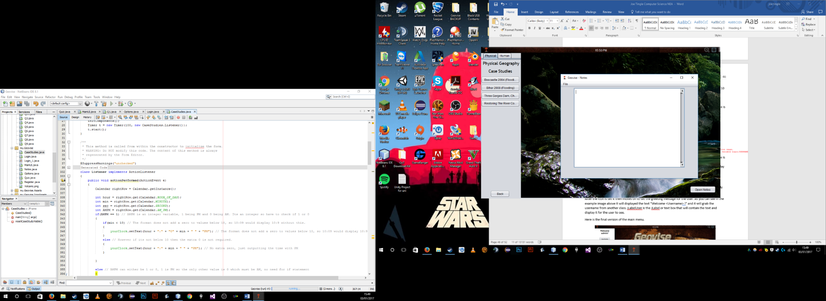You can see **evidence** of the stakeholder’s opinion of this on **pg.84** where they stated, when I asked for feedback on the then current prototype, that the interface looked easy for the use to use but it was still using the same basic block shape and didn’t pop out to them. More evidence can also be seen by looking at all of the windows together as you can see below:

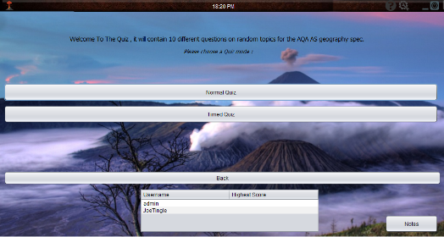

As you can see they are all the same shape which is the point that the stakeholder was making and it doesn’t stand out and give the pop out effect, which I have described in the design of the usability.

# Appendices

***Appendix A:***

*Transcript from Interview:*

*The interviewee is a Current A2 Geography Student from John Kyrle High School & Sixth from Centre*

***Interviewer****: “So what do you believe is wrong with the current revision materials available to you on the Geography specification?”*

***Interviewee****: ”Currently I have to look around lots of different websites and find textbooks to find maybe one case study or a piece of information which is key and I need to know in more detail, that wastes quite a bit of precious revision time which could have been used actually revising.”*

***Interviewer****: “What do you think can be done to greatly improve the revision process?”*

***Interviewee****: “There should be one central place, whether it be one textbook or a piece of software that has all of the required information including case studies and the basic facts which are most of the times missed in textbooks.”*

***Interviewee****: “The current system wastes time and sometimes means you don’t get any revision done at all”*

**Appendix B:**

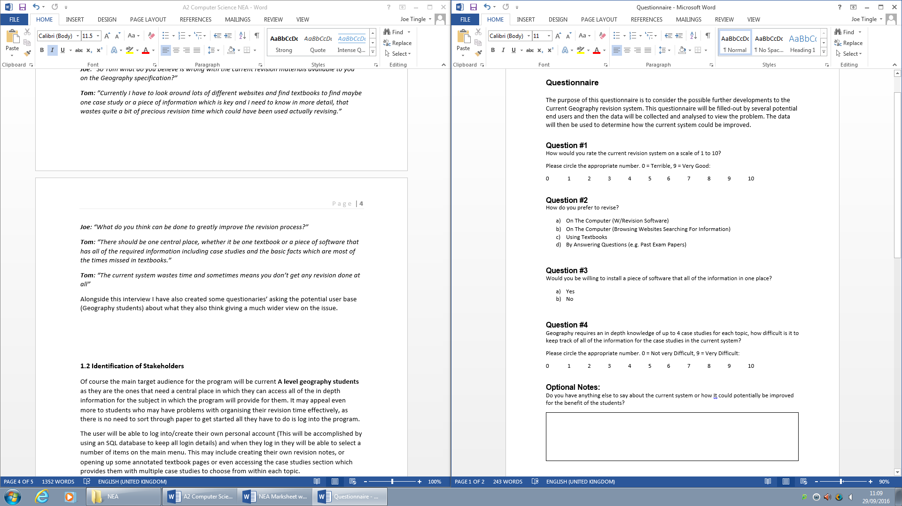

# Bibliography

* AQA | Geography | AS and A-level | Geography. 2016. AQA | Geography | AS and A-level | Geography. [ONLINE] Available at: <http://www.aqa.org.uk/subjects/geography/as-and-a-level/geography-2030>. [Accessed 03 October 2016].
* Types of SQL Statements. 2016. Types of SQL Statements. [ONLINE] Available at: <https://docs.oracle.com/cd/B12037_01/server.101/b10759/statements_1001.htm>. [Accessed 03 October 2016].
* Trail: Creating a GUI with JFC/Swing (The Java Tutorials). 2016. Trail: Creating a GUI with JFC/Swing (The Java Tutorials). [ONLINE] Available at: <https://docs.oracle.com/javase/tutorial/uiswing/>. [Accessed 03 October 2016].
* Oracle. 2014. NetBeans IDE basics. [ONLINE] Available at: <https://docs.oracle.com/javase/tutorial/uiswing/learn/netbeansbasics.html>. [Accessed 3 October 2016].
* P M Heathcote, 2016. OCR AS and A Level Computer Science. Edition. PG Online Limited.
* Codecademy. 2017. Learn SQL | Codecademy. [ONLINE] Available at: <https://www.codecademy.com/learn/learn-sql>. [Accessed 13 March 2017].

# Code Listing